**Project Report**

**Topic:** Online Food Delivery System

# **Course:** Introduction to Software Engineering



Online Food Delivery System

# Contents

ABSTRACT 3

Existing System 3

Proposed System 3

SOCIO TECHNICAL SYSTEM 3

MODEL 4

RUP Model (Rational Unified Process Model) 4

Advantages of RUP Software Development 4

Other Models 5

Waterfall model 5

Incremental model 5

RAD model 5

Prototype model 5

Spiral model 5

FUNCTIONAL & NON-FUNCTIONAL REQUIREMENTS 5

Functional Requirements 5

Non-Functional Requirements 6

UML DIAGRAMS 7

Sequence Diagram 7

Activity Diagram 8

Class Diagram 8

User-case Diagram 9

TESTING 9

Unit Testing: 9

Module Testing: 9

Sub-system Testing: 9

System Testing: 9

Acceptance Testing: 9

Online Food Delivery System

## ABSTRACT

Online Food Delivery System is a system which will help restaurant to optimized and control over their restaurants. For the waiters, it is making life easier because they don’t have to go kitchen and give the orders to chef easily. For the management point of view, the manager will able to control the restaurant by having all the reports to hand and able to see the records of each employees and orders. This application helps the restaurants to do all functionalities more accurately and enhances the spend of all the tasks. Online Food Delivery System reduces manual works and improves efficiency of restaurant.

The online food delivery system set up menu online and the customers easily places the order with a simple mouse click. Also with a food menu online you can easily track the orders, maintain customer's database and improve your food delivery service. This system allows the user to select the desired food items from the displayed menu. The user orders the food items.

The payment can be made online or pay-on-delivery system. The user’s details are maintained confidential because it maintains a separate account for each user. An id and password is provided for each user. Therefore, it provides a more secured ordering.

### Existing System:

In existing system for giving any orders users should visit hotels or restaurants to know about food items and then give order and pay advance. In this method time and manual work is required. Maintaining critical information in the files and manuals is full of risk and a tedious process.

### Proposed System:

This online application enables the end users to register online, select the food from the e-menu card, read the E-menu card and order food online. By just selecting the food that the user wants to have. The results after selecting the food from the E-menu card will directly appear in the screen near the Chef who is going to cook the food for you. By using this system, the work of the Waiter is reduced and we can also say that the work is nullified. The benefit of this is that if there is rush in the Restaurant then there will be chances that the waiters will be unavailable and the users can directly order the food to the chef online by using this system. The user will be given a username and a password to login.

## SOCIO TECHNICAL SYSTEM

This system is a socio-technical system as the system has such properties:

* Involves operational processes
* Include people who use and interact with the technical system.

So, we can conclude that the system is **Social technical** system because it involves operational processes (like place order, online payment) and include people.

Online Food Delivery System

## MODEL

### RUP Model (Rational Unified Process Model)

For the implementation of the system the RUP Model (Rational Unified Process Model) is used. Its goal is to ensure the production of the high-quality software that meets the needs of its end users within a predictable schedule. It is easily customized and useful for web based implementations.

RUP methodology has a highly flexible development path. It uses the some of the industry’s best practices. These are known as six best practices of RUP methodology. The reasons why we are using RUP model for developing this system are also these best practices.

**Develop Iteratively**: The [software requirements specification (SRS)](http://www.my-project-management-expert.com/software-requirements-specification.html) keeps on evolving throughout the development process and loops are created to add them without affecting the cost of development.

**Manage Requirements:** The [business requirements documentation](http://www.my-project-management-expert.com/business-requirements-documentation.html) and [project management](http://www.my-project-management-expert.com/project-management-requirements.html) [requirements](http://www.my-project-management-expert.com/project-management-requirements.html) need to be gathered properly from the user in order to reach the targeted goal.

**Use Components:** The components of large project which are already tested and are in use can be conveniently used in other projects. This reuse of components reduces the production time.

**Model Visually:** Use of Unified modelling language (UML) facilitates the analysis and design of various components. Diagrams and models are used to represent various components and their interactions.

**Verify Quality:** Testing and implementing effective [project quality management](http://www.my-project-management-expert.com/project-quality-management.html) should be a major part of each and every phase of the project from initiation to delivery (aka the [project](http://www.my-project-management-expert.com/project-management-lifecycle.html) [management life cycle](http://www.my-project-management-expert.com/project-management-lifecycle.html)).

**Control Changes:** Synchronization of various parts of the system becomes more challenging when the parts are being developed by various teams working from different geographic locations on different development platforms. Hence special care should be taken in this direction so that the changes can be controlled.

### Advantages of RUP Software Development

1. This is a complete methodology with an emphasis on accurate documentation
2. It is proactively able to resolve the project risks associated with the client's evolving requirements requiring carefu[l change request management](http://www.my-project-management-expert.com/change-request-management.html)
3. Less time is required for integration as the process of integration goes on throughout

the [software development life cycle.](http://www.my-project-management-expert.com/software-development-life-cycle-model.html)

1. The development time required is less due to reuse of components.

Online Food Delivery System

### Other Models

#### Waterfall model

The waterfall model can be used for the development of the system but we are not using it because the requirements must be known at the start otherwise it would be a disaster as the requirements are frozen before the designing of the system. In our system we need the testing at every phase but in waterfall model there is only Big Bang testing which is done at the end of the completion of all the phases.

#### Incremental model

The incremental model is not used by us just because the RUP (Rational Unified Process) Model is the best version of Incremental and Iterative model as it contains all the best features of both models. Incremental model is somehow costly as compared to RUP model and when we are getting the best features of two models in one single model then why would we not choose it?

#### RAD model

The reason we are not using this process model is that the requirements cannot be changed at later stages as, if the requirements are not well understood at the start then it would be very difficult. This process model, is no doubt for small scale projects like ours but work force is needed as number of teams are working parallel and that can be risky and costly.

#### Prototype model

The prototype model is not used by us because the risk factors are very high in this model. If our system is not accepted by the user then it will remain in an unending loop which will cause a lot of financial drop.

#### Spiral model

The spiral model is used by us in development our system as it is not suitable for low risk systems. In this model, it is hard to define objective, verifiable milestones and doesn’t work well for our type of smaller projects. Similarly, it can be a costly model to use and risk analysis requires highly specific expertise.

## FUNCTIONAL & NON-FUNCTIONAL REQUIREMENTS

### Functional Requirements:

#### Registration

If customer wants to order the food then he/she must be registered, unregistered user can’t go for ordering.

#### Login

The customer login to the system by entering valid user id and password for ordering.

#### Display the menu

In the system all the items are displayed with their rates.

Online Food Delivery System

#### Modify menu

System can make changings in menu like adding or removing food items which are not available.

#### Select food item/s

Items are selected customer feel free to order.

#### Changes to order

Changes to order means the customer can make changings in order like he/she can delete or add food item in order.

#### Review the order before submitting

Before submitting the complete order is reviewed to the customer. Customer name, phone number, location (address) and placed order, hen finally order is submitted.

#### Payment

For customer there are many type of secure billing will be prepaid as debit or credit card, postpaid as after delivering, check or bank draft.

#### Provide delivery and payment details

Here bill is generated, order no. and payment is given and confirmation of delivery is done.

#### Logout

After the payment or surf the product the customer will log out.

### Non-Functional Requirements:

#### Portability

System running on one platform can easily be converted to run on another platform.

#### Reliability

The ability of the system to behave consistently in a user-acceptable manner when operating within the environment for which the system was intended.

#### Availability

The system should be available at all times, meaning the user can access it using a web browser, only restricted by the down time of the server on which the system runs.

#### Maintainability

A commercial database is used for maintaining the database and the application server takes care of the site.

#### Security

Secure access of confidential data (customer information).

Online Food Delivery System

#### User friendly

System should be easily used by the customer.

#### Performance

Performance should be fast.

#### Efficient

System should be efficient that it won’t get hang if heavy traffic of order is placed.

#### Safety

Data in the database of system should not loss or damage.

#### Privacy

Personal data of the system should not disclose to anyone.

### Sequence Diagram

## UML DIAGRAMS

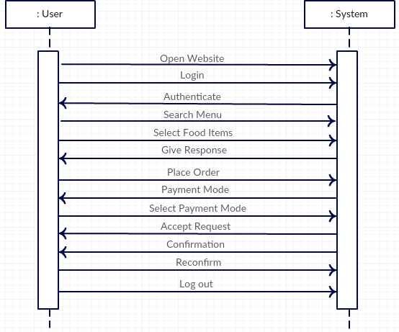

Online Food Delivery System

### Activity Diagram

**Class Diagram**

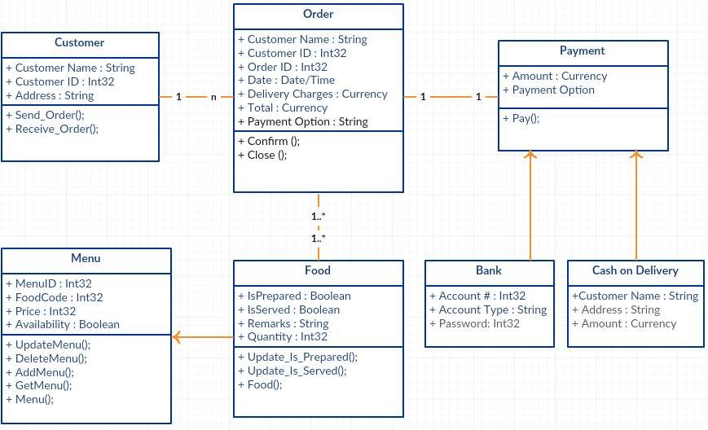

Online Food Delivery System

### User-case Diagram

## TESTING

At the end, the software testing is done to point out the [defects](http://istqbexamcertification.com/what-is-defect-or-bugs-or-faults-in-software-testing/) and errors that were made during the [development phases.](http://istqbexamcertification.com/what-are-the-software-development-life-cycle-sdlc-phases/) It’s essential since it makes sure of the Customer’s reliability and their satisfaction in the system. Here we just mentioned that how the testing is related to this system and in which way we have test the software? In our project we have used 5 types of testing these are listed below.

**Unit Testing:** Unit testing where individual program units or object classes are tested. Here by using this testing we have focused on testing the functionality of methods.

**Module Testing:** Where this is the combination of unit program is called module. Here we tested the unit program (5-6 programs) is where the module programs have dependency.

**Sub-system Testing:** Then we combined some module for the Preliminary System Testing in our Project.

**System Testing:** It is the combination of two or more sub-system and then it is tested. Here we tested the Entire system as per the requirements.

**Acceptance Testing:** Normally this type of testing is done to verify if system meets the customer specified requirements. After submitting the project to user, they test it and determine whether to accept the system or not. It is the system testing performed by the customer(s) to determine whether they should accept the delivery of the system.