**React Native Assignment**

### **React Native CLOCK**

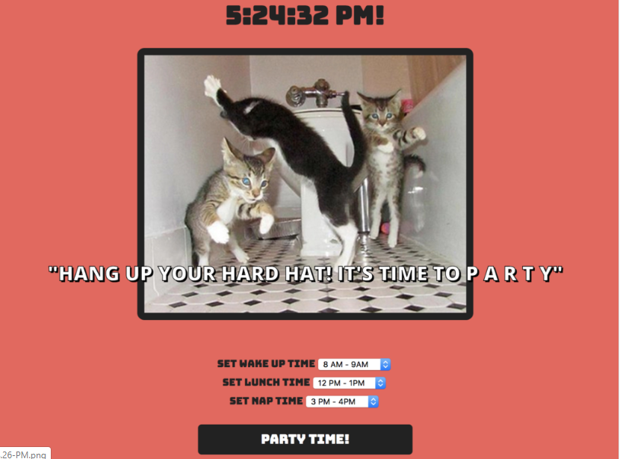

### **2. React Native TIP CALCULATOR**

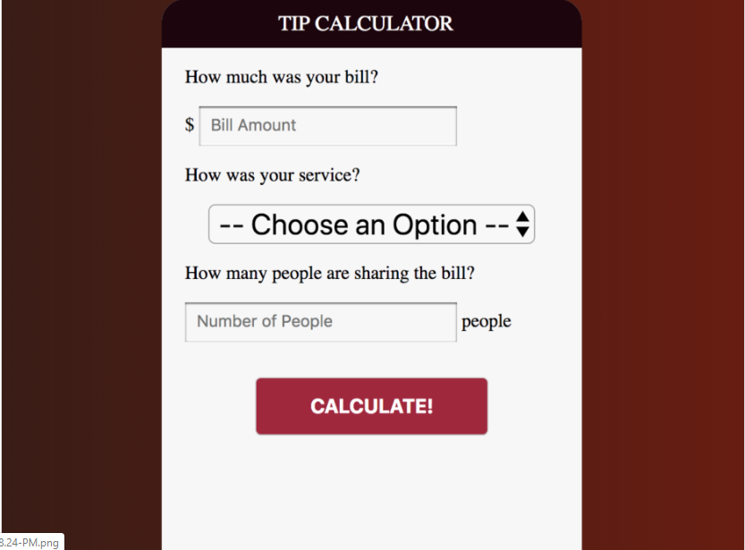

### **3. BUILD A React Native ANIMATED NAVIGATION TOGGLE**

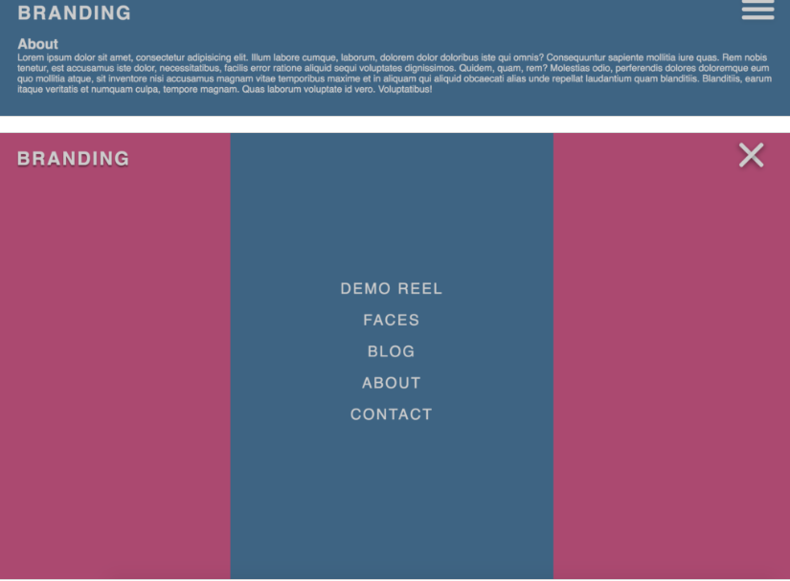

### **4- React Native MAP**

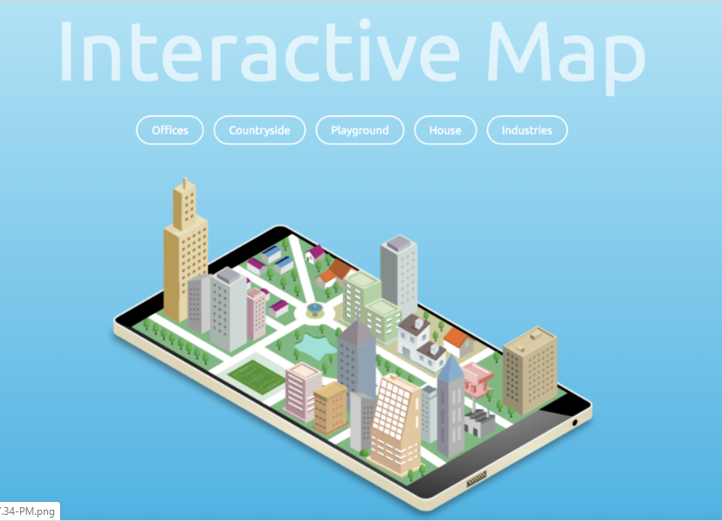

### **5. BUILD A React Native GAME**

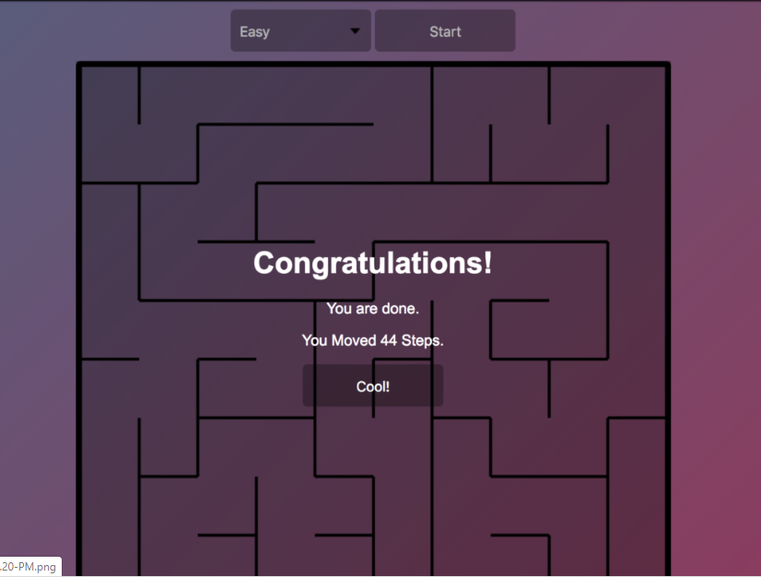

### **6-** **DRAWING**



### **7-TO-DO LIST**

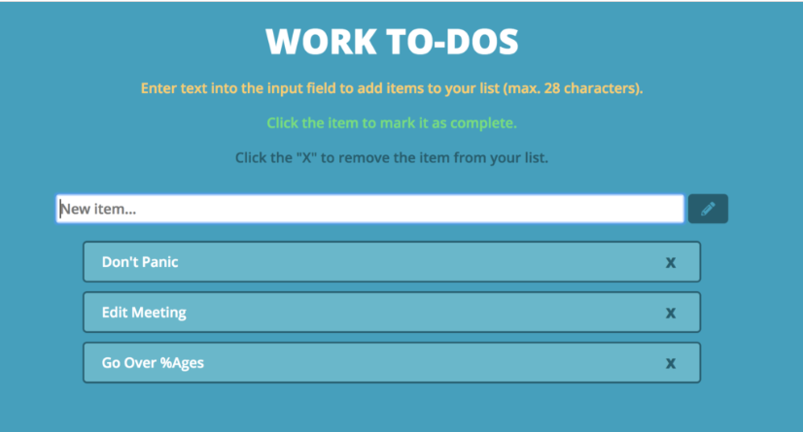

### **8. BUILD A JAVASCRIPT QUIZ**

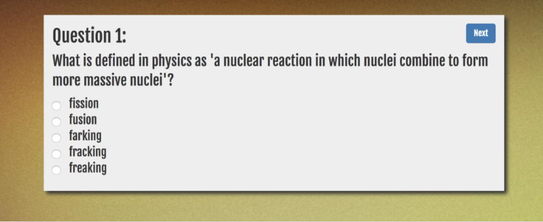

### 9. MOUSEOVER ELEMENT Using Java Script



### **10. JAVASCRIPT LOGIN AUTHENTICATION**

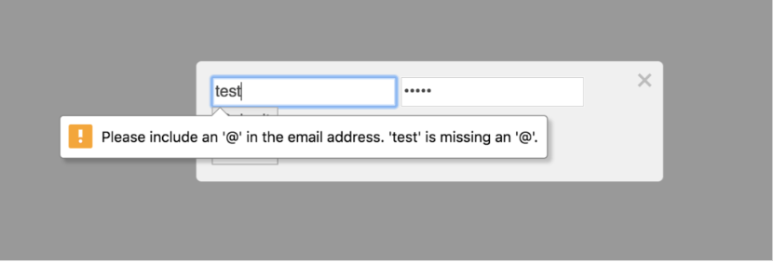

## 11-Weather App

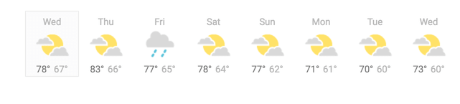

## 12- News Search

## 