DrowzyGuard
Real-Time Driver Drowsiness Detection System
Project Guide — technologies, modules, and how everything works
React · Vite · Flask · OpenCV · TensorFlow/Keras (CNN) · MongoDB
Study and presentation guide

Contents
1. Project Overview — The problem, what the system does, main features
2. Technologies Used — Every library and tool, and why it was chosen
3. System Architecture — How the browser, server and database work together
4. Project Structure — What every folder and file is for
5. Backend Modules — app.py, auth.py, database.py, detection.py, model.py, alerts.py, train.py
6. How Detection Works — Step-by-step pipeline, score formula, thresholds, alarm
7. The CNN Model — Architecture, training, MRL dataset, measured accuracy
8. Frontend (React) — Pages, components and screenshots
9. Database (MongoDB) — Collections, relationship, when results are saved
10. REST API — Endpoints, requests, responses and error codes
11. Security — Password hashing, JWT tokens, secrets
12. Testing — What was tested and the results
13. How to Run — Commands for Windows
14. Limitations and Future Work
15. Likely Teacher Questions — 20 questions with answers for your viva
16. Glossary — Simple meanings of technical terms
Tip: in Word, open View → Navigation Pane to jump between sections.

1. Project Overview

1.1 The problem
Driver fatigue is a well-known cause of road accidents. A tired driver's eyes close for longer than a normal blink, and the driver may not notice it happening. DrowzyGuard watches the driver's eyes through a webcam and warns them with an alarm when their eyes stay closed too long.

1.2 What the system does
- The driver registers and logs in (accounts are stored in MongoDB).
- On the Detection page the webcam turns on and frames are analysed about 4 times per second.
- For each frame the backend finds the face, then the eyes, and a CNN decides how closed the eyes are.
- A drowsiness score (0–100%) is calculated from the last 15 frames and mapped to Awake / Warning / Drowsy.
- When the driver is Drowsy, a flashing banner appears and an alarm sound plays.
- Results are saved to MongoDB and shown on the Dashboard and History pages.

1.3 Main features
Feature | Description
Login / Register / Logout | Email + password accounts; passwords are hashed; sessions use JWT tokens
Live detection | Webcam → face → eyes → CNN → score, about 4 frames per second
Status levels | Awake (0–30%), Warning (31–60%), Drowsy (61–100%), No face
Alerts | Flashing “DROWSINESS DETECTED” banner + alarm tone generated in the browser
Dashboard | Current status, latest score, total alarms, most recent detection
History | Sessions grouped by day, score charts, plain-language event timeline, filters
Trained model | CNN trained on the MRL Eye Dataset (98.57% on its test set)
Fallback mode | Works without the model using OpenCV only (less accurate)

Important: DrowzyGuard is an educational project, not a certified safety device. The score thresholds are application settings chosen for this project, not medically validated values.

2. Technologies Used
The project has three parts: a frontend (what the user sees, runs in the browser), a backend (the server that does the AI work) and a database (where accounts and results are stored).

2.1 Frontend (browser)
Technology | What it is | What we use it for
React 19 | JavaScript library for building user interfaces from components | All pages (Login, Dashboard, Detection, History) and reusable components
Vite 8 | Fast development server and build tool | Runs the frontend at localhost:5173 and builds it for production
React Router 7 | Page navigation for React apps | Switching between pages without reloading
JavaScript (ES modules) | Programming language of the web | All frontend logic
CSS | Styling language | Dark theme, cards, layout, responsive phone design
getUserMedia API | Browser API for camera access | Opening the webcam
Canvas API | Browser drawing API | Capturing a frame from the video as a JPEG image
Web Audio API | Browser API for generating sound | The alarm tone (no sound file needed)
fetch API | Browser API for HTTP requests | Talking to the Flask backend
localStorage | Small key-value storage in the browser | Keeping the login session after a page reload

2.2 Backend (server)
Technology | What it is | What we use it for
Python 3.11 | Programming language | All backend code
Flask 3.1 | Lightweight Python web framework | The REST API (register, login, detection, history, health)
flask-cors | Flask extension | Allowing the frontend (port 5173) to call the backend (port 5000)
python-dotenv | Reads a .env file | Loading settings and secrets (MongoDB URI, JWT secret)
OpenCV 4.14 | Computer-vision library | Decoding images, grayscale, face and eye detection (Haar cascades)
TensorFlow 2.21 / Keras 3 | Deep-learning framework | Building, training and running the CNN model
NumPy | Numerical arrays library | Image data as arrays for OpenCV and TensorFlow
PyMongo 4.18 | MongoDB driver for Python | Reading and writing users and detections
PyJWT 2.15 | JSON Web Token library | Creating and checking login tokens
Werkzeug (with Flask) | Utilities library | Password hashing with scrypt

2.3 Database and data
Item | What it is | What we use it for
MongoDB | NoSQL document database | Two collections: users and detections
MRL Eye Dataset | Public dataset of open/closed eye images | Training and testing the CNN
drowsiness_model.h5 | Saved Keras model file (4.7 MB) | Loaded once when the backend starts

2.4 Why these choices?
- Flask instead of a bigger framework: the API has only five routes, so a small framework keeps the code simple.
- REST + regular HTTP requests instead of WebSockets: sending one frame and getting one result back is simple and reliable at 4 frames per second.
- Haar cascades for finding face and eyes: fast on a normal CPU, built into OpenCV, no extra model files.
- A small CNN for eye state: learns open vs closed eyes from data, much more accurate than hand-written rules.
- MongoDB: stores records as JSON-like documents, which matches the API responses directly.
- No GPU needed: the model is small (about 388,000 parameters) and runs in a few milliseconds per eye on a CPU.

3. System Architecture
DrowzyGuard uses a classic three-tier architecture: the browser (presentation), the Flask server (application logic and AI), and MongoDB (data).
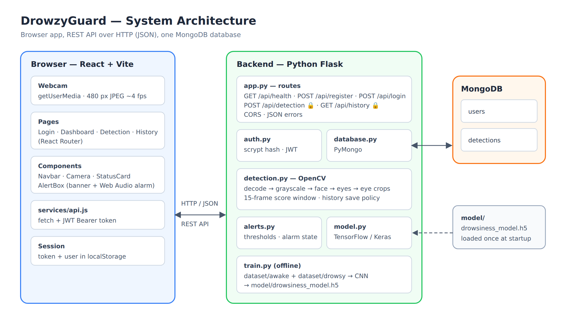
Figure 1 — System architecture

3.1 How a single frame travels through the system
- The Camera component captures a 480-pixel-wide JPEG from the webcam.
- api.js sends it to POST /api/detection together with the login token.
- app.py checks the token (auth.py) and passes the image to detection.py.
- detection.py finds the face and eyes with OpenCV and asks model.py (the CNN) how closed each eye is.
- The score and status are calculated; alerts.py decides whether the alarm is on.
- If needed, the result is saved to MongoDB by database.py.
- The JSON result goes back to the browser, which updates the screen and plays the alarm if alert is true.
- Only after the response arrives is the next frame captured, so requests never pile up.

4. Project Structure
DrowzyGuard/
├── backend/
│ ├── app.py Flask app: settings and all API routes
│ ├── auth.py Register, login, password hashing, JWT tokens
│ ├── database.py MongoDB connection, users, detection history
│ ├── detection.py Image decoding, face/eye detection, scoring
│ ├── model.py Loads the CNN once; predict()
│ ├── alerts.py Status thresholds and alarm state
│ ├── train.py Trains the CNN from eye images
│ ├── requirements.txt Python packages with exact versions
│ └── .env.example Template for settings/secrets (.env)
├── frontend/
│ ├── src/
│ │ ├── components/ Navbar, Camera, StatusCard, AlertBox
│ │ ├── pages/ Login, Dashboard, Detection, History
│ │ ├── services/ api.js (all calls to the backend)
│ │ ├── App.jsx Page routing and login session
│ │ ├── config.js Backend URL, frame interval
│ │ ├── index.css Theme and layout
│ │ └── main.jsx React entry point
│ ├── index.html, package.json, vite.config.js
├── model/drowsiness_model.h5 The trained CNN
├── dataset/awake, dataset/drowsy Place for training images
├── docs/ Diagrams and this guide
└── README.md Setup and usage instructions

5. Backend Modules (Python)
Each backend file has one clear job. They are plain modules with simple functions, not complicated class hierarchies, which makes them easy to read and debug.

5.1 app.py — the web server and API
Creates the Flask application, loads settings from .env, enables CORS, loads the model once at startup, and defines every API route. It also converts all errors into the same JSON format: {"error": "message"}.
Route | What it does
GET /api/health | Reports whether the database is connected and whether the model is loaded
POST /api/register | Creates an account and returns a token
POST /api/login | Checks email + password and returns a token
POST /api/detection 🔒 | Analyses one webcam frame and returns status, score, eyes, alert
GET /api/history 🔒 | Returns the user's saved results and total alarm count
🔒 = the request must include a valid login token.

5.2 auth.py — accounts and security
Function | Purpose
register(email, password) | Validates input, hashes the password, creates the user, returns a token
login(email, password) | Finds the user, checks the password hash, returns a token
hash_password / verify_password | Werkzeug scrypt hashing — the real password is never stored
create_token(user_id) | Makes a signed JWT that expires after 7 days
require_auth (decorator) | Protects routes: rejects missing, forged or expired tokens with 401

5.3 database.py — MongoDB access
Function | Purpose
get_db / init_db | Connects to MongoDB and creates indexes (unique email; userId + time)
create_user, find_user_by_email, find_user_by_id | User operations (emails stored in lowercase)
save_detection | Stores one result: score, status, alert, timestamp
get_history, get_latest_detection, count_alerts | Reads a user's history, newest first

5.4 detection.py — the computer-vision pipeline
Function | Purpose
decode_image | Turns the base64 JPEG from the browser into an OpenCV image
detect_face | Finds the largest face with the Haar cascade face detector
detect_eyes | Looks for eyes in the upper part of the face
estimate_eye_regions | If eyes are not found (common when closed), estimates where they are from face proportions
preprocess_eye | Crops an eye, converts to 64×64 grayscale, scales pixels to 0–1
eye_closure | Asks the CNN for P(closed) for each eye and averages them
analyze_frame | Runs everything for one frame and returns the result
history_record | Decides whether this result should be saved (see Section 9)

5.5 model.py — the CNN
Function | Purpose
load_model | Loads drowsiness_model.h5 once at startup; the app still runs if the file is missing
input_shape | Reads the image size the model expects (64×64×1) from the model itself
predict(image) | Returns P(eye closed) between 0 and 1 in about 2–3 ms on a CPU

5.6 alerts.py — thresholds and alarm
All thresholds are in this one file so they are easy to change:
AWAKE_MAX = 30 # 0–30% → awake
WARNING_MAX = 60 # 31–60% → warning, 61–100% → drowsy
ALARM_OFF_SCORE = 40 # alarm keeps sounding until score ≤ 40%

5.7 train.py — training the CNN
Loads eye images from two folders (awake, drowsy), holds back 20% for testing, applies data augmentation, builds and trains the CNN, prints the measured accuracy, and saves model/drowsiness_model.h5. Details are in Section 7.

6. How Detection Works
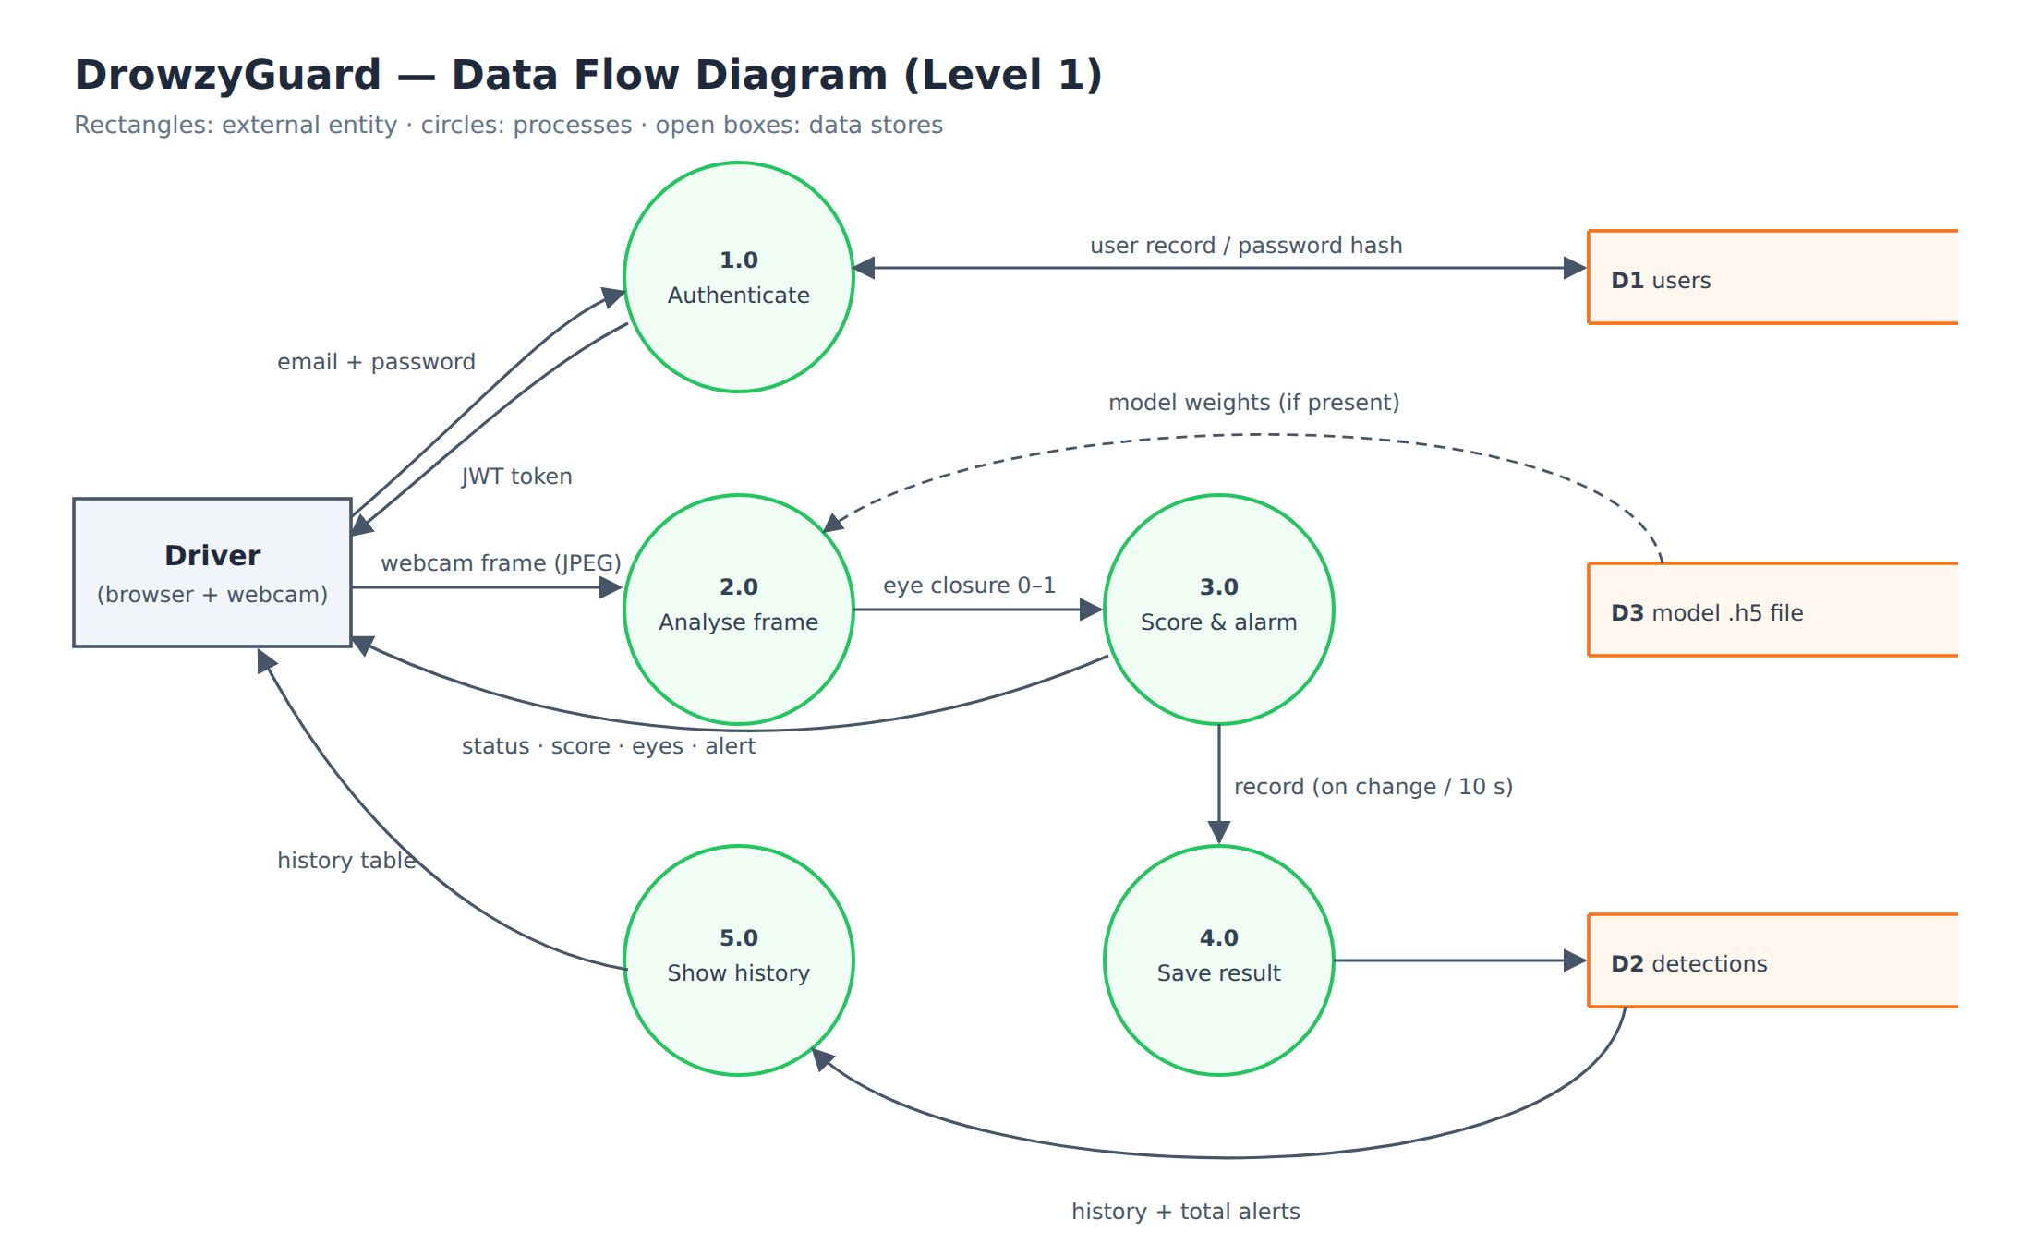
Figure 2 — Data flow diagram (Level 1)

6.1 Step by step
- Capture: the browser takes a 480-pixel-wide JPEG from the webcam every ~250 ms.
- Pre-process: the backend converts it to grayscale and equalises the histogram (improves contrast in bad lighting).
- Face detection: OpenCV's Haar cascade finds the largest face.
- Eye detection: a second Haar cascade searches the upper half of the face for eyes. If none are found, eye positions are estimated from the face shape.
- Eye classification (CNN): each eye is cropped to 64×64 grayscale and the CNN outputs the probability that it is closed (0 = open, 1 = closed).
- Score: the average eye closure over the last 15 frames, shown as a percentage.
- Status: the score is compared with the thresholds (30% and 60%).
- Alarm: turns on when Drowsy; turns off only when the score falls to 40% or below.

6.2 The drowsiness score formula
score = round( 100 × (sum of eye-closure values in the last 15 frames) / 15 )
Why use the last 15 frames instead of a single frame?
- A normal blink closes the eyes for only one frame, so the score rises by only about 7% — no false alarm.
- If the eyes stay closed, the score rises by about 7% every frame and reaches the Drowsy level after about 2.5–3 seconds.
- Dividing by 15 even when fewer frames exist makes the score start at 0 and ramp up, instead of jumping to 100% on the first frame.

6.3 Status levels
Score | Status | What the user sees
0–30% | ✓ Awake | Green status, no alarm
31–60% | ! Warning | Amber status, no alarm yet
61–100% | ⚠ Drowsy | Red banner “DROWSINESS DETECTED” + alarm sound
— | No face | Asks the driver to centre their face

6.4 Alarm hysteresis (why 60% on, 40% off)
If the alarm switched on above 60% and off below 60%, a score hovering around 60% would make the alarm flicker on and off every frame. Using two different thresholds (on above 60%, off at 40%) is called hysteresis. It is the same idea a home thermostat uses.
The alarm also keeps sounding if the face disappears while the driver is drowsy, because a dropped head is exactly the dangerous moment.

6.5 Fallback mode without the CNN
If the model file is missing, the system still works: OpenCV's eye detector mostly finds open eyes, so a visible face with no detected eyes is treated as closed eyes. This is less accurate (glasses and bad lighting confuse it). The Detection page shows a badge saying whether “AI model” or “OpenCV fallback” is active.

7. The CNN Model

7.1 What is a CNN?
A Convolutional Neural Network (CNN) is a type of neural network designed for images. Instead of looking at every pixel separately, it slides small filters (for example 3×3 pixels) across the image to detect patterns: first simple ones like edges, then more complex ones like the curve of an eyelid or the dark circle of a pupil. Pooling layers shrink the image step by step, and the final layers make the decision.

7.2 Our CNN architecture
# | Layer | Output shape | Parameters
— | Input: 64×64 grayscale eye image | 64×64×1 | 0
1 | Conv2D — 32 filters 3×3, ReLU | 62×62×32 | 320
2 | MaxPooling 2×2 | 31×31×32 | 0
3 | Conv2D — 64 filters 3×3, ReLU | 29×29×64 | 18,496
4 | MaxPooling 2×2 | 14×14×64 | 0
5 | Conv2D — 128 filters 3×3, ReLU | 12×12×128 | 73,856
6 | MaxPooling 2×2 | 6×6×128 | 0
7 | Flatten | 4,608 | 0
8 | Dropout 50% | 4,608 | 0
9 | Dense 64, ReLU | 64 | 294,976
10 | Dense 1, Sigmoid → P(drowsy) | 1 | 65
 | Total trainable parameters |  | 387,713

7.3 Training settings
Setting | Value | Meaning
Optimizer | Adam | Algorithm that adjusts the weights to reduce the error
Loss function | Binary cross-entropy | Standard error measure for two classes (awake / drowsy)
Output | Sigmoid (0 to 1) | Probability that the eye is closed
Image size | 64×64 grayscale | Small input keeps the model fast
Data augmentation | Flip, small rotation, contrast | Creates varied copies so the model generalises better
Dropout | 50% | Randomly switches off neurons during training to prevent overfitting
Early stopping | Patience 3 epochs | Stops when validation loss stops improving, keeps the best weights
Epochs used | 10 | Full passes through the training images
Hardware | CPU (Windows) | About 2 minutes per epoch; no GPU needed

7.4 Dataset — MRL Eye Dataset
- Created by the Media Research Lab (MRL), VŠB – Technical University of Ostrava.
- About 85,000 close-up infrared images of single eyes from 37 people, labelled open or closed.
- We used the Kaggle version akashshingha850/mrl-eye-dataset (v4), already split into train / val / test folders.
- Class names: awake = open eyes, sleepy = closed eyes (renamed to drowsy for our code).
Split | Open eyes (awake) | Closed eyes (sleepy) | Total
train | 25,770 | 25,167 | 50,937
val | 8,591 | 8,389 | 16,980
test | 8,591 | 8,390 | 16,981
Total |  |  | 84,898

7.5 Results (measured)
Evaluation | Images | Accuracy
20% held back from the train folder (by train.py) | 10,187 | 98.40%
The dataset's separate test folder | 16,981 | 98.57%

During training the accuracy went from 90.96% (epoch 1) to 98.10% (epoch 10), and the validation accuracy stayed close to the training accuracy, which shows the model was not overfitting.
Honest limitation: MRL images are infrared, while a normal webcam uses visible light. Accuracy on a webcam has not been measured and may be lower than 98.57%. Also, it is not confirmed whether the Kaggle version keeps different people in the train and test folders.

8. Frontend (React)

8.1 Pages
Page | What it shows
Login.jsx | Email + password form; switches between Login and Register
Dashboard.jsx | Welcome message, latest status and score, total alarms, most recent detection, Start Detection button
Detection.jsx | Live camera, large score, status, eyes, alarm state, Start/Stop buttons, tips
History.jsx | Summary, stat tiles, filters, sessions grouped by day with score charts and event timelines

8.2 Reusable components
Component | Purpose
Navbar.jsx | Sidebar with Dashboard / Detection / History and Logout (a top bar on phones)
Camera.jsx | Opens the webcam, captures frames in a loop, handles camera errors
StatusCard.jsx | The reusable card showing a label, value, colour and optional progress bar
AlertBox.jsx | The flashing drowsiness banner and the alarm sound

8.3 Other frontend files
- App.jsx — defines the routes and keeps the login session (token + user) in localStorage.
- services/api.js — the only file that calls the backend; adds the token and turns errors into readable messages. If a token expires, the user is logged out automatically.
- config.js — the backend URL (VITE_API_URL) and the frame interval (250 ms).
- index.css — the dark theme, cards, colours and phone layout.

8.4 Interesting details
- No overlapping requests: the next frame is captured only after the previous answer arrives.
- The alarm sound is generated with the Web Audio API (alternating 880 Hz / 660 Hz beeps every 500 ms), so no audio file is needed. Browsers only allow sound after a click, so pressing Start unlocks it.
- Colours are never the only signal: every status also has an icon and a text label (✓ Awake, ! Warning, ⚠ Drowsy), so colour-blind users can read it.
- History sessions: records more than 90 seconds apart start a new session, and repeated statuses are merged into readable events such as “Became drowsy · 14 s · peak 93% · Alarm triggered”.

8.5 Screenshots
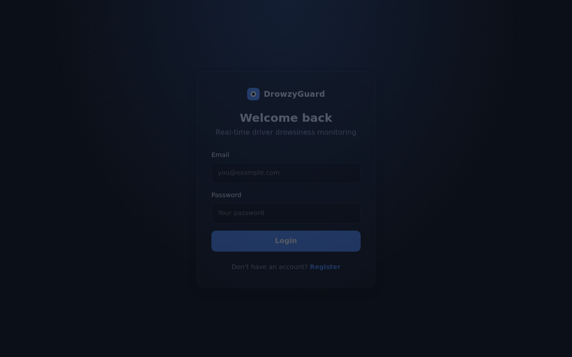
Figure 3 — Login page
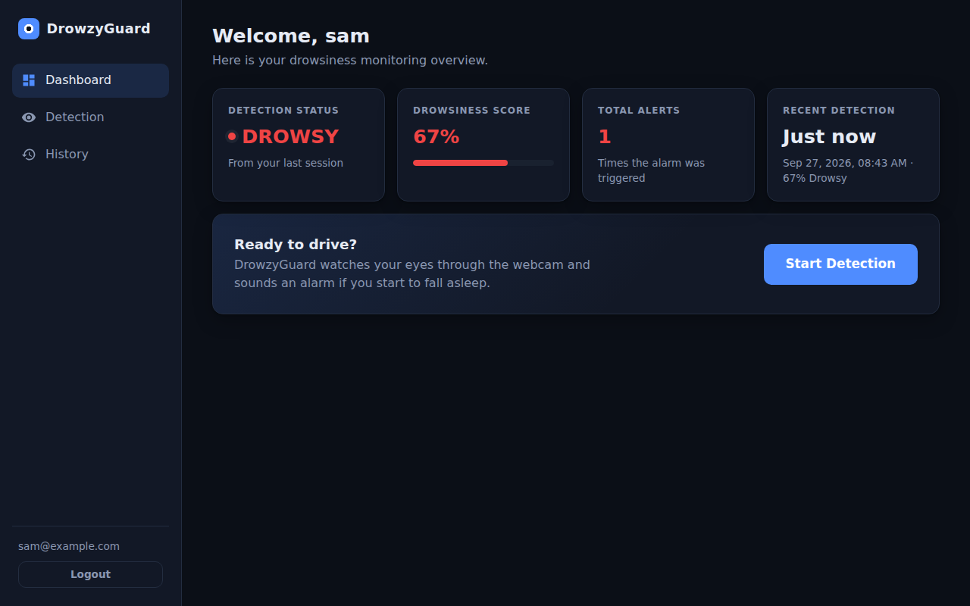
Figure 4 — Dashboard (demo data)
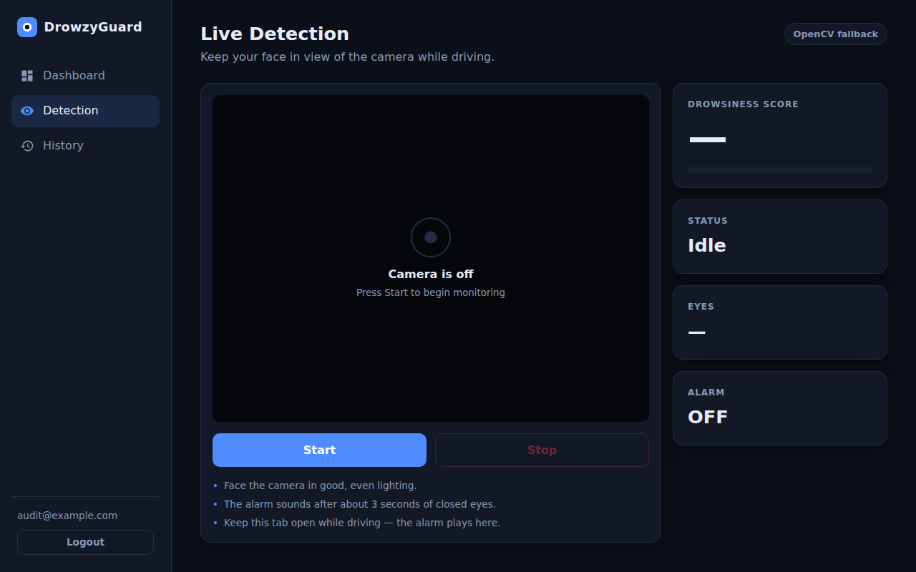
Figure 5 — Live Detection page (camera off)
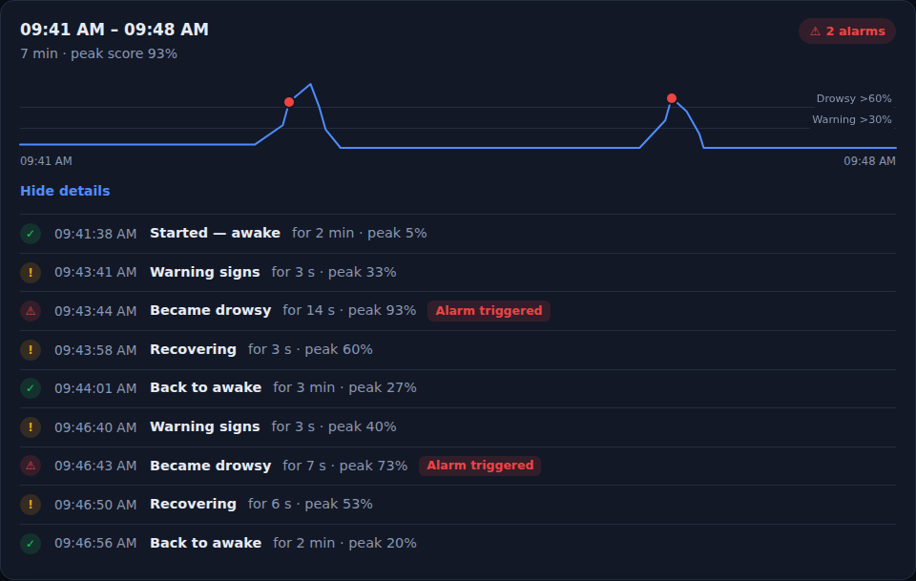
Figure 6 — A session on the History page (demo data)

9. Database (MongoDB)
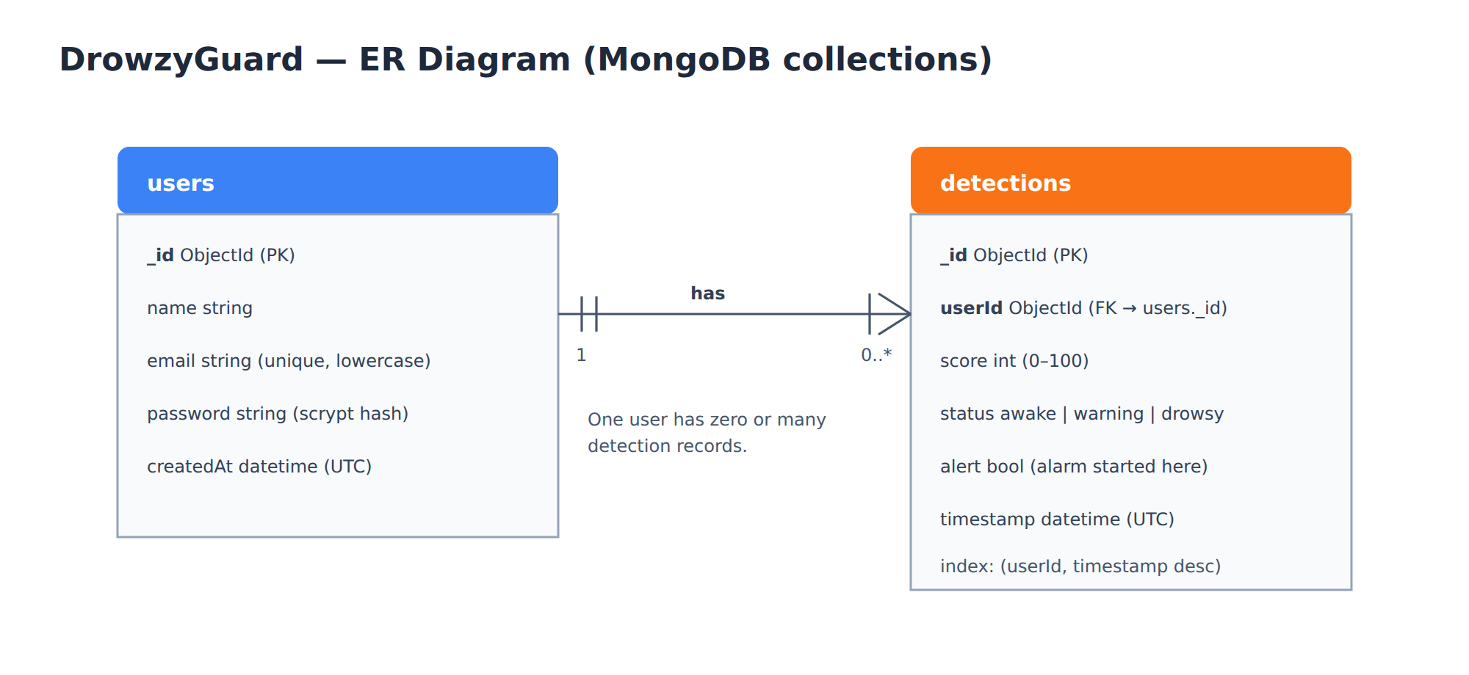
Figure 7 — ER diagram

9.1 Collections
Collection | Fields | Notes
users | _id, name, email, password, createdAt | email is unique and lowercase; password is a scrypt hash
detections | _id, userId, score, status, alert, timestamp | userId links to users._id; index on (userId, timestamp)

Relationship: one user has zero or many detection records (one-to-many).

9.2 When is a result saved?
Saving 4 results per second would flood the database, so a record is saved only:
- when the status changes (for example Awake → Warning), or
- when the alarm switches on or off, or
- every 10 seconds otherwise.
Frames with no face are not saved. The alert field is true only on the record where an alarm started, so counting these records gives the number of alarm events.

10. REST API
All responses are JSON. Errors always have the form {"error": "message"}.
Method & path | Sends | Returns
GET /api/health | — | {status, database, model, detection}
POST /api/register | {email, password} | 201 {token, user}
POST /api/login | {email, password} | {token, user}
POST /api/detection 🔒 | {image, reset} | {status, score, eyes, face, alert}
GET /api/history 🔒 | ?limit=100 | {history: [...], totalAlerts}

Example detection response
{ "status": "drowsy", "score": 82, "eyes": "closed", "face": true, "alert": true }
HTTP code | Meaning
400 | Invalid input (bad email, short password, invalid image)
401 | Not logged in, wrong password, or expired/invalid token
409 | Email already registered
413 | Image larger than 2 MB
503 | Database unavailable

11. Security
- Password hashing (scrypt): passwords are turned into a one-way hash before saving. Even someone who reads the database cannot see the real passwords.
- JWT tokens: after login the server gives a signed token (HS256, valid 7 days). Every protected request must include it; forged or expired tokens are rejected.
- Same error for wrong email and wrong password: “Invalid email or password”, so attackers cannot find out which emails have accounts.
- Secrets in .env: the MongoDB address and JWT secret are never written in the code; .env is excluded from Git.
- CORS: only the frontend's address is allowed to call the API from a browser.
- Input limits: images over 2 MB are rejected; passwords must be 6–128 characters.
- Per-user data: each user only sees their own history and has their own score.

12. Testing
Every phase was tested before moving on. Tests used a real MongoDB server and a real Chromium browser with a simulated webcam video (eyes open, then closed).
Area tested | Checks | Result
Database (users, detections, indexes) | 19 | All passed
Model loading (missing, corrupt, 1 or 2 outputs) | 24 | All passed
Authentication (register, login, tokens) | 22 | All passed
History saving rules and API | 18 | All passed
Alarm logic (hysteresis, face lost) | 20 | All passed
Browser: login, session expiry | 13 | All passed
Browser: detection → dashboard → history | 9 | All passed
Browser: alarm sound timing and stopping | 9 | All passed
Browser: backend down and recovery | 5 | All passed
Browser: History page redesign | 14 | All passed

Measured performance: about 28 ms per frame without the CNN and about 53 ms with it; the CNN itself takes about 2–3 ms per eye on a CPU. In the browser test the alarm fired about 2.8 seconds after the eyes closed.

13. How to Run the Project (Windows)

Every time — Terminal 1 (backend)
cd DrowzyGuard\backend
venv\Scripts\activate (you must see (venv) in the prompt)
python app.py (backend at http://localhost:5000)

Every time — Terminal 2 (frontend)
cd DrowzyGuard\frontend
npm run dev (open http://localhost:5173)

First-time setup only
cd DrowzyGuard\backend
python -m venv venv
venv\Scripts\activate
pip install -r requirements.txt
copy .env.example .env (then set JWT_SECRET)
cd ..\frontend
npm install
Check http://localhost:5000/api/health — it should show "database": "connected" and "model": "loaded". MongoDB must be running.
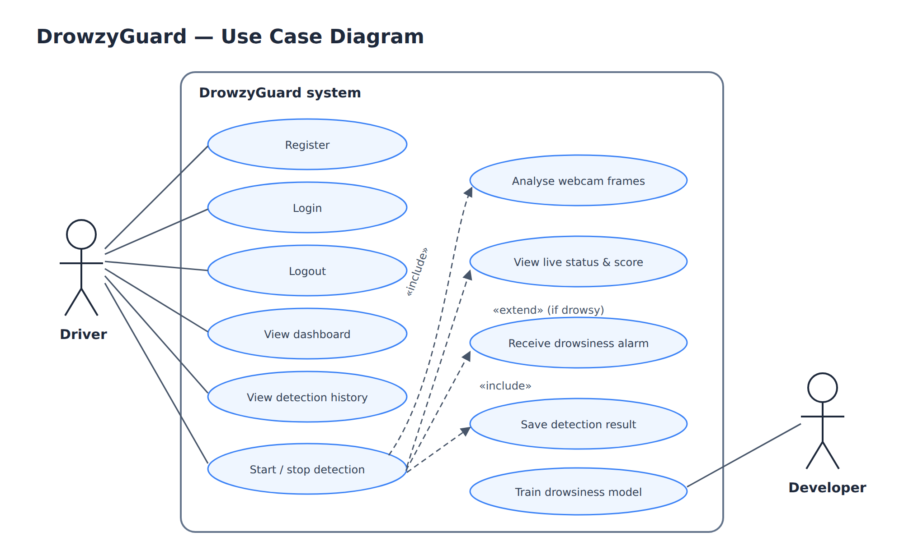
Figure 8 — Use case diagram

14. Limitations and Future Work

14.1 Limitations
- The CNN was trained on infrared eye images; accuracy with a normal webcam is not measured.
- Haar cascades can miss faces that are turned sideways, very dark, or partly covered.
- Glasses and reflections can make eye detection harder.
- Only eye closure is used; yawning and head nodding are not detected yet.
- The thresholds (30% / 60%) are application settings, not medically validated values.
- It needs a laptop/computer with a webcam and a browser tab kept open.

14.2 Possible improvements
- Add some webcam eye images to the training data to close the infrared/visible-light gap.
- Yawning detection (mouth opening) as a second sign of tiredness.
- Head-pose / nodding detection using facial landmarks.
- Charts of drowsiness over weeks, a PDF report, light/dark theme, a session timer.
- A mobile app version for use in a car.

15. Likely Teacher Questions (Viva Preparation)
Q1. What problem does your project solve?
It detects when a driver's eyes stay closed for too long (a sign of drowsiness) and warns them with a visual alert and an alarm sound, to help prevent fatigue-related accidents.
Q2. Which technologies did you use and why?
React + Vite for the user interface, Flask (Python) for the API, OpenCV for face and eye detection, TensorFlow/Keras for the CNN, and MongoDB for storing users and results. Each is widely used, well documented, and simple enough for a clear architecture.
Q3. Where is the CNN used exactly?
Only for classifying each eye image as open or closed. Face and eye locations are found by OpenCV Haar cascades; the CNN then outputs the probability that each eye is closed.
Q4. Describe your CNN architecture.
Three Conv2D + MaxPooling blocks with 32, 64 and 128 filters (3×3, ReLU), then Flatten, Dropout 50%, a Dense layer of 64 neurons and a Dense sigmoid output. Input is a 64×64 grayscale eye; it has 387,713 trainable parameters.
Q5. Which dataset did you use?
The MRL Eye Dataset (Kaggle version by akashshingha850, v4): about 85,000 infrared eye images from 37 people, labelled open or closed. I trained on the 50,937-image train split.
Q6. What accuracy did you get?
98.40% on the 20% held back during training and 98.57% on the dataset's separate test set of 16,981 images. Webcam accuracy was not separately measured.
Q7. Why sigmoid and binary cross-entropy?
There are only two classes (open/closed). A sigmoid gives one probability between 0 and 1, and binary cross-entropy is the standard loss for that.
Q8. What is dropout and why use it?
During training it randomly switches off 50% of neurons in that layer, so the network cannot rely on a few neurons and generalises better (less overfitting).
Q9. What is data augmentation?
Creating slightly changed copies of training images (flipped, rotated, different contrast) so the model learns to handle variation it has not seen exactly.
Q10. How is the drowsiness score calculated?
It is the average eye-closure probability over the last 15 frames, multiplied by 100. A blink changes it by only about 7%; eyes closed for about 3 seconds push it above 60%.
Q11. Why not raise the alarm on a single closed-eye frame?
Because normal blinks would trigger false alarms constantly. Averaging over 15 frames (about 3–5 seconds) separates blinks from real eye closure.
Q12. What is hysteresis in your alarm?
The alarm starts above 60% but stops only at 40% or below. Using two thresholds prevents the alarm from flickering when the score is close to 60%.
Q13. What are Haar cascades?
A classic fast object-detection method (Viola–Jones) built into OpenCV. It uses simple light/dark rectangle features and a cascade of classifiers to find faces and eyes quickly on a CPU.
Q14. Does it run on a GPU?
No, it runs on the CPU. TensorFlow does not support GPUs on native Windows after version 2.10, and the model is small enough to predict in a few milliseconds per eye on a CPU.
Q15. How are passwords stored?
As scrypt hashes using Werkzeug. The original password is never stored, and login compares hashes.
Q16. What is a JWT and why do you use it?
A JSON Web Token is a signed token given after login. The browser sends it with every request so the server knows who the user is without storing sessions. Ours expire after 7 days.
Q17. Why did you choose MongoDB?
Results are simple JSON-like documents, so MongoDB stores them naturally with no table design needed. We use only two collections: users and detections.
Q18. How does the frontend talk to the backend?
Through REST API calls (HTTP + JSON) from services/api.js. The webcam frame is sent as a base64 JPEG to POST /api/detection.
Q19. What happens if the model file is missing?
The app still works in OpenCV fallback mode: a visible face with no detected open eyes counts as closed. The Detection page shows which mode is active.
Q20. What are the limitations?
Trained on infrared images, so webcam accuracy is unverified; Haar cascades struggle with turned heads, glasses and poor light; only eye closure is used; thresholds are not medically validated.

16. Glossary
Term | Simple meaning
API | A set of URLs a program can call to get or send data
REST | A simple style of API using HTTP methods like GET and POST
JSON | A text format for data, e.g. {"score": 82}
Frontend / Backend | The part in the browser / the part on the server
CNN | Convolutional Neural Network — a neural network specialised for images
Convolution | Sliding a small filter over an image to detect a pattern
Max pooling | Shrinking an image by keeping the strongest value in each small area
ReLU | Activation that keeps positive values and turns negatives into 0
Sigmoid | Function that squeezes any number into the range 0–1 (a probability)
Epoch | One full pass through all training images
Overfitting | When a model memorises the training data and does badly on new data
Validation / Test set | Images kept away from training, used only to measure accuracy
Data augmentation | Making varied copies of training images to improve generalisation
Haar cascade | Fast classic face/eye detector in OpenCV (Viola–Jones method)
Grayscale | An image with only brightness, no colour
Hashing | One-way conversion of a password into a code that cannot be reversed
JWT | JSON Web Token — a signed login token
CORS | Browser rule controlling which websites may call an API
Hysteresis | Using different on and off thresholds to avoid flickering
Environment variables (.env) | Settings and secrets kept outside the code

