Alpha Dreamers Bank | Credit Risk Analysis


PREPARED BY: AMANTLE MICHELLE MAKATI
DATE: 11 MARCH 2026

PREDICTION AND MINIMIZATION OF PERSONAL LOAN DEFAULTS FOR ALPHA DREAMERS BANKING CONSORTIUM

Overview of the Project
Alpha dreamers Banking consortium is a financial institution that provides business loans, savings accounts, and checking accounts for individuals and businesses. The loans department has realized that there is a high default rate for personal loans and a machine learning pipeline is needed to predict and identify customers who potentially have a high risk of defaulting. These measures will allow the institution to optimize credit approval workflows and minimize capital loss.
The objective of this project was to develop a predictive model to identify high-risk loan applicants. The workflow began with comprehensive Exploratory Data Analysis (EDA), where geographic, demographic, and financial features were visualized to uncover key risk drivers. These insights informed a Logistic Regression model designed to classify applicants into binary risk categories: Low Risk (0) and High Risk (1). This system serves as a critical filter, allowing the institution to proactively mitigate defaults before a loan is issued.

Project Workflow
To build a reliable model for predicting loan risk, a step-by-step process was followed known as a Machine Learning Pipeline. This ensured the model learned from the data correctly and could make fair predictions for new applicants.
1. Preparing the Data
- Loading and Checking: We started by importing the CSEdata.csv file and exploring the information to see how it was structured.
- Cleaning: Errors were fixed in the data, such as removing duplicates or handling missing information. We also performed text cleaning, for example, removing extra brackets from the names in the City column so that the computer would not get confused by inconsistent spelling (e.g. Tiruchirappalli[10] is the same as Tiruchirappalli).
2. Setting Up the Experiment
- Splitting the Data: The dataset was divided into two groups: 80% for Training (the study guide the model uses to learn) and 20% for Testing (the final exam or unseen data to see if the model actually works).
- Preventing Data Leakage: To make sure the model only learned patterns from the training dataset, by keeping the testing dataset completely hidden until the very end. This ensured results were honest and not based on the model accidentally seeing the answers early.
3. Data Preprocessing
Computers only understand numbers, so the text data had to be translated into a format the model could process:
- Categorical Encoding: Three different encoding methods were used:
- Binary Mapping: Simple "Yes/No" choices became 1s and 0s.
- One-Hot Encoding: For categories like House Ownership, we created separate columns for "Rented", "Owned" and “Norent_Noown”
- Target Encoding: For long lists like City, State and Profession, the names were replaced with their average risk scores.
- Feature Scaling: This was a vital step. Income is a large number (like 50,000) and Age is a small number (like 25), the model might think income is more important just because the number is bigger. A StandardScaler was used to put all numbers on the same playing field so they could be compared fairly.
4. Training and Testing
- Exploring Patterns with Exploratory Data Analysis and Feature Engineering: Charts and graphs were used to visualize how factors like where someone lives or what they do for a living affect their risk of defaulting on a loan.
- Model Training: A Logistic Regression model was used. The data had more low risk ("safe") people than high risk ("risk") people, a special setting (class_weight) was used to tell the model to pay extra attention to the "risk" cases.
- The Final Test: Finally, the hidden 20% testing data was run through the model to see how well it could predict risk for people it had never seen before. And evaluation metrics such as accuracy, recall, precision and F1-score were calculated.

Technical Stack
The tools used for the project:
- Environment: Google Colab/ Jupyter
- Programming Language: Python
- Libraries: Pandas, NumPy, Matplotlib, Seaborn, Scikit-Learn (sklearn)

OVERVIEW VISUALIZATION OF THE ENTIRE DATASET
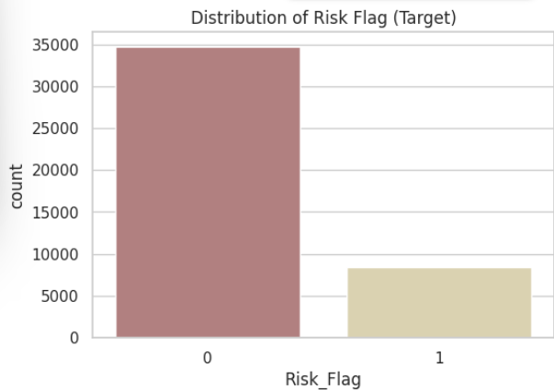
Interpretation: The graph above shows Risk_Flag (0) that represents low risk and Risk_Flag (1) that represents high risk as mentioned. Risk_Flag (0) appears to have a higher count of customers than Risk_Flag (1), which has a lower count of customers. This shows that there were more low risk customers than high risk customers in the entire dataset, which shows an imbalance in data. It Is expected to find imbalanced data in the banking institution especially with analyzing loan risk, where there majority of the customers are low risk (non-defaulters) , than high risk (defaulters), as it shows that the institution is doing good in approving loans for customers that will pay their loans well on time not affecting the banks loss of money. However, imbalanced data affects the performance of the machine learning model especially with the flagging of credit risk, as it will predict low risk for everyone to get a high accuracy score while failing to catch the actual risky loans. This is due to having an unequal number of data for the things you want the computer to learn which in this case is the number of low risk and high risk customer
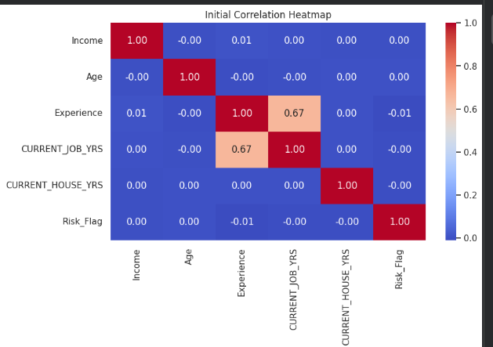
Interpretation: Experience encompasses the number of previous work experience and current job years, that is why we see a 0.67% correlation. The need to separate them into independent features is to avoid multicollinearity. So Experience was split into a new column “Previous Experience” which was calculated by subtracting Current Job Years from Experience, and the column “Experience” was dropped. This was to know if the clients actual previous experience, that does not encompass their current job years, will have an influence on the default rate.

RESEARCH QUESTIONS
To better understand the data, the specific questions were formulated to test how each feature affects the probability of a default. This interaction analysis helped reveal exactly where the risks are located across different demographics, financial, and geographic locations:
1. Demographic Features
These features describe who the applicant is. They help the model understand the life stage and stability of the person.
- Marital Status vs Default rate: Does being married have a low risk default rate?
- Age Group vs Default Rate: Does being older in terms of age make one less likely to default on loans?
- Profession vs Default Risk: Does the profession one does have an affect on default rate?
- Previous Experience vs Default Rate: Does a customer with more previous work experience make them less likely to default on their loans?
2. Financial Features
These features describe how much the applicant earns and their relationship with debt or assets.
- Asset Profile vs Default Rate: Does owning an asset like a house and car make a customer a low risk defaulter?
- Income Vs Default Risk: Does having a high annual income guarantee being a lower risk defaulter?
- CURRENT_JOB_YRS Vs Default Rate: Does staying at one job for a long time actually make a person less likely to default on a loan?

3. Geographic Features
These features describe where the applicant lives.
- City and State Vs Defaulter Risk: Is a customer's specific city (local data) a stronger warning sign for loan default than the state (region data) they live in?
- House Tenure vs Default Risk: Does staying in house for a long time result in a low default risks?

DATA VISUALIZATION OF THE RESEARCH QUESTIONS
Below will be the charts and graphs of each research question mentioned to get a better understanding of which features have an influence on the default risk. Exploratory Data Analysis (EDA) and Feature engineering was implemented and the new columns were made sure to be implemented on both the train and test dataframes as they have to mirror each other so that the model does not get confused.
- Marital Status vs Default rate: Does being married have a low risk default rate?
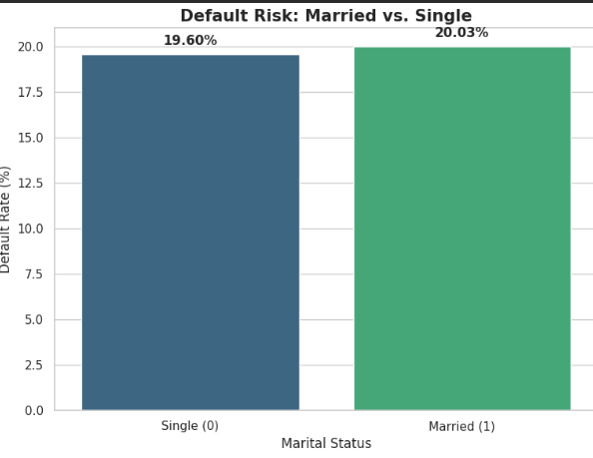
Interpretation of Marital Status vs Default Rate: Single applicants demonstrate a lower likelihood of default (19.60%) than Married applicants (20.03%). This suggests that the financial flexibility of a single-person household is a more powerful predictor of loan repayment than the traditional stability associated with marriage. This high risk of defaulting in married people could be due to higher household expenditures or increased financial leverage, such as childcare costs or mortgage debt, which impacts overall repayment capacity of the loan.
- Age Group vs Default Rate: Does being older in terms of age make one less likely to default on loans?
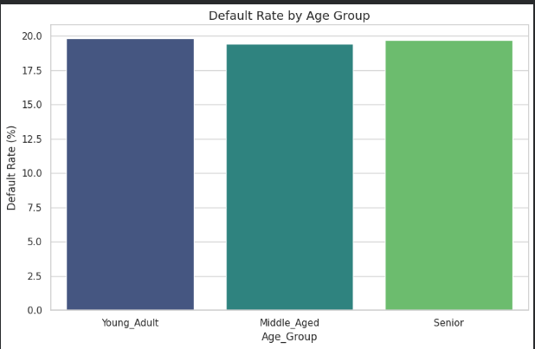
Age_Group | Default_Rate (%)
Young_Adult | 19.821429
Middle_Aged | 19.430229
Senior | 19.678352.

Interpretation for Age_Group vs Defaulter Rate: The middle aged customers have the lowest default rate 19.43, they are considered the safe borrowers compared to the other age groups. Seniors (19.68%) were only slightly less likely to default than Young Adults (19.82%). While this supports the idea that older age was less likely to default on their loans due to being more financially stable, the 0.14% gap is too small for age to be a primary factor for customers to default on their loans. Additional advanced feature interactions with other features could help to find the real risk patterns.
- Profession vs Default Risk: Does the profession one does have an affect on default rate?
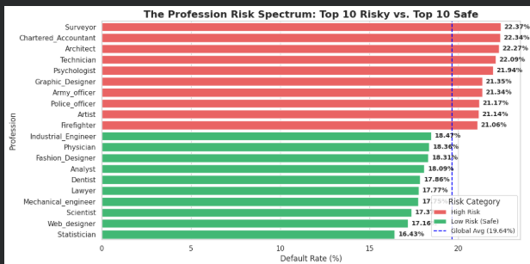
Interpretation of Profession vs Default Rate: Analysis utilized the Global Average Risk (19.64%). The global average risk is the average percentage of anyone from the population in the dataset defaulting on their loan. Professions represented by Red Bars exhibit default rates significantly above this baseline, serving as primary indicators for high risk classification. Conversely, Green Bars identify professions with a lower than average risk profile, allowing the model to classify these applicants as low risk defaulters.
Professions appearing in the Red chart typically represent industries income volatility, so the professional status is not what makes one to be a high or low risk defaulter. However, the target encoded profession feature helped create an average risk rate of each profession in the data frame that have a behaviour of being low or high risk defaulters.
- Previous Experience vs Default Rate: Does a customer with more previous work experience make them less likely to default on their loans?
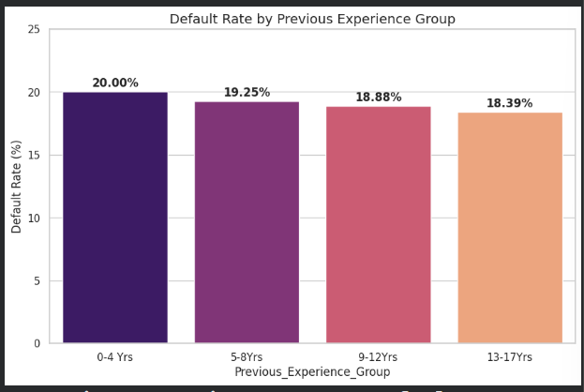
Previous_Experience_Group | Default_Rate (%)
0-4 Yrs | 20.003586
5-8 Yrs | 19.246127
9-12 Yrs | 18.881830
13-17 Yrs | 18.390244

Interpretation for the Previous_Experience vs Default Rate: Analysis demonstrates a direct correlation between professional previous work experience and loan reliability. We observed a consistent decline in default risk as previous work experience increases, dropping from 20.00% for individuals with 0-4 years previous work experience to a low of 18.39% for individuals with 13-17 years of previous work experience. This proves that professional previous work experience longevity is one of the most stable indicators of a borrower's ability to have handled financial responsibilities for a long time.
- Asset Profile vs Default Rate: Does owning an asset like a house and car make a customer a low risk defaulter?
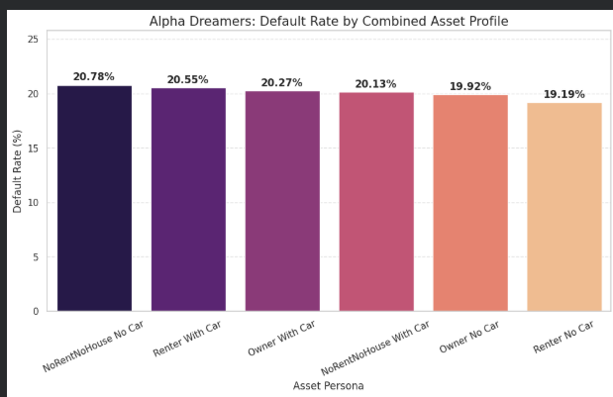
Interpretation for Asset Profile vs Default Rate: Analysis identifies two distinct safe low risk profiles within the dataset. First, we observe that as a customer moves from having no assets to owning both a home and a vehicle, the default risk steadily declines from 20.78% to 20.27%. However, a second, more compelling trend emerges, where customers who rent and do not own a vehicle exhibit the lowest overall default risk out of all the asset profiles. This suggests that for this specific demographic, minimal fixed overhead is a more powerful predictor of repayment than physical collateral.
- Income Vs Default Risk: Does having a high annual income guarantee being a lower risk defaulter?
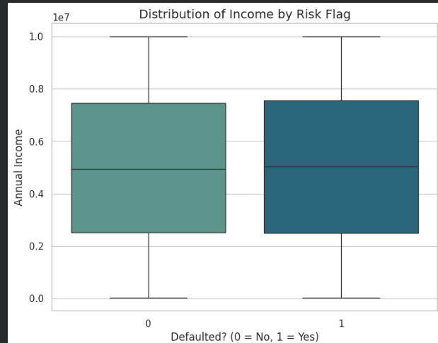
Interpretation for Income vs Default Rate: Annual income is traditionally viewed as a primary indicator of credit risk, our box plot analysis reveals a more complex reality. The almost perfect overlap in income distributions between low-risk and high-risk groups suggests that, for this population, income is a neutral factor. This outcome highlights that a high salary does not inherently guarantee loan repayment.
- CURRENT_JOB_YRS Vs Default Rate: Does staying at one job for a long time actually make a person less likely to default on a loan?
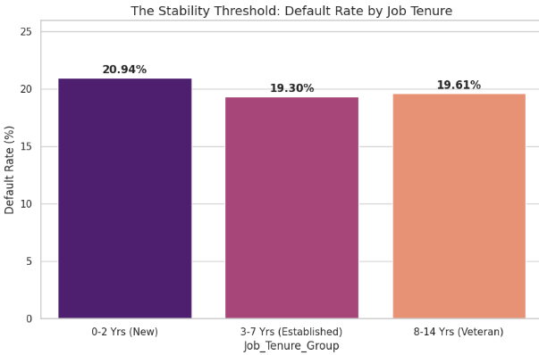
Interpretation for the CURRENT_JOB_YEARS vs Default Risk: The analysis reveals that job stability is a non-linear predictor of risk. The highest default rate (20.94%) occurs within the first two years of employment, representing early tenure volatility and lower job security. Reliability peaks in the 3-7 year 'Established' window (19.30%), before the risk rises slightly as employees reach 'Veteran' status likely due to increased life-stage financial obligations. This suggests that the 'Safe Spot' for lending is to those who have moved past the initial risks of a new role but remain in the peak of their professional stability, which is the established group, which also shows immediate job security.
- City and State Vs Defaulter Risk: Is a customer's specific city (local data) a stronger warning sign for loan default than the state (region data) they live in?
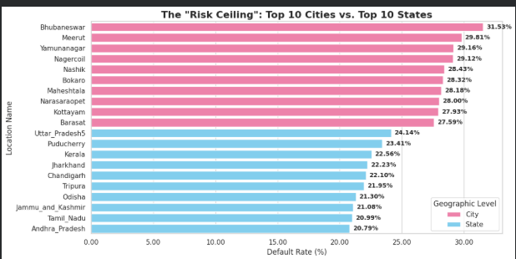
Interpretation for City and State vs Default Rate: The chart above identifies which 10 states and cities have the highest percentage of people who did not pay back their loans. Only 10 cities and states were used because there are hundreds of cities and states so its best to look at the worst 10. The barplot above used Granularity. This is when we move from a large view in this case the state to a small view the city. The pink bars(city) are all higher than the blue bars(state) which proves that the local data (city) is a stronger warning sign for loan default than the regional data(state). Target encoding of the city and state features helped us view closely on the geographical feature, city, to see those hidden risks that the feature state would have missed.

- House Tenure vs Default Risk: Does staying in house for a long time result in a low default risk?
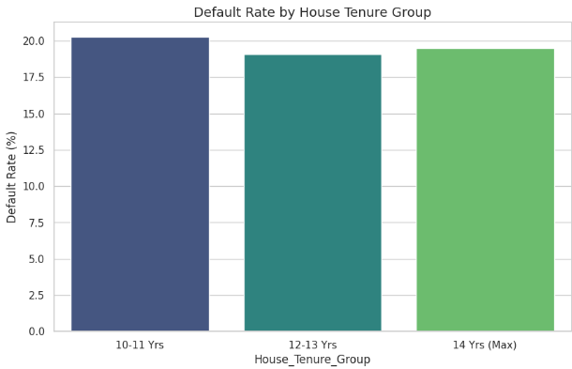
House_Tenure_Group | Default_Rate (%)
10-11 Yrs | 20.271058
12-13 Yrs | 19.088750
14 Yrs (Max) | 19.509733

Interpretation for House Tenure vs Default Rate: A low risk default was discovered for loan safety between 12 and 13 years of living in a home, where the risk of default is at its lowest (19.09%). Interestingly, those who have lived in their homes for slightly less time (10-11 years) are actually the riskiest group at 20.27%. Even more surprising is that after 13 years, the risk starts to creep back up again. This suggests that while staying in one place is generally good, the 14 year mark brings new financial pressures such as home repairs or university fees as children leave the house. This shows a non-linear relationship so the longer one has resided in their house does not guarantee that they will be low defaulters.

DATA VISUALIZATION FOR THE FEATURES THAT HAVE AN INFLUENCE ON LOAN RISK
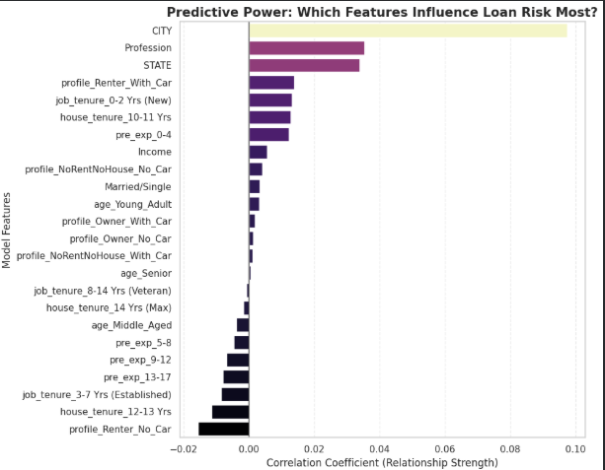
Interpretation: The bars to the right have a positive correlation to default risk. These features increase the risk so as these numbers go up, the chance of default goes up as well. While the bars to the left have a negative correlation to default risk. These features decrease risk and are the safety signals for loan borrowing. The longer the bar is in either direction (to the right or to the left) the more powerful the feature has on the default rate. In our dataset, City is clearly the most powerful feature that has a high default rate while the asset profile for renters with no car is the most powerful feature that has a low default rate for defaulters.
Summary: The most striking insight from our model is the dominance of geographic location over personal demographics and financial features. While demographic and financial features are relevant, the city feature data acts as a proxy for the broader socio-economic pressures an applicant faces. This has captured the impact of regional cost-of-living disparities; even a high-earning, experienced professional may face significant default risk if they reside in an economically distressed or hyper-expensive urban center.

EVALUATION FOR LOGISTIC REGRESSION MODEL
To combat imbalanced data, a weighed model (specifically class_weight=”balanced) was used. This changes how the model pays attention to the data.
Evaluation Metrics | Result (%)
Accuracy | 54
Precision | 19
Recall | 44
f1_Score | 27
- Accuracy (54%): The accuracy is 54%. The model is at least struggling to distinguish between the two classes rather than just picking the most frequent class which is low risk(0) in this case.
- Precision (19%): The model managed to label customers as high risk 19% of the time.
- Recall (44%): The model successfully identified 43% of all actual defaulters in the dataset.
- F1-Score (27%): The average of precision and recall.
The balanced model is useful because it caught nearly half of the bad loans (44% Recall) which is better than a standard model that will likely catch none (0%) of the bad loan defaulters. This has made the model sensitive, it will now over-flag leading to false positives.

Confusion Matrix
It shows exactly where the Logistic Regression model succeeded and where it got confused.
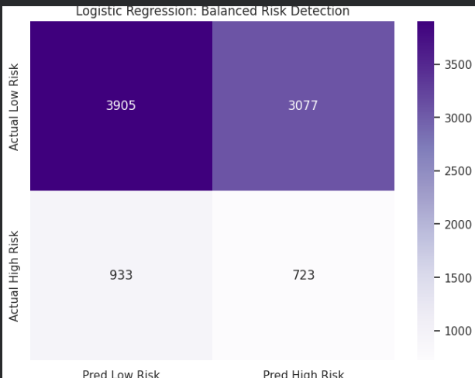
 | Predicted Low Risk (0) | Predicted High Risk (1)
Actual Low Risk (0) | 3,899(True Negatives) | 3,083 (False Positives)
Actual High Risk (1) | 942 (False Negatives) | 714 (True Positives)
- True Positives (714): 714 risky customers were correctly identified as high-risk
- True Negatives (3,899): 3,899 safe customers were correctly classified as low-risk.
- False Positives (3,083): 3,083 safe customers were incorrectly flagged as high-risk.
- False Negatives (942): 942 risky customers were incorrectly classified as low-risk.
Summary: The Logistic Regression model is now extra sensitive and it might become slightly more conservative. It may flag more low risk customers as high risk just to be safe but this is acceptable because the loaning process is not automatically accepted, it first has to be manually reviewed by the loan department (Senior Underwriter) to be finally accepted. Manual reviewing is done for ethical oversight (models can sometimes be biased so manual reviewing ensures the bank is not unfairly rejecting someone based on a statistical fluke), legal compliances (in many countries, if a loan is rejected the law requires an explanation as to why and a human is much better at explaining a decision than a probability score) and lastly, manual review is done because the model can miss context such as the reason for a past late payment or the specific industry the person works in.
Recommendations
Instead of using a Logistic Regression model with class_weight=”balanced”, an alternative is to use the Random Forest Classifier with class_weight=”balanced” because it handles these trade-offs better than logistic regression as it picks up on non_linear patterns. For example, age being risky only when income is low. Moreover, by default the model predicts high risk if the probability is above 0.5 (50%) so you can adjust the threshold to let the user choose the sensitivity of risk assessment.

