SESSION 11 ASSIGNMENT 1

Problem Statement:

Perform and explain the code flow and the associated result for the below tasks. Candidates should

create and use their own employee dataset for the same. Share the screenshot of the commands used and its associated result.

Transfer data between Mysql and HDFS (Import and Export) using Sqoop.

sudo service mysqld start

mysql -u root

create database session_11;

use session_11;

create table employee

(

id int,

name varchar(20),

grade varchar(02)

);

insert into employee values(1, 'AMAN','A4');

insert into employee values(2, 'PRACHI','A4');

insert into employee values(3, 'ANKIT','B1');

grant all on *.* to 'root'@'localhost' with grant option;

flush privileges;

commit;

exit;

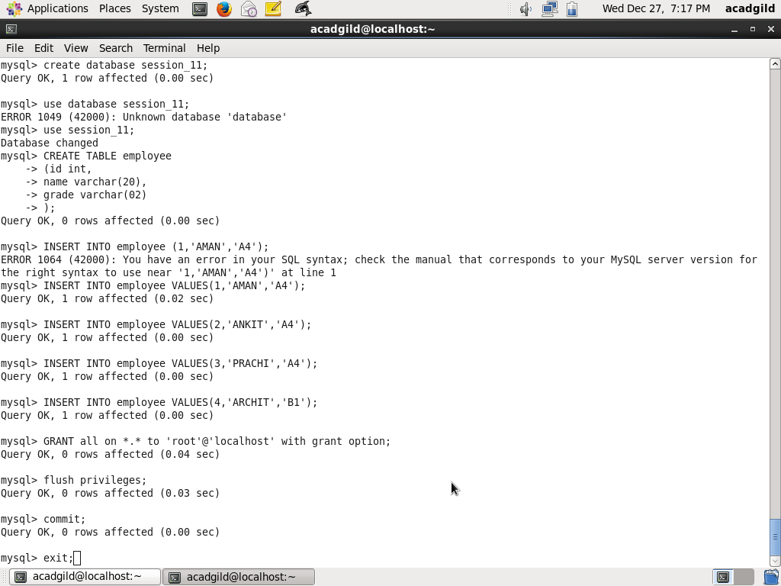

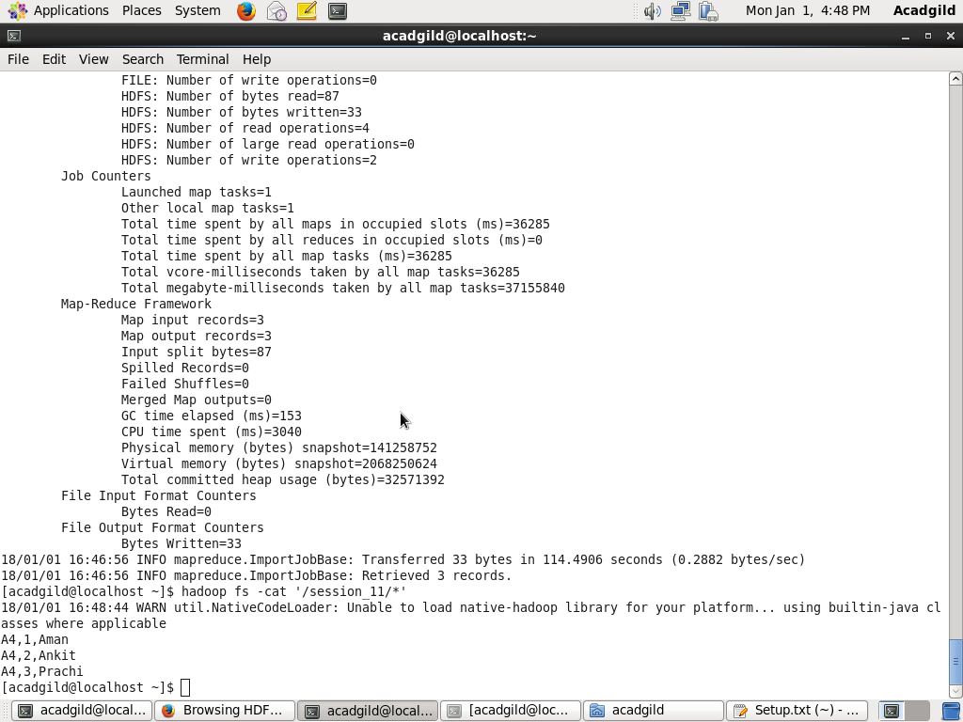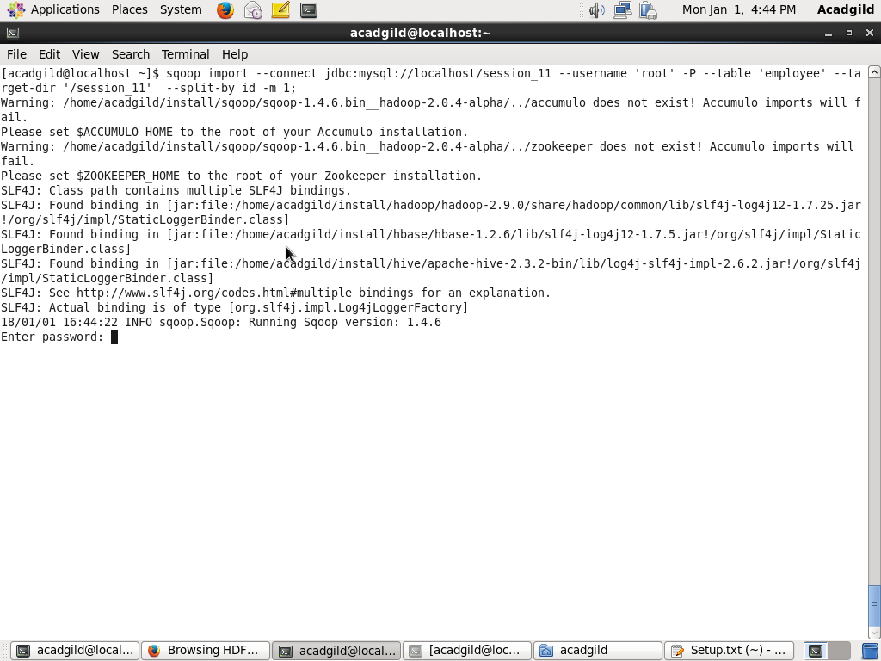sqoop import --connect jdbc:mysql://localhost/session_11 --username 'root' -P --table 'employee' --target-dir '/session_11' --split-by id -m 1;

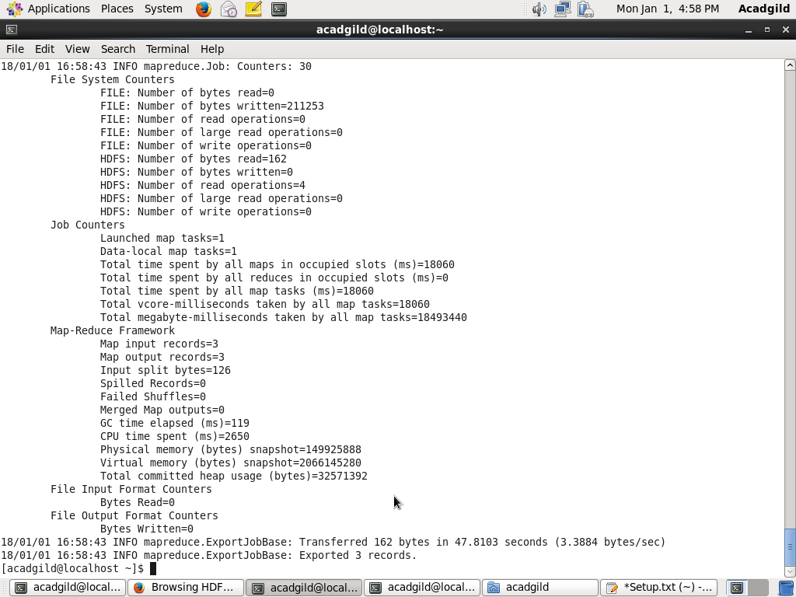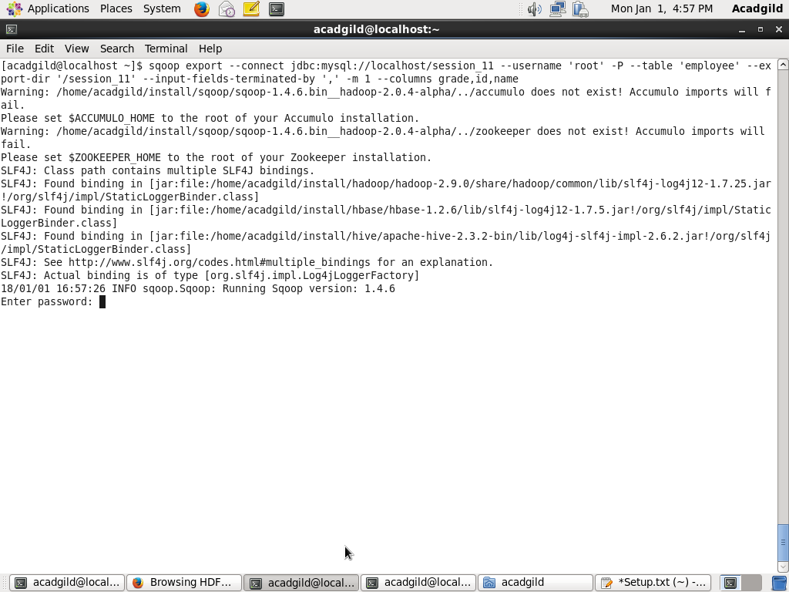sqoop export --connect jdbc:mysql://localhost/session_11 --username 'root' -P --table 'employee' --export-dir '/session_11' --input-fields-terminated-by ',' -m 1 --columns id,name,grade

Transfer data between Mysql and Hive (Import and Export only selected columns) using Sqoop.

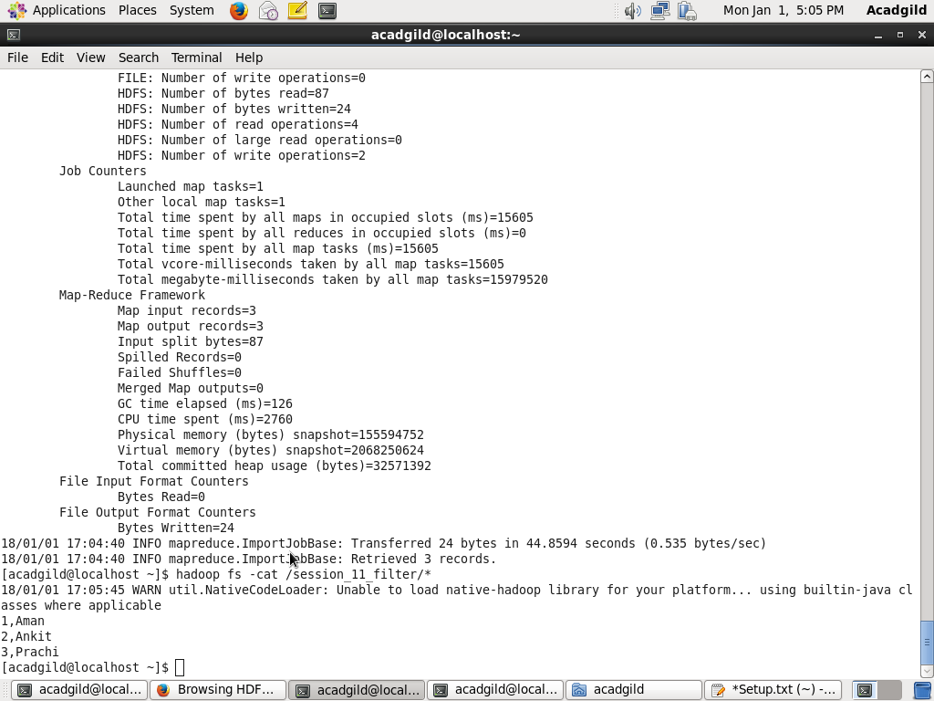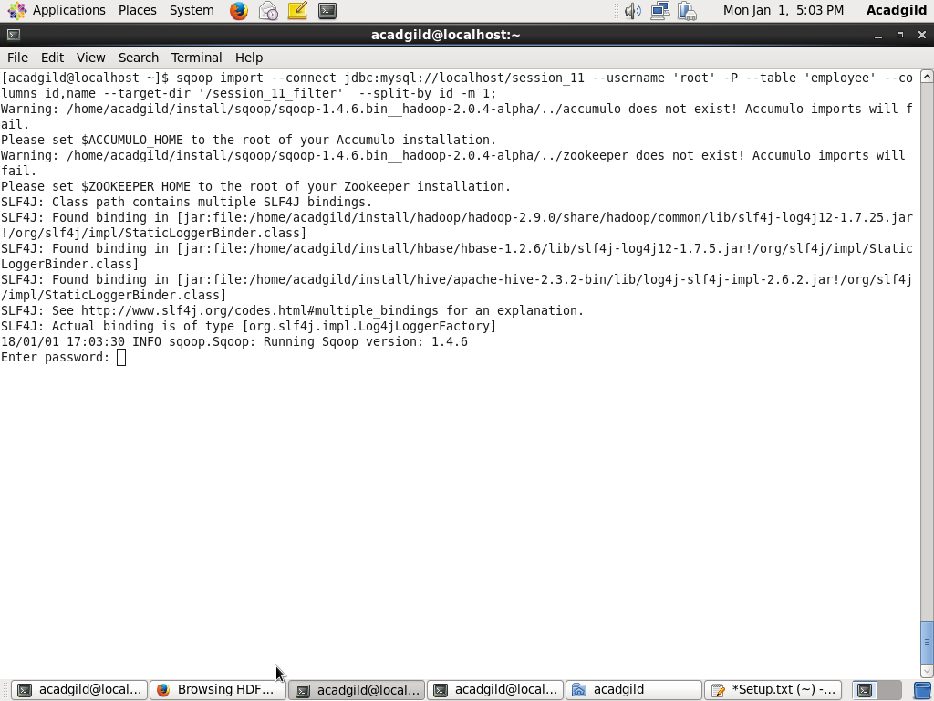sqoop import --connect jdbc:mysql://localhost/session_11 --username 'root' -P --table 'employee' --target-dir '/session_11_filter' --split-by id -m 1 --column id,name;

sqoop export --connect jdbc:mysql://localhost/session_11 --username 'root' -P --table 'employee' --export-dir '/session_11_filter' --input-fields-terminated-by ',' -m 1 --columns id,name

