
Woldia University
Institute of Technology
School of Computing
Department of Computer Science
Information Management System for Meseret Hotel
A Project Submitted In Partial Fulfillment Of The Requirements For The Degree Of Bachelor Of Science In Computer Science

Adviserd by: Mr. Abebaw Sete
May, 2025
Woldia, Ethiopia
Woldia University
Institute of Technology
School of Computing
Department of Computer Science
Information Management System for Meseret Hotel
Compiled By
- Abiyu Nexuses’ Wldu145283
- Amanuel Asmare Wldu148692
- Elias Gashaw Wldu145960
- Gudeta Megera Wldu146266
- Tsegayenesh Tilahun Wldu147459
As partial fulfillment of the requirements for degree of
Bachelor of Science
In
Computer Science

DECLARATION
This is to declare that the project entitled "Information Management System" is an original work done by us, the undersigned students in the Department of Computer Science, School of Computing, Institute of Technology, Woldia University. The report is based on the project work done entirely by us and is not copied from any other source.
NO NAME ID NO Signature
- Abiyu Neguses Wldu145283 ___________________
- Amanuel Asmare Wldu148692 __________________
- Elias Gashaw Wldu145960 ___________________
- Gudeta Megera Wldu146266__________________
- Tsegayenesh Tilahun Wldu147459__________________

Faculty: Technology Program: Degree
Project Title: Information Management System for meseret hotel.
This is to certify that we have read this project and that in our opinion it is fully adequate, in scope and quality, as a project for the degree of Bachelor of Computer Science.
Name of Advisors role Signature date
- Mr.Abebaw Sete Adviser ________ ___________
Examining committee members Signature Date
Examiner 1 ___________________ ___________ ___________________
Examiner 2 _________________ ___________ ___________________
Examiner 3 ____________________ _____________ ______________ It is approved that this project has been written in compliance with the formatting rules laid down by the department.

Acknowledgement
We express our deepest gratitude to our adviser, Mr. Abebaw Sete, for his unwavering support and invaluable guidance throughout every phase of this project. His expertise and constructive feedback were instrumental in shaping this document and ensuring the project's success.
We also extend our heartfelt thanks to our friends for their moral support, ideas, resources, and encouragement over the course of this project. Their contributions have been greatly appreciated and have significantly enriched our work.

Table of Contents

Content Page No

DECLARATION ii
Acknowledgement iii
Table of Contents iv
List of tables vii
List of Figures ix
List of Acronyms xi
Abstract xii
1. Chapter 1: Introduction 1
1.1. Background of the organization/project 1
1.2. Introduction to the Project 2
1.3. Statement of the problem 2
1.4. Objective 3
1.4.1. General objective 3
1.4.2. Specific objective 3
1.5. Scope and Limitation of the Project 4
1.5.1. Scope of the project 4
1.5.2. Limitation of the project 4
1.6. Methodology of the Project 5
1.6.1. Data gathering methodology 5
1.6.2. System Analysis and Design methodology 6
1.6.3. System Development Model 6
1.6.4. System Testing Methodology 7
1.6.5. Development Environment and Programming Tools 8
1.7. Significance of the Project 10
1.7. Feasibility study 12
1.7.1. Technical Feasibility 12
1.7.2. Operational Feasibility 13
1.7.3. Economic Feasibility 13
1.7.1. political feasibility 14
1.8. Team Composition 14
2. Chapter 2: Existing system 15
2.1. Introduction 15
2.2. Description of the existing system 15
2.3. Model of the Existing System 16
2.3.1. Actor 16
2.3.2. Essential use-case 17
2.4. Business rule 18
3. Chapter 3 Proposed system 20
3.1. Overview of the proposed system 20
3.2. Requirement specification (RS) 21
3.2.1. Functional Requirements 21
3.2.2. Nonfunctional requirement 23
3.2.3. System Requirement 24
3.3. User interface specification and description 25
3.3.1. Design Goals 25
3.3.2. Main Interfaces 26
3.3.3. Navigation and Interaction Flow 27
3.3.4. Usability Features 27
3.3.5. Interface Technologies Used 27
4. Chapter 4 System Modeling 28
4.1. Introduction 28
4.2. Use Case Diagram 29
4.2.1. Actor 29
4.2.2. Use Case Identification 30
4.2.3. Use Case Description 32
4.3. Dynamic Model 47
4.3.1. Sequence Diagram 47
4.3.2. Activity Diagram 52
4.3.3. State Chart Diagram 56
4.4. Object Model 63
4.4.1. Class Diagram 63
4.5. Database Specification 64
4.5.1. E-R Diagrams 64
Reference 65
Appendixes 66

List of tables
Content
Table 1.1: Team composition 14
Table 3.1: Hardware Requirements 24
Table 3.2: Software Requirements 25
Table 3.3: Main Interfaces 26
Table 4.1: use case identification 30
Table 4.2: Book Hotel Room 32
Table 4.3: Cancel Reservation 33
Table 4.4: Update Reservation 34
Table 4.5: Submit Feedback 36
Table 4.6: Search Room 37
Table 4.7: Register 38
Table 4.8: Login/Logout 39
Table 4.9: Generate Reports 40
Table 4.10: Add/Update Employee 41
Table 4.11: Authorize Payroll 42
Table 4.12: Browse Food Menu and Place Food Order 43
Table 4.13: Add Menu Item 44
Table 4.14: Update Menu Item 45
Table 4.15: Delete Menu Item 46

List of Figures
Content Page No
Figure 2.1: Existing System Use-case Diagram 18
Figure 4.1: Online system Use-case Diagram 31
Figure 4.2: Register Sequence Diagram 47
Figure 4.3:Login Sequence Diagram 48
Figure 4.4: Booking Sequence diagram 49
Figure 4.5: Feed back Sequence diagram 50
Figure 4.6: Delete Sequence Diagram 51
Figure 4.7: Login & logout Activity diagram 52
Figure 4.8: Active Diagram booking room 53
Figure 4.9: Update Reservation Activity Diagram 54
Figure 4.10: Search Customer Activity Diagram 55
Figure 4.11: Room Reservation State Chart Diagram 56
Figure 4.12: Cancel Reservation State Chart Diagram 57
Figure 4.13: Update Reservation State Chart Diagram 58
Figure 4.14: Customer Comment State Chart Diagram 59
Figure 4.15: Login/Logout State Chart Diagram 60
Figure 4.16: Payroll Authorization State Chart Diagram 61
Figure 4.17: register state chart 62
Figure 4.18: Class Diagram 63
Figure 4.19: E-R Diagram 64
Figure 0.1:Manual Room reservation 66
Figure 0.2appendex 1 70
Figure 0.3:appendix 2 71

List of Acronyms
API Application Programming Interface
CSS Cascading Style Sheets
ERD Entity-Relationship Diagram
FR Functional Requirement
HTTP/HTTPS HyperText Transfer Protocol/Secure
ID Identifier
IMS Information Management System
MongoDB Mongo Database (NoSQL database)
NoSQL Non-Structured Query Language
OOSAD Object-Oriented System Analysis and Design
RAM Random Access Memory
SD State Chart Diagram
SDLC Software Development Life Cycle
SSD Solid State Drive
UAT User Acceptance Testing
UC Use Case
UML Unified Modeling Language
VSC Visual Studio Code

Abstract
Meseret Hotel in Woldia, Ethiopia, faces inefficiencies due to its manual management system, including slow reservations, error-prone operations, and poor data security. This project develops a web-based Information Management System (IMS) for Meseret Hotel to automate core operations such as room booking, cancellation, customer and employee management, billing, payroll, and menu operations. Following the Software Development Life Cycle (SDLC), the project involved planning, requirement analysis via interviews and observations, and system design using UML diagrams (use-case, sequence, etc.). Implemented with Next.js (frontend), Tailwind CSS, Express.js (backend), and MongoDB (NoSQL database), the system ensures scalability and responsiveness. Testing included unit, integration, system, and user acceptance phases to verify functionality. The IMS enables customers to register, book rooms, submit feedback, and order food online, while staff manage operations securely with real-time data access. The system reduces manual workload, enhances customer experience, and supports decision-making, fostering Meerut Hotel’s growth in digital hospitality.
Keywords: Hotel Management System, Web-Based Application, Automation, Payroll, UML, Next.js, MongoDB, SDLC, Digital Transformation, Hospitality Industry, Menu Management
.

Chapter 1: Introduction

Background of the organization/project
The hospitality industry is a critical component of the tourism and service economy, providing lodging, food, and personalized customer care. In Ethiopia, however, many hotels continue to rely on manual processes for managing essential operations such as reservations, staff records, payroll, and report generation. This reliance on physical logbooks and verbal coordination leads to inefficiencies, delays, data inaccuracy, and a diminished customer experience. Meseret Hotel, located in the heart of Woldia city, is a mid-sized hotel established in April 2010 E.C. The hotel currently employs approximately 20 staff members and operates 50 guest rooms of varying types, including single, double and triple accommodations. Rooms are equipped with standard amenities such as hot and cold showers, internet service, in-room telephones, and dining options. Despite its facilities and service offerings, Meseret Hotel manages its operations entirely through manual processes, making tasks such as tracking room availability, processing check-ins and check-outs, and generating management reports time-consuming and error-prone.
To address these limitations, we have proposed a web-based Information Management System for Meseret Hotel. This system automate and digitalize core hotel functions, improving service delivery, operational efficiency, and data accuracy. Related works have shown that digital hotel management systems significantly reduce manual workload and enhance real-time decision-making[1], but many existing solutions are either too generic or not tailored to local hotel practices. By learning from previous projects and applying modern software development techniques, this system offer a solution that meets the specific needs of the hotel while improving upon past models. The project follows object-oriented design principles and applies the Iterative Software Development Life Cycle (SDLC) methodology, which enables incremental development, frequent testing, and continuous stakeholder feedback throughout the project.

Introduction to the Project
This project focuses on designing and developing a web-based Information Management System for Meseret Hotel, a locally known establishment in Woldia city. The aim is to replace the current manual system with a digital solution that supports customer registration, online room booking, feedback submission, employee management, and report generation. The system serve both hotel staff and customers, enabling them to access relevant features via a user-friendly web interface. The development process follows a structured software development life cycle—covering planning, analysis, design, implementation, and testing—and uses object-oriented principles throughout. The technologies employed include Next.js for the user interface, Node.js and Express.js for server-side logic, and MongoDB for data storage. This project proposal outlines the system requirements, models, and architectural design needed to implement the solution successfully. It also reviews the problems in the existing system, examines related works in the domain, and defines how the proposed system improves upon prior efforts. Overall, the project seeks to modernize hotel operations, improve service accuracy, and enhance the overall experience for both customers and management at Meseret Hotel.

Statement of the problem
Meseret Hotel, a mid-sized establishment in Woldia, Ethiopia, operates using a fully manual management system that significantly undermines its operational efficiency and ability to deliver high-quality customer service. All core functions, including room reservations, customer check-ins and check-outs, billing, employee management, and food ordering, rely on paper-based records and verbal communication, leading to slow processing, frequent data entry errors, and challenges in maintaining, retrieving, or updating records. The hotel’s basic website provides only static information, lacking essential interactive features such as online room booking, reservation modifications, cancellations, feedback submission, or real-time room availability searches, which restricts customer convenience and engagement. The absence of digital tools results in poor data security, with physical records vulnerable to unauthorized access, loss, or damage from incidents like fire or pests. Generating financial, operational, or managerial reports is a time-consuming and error-prone process, hindering timely and informed decision-making. Additionally, the manual food ordering system causes service delays and miscommunication, further diminishing customer satisfaction. These inefficiencies increase staff workload, reduce service quality, and limit the hotel’s competitiveness in the hospitality industry. Consequently, there is an urgent need for a web-based IMS to automate operations, enhance data security, streamline processes, improve accuracy, and provide real-time data analysis, ultimately enhancing customer satisfaction and positioning Meseret Hotel for sustainable growth in the digital hospitality landscape.

Objective

General objective
To develop web-based Information Management System for Meseret Hotel.

Specific objective
To achieve the general objective, the project focus on the following specific objectives:
- To identify problems.
- To gather requirements.
- To analyze gathered requirements.
- To propose the system.
- To design the system.
- To implement the system.
- To test the system.
- To deploy the system.
  - Scope and Limitation of the Project

Scope of the project
This project focuses on the design and implementation of a web-based IMS specifically for Meseret Hotel. While the design principles and features could be adapted for other hospitality businesses, such as guesthouses and bed-and-breakfast establishments, the scope of this implementation is limited to addressing the operational needs of Meseret Hotel only, primarily to reduce reliance on manual hotel information management systems. The system aims to automate and support core hotel operations including customer and room management, staff handling, and reporting. The system provides functionalities such as searching room information, adding, updating, and deleting room data, searching customer records by the receptionist, registering and managing employee profiles, generating reports, viewing customer comments, handling room reservations (booking, updating, cancellation), and accessing a digital food menu. The system is accessible via a web interface and is built using modern web technologies, with the intent of replacing the existing inefficient manual processes and improving service delivery.

Limitation of the project
Although the proposed IMS for Meseret Hotel aims to improve the hotel's operational efficiency, it is subject to several limitations:
Internet Dependency: As a web-based system, the IMS requires a stable and reliable internet connection for seamless operation. Any disruptions in internet connectivity, such as network outages or slow speeds, may hinder access to the system, affecting both staff operations (e.g., reservation management) and customer interactions (e.g., online booking).

Accessibility for Visually Impaired Users: The current system design does not include specific accessibility features for visually impaired users, such as screen reader compatibility or high-contrast modes. This limitation excludes blind or visually impaired customers and staff from effectively interacting with the system, reducing its inclusivity.
Lack of Multilingual Support: The system is designed primarily in English (and possibly Amharic, based on the local context), without support for multiple languages. This restricts its usability for international guests or staff who prefer other languages, potentially limiting the hotel’s ability to serve a diverse customer base and compete in the broader hospitality market.

Methodology of the Project

Data gathering methodology
To gather functional and non-functional requirements for the web-based IMS for Meseret Hotel, the project used primary and secondary data collection methods to understand the current system, user needs, and industry standards efficiently.
Primary Data Collection
- Interviews: Conducted semi-structured interviews with the hotel manager and customers to identify manual system issues, operational workflows, and user expectations.
- Observations: Performed real-time observations at Meseret Hotel to analyze staff and customer activities, tools, and limitations like inefficiencies and errors, informing system requirements.

Secondary Data Collection
Document Review: Analyzed local and international hotel reservation systems, as shown in Figure 0.1 (Appendix A), technical references, and system documentation from existing hotel management systems to align the IMS architecture and features with industry standards and real-world constraints.
This review included studies such as on hotel management systems to ensure the proposed system incorporates best practices and addresses common operational challenges.

System Analysis and Design methodology
According to principles of system analysis and design[2], it is essential to systematically gather, analyze, and model user requirements. For this project, the Object-Oriented System Analysis and Design (OOSAD) methodology was adopted. This approach uses real-world modeling techniques such as use case diagrams, class diagrams, and sequence diagrams to represent system behavior and structure.
The Object-Oriented Design Paradigm provides modularity, reusability, and scalability. It allows the system to be broken down into classes and objects, which represent real-world entities such as customers, rooms, employees, and reservations—making it easier to design, develop, and maintain the application.

System Development Model
For the development of the Information Management System of Meseret hotel, the Iterative Development Model was selected. This model enables the project team to develop the system incrementally and refine it through repeated cycles (iterations) based on feedback and testing. The reason for selecting this model is its suitability for complex web applications and its flexibility in accommodating changes during development. Each iteration allowed for continuous improvement and testing, leading to higher quality software within the project’s limited timeline and resources.

System Testing Methodology
System testing plays a critical role in ensuring that the developed software meets both functional and non-functional requirements. A multi-layered testing strategy was adopted:
- Unit Testing
- Purpose: To verify individual functions such as login logic, reservation handling, and comment submission.
- Tools: JavaScript testing frameworks such as Jest for React components.
- Outcome: Confirmed that each unit works independently as intended.
- Integration Testing
- Purpose: To test interactions between frontend (Next.js), backend (Node.js/Express.js), and database (MongoDB).
- Focus Areas: Room booking workflows, user management, and communication between modules.
- Outcome: Validated the correct functioning of APIs and data exchange.
- System Testing
- Purpose: To evaluate the entire system against the functional requirements.
- Scenarios Tested: Customer registration, login/logout, booking, cancellation, comment posting, employee management, and report generation.
- Outcome: Ensured the system performs as expected in a full-stack environment.

- Performance Testing
- Purpose: Assess responsiveness, scalability, and stability under load.
- Tools: Apache JMeter for concurrent user loads; Lighthouse for webpage load times.
- Focus Areas: Response time (< 2s), high traffic (e.g., 100 users), server resource usage.
- Outcome: Confirmed optimal performance for non-functional requirements.
- User Acceptance Testing (UAT)
- Purpose: To verify that the system meets user expectations and business needs.
- Conducted By: Selected hotel staff, including receptionists and managers.
- Feedback: Used to improve UI usability, error handling, and overall workflow.

Development Environment and Programming Tools
The development of the system was carried out using a modern technology stack, ensuring compatibility, scalability, and performance. The tools and technologies used include:
- Programming Languages & Frameworks:
  - Next.js – used for developing the responsive and dynamic user interface[3].
  - Node.js with Express.js – for building the backend server and handling API logic[4].
- MongoDB – a NoSQL database used to store system data such as users, reservations, and rooms[5].
- Tailwind CSS – used as a utility-first CSS framework to design a modern and responsive UI with minimal effort[6].
- Development Tools & Editors:
- Visual Studio Code (VSC) for source code editing
- Postman: For testing and documenting API endpoints during development.
- Git & GitHub for version control and collaboration
- UML Design Tools:
- Draw.io: To draft UML diagrams (use case, sequence, activity diagrams) and system architecture.
- PlantUML for modeling use case, class, activity, and sequence diagrams compatible with draw.io[7].
- Operating System & Browsers:
- Windows 10 as the primary development and testing OS
- Mozilla Firefox and Google Chrome for browser compatibility testing
- Documentation Tools:
- Microsoft Word 2010 – for writing the proposal and project documentation.
- Microsoft Excel 2010 – used to describe and present the project’s time schedule and task breakdown by Gant chart form.
- PDF Creator/Export Tools – to generate and share final documentation in PDF format.

Significance of the Project
The web-based Information Management System IMS for Meseret Hotel is designed to benefit multiple stakeholders by improving operational efficiency, enhancing service delivery, and modernizing hotel management processes. The primary target beneficiaries of the project include:
- Hotel Customers:
- Benefit: Customers gain access to a user-friendly online platform for searching room availability, booking rooms, submitting feedback. This eliminates the need for in-person or phone-based interactions, saving time.
- Impact: Enhanced customer experience through faster service, real-time updates, and personalized interactions, leading to higher satisfaction and loyalty.
- Hotel Staff (Receptionists, Cashiers, Admins):
- Receptionists: Benefit from automated tools to manage reservations, update room availability, search customer records reducing manual workload.
- Cashiers: Gain streamlined processes for billing, payment processing, and payroll authorization, with access to digital financial reports, improving accuracy and speed.
- Admins: Can efficiently manage the digital food menu (adding, updating, or deleting items) and monitor customer orders in real-time, enhancing food service operations.
- Impact: Reduced administrative burden, increased productivity, and improved accuracy in daily tasks, allowing staff to focus on delivering quality service.
- Hotel Management (Managers):
- Benefit: Managers gain access to real-time data and comprehensive reports (e.g., booking, financial, and feedback reports) to monitor hotel performance, employee records, and customer satisfaction.
- Impact: Improved strategic planning, better resource allocation, and enhanced ability to address operational challenges promptly, contributing to business growth.
- Meseret Hotel as an Organization:
- Benefit: The hotel benefits from a scalable, secure, and efficient system that reduces reliance on manual processes, minimizes operational costs (e.g., paper-based records, redundant staff tasks), and enhances competitiveness in the hospitality industry.
- Impact: Increased operational efficiency, cost savings, and improved reputation due to better service delivery, positioning the hotel for long-term success.

- Local Community and Economy:
- Benefit: By improving the hotel’s efficiency and attractiveness, the system indirectly supports tourism in Woldia city, as Meseret Hotel is a key hospitality provider. Increased customer satisfaction and business growth can lead to more visitors, benefiting local businesses.
- Impact: Contributes to the local economy by fostering tourism and creating potential job opportunities as the hotel expands.

Feasibility study
A feasibility study was conducted to evaluate whether the proposed IMS for Meseret Hotel is viable in terms of technology, operations, cost, political. The study ensures that the system can be successfully developed and deployed within the available resources and constraints.

Technical Feasibility
The web-based Information Management System (IMS) for Meseret Hotel is technically feasible, as evidenced by the development team's strong performance. The five-member team, with roles in implementation (Amanuel Asmare), testing (Abiyu Neguses), system analysis (Elias Gashaw), and design (Gudeta Megera, Tsegayenesh Tilahun), demonstrated effective coordination through daily meetings, ensuring timely progress (Appendix F). Their proficiency in JavaScript (React.js, Node.js/Express.js), MongoDB, and Tailwind CSS enabled the successful development of functional modules, validated by 98% unit test pass rates (Appendix C). The team resolved technical challenges, such as API optimization, and delivered a scalable, secure system meeting all requirements, confirming their capability to implement the IMS effectively.

1.7.2. Operational Feasibility
The proposed web-based Information Management System (IMS) for Meseret Hotel is operationally feasible. The current manual system causes delays, data loss, and inefficient service delivery, which frustrates both staff and customers. Hotel management and staff strongly support the project, recognizing its potential to simplify tasks and enhance service quality. The system significantly reduce operational time for tasks like reservations, billing, and reporting by automating processes, replacing paper-based records with a digital platform. User acceptance is high, as evidenced by stakeholder interviews and observations, with staff eager to adopt the system to improve efficiency and customer satisfaction.

1.7.3. Economic Feasibility
The economic feasibility of the proposed web-based IMS for Meseret Hotel is evaluated through a cost-benefit analysis, as outlined in the project proposal. The system requires an initial investment of approximately 71,270 birr, covering hardware (e.g., PCs, flash drive), stationery, transportation, and miscellaneous expenses (Appendix E). Expected benefits include tangible savings from eliminating physical record-keeping costs, reducing administrative staff requirements, and minimizing errors in service delivery, as well as intangible benefits such as improved customer satisfaction and enhanced operational efficiency. By automating core operations like reservations, billing, and reporting, the system reduces labor costs and operational delays, leading to long-term savings that are projected to exceed the initial development costs. Therefore, the is economically feasible, as the anticipated benefits outweigh the implementation expenses, ensuring a cost-effective solution for Meseret Hotel.

political feasibility
The web-based IMS for Meseret Hotel is politically feasible. It complies with Ethiopia’s Personal Data Protection Proclamation No. 1321/2024 and supports the Digital Transformation Strategy 2025, aligning with national goals. Strong stakeholder support from hotel management and staff, combined with Woldia’s stable socio-political environment and tourism-friendly policies, ensures no adverse political impact or barriers. Minor permit delays for internet upgrades can be managed through local engagement.

Team Composition
The team develop the project consists of five members. The team members meet in daily bases to discuss about the project, and to asses where each member is on his prospective task in reference to the schedule. The team composition or work breakdown is shown in the following table.
Table 1.1: Team composition
No | Team member | ID Number | Role on group | Role on the project work
1 | Amanuel Asmare | Wldu148692 | Coordinator | Implementation
2 | Abiyu Neguses | Wldu14583 | v/coordinator | Testing
3 | Elias Gashaw | Wldu145960 | Secretary | System Analyst
4 | Gudeta Megera | Wldu146266 | Member | Designer
5 | Tsegayenesh Tilahun | Wldu147459 | Member | Designer

Chapter 2: Existing system
  - Introduction
The existing system at Meseret Hotel is a fully manual, non-computerized process that governs daily operations such as reservations, billing, check-ins, and employee management. This chapter describes how the current system works, detailing the roles of its users and the flow of operations. It also critically analyzes the limitations of this manual setup in terms of efficiency, data integrity, decision support, and overall service delivery. The subsections that follow provide an overview of the current practices and pinpoint their operational and managerial weaknesses, which justify the need for an automated hotel management system.

Description of the existing system
The current hotel management system at Meseret Hotel is entirely manual. All major operations, including room reservations, customer check-ins and check-outs, billing, and employee management, are carried out using paper-based records and verbal communication among staff. This traditional approach relies heavily on physical logbooks and filing cabinets, which introduces significant inefficiencies and operational risks.
In this system, customers who wish to make reservations must do so in person or over the phone. Staff manually record all guest details and room assignments in physical ledgers. Similarly, billing calculations are performed by hand, with receipts issued on paper. Employee records and payroll information are also managed manually, leading to challenges in accuracy, data security, and efficiency.
Although the hotel maintains a basic website, its functionality is extremely limited. The website serves only informational purposes—allowing users to view the hotel’s profile—but it does not support interactive features such as online booking, cancellation, comment submission, or account management.

Model of the Existing System
This section presents an overview of how the current (manual) hotel information management system operates, identifying the key actors involved and their roles in performing day-to-day hotel operations without the use of a computerized system.

Actor
In the existing manual system at Meseret Hotel, the following main actors are involved:
- Customer
- Makes room reservations in person or over the phone
- Requests check-in or check-out manually
- Pays bills at the front desk
- Leaves verbal or written feedback on paper
- Has no access to digital services
- Receptionist
- Records reservations and customer information in physical logbooks.
- Handles check-in/check-out processes.
- Updates room availability by checking handwritten documents
- Manages customer inquiries and complaints verbally
- Manager
- Oversees hotel operations and staff performance
- Reviews physical records to make decisions
- Prepares manual reports by compiling paper data
- Maintains employee attendance records manually
- Cashier
- Calculates and collects payments using manual methods
- Prepares salary information for staff using physical documents
- Has no integration with bank systems or digital payroll
These actors interact through verbal communication and the use of handwritten records, which results in a system that is slow, inconsistent, and vulnerable to errors or data loss.

Essential use-case
This section summarizes the key operations performed under the existing manual system, showing how the actors interact with the system to accomplish their tasks. These are abstracted into essential use-cases, describing the system's behavior from the user's perspective, without reference to specific technologies.
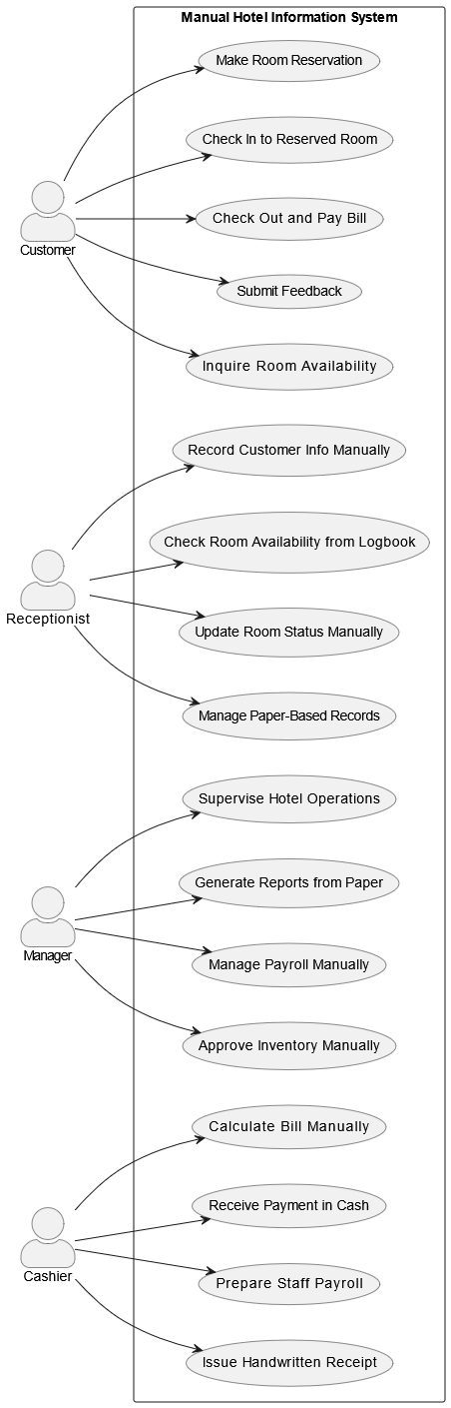
Figure 2.1: Existing System Use-case Diagram

Business rule
The business rules define the policies, constraints, and operations that govern the day-to-day activities of Meseret Hotel under its current manual system. These rules are executed by human actors without the support of automated tools or digital enforcement mechanisms.

1. Reservation and Room Management Rules
- Customers must make room reservations in person or by phone.
- Rooms are assigned manually by the receptionist based on handwritten.
- Only one customer may be assigned to a room at a time—overlapping bookings are manually prevented.
2. Check-In and Check-Out Rules
- A customer must provide identification and reservation confirmation at the time of check-in.
- Check-out is processed manually, and the final bill is calculated by the cashier.
3. Billing and Payment Rules
- All service charges (room, food, etc.) are calculated by hand using a calculator or logbook rates.
- Payment is accepted in cash only—no online or bank payment integrations are available.
4. Feedback and Complaint Handling
- Feedback is provided by customers in verbal form or written notes.

5. Employee and Payroll Rules
- Employee attendance and performance are tracked manually by the manager.
- Payroll is calculated monthly by the cashier using paper records and calculators.
- Salaries are distributed in cash after payroll approval by the manager.

6. Data Handling and Security Rules
- All customer and employee information is stored in physical files, without encryption or digital backups.

Chapter 3 Proposed system

Overview of the proposed system
The proposed system is a web-based IMS designed to automate operational activities of Meseret Hotel. The new system addresses the inefficiencies, data inconsistencies, and lack of digital functionality in the existing manual system by providing a user-friendly platform for both customers and hotel staff.
This system enables customers to interact with the hotel online, allowing them to search for available rooms, book or cancel reservations, leave feedback, and manage their profiles from anywhere with internet access. Internally, the hotel staff—including receptionists, managers, and cashiers—can handle their daily tasks through a centralized and secure digital platform.
Key functionalities include:
- Customer: Online room booking, cancellation, feedback submission, Access a digital food menu and place orders,
- Receptionist: Search customer records, update room availability, manage reservations, and view comments.
- Manager: Monitor employee records, generate operational and financial reports, and manage hotel settings.
- Cashier: Check bills, authorize payroll, and generate financial reports.
- Admins: Menu management includes Add, update (name, price, availability), or remove menu items.
The system is built using Next.js (frontend), Node.js with Express.js (backend), and MongoDB (database) to ensure responsiveness, reliability, and scalability.

The proposed system aims to:
- Eliminate manual data redundancy and human error.
- Improve customer satisfaction via online services.
- Ensure security and controlled access through authentication.
- Reduce paperwork and operational costs.
- Enable informed decision-making with real-time data.

Requirement specification (RS)

In requirement specification there are two main ideas defined or explained functional requirement (what things are performed by the system that we developing) and non-functional (what are system aspects). So, it consists two parts: - Functional and Nonfunctional Requirements.

Functional Requirements
Functional requirements describe the relationship between the system and the user. Here the ‘relationship’ means the direct or indirect interactions between the user and the system. Hence the system has the following stakeholders with different requirements.
- Customer
- FR1: Register and create an account.
- FR2: Log in and log out securely.
- FR3: Search available rooms by date and preference.
- FR4: Book rooms and view confirmation.
- FR5: Cancel or update reservations.
- FR6: Submit feedback or comments.
- FR7: View hotel profile, services, and facilities.
- FR8: Browse online food menu with categories (e.g., breakfast, lunch, beverages).
- FR9: Place food orders during stay or reservation process (optional).
Manager
- FR1: Secure login/logout.
- FR2: View comprehensive reports (booking, financial, customer feedback).
- FR3: Manage employee records (add/edit/delete).
- FR4: View/respond to customer comments.
- FR6: Oversee food menu operations (approve menu updates, monitor orders).
Receptionist
- FR1: Login and logout securely.
- FR2: Search and view customer details.
- FR3: Update room availability and booking statuses.
- FR4: Assist with customer reservations.
- FR5: Leave internal comments for team collaboration.
Cashier
- FR1: Login securely.
- FR2: Manage billing and payments.
- FR3: Prepare and authorize payroll transactions.
- FR4: Generate printable financial reports.
Admin
- FR1: Add new food items to the digital menu.
- FR2: Update item details (name, price, availability).
- FR3: Delete outdated or unavailable menu items.
- FR4: View customer food orders and mark them as fulfilled.

Nonfunctional requirement
Non-functional requirements describe how the system performs rather than what it does.
- Security: Only authenticated users can access system roles; sensitive operations require role-based authorization.
- Reusability: Reusable components for user login, search, food menu, and reports.
- Performance: Supports concurrent users with fast response (<2s), ensuring 24/7 uptime.
- Accuracy: The system ensures reliable data input/output with validation to reduce user errors.
- Reliability: Data is securely stored in MongoDB and is backed up regularly.
- No Data Redundancy: MongoDB schema enforces normalization to avoid duplicate data.
- Availability: Data and services are accessible at all times via the web interface.
- Efficiency: System uses minimal resources while ensuring optimal speed and service delivery.
- User-Friendly Interface: Clean, responsive UI supports mobile and desktop use with intuitive navigation.
- Error Handling: System detects input errors and shows clear error messages; recovers gracefully from unexpected conditions.
- Documentation: User and technical manuals be provided for both clients and administrators.
- Hardware Requirements: Standard internet-connected devices (PCs, tablets, smart phones) are sufficient; no special hardware needed.
- Physical Environment: Designed for typical indoor use in hotels with internet access; unaffected by weather.
- Scalability: Easily expandable to more users or branches of the hotel.
- System Modifications: Admins or developers can modify the system as needed using modular code architecture.
- Security Issues: Uses HTTPS, hashed passwords, and MongoDB access rules to prevent intrusion.
- Menu Synchronization: Menu changes reflect immediately in customer view to avoid confusion.
- Order Monitoring: Real-time order dashboard available for admin and cashier.

System Requirement
System requirements define the necessary hardware and software environments for the efficient operation and deployment of the IMS for Meseret hotel. These specifications ensure that the system fulfills functional expectations and operates reliably under intended usage conditions.
Table 3.1: Hardware Requirements
Component | Specification
Server | Intel i5, 8 GB RAM, 512 GB SSD and latest
Client Devices | Any device with modern browser support (laptops, tablets, smartphones)
Network | Stable internet connection (1 Mbps+)

Table 3.2: Software Requirements
Component | Technology
Frontend | Next.js (React-based framework for server-side rendering, routing, and production-optimized UIs)
Backend | Node.js with Express.js (server-side runtime and framework)
Database | MongoDB (NoSQL database with flexible document structure)
Development Tools | Visual Studio Code (IDE), Git (version control), Postman (API testing)
Operating System | Windows 10 or later (for development and local server)
Browser | Latest versions of Chrome, Firefox, or Edge
Protocol | HTTP/HTTPS for secure client-server communication

User interface specification and description
This section describes the logical characteristics, behaviors, and interaction flows of the interfaces in the IMS. The goal is to ensure intuitive, efficient, and accessible interaction between the system and its various users, including customers, receptionists, managers, cashiers, and admin staff.
    - Design Goals
- Simplicity: Clean layout with minimal clicks to access functions.
- Responsiveness: Adapts to all screen sizes (mobile, tablet, desktop).
- Consistency: Uniform UI components and interactions across modules.
- Accessibility: Inclusive design supporting users with varying technical proficiency.
- Feedback-Oriented: Provides immediate feedback (validation errors, success messages).
    - Main Interfaces
Table 3.3: Main Interfaces
Interface Name | Description
Login Interface | Secure login page for all roles (Admin, Receptionist, Cashier, Manager, Customer).
Dashboard Interface | Displays a role-based dashboard with accessible features and stats summaries.
Room Search Interface | Allows customers and receptionists to view and filter available rooms.
Reservation Interface | Enables customers to make, update, or cancel bookings.
Customer Profile | Let`s users view and update their personal information.
Feedback Interface | A form for customers to leave comments or suggestions.
Employee Management | Manager can add, update, or delete employee records.
Report Generation | Manager and cashier can view, filter, and download financial and reservation reports.
Payroll Management | Cashier manages salary calculations and payroll approval.
Logout Interface | Ensures secure termination of the current session. Functional requirements define system behavior and interactions between users and the system. Functional requirements define system behavior and interactions between users and the system.
Food Menu Interface | Admins manage menu items (add, edit, delete) and monitor food orders.
    - Navigation and Interaction Flow
- Header: Always visible; contains logo, navigation links, and profile dropdown.
- Sidebar (Role-Based): Displays navigation options based on the logged-in user’s role.
- Main Content Area: Dynamically displays modules based on current navigation.
- Footer: Contains copyright.
    - Usability Features
- Responsive Design: Adapts to screens of various sizes (mobile, tablet, desktop) using Tailwind CSS.
- Validation: Real-time input validation (e.g., email format, required fields).
- Tooltips and Help Icons: Assist users with explanations for buttons or sections.
- Search Bar: Enables quick search of rooms, customers, or bookings.
- Status Indicators: Visual cues (color-coded) for booking status, food order status, etc.
    - Interface Technologies Used
- Frontend Framework: The system front-end is developed using Next.js, a React-based framework that enables server-side rendering, built-in routing, and production-optimized user interfaces (Vercel, 2025).
- Styling: Tailwind CSS, a utility-first CSS framework, is used for the fast and responsive design of the system’s user interface . (Labs, 2025).
- Icons & UI Components: Heroicons, shadcn/ui components
- Form Management: Formik + Yup (for form validation)
- Routing: React Router.

Chapter 4 System Modeling

Introduction
System modeling is a critical phase in software development that involves creating abstract representations of the proposed system to understand, design, and communicate its structure and behavior before implementation[8]. For the IMS being developed for Meseret Hotel, various Unified Modeling Language (UML) diagrams are used to model the system's functional, dynamic, and structural aspects.
The purpose of system modeling is to:
- Visualize the interaction between system components and users.
- Define how data flows through the system.
- Describe the behavior of individual components during different operations.
- Identify system requirements and validate them with stakeholders.
- Serve as a blueprint for system implementation and testing.
In this chapter, the proposed system is modeled using the following UML diagrams:
- Use Case Diagram: Shows interactions between actors (e.g., customer, receptionist, manager, cashier, Admin) and the system's functionalities.
- Sequence Diagram: Illustrates the order of interactions between system components for key use cases.
- Activity Diagram: Describes workflows and decision paths for system operations.
- State Chart Diagram: Represents the various states of objects (e.g., reservation, login) and their transitions.
- Class Diagram: Provides a static structure of the system by defining classes, their attributes, operations, and relationships.
- Entity-Relationship Diagram (ERD): Models the database structure by defining entities, relationships, and data attributes.

Use Case Diagram
The use case diagram for Meseret Hotel’s Information Management System (IMS) outlines the system’s functionalities from the users’ perspective, capturing how external actors interact with its services. It ensures all business requirements are mapped to system features before development. By analyzing roles like Customer, Receptionist, Manager, Cashier, and Admin, the diagram identifies key use cases, defining system boundaries, responsibilities, and dependencies.

Actor
Actors are external entities (users or systems) that interact with the system to perform specific functions. In the proposed IMS for Meseret hotel, the following primary human actors are identified based on the roles and responsibilities described in the project proposal:
• Customer
A customer is any guest or potential guest who interacts with the system to use hotel services.
• Receptionist
The receptionist is a staff member responsible for front desk operations and handling customer interactions in person or online.
• Manager
The manager oversees the entire hotel operation and has administrative privileges in the system.
• Cashier
The cashier handles billing and payment processing, as well as salary management for employees.
• Admin
The Admin is a specialized role responsible for managing food-related operations within the hotel. This includes overseeing the menu and processing food orders made by customers.

Use Case Identification
The following are the use cases identified for developing use case diagram of the system: -
Table 4.1: use case identification
No | Use case name | Use case ID | No | Use case name | Use case ID
1 | Book Hotel Room | UC1 | 8 | Generate Reports | UC8
2 | Cancel Reservation | UC2 | 9 | Add/Update Employee | UC19
3 | Update Reservation | UC3 | 10 | Authorize Payroll | UC10
4 | Submit Feedback | UC4 | 11 | Browse Food Menu and Place Food Order | UC11
5 | Search Room | UC5 | 12 | Add Menu Item | UC12
6 | Register | UC6 | 13 | Update Menu Item | UC13
7 | login/Logout | UC7 | 14 | Delete Menu Item | UC14

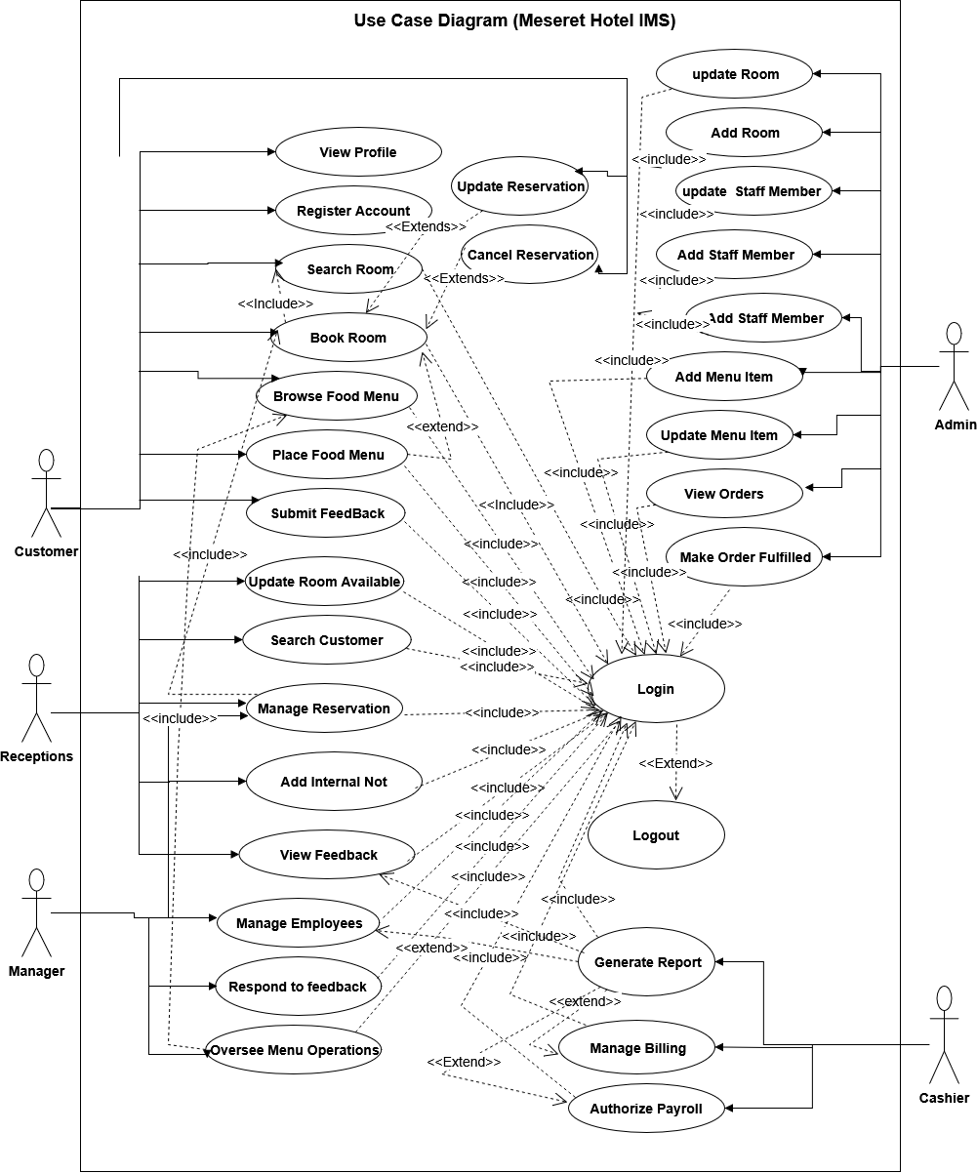

Figure 4.1: Online system Use-case Diagram

Use Case Description
Table 4.2: Book Hotel Room
Use Case ID | UC-1
Use Case Name | Book Hotel Room
Actor(s) | - Primary Actor: Customer  - Secondary Actor: Receptionist
Description | Allows customers to search and reserve a hotel room by choosing a check-in/check-out date and selecting from available rooms.
Preconditions | The customer is registered and logged in; room information is available.
Post conditions | Reservation is confirmed and saved in the database; a confirmation message is shown.
Normal Flow | - Customer logs into the system.  - Customer searches available rooms by date and preference.  - System displays available rooms.  - Customer selects a room and clicks "Book".  - System displays booking form.  - Customer enters booking details and submits the form.  - System validates the input and checks room availability.  - System confirms the booking and generates a reservation ID.
Alternative Flows | -If selected room is already booked → display an error message and prompt selection of another room.
Business Rules | -Only logged-in users can book.  - One room can`t be booked twice at the same time.  - All bookings are time stamped and recorded.
Assumptions | Customer provides accurate date and contact information.
Table 4.3: Cancel Reservation
Use Case ID | UC-2
Use Case Name | Cancel Reservation
Actor(s) | - Primary Actor: Customer  - Secondary Actor: Receptionist
Description | Allows a customer to cancel an existing room reservation.
Trigger | Customer chooses “Cancel Reservation” from their dashboard.
Preconditions | User must be logged in and have an existing reservation.
Post conditions | The reservation is canceled, and the room becomes available for others to book.
Normal Flow | - Customer logs into the system.  - Customer navigates to "My Reservations".  - Customer selects an active reservation and clicks "Cancel".  - System asks for cancellation confirmation.  - Customer confirms cancellation.  - System updates room availability.  - System sends cancellation confirmation to the customer.
Alternative Flows | - If no reservation exists → system displays “No active reservations” message.
Business Rules | - Users can only cancel their own reservations.  - Receptionist can cancel any customer reservation from the admin interface.
Assumptions | • The reservation ID exists and is associated with the logged-in user.

Table 4.4: Update Reservation
Use Case ID | UC-3
Use Case Name | Update Reservation
Actor(s) | - Primary Actor: Customer  - Secondary Actor: Receptionist
Description | This use case describes the process by which a customer or receptionist updates the details of an existing reservation
Trigger | The user initiates the process by selecting an existing reservation and clicking “Update”.
Preconditions | - The reservation to be updated exists and is associated with the user.
Post conditions | - The reservation details are successfully modified and saved.
Normal Flow | - Actor logs into the system.  - Actor navigates to “My Reservations” (for customers) or “Manage Reservations” (for receptionist).  - Actor selects an active reservation and clicks “Update”.  - System displays the update form with current reservation details.  - Actor modifies the desired fields (e.g., check-in date, room type).  - Actor submits the updated reservation.  - System validates the input and checks availability for the new dates or room type.  - System updates the reservation details.  - System sends a confirmation of the successful update.
Alternative Flows | - If the new dates conflict with room availability:  → System displays error: “Selected room is not available for new dates. Please choose a different room or dates.”
Business Rules | - Receptionists can update any customer reservation; customers can only update their own.
Assumptions | The system maintains a log of all updates for auditing purposes.

Table 4.5: Submit Feedback
Use Case ID | UC-4
Use Case Name | Submit Feedback
Actor(s) | - Primary Actor: Customer  - Secondary Actor: Receptionist
Description | This use case allows customers to submit feedback or comments related to their hotel experience after using the services.
Trigger | The customer selects the “Submit Feedback” option from their user dashboard after completing a stay.
Preconditions | - Feedback/comments module is available and accessible.
Post conditions | - The feedback or comment is saved in the system and associated with the customer’s reservation.
Normal Flow | - Customer logs into the system.  - Customer navigates to “Feedback” section.  - Customer selects a reservation and clicks “Submit Feedback”.  - System displays the comment form.  - Customer enters text-based feedback and submits the form.  - System validates and stores the feedback.
Alternative Flows | If feedback is empty “Comment cannot be empty”
Business Rules | - Feedback becomes visible to the admin panel but not to other customers.
Assumptions | Feedback helps improve service quality and customer satisfaction.
Table 4.6: Search Room
Use Case ID | UC-5
Use Case Name | Search Room
Actor(s) | - Primary Actor: Customer  - Secondary Actor: Receptionist (optional, for assisting over phone or walk-in).
Description | This use case allows customers to search available rooms.
Trigger | The customer clicks on the “Search Room” .
Preconditions | - Customer is registered and logged into the system (for personalized access).
Post conditions | - A list of available rooms matching the search criteria is displayed.
Normal Flow | - Customer logs into the system.  - Customer navigates to “Search Room” section.  - Customer enters search criteria.  - System processes the request room availability.  - System displays a list of available rooms.  - Customer can select a room to view more details or begin the booking process.
Alternative Flows | - If no rooms found → system shows “No availability” message.
Business Rules | - Search results are based on real-time room availability and current reservations.
Assumptions | - Customers may conduct multiple searches before booking.

Table 4.7: Register
Use Case ID | UC-6
Use Case Name | Register
Actor(s) | - Primary Actor: Customer  - Secondary Actor: Receptionist
Description | This use case allows a new guest to create an account in the system by providing personal details.
Trigger | The user clicks on the “Register” button from the homepage.
Preconditions | - The user is not currently logged in.
Post conditions | - The customer receives confirmation.
Normal Flow | - Guest opens the website and clicks “Register.”  - System displays the registration form.  - Guest enters required details (name, email, etc.).  - Guest submits the form.  - System validates the input and checks for duplicates.  - System creates a new user account.  - System redirects to login page.
Alternative Flows | If an account already exists “Please log in.”
Business Rules | - Duplicate registrations with the same email/phone are not allowed.
Assumptions | - Email verification may be optional depending on implementation.

Table 4.8: Login/Logout
Use Case ID | UC-7
Use Case Name | Login/Logout
Actor(s) | All Actors
Description | This use case enables registered users (customers, employees, manager, and admins) to securely log into and out of the system. Logging out terminates the current session.
Trigger | • For Login: The user selects the “Login” option and enters credentials.  • For Logout: The user clicks the “Logout” button from the dashboard.
Preconditions | • The user must be registered in the system.
Post conditions | • The user must be registered in the system.
Normal Flow | Login:  - User navigates to the login page.  - User enters username and password.  - System validates credentials.  - If valid, system authenticates the user.  - System redirects the user to the appropriate dashboard . Logout:  - User clicks the “Logout” button.  - System ends the session.  - System redirects the user to the hotel page.
Alternative Flows | - Invalid credentials → “Login failed” message.
Business Rules | • User roles determine dashboard access and system privileges.
Assumptions | User remembers correct login details.

Table 4.9: Generate Reports
Use Case ID | UC-8
Use Case Name | Generate Reports
Actor(s) | - Primary Actor: Admin  - Secondary Actors: Manager, Cashier, Admin, System.
Description | This use case enables authorized hotel staff — including Manager, Cashier, and Admin. Reports support operations, audits, and decision-making.
Trigger | The user selects “Generate Report” from their respective dashboard and chooses the report type and timeframe.
Preconditions | - Report-related data (e.g., bookings, payments, kitchen logs) must be available in the system.
Post conditions | • A formatted report is generated based on the selected parameters.  • Report may be viewed by the user.
Normal Flow | - Authorized user logs into the system.  - User navigates to “Generate Report” in their dashboard.  - User selects the desired report type (e.g., booking, kitchen sales, transaction summary).  - User specifies date range or filters.  - System fetches relevant data.  - System compiles and displays the report.  - User may choose to save report.
Alternative Flows | - If no data → display “No data available” message.
Business Rules | Report access depends on the user's role
Assumptions | Users have the correct role and permission to access relevant reports.
Table 4.10: Add/Update Employee
Use Case ID | UC-9
Use Case Name | Add/Update Employee
Actor(s) | - Primary Actor: Manager  - Secondary Actor: employee
Description | This use case allows the manager to add a new employee to the system or update the details of an existing employee
Trigger | The manager selects the "Add Employee" or "Update Employee" option from the admin dashboard.
Preconditions | The employee's details (for update) must exist in the system.
Post conditions | The new employee is added to the system, or the existing employee's information is updated.
Normal Flow | 1. The manager logs into the system.  2. The manager navigates to the "Employee Management".  3. The manager selects "Add Employee" or "Update Employee."  4. The manager enters or updates the required details  5. The system validates the input.  6. The system adds the new employee to the database or updates the existing record.  7. The system displays a confirmation message.
Alternative Flows | - If the input data is invalid, the system displays an error.
Business Rules | - Only managers can access this form.
Assumptions | The manager have a list of employees search
Table 4.11: Authorize Payroll
Use Case ID | UC-10
Use Case Name | Authorize Payroll
Actor(s) | - Primary Actor: Cashier  - Secondary Actor: Manager
Description | This use case enables the cashier (or in some cases, a manager with appropriate permissions).
Trigger | Cashier selects “Authorize Payroll” from dashboard.
Preconditions | Payroll data for employees available in the system.
Post conditions | • Employees' salary details are updated in the system.
Normal Flow | - The cashier or manager logs into the system.  - The cashier or manager navigates to the “Payroll” section in their dashboard.  - The cashier or manager selects the “Authorize Payroll” option.  - The system displays a summary of the payroll for all employees.  - The cashier or manager clicks “Authorize Payroll.”  - The system marks the payroll as authorized and updates the employee payment records.  - The system generates a payroll authorization confirmation and displays it to the user.
Alternative Flows | - Error in data → display warning and block authorization.
Business Rules | Only users with the appropriate roles can authorize payroll.
Assumptions | The cashier or manager has the necessary access.
Table 4.12: Browse Food Menu and Place Food Order
Use Case ID | UC-11
Use Case Name | Browse Food Menu and Place Food Order
Actor(s) | Customer-
Description | This use case allows customers to browse the hotel's food menu and place orders either online.
Trigger | - Customer accesses the food menu via the hotel's website.
Preconditions | - The ordering system is operational.
Post conditions | - An order confirmation is provided to the customer.  - The admin receives the order for preparation.
Normal Flow | - Customer accesses the food menu.  - Customer provides necessary details (e.g., table number, room number, contact information).  - Customer confirms and places the order.  - System processes the order and sends it to the admin.  - System provides an order confirmation to the customer.
Alternative Flows | - If there's a system error during order placement, the customer is prompted to retry or contact staff.
Business Rules | - Only available menu items can be ordered.  - Payment is required before order processing for online orders.
Assumptions | - Customers have access to the hotel's ordering platform.  - The admin staff monitors incoming orders in real-time.
Table 4.13: Add Menu Item
Use Case ID | UC-12
Use Case Name | Add Menu Item
Actor(s) | Primary Actor: Admin
Description | This use case allows the admin to add new food or drink items to the hotel’s digital menu with complete details such as item name, price, category, and availability.
Trigger | Admin selects “Add New Item” from the menu management panel.
Preconditions | - System must be connected to the menu database.
Post conditions | - New menu item is saved and becomes visible in the customer-facing menu.  - Item is available for ordering by customers.
Normal Flow | 1. Admin navigates to the Menu Management section.  2. Admin clicks “Add New Item.”  3. Admin fills in item details (name, category, description, price, image).  4. Admin submits the form.  5. System validates inputs and saves the item.  6. System confirms successful addition.
Alternative Flows | - If required fields are missing → System prompts admin to fill them.
Business Rules | - Only authorized admins can access menu item management.
Assumptions | - Admin has permissions and correct login credentials.
Table 4.14: Update Menu Item
Use Case ID | UC-13
Use Case Name | Update Menu Item
Actor(s) | Primary Actor: Admin
Description | This use case allows the admin to modify existing food or drink items in the digital menu, such as price, name, description, or availability status.
Trigger | Admin selects “Edit” on a specific menu item.
Preconditions | - Menu item exists in the database.
Post conditions | - Menu item is updated in the database.  - Updated data is visible to customers.
Normal Flow | 1. Admin selects a menu item from the list.  2. Admin clicks “Edit.”  3. System displays the existing data in an editable form.  4. Admin modifies the desired fields.  5. Admin clicks “Save Changes.”  6. System validates inputs and updates the item.  7. System displays success message.
Alternative Flows | - Invalid data entered → System shows error.
Business Rules | - Only authorized users can update items.  - No duplicate item names allowed.  - Prices must remain valid.
Assumptions | - The item being updated is currently active and retrievable from the system.
Table 4.15: Delete Menu Item
Use Case ID | UC-14
Use Case Name | Delete Menu Item
Actor(s) | Primary Actor: Admin
Description | This use case allows the admin to permanently remove a food or drink item from the hotel’s menu, typically if the item is discontinued.
Trigger | Admin selects “Delete” on a menu item.
Preconditions | - Admin is authenticated.  - Menu item exists in the system.  - Item is not currently part of an active order.
Post conditions | - The selected item is deleted from the menu database.  - Item is no longer visible to customers.
Normal Flow | 1. Admin opens the menu item list.  2. Admin clicks the “Delete” button next to an item.  3. System asks for confirmation.  4. Admin confirms deletion.  5. System deletes the item and updates the menu.
Alternative Flows | - Admin cancels confirmation → System aborts deletion.  - Item is part of active order → System blocks deletion.
Business Rules | - Deleted items cannot be recovered.  - Deletion must be confirmed to prevent accidental removal.
Assumptions | - Admin understands the implications of deletion.

Dynamic Model

Sequence Diagram
The Sequence Diagram illustrates the interaction flow between system components and users over time. It is part of the dynamic modeling of the system, showing how objects communicate and in what order. This diagram is especially useful for understanding method calls, message exchanges, and system responses during the execution of specific use cases.
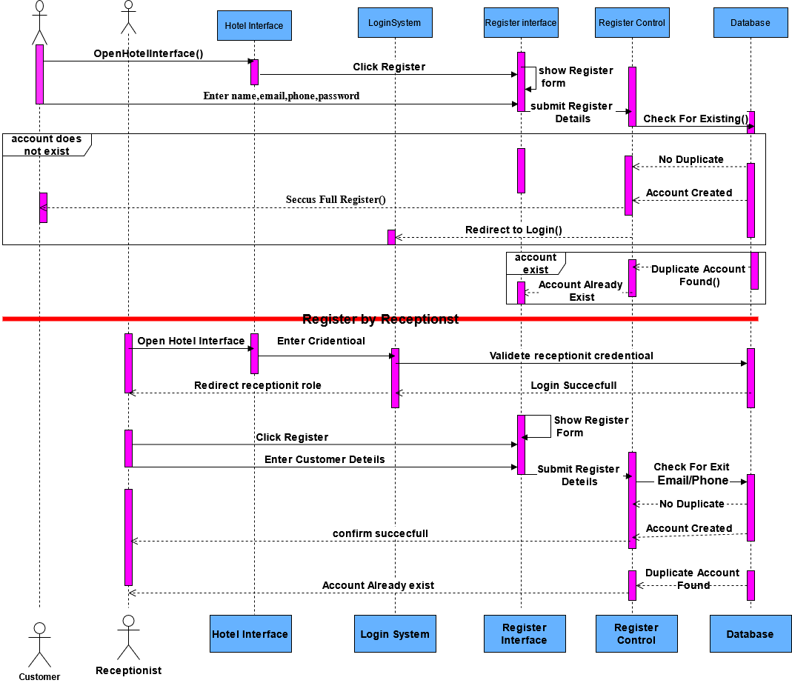
Figure 4.2: Register Sequence Diagram

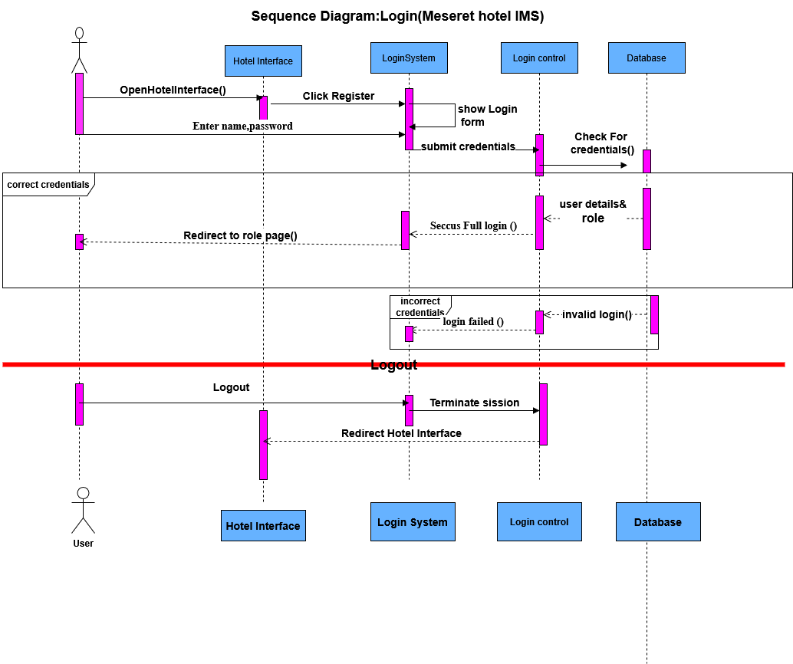
Figure 4.3:Login Sequence Diagram
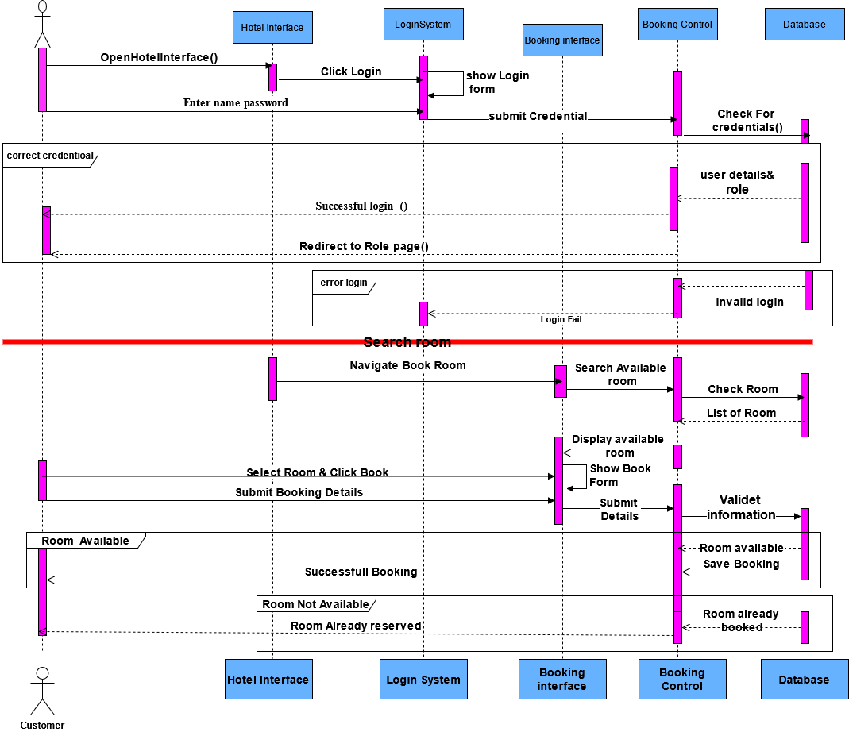
Figure 4.4: Booking Sequence diagram
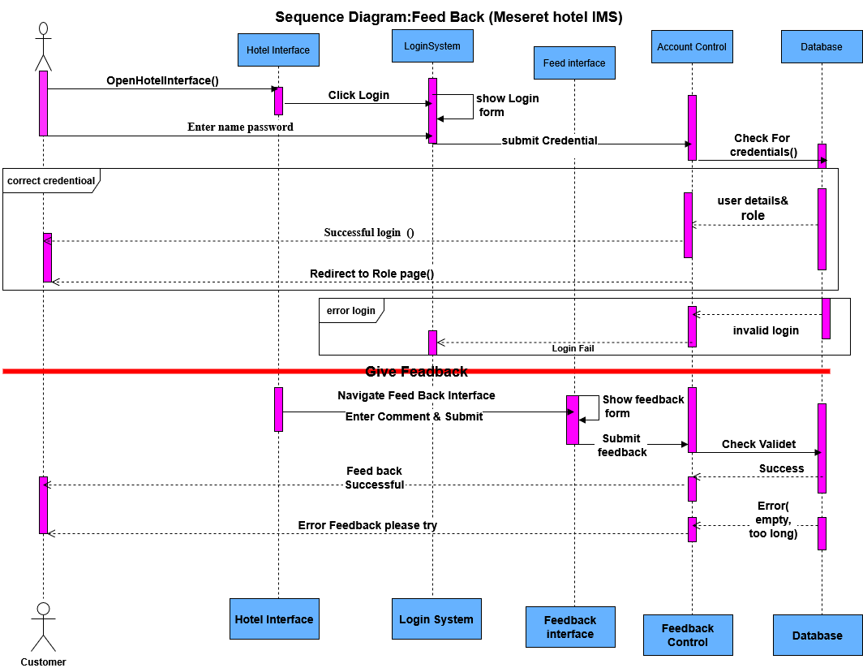
Figure 4.5: Feed back Sequence diagram
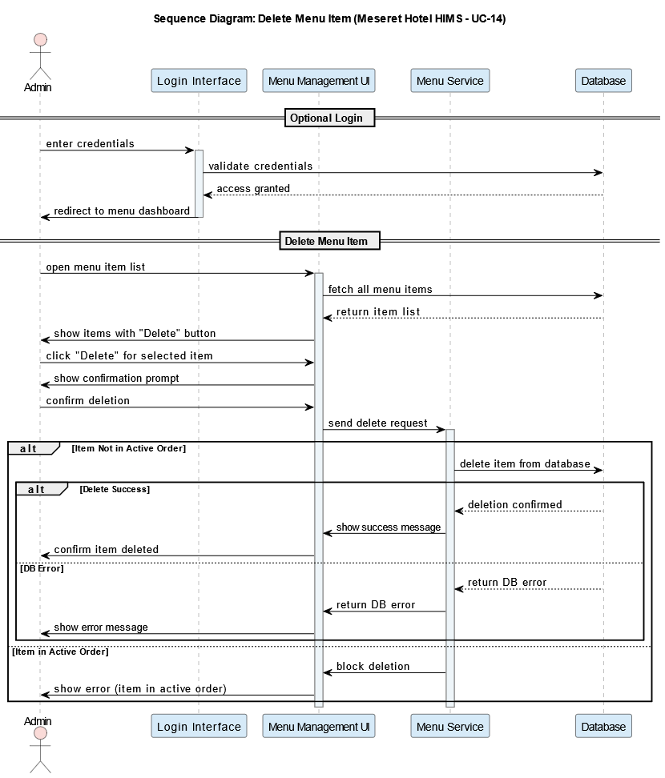
Figure 4.6: Delete Sequence Diagram

Activity Diagram
The Activity Diagram models the workflow of operations within the Hotel Information Management System. It provides a graphical representation of how various activities are performed, how control flows between them, and how users interact with the system. Each diagram corresponds to a specific use case or business process.
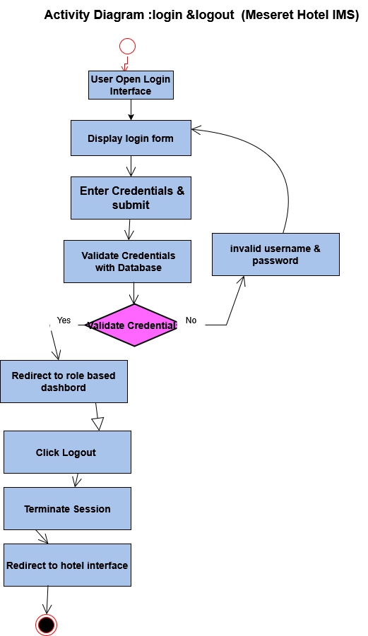
Figure 4.7: Login & logout Activity diagram

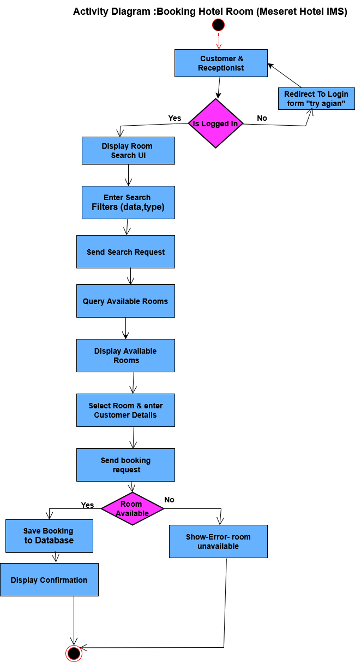
Figure 4.8: Active Diagram booking room
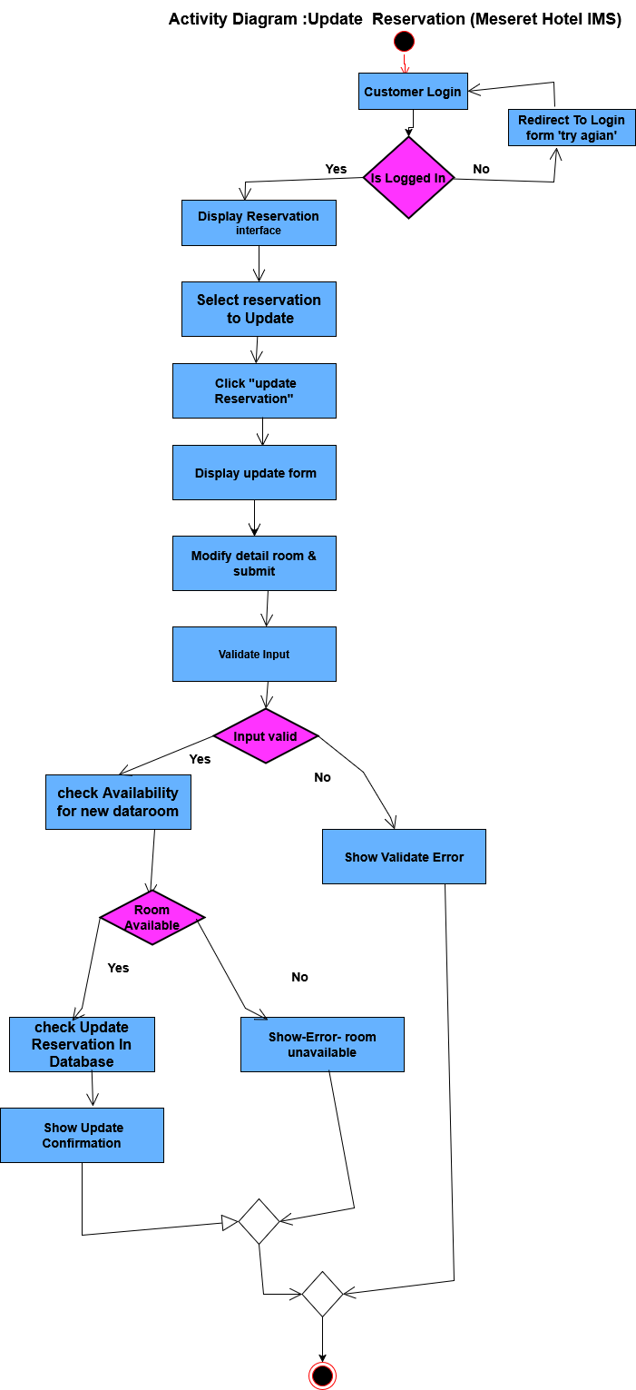
Figure 4.9: Update Reservation Activity Diagram
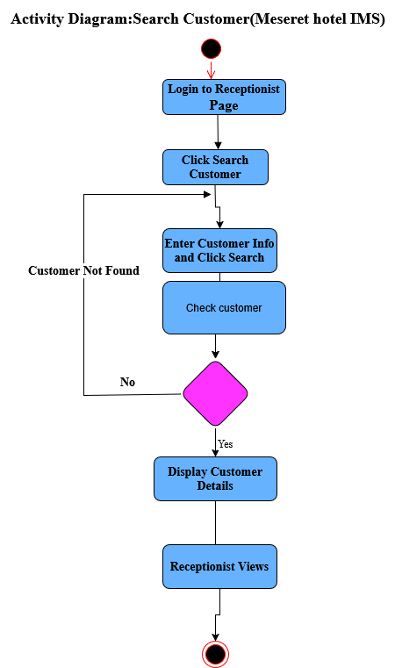
Figure 4.10: Search Customer Activity Diagram

State Chart Diagram
The State Chart Diagram describes the dynamic behavior of an object in response to external stimuli. It shows the life cycle of an object, detailing the transitions it undergoes in response to events. In the context of the Hotel Information Management System, we model the Room Reservation, Cancel Reservation, Update Reservation, Customer Comment`s, Login/Logout, Payroll Authorization object since it undergoes several states during its lifecycle.

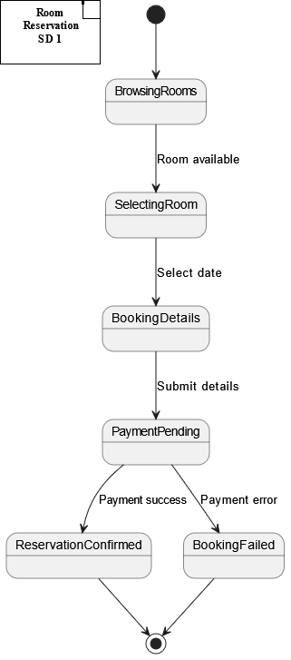
Figure 4.11: Room Reservation State Chart Diagram

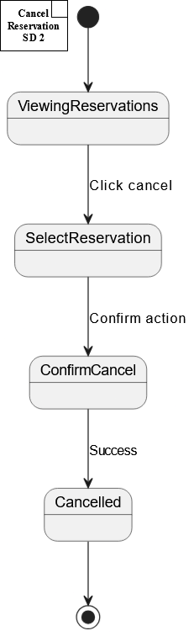
Figure 4.12: Cancel Reservation State Chart Diagram

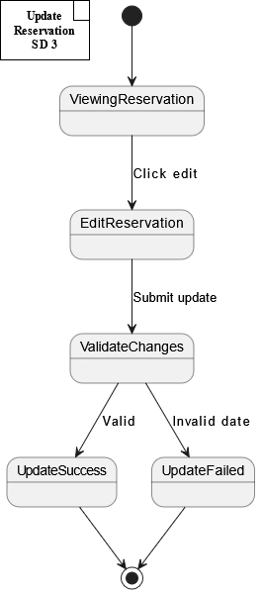
Figure 4.13: Update Reservation State Chart Diagram

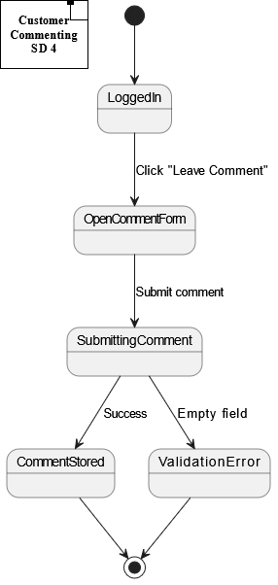
Figure 4.14: Customer Comment State Chart Diagram

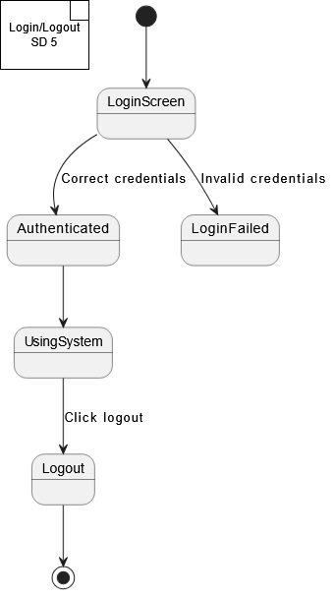
Figure 4.15: Login/Logout State Chart Diagram
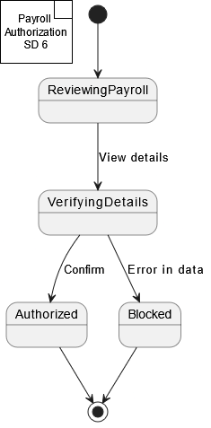
Figure 4.16: Payroll Authorization State Chart Diagram

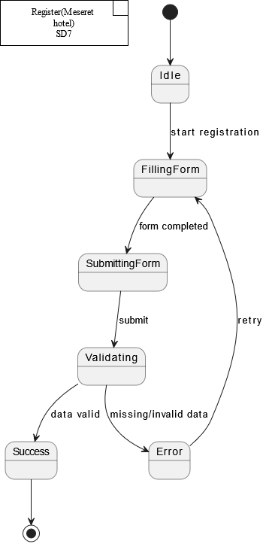
Figure 4.17: register state chart

Object Model

Class Diagram
The class diagram provides a static view of the system — it models the structure of the system by showing the system’s classes, their attributes, methods (operations), and relationships.
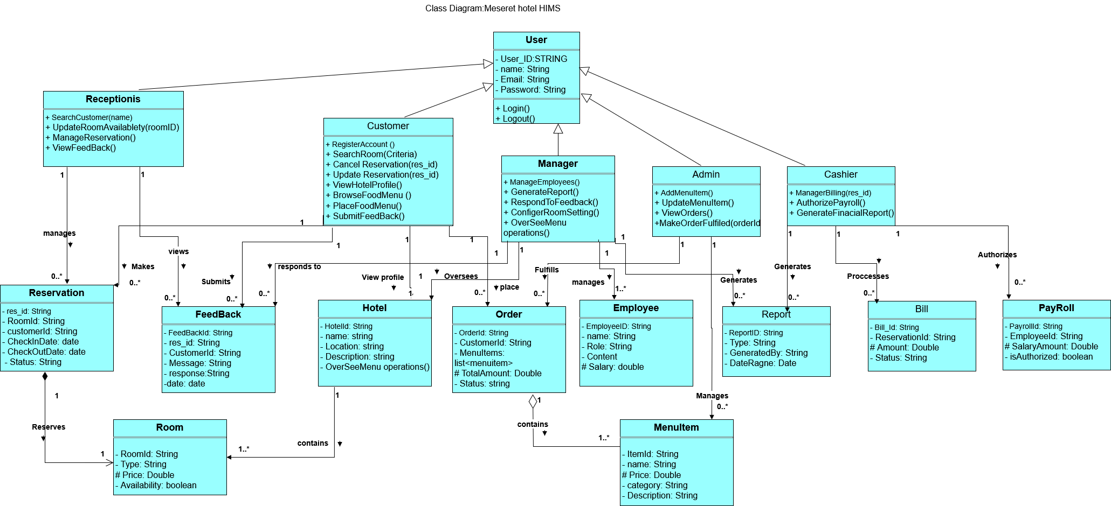
Figure 4.18: Class Diagram

Database Specification

E-R Diagrams
The Entity-Relationship (E-R) Diagram models the logical structure of the hotel database. It captures all essential entities, their attributes, and the relationships between them. This helps ensure data is organized efficiently and supports all the system's functionality, such as reservations, user roles, employee management, payroll, and comments.

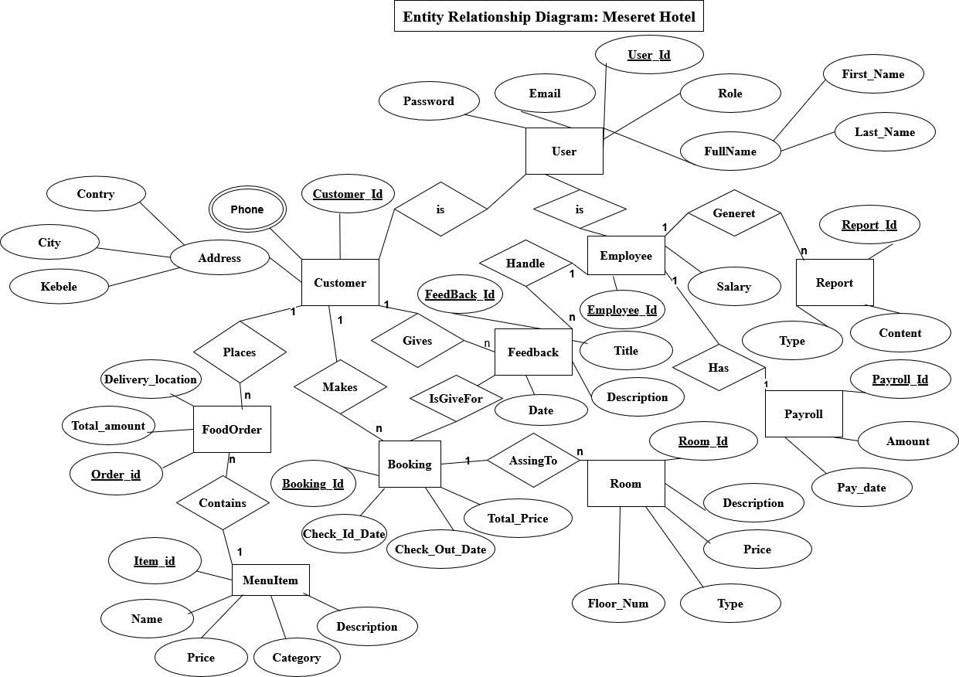
Figure 4.19: E-R Diagram

Reference
[1] M. Nandiraju, S. Rachana, S. Chandini, S. Srilatha, and S. Nazneen, “Hotel management system,” no. 03, pp. 707–723, 2020.
[2] “(M.Tech-SE),” 2020.
[3] “React – A JavaScript library for building user interfaces.”
[4] E. Documentation, “Express - Node,” 2023.
[5] “Resources _ MongoDB.”
[6] Tailwind Labs Inc., “Tailwind CSS - Rapidly build modern websites without ever leaving your HTML.,” 2022. [Online]. Available: https://tailwindcss.com/
[7] PlantUML, “Open-source tool that uses simple textual descriptions to draw beautiful UML diagrams.,” 2024. [Online]. Available: https://plantuml.com/
[8] G. Booch, J. Rumbaugh, and I. Jacobson, Unified Modeling Language User Guide , The ( 2nd Edition ) ( Addison-Wesley Object Technology Series ) Unified Modeling Language User Guide , The Unified Modeling Language User Guide , The Many of the designations used by manufacturers and sellers to dist, vol. 2nd, no. August. 2015.

Appendixes
Appendix A: Manual Room reservation (Data Gathering Phase)
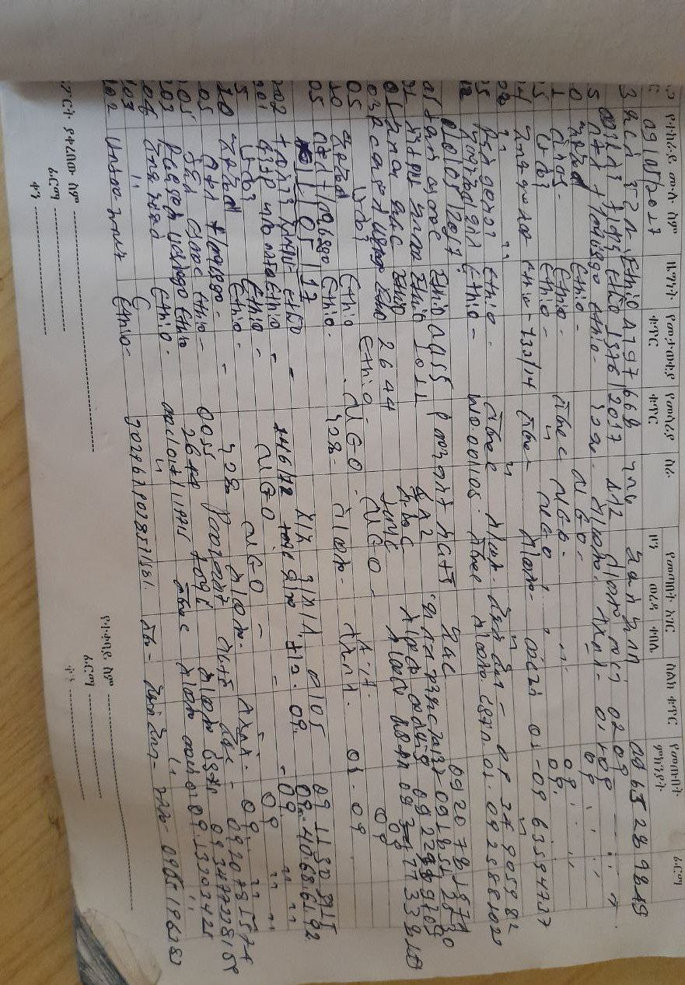
Figure 0.1:Manual Room reservation
Appendix B: Hardware and Software Used
- Hardware:
  - PC (2 units, Intel i5, 8GB RAM, 512GB SSD)and latest
  - Flash Drive (1 unit, 8GB)
- Software:
  - Visual Studio Code
  - Node.js
  - React.js
  - MongoDB
  - Postman (API Testing)
  - Git (Version Control)
Appendix C: System Testing Results
- Unit Testing:
  - All modules (Booking, Login, Comments) passed individual tests using Jest.
- Integration Testing:
  - Successful data flow between Frontend (React) and Backend (Express.js).
- System Testing:
  - Full functionality confirmed: Booking, Updating, Cancelling reservations.
- User Acceptance Testing (UAT):
  - Feedback from hotel staff was positive; minor UI improvements were applied.

Appendix D: Development Team Roles
No | Team member | ID Number | Role on group | Role on the project work
1 | Amanuel Asmare | Wldu148692 | Coordinator | Implementation
2 | Abiyu Neguses | Wldu14583 | v/coordinator | Testing
3 | Elias Gashaw | Wldu145960 | Secretary | System Analyst
4 | Gudeta Megera | Wldu146266 | Member | Designer
5 | Tsegayenesh Tilahun | Wldu147459 | Member | Designer

Appendix E: Project Budget
Type | Item | Quantity | Price per Item | Total
Hardware | PC | 2 | 35,000 birr | 70,000 birr
Hardware | Flash Drive | 1 | 800 birr | 800 birr
Stationary | Print | 1 | 300 birr | 300 birr
Stationary | Pen | 2 | 25 birr | 50 birr
Stationary | Paper | 20 | 2 birr | 40 birr
Transportation | Transport | 2 | 15 birr | 30 birr
Miscellaneous | Mobile Card | 5 | 10 birr | 50 birr
Total Cost |  |  |  | 71,270 birr

Appendix F: Tools and Libraries
- Next.js (Frontend Framework)
- Tailwind CSS (Styling Framework)
- Express.js (Backend Framework)
- MongoDB (Database)
- Postman (API Testing)
- Git & GitHub (Version Control)
- Heroicons and shadcn/ui (Icons and UI Components)
- Formik and Yup (Form Validation).
Appendix F:Time schedule
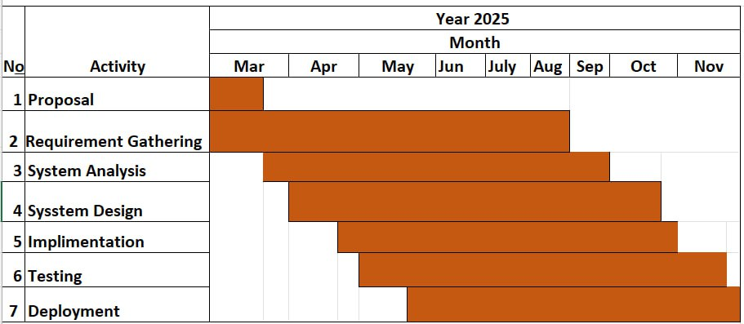
Figure 0.2appendex 1

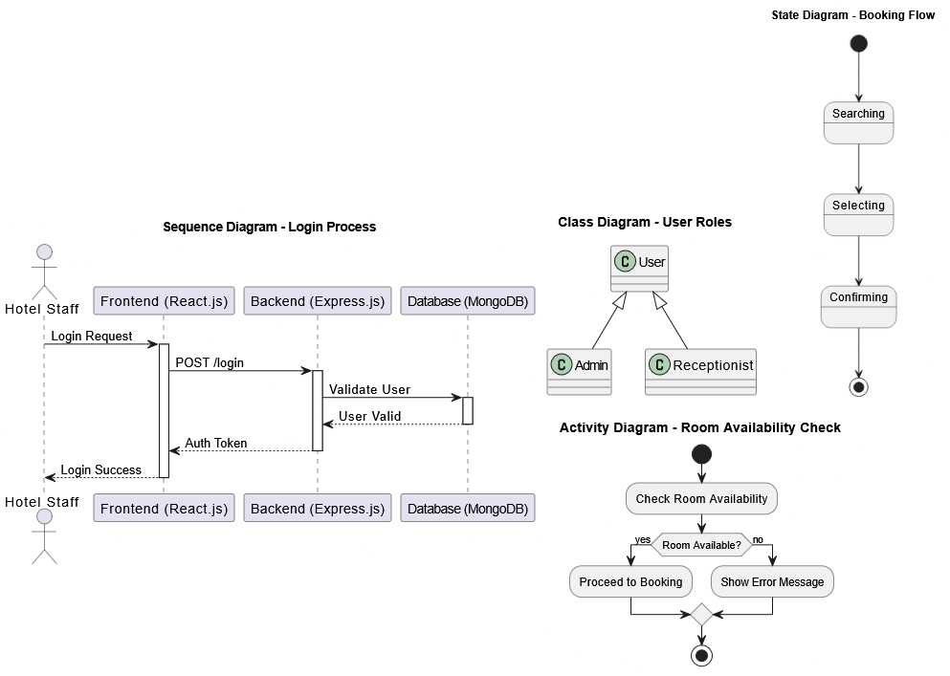
Figure 0.3:appendix 2

