
Addis Ababa Institute of Technology
Center of Information Technology and Scientific Computing
Department of SW Eng.

AI BOT FOR A 2D GAME
Software Requirements Specification

Team Members
Amanuel Genene
Fasil Haymanot
Gerizan Tibebe
Henok Edmealem
Kidus Paulos
Sibhat Teshome

Advisor: Mr. Fitsum Alemu

April 2018
Revision History

Date | Description | Author | Comments
April, 4 2018 | Version 1.0 | Group Members | Initial Draft
April, 18 2018 | Version 2.0 | Group Members | Use cases, Functional requirements were added
May, 4 2018 | Version 3.0 | Group Members | Use case correction, add key binding interface and some grammar corrections

Document Approval

The following Software Requirements Specification has been accepted and approved by the following:
Signature | Printed Name | Title | Date
 | Mr. Fistum Alemu | Advisor

Table of Contents
Document Approval…………………………………………………………………………………………. ii
List of Tables…………………………………………………………………………………………………... v
List of Figures…………………………………………………………………………………………………. v
DECLARATION………………………………………………………………………………………………… vii
1. Introduction…………………………………………………………………………………………………. 1
1.1 Purpose………………………………………………………………………………………………………… 1
1.2 Scope…………………………………………………………………………………………………………… 1
1.3 Overview……………………………………………………………………………………………………… 1
2. General Description……………………………………………………………………………………… 2
2.1 Product Perspective………………………………………………………………………………………… 2
2.2 Product Functions…………………………………………………………………………………………… 2
2.3 User Characteristics………………………………………………………………………………………... 3
2.4 General Constraints………………………………………………………………………………………... 3
3. Specific Requirements…………………………………………………………………………………… 4
3.1 External Interface Requirements………………………………………………………………………… 4
3.1.1 User Interfaces……………………………………………………………………………………………. 4
3.1.2 Hardware Interfaces……………………………………………………………………………………… 9
3.1.3 Software Interfaces……………………………………………………………………………………….. 9
3.1.4 Communications Interfaces………………………………………………………………………………. 9
3.2 Functional Requirements…………………………………………………………………………………... 10
3.2.1 FR-01 Play Game………………………………………………………………………………………... 10
3.2.2 FR-02 Change Settings…………………………………………………………………………………... 10
3.2.3 FR-03 Exit Game………………………………………………………………………………………… 10
3.2.4 FR-04 Movement………………………………………………………………………………………… 11
3.2.5 FR-05 Jumping…………………………………………………………………………………………... 11
3.2.6 FR-06 Attack and maneuver……………………………………………………………………………... 11
3.2.7 FR-07 Pause Game……………………………………………………………………………………… 12
3.2.8 FR-08 Predict Move……………………………………………………………………………………... 12
3.3 Use Cases…………………………………………………………………………………………………….. 13
3.3.1 Use Case #1……………………………………………………………………………………………… 13
3.3.2 Use Case #2……………………………………………………………………………………………… 14
3.3.3 Use Case #3……………………………………………………………………………………………… 14
3.3.4 Use Case #4……………………………………………………………………………………………… 15
3.3.5 Use Case #5……………………………………………………………………………………………… 15
3.3.6 Use Case #6……………………………………………………………………………………………… 16
3.3.7 Use Case #7……………………………………………………………………………………………… 17
3.4 Non-Functional Requirements…………………………………………………………………………… 17
3.4.1 Performance……………………………………………………………………………………………... 17
3.4.2 Reliability………………………………………………………………………………………………... 18
3.4.5 Maintainability…………………………………………………………………………………………... 18
3.4.6 Portability………………………………………………………………………………………………... 18
3.5 Inverse Requirements……………………………………………………………………………………… 18
3.6 Design Constraints………………………………………………………………………………………… 18
3.7 Logical Database Requirements…………………………………………………………………………. 18
3.8 Other Requirements………………………………………………………………………………………... 18
4. Change Management Process……………………………………………………………………….. 19
References……………………………………………………………………………………………………… 20

List of Tables
Table 1: FR-01 10
Table 2: FR-02 10
Table 3: FR-03 10
Table 4: FR-04 11
Table 5: FR-05 11
Table 6: FR-06 11
Table 7: FR-07 12
Table 8: FR-08 12

List of Figures
Figure 1: Title page 4
Figure 2: Settings page 5
Figure 3: Audio settings page 6
Figure 4: Difficulty settings page 7
Figure 5: Pause game page 8
Figure 6: Change key bindings 9

Definitions, Acronyms, and Abbreviations

FPS: First person shooter games.
Noob: A novice player (in gamer terms).
NPC: Non-player components that exist in a game.
Platformer: a computer game in which the player controls a character who jumps and climbs between platforms at different positions on the screen.
SRS: Software Requirement Specification, a documentation holding descriptions on the system to be developed.

DECLARATION
We declare that this written submission represents our ideas in our own words and where others’ ideas or words have been included. We have adequately cited and referenced the original sources. We also declare that we have adhered to all principles of academic honesty and integrity and have not misrepresented or fabricated or falsified any idea/data/fact/source in our submission. We understand that any violation of the above will be cause for disciplinary action by the Institute and can also evoke penal action from the sources which have thus not been properly cited or from whom proper permission has not been taken when needed.
Group 7: April 2018

1. Introduction

1.1 Purpose
The intent of this document is to notify the reader about the requirements needed to address in order to accomplish this project. By thoroughly explaining, one can create a comforting state of mind, which induces clarity.
This Document is directed towards various bodies who would want to know and also who have the resources to scale it to a higher and broader level. People that would like to get an insight about the system can get a short description so that they can think of the infinite possibilities to where this system can build up to.

1.2 Scope
The system is developed for gamers but anyone who can use a computer can use this system, the game is 2d platformer. The game will feature a single level with an AI incorporated to it.
The game will have features like:
- Setting to change audio mode,
- setting to change key bindings,
- setting to change difficulty level,
- welcome screen,
- pause capabilities and
- a dedicated exit method.

1.3 Overview
The remainder of this document includes three sections, references and appendixes. The first part provides an overview of the general description. This section includes Product Perspective, Product Functions, User Characteristics and General Constraints.
The second section provides the requirements specification in detailed terms this includes external interface requirements, use cases, non-functional requirements, inverse requirements, design constraints, logical database requirements and other sub-sections are discussed. It is mainly written for the developers and describes in technical terms the details of the functionality of the project.
The third and the last part presents the change management process which defines the set of activities that need to be performed when there are some new requirements.
Readers can find References and Appendices at the end of the document.

2. General Description

2.1 Product Perspective
There are some games like this one that have implemented a somewhat smart non-player components (NPCs). To point out some of them: -
PAC-MAN is the most infamous example; it is a 2D game with 4 NPCs. All 4 bots have their own colors and patterns of movement. They get more aggressive as the game proceeds further and they change their patterns and become hard to predict. This game is now ported to almost all platforms including android and iOS.
There is also a primitive AI bot made for checkers, it was written by Christopher Strachey in 1951. It eventually achieved sufficient skill to challenge respectable amateurs.
The concept of emergent AI has recently been explored in games such as Creatures, Black & White and Nintendogs and toys such as Tamagotchi. The "pets" in these games are able to "learn" from actions taken by the player and their behavior is modified accordingly. While these choices are taken from a limited pool, it does often give the desired illusion of an intelligence on the other side of the screen.
Far cry 2 is a first-person shooter (FPS) where the player fights off numerous mercenaries and assassinates faction leaders. The AI is behavior based and uses action selection, essential if an AI is to multitask or react to a situation. The AI can react in an unpredictable fashion in many situations. The enemies respond to sounds and visual distractions such as fire or nearby explosions and can be subject to investigate the hazard, the player can utilize these distractions to his own advantage. There are also social interfaces with an AI but however not in the form of direct conversation but more reactionary, if the player gets too close or even nudges an AI, the player is subject to getting shoved off or sworn at and by extent getting aimed at. Other social interfaces between AI exist when in combat, or neutral situations, if an enemy AI is injured on the ground, he will shout out for help, release emotional distress, etc.
The major thing that differentiates the games stated above from this system is that they are all products of western companies. There is also the fact that the AIs work only for their genre and cannot work for any other game. This project intends to make an AI bot that takes advantage of all the mechanics available to it.

2.2 Product Functions
The main use of this AI bot will directly be aimed at enhancing the skills of the player. As we all know everyone have their own way on how to tackle problems. Nonetheless, the approach is as wide, creative and precise as the person’s horizon is. In order to say which is better than the other by how decisive, good or effective; the final outcome at the end of the situation is an important factor to determine the answer to the question.
The AI bot works in a simple manner such that is quiet easy to grasp. What it does is that it constantly learns the moves made by the player accordingly to the pace and way of playing. In addition to this it doesn’t lose the pattern it adopted after one game session rather it updates on the already stored moves that it learned over each gaming session.
Therefore, the functionality of the bot will continue until the player runs out of moves because it’s only then, that it will be there for just tracing the moves that it already has knowledge of rather than aiding the player in enhancing the gaming skills or helping the player with confronting the gaming ways, so you have to come up with new moves to beat it.

2.3 User Characteristics
As all humans do gamers as well like to take the easy route towards facing problems and overcome these so called “problems”. In this case which the problem would be the game and the main objective being able to defeat it.
There will be two general types of users for this system; advanced gamers and novice gamers (or noobs). A user of this system is expected to know no more than simple windows commands to operate this game.

2.4 General Constraints
No special constraints have been identified yet. Although, for safety reasons the developers urge the users not to spend more than two hours at a time on the game. The game will not over extend its criticality as an application on the operating system, so system should function normal.
2.5. Assumptions and Dependencies
No special assumptions or dependencies have been identified.

3. Specific Requirements

3.1 External Interface Requirements

3.1.1 User Interfaces
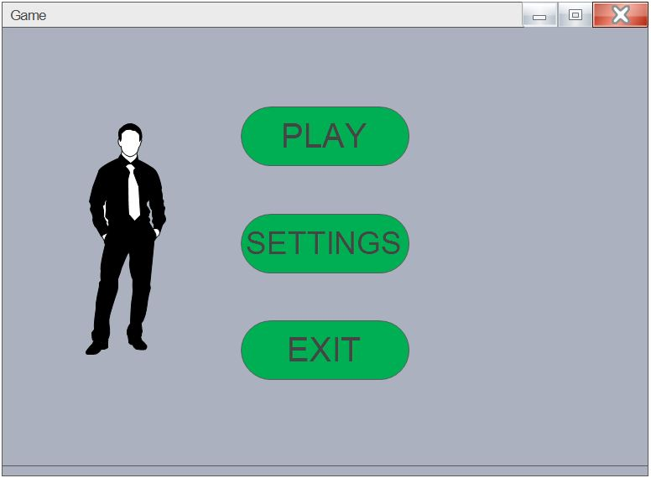
Figure 1: Title page
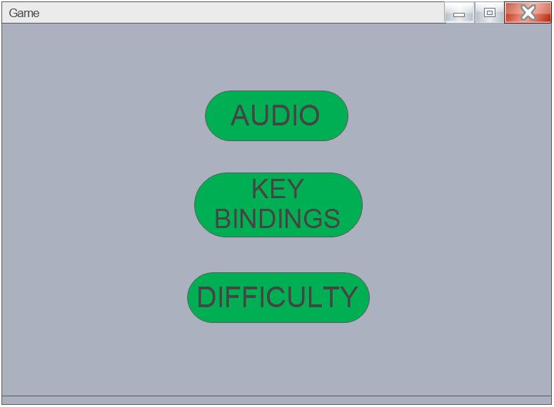
Figure 2: Settings page
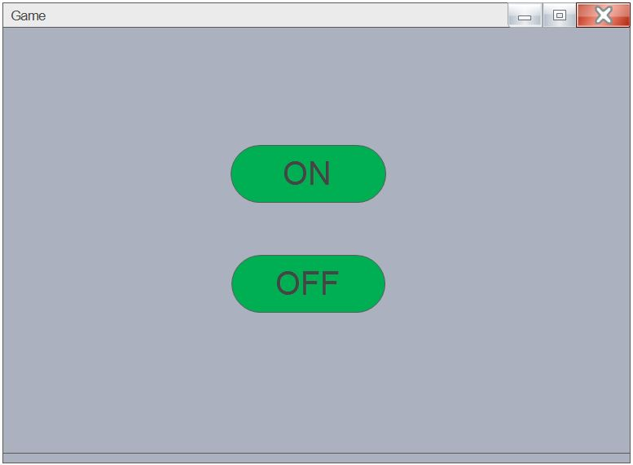
Figure 3: Audio settings page
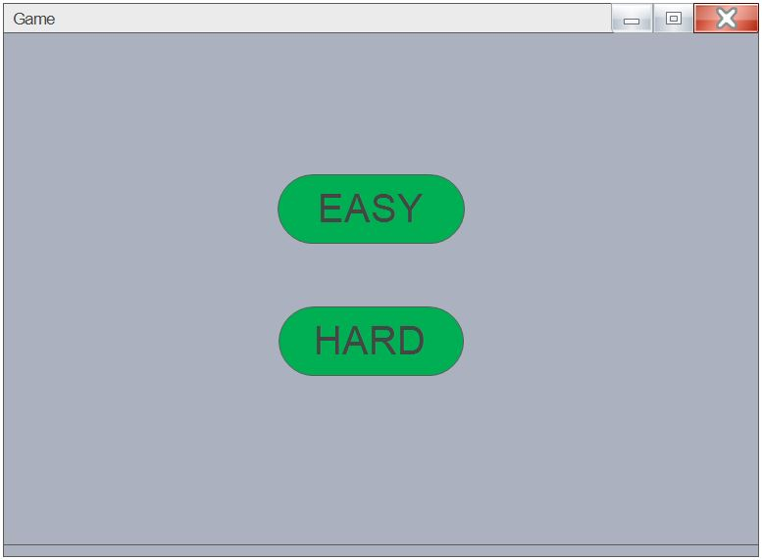
Figure 4: Difficulty settings page
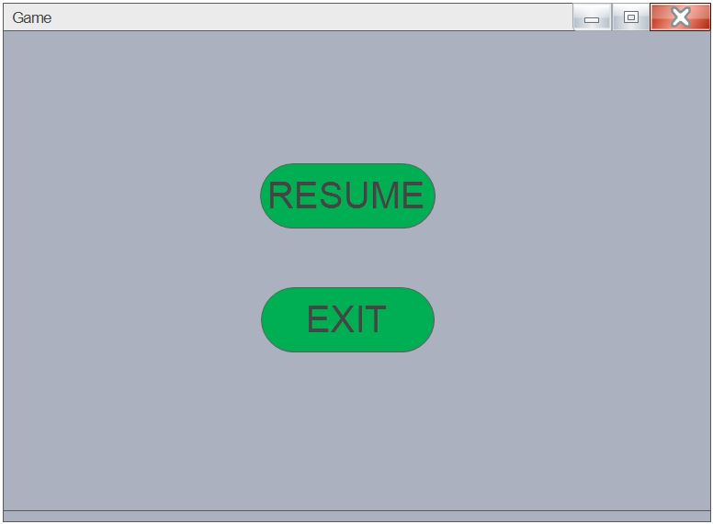
Figure 5: Pause game page
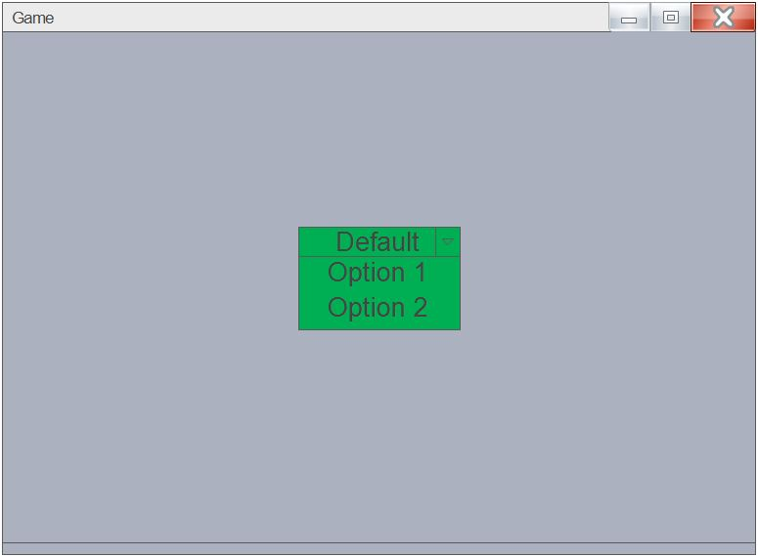
Figure 6: Change key bindings

3.1.2 Hardware Interfaces
The system has no hardware interface requirements.

3.1.3 Software Interfaces
The system shall be capable of running on any version of Windows system, the system shall make use of the operating system calls to the file management system to store and retrieve game states. Therefore, the operating system ought to use a standard windows directory system. If this requirement is existing there will be no other third party software that needs installing.

3.1.4 Communications Interfaces
There are no communications interface requirements that the developers of this system need to worry about, because all the interactions with the hardware is managed by the underlying operating system.

3.2 Functional Requirements

3.2.1 FR-01 Play Game
Table 1: FR-01
NAME | FR-01 play game
INTRODUCTION | The system shall allow user to play.
INPUT | Input will be from the user click.
DESCRIPTION | The system shall prompt the user with a page containing a play option to proceed onto playing the main game.
OUTPUT | The system shall prompt the user with a new page on which one can access all the game sprites, game mechanics and be able to play using the allocated input devices.
ERROR HANDLING | Clicking outside the play option results no error.

3.2.2 FR-02 Change Settings
Table 2: FR-02
NAME | FR-02 change settings
INTRODUCTION | The system shall allow user to change settings.
INPUT | Input will be from the user click.
DESCRIPTION | The system shall prompt the user with a page containing a setting option to proceed onto a new setting page.
OUTPUT | The system shall prompt the user with a new page on which one can access the available game settings.
ERROR HANDLING | Clicking outside the setting option results no error.

3.2.3 FR-03 Exit Game
Table 3: FR-03
NAME | FR-03 Exit Game
INTRODUCTION | The system shall allow user to exit the game.
INPUT | Input will be from the user click.
DESCRIPTION | The system shall prompt the user with a page containing an exit option to return to windows.
OUTPUT | The system shall close and the user will be back to one’s window.
ERROR HANDLING | Clicking outside the exit option results no error.

3.2.4 FR-04 Movement
Table 4: FR-04
NAME | FR-04 Movment
INTRODUCTION | User shall be able to move by using the appropriate key bindings.
INPUT | Input will be from the keyboard, a user key press.
DESCRIPTION | Being the primary method of player input, movement maintains the highest game-play priority. This mechanic allows the user to navigate the map horizontally.
OUTPUT | The character moves with a constant speed horizontally if movement is possible.
ERROR HANDLING | Pressing unbounded key won’t result in an error.

3.2.5 FR-05 Jumping
Table 5: FR-05
NAME | FR-05 jumping
INTRODUCTION | User shall be able to jump by using the appropriate key bindings.
INPUT | Input will be from the keyboard, a user key press.
DESCRIPTION | Being the secondary method of player input, jumping maintains the second highest game-play priority. This mechanic allows the user to navigate gaps vertically.
OUTPUT | The character jumps with a constant force vertically if possible.
ERROR HANDLING | Pressing unbounded key won’t result in an error.

3.2.6 FR-06 Attack and maneuver
Table 6: FR-06
NAME | FR-06 Attack and maneuver
INTRODUCTION | User shall be able to attack and maneuver by using the appropriate key bindings.
INPUT | Input will be from the keyboard, a user key press.
DESCRIPTION | This mechanics allow the user to utilize wining moves by either attacking the enemy or by evading fatal attacks. This bring the game from “playable” to “enjoyable”.
OUTPUT | The character attacks an enemy with a certain hit point or dashes away from an attack.
ERROR HANDLING | Pressing unbounded key won’t result in an error.

3.2.7 FR-07 Pause Game
Table 7: FR-07
NAME | FR-07 Pause Game
INTRODUCTION | The system shall allow user to pause the game.
INPUT | Input will be from the keyboard, a user key press.
DESCRIPTION | The system shall give the user a hotkey (for example the Esc key) to automatically pause an already running game session.
OUTPUT | The system shall prompt the user with a new page on which one can choose to resume or exit the game. Note, resume can be called with the same hotkey that is used to pause.
ERROR HANDLING | Pressing unbounded key won’t result in an error.

3.2.8 FR-08 Predict Move
Table 8: FR-08
NAME | FR-08 Predict Move
INTRODUCTION | The system shall allow user to be challenged with a worthy opponent.
INPUT | Input will be from previous sessions with test groups
DESCRIPTION | The system shall learn from user gameplay sessions. The Artificial intelligence (AI) of this system will try to learn user moves and store it as a data to overcome upcoming confrontations of similar tactics.
OUTPUT | The system shall present the user with more human like opponent that adapts to its moves.
ERROR HANDLING | The system shall not encounter any errors for the task at hand.

3.3 Use Cases
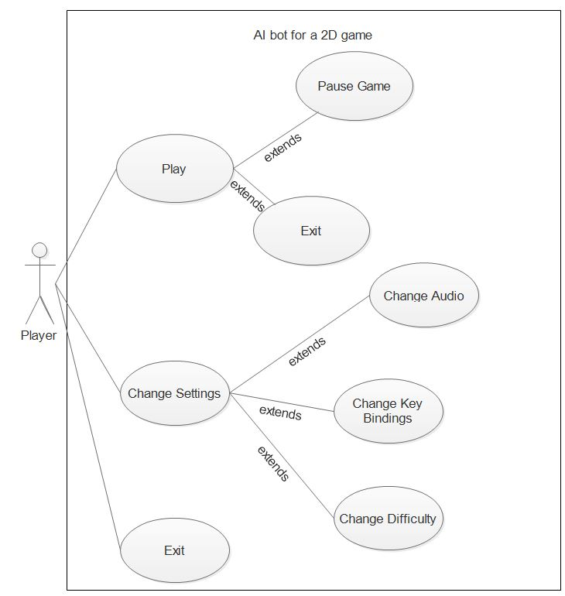

3.3.1 Use Case #1
Use Case: Play Game.
Goal: The user wants to play the game.
Primary Actor: Player.
Scope: AI bot for a 2D game.
Level: User.
Precondition: None.
Post condition: The game starts.
Failure: None.
Trigger: The user launches the game.
Main Success Scenario
- Player clicks on the play option from the title screen.
- The system takes the player to the game play screen.
Extension
None.

3.3.2 Use Case #2
Use Case: Pause the game.
Goal: The user wants to pause the game.
Primary Actor: Player.
Scope: AI bot for a 2D game.
Level: User.
Precondition: None.
Post condition: The gameplay and drawing should be paused, FPS should be decreased to 1 or 0.
Failure: None.
Trigger: The user is playing the game.
Main Success Scenario
- Player clicks on the play option from the title screen.
- The system takes the player to the game play screen.
- The player presses the pause hotkey.
- The system pauses the drawing of graphics.
Extension
None.

3.3.3 Use Case #3
Use Case: Exit the game.
Goal: The user wants to Exit the game.
Primary Actor: Player.
Scope: AI bot for a 2D game.
Level: User.
Precondition: None.
Post condition: The game process is killed.
Failure: None.
Trigger: The user is playing the game.
Main Success Scenario
- The player pauses the game.
- The system takes the player to the pause screen.
- The player clicks the exit option.
- The system terminates.
Extension
None.
Alternative
- The player clicks the exit option from the title screen.

3.3.4 Use Case #4
Use Case: Change settings.
Goal: The user wants to access the settings of the game.
Primary Actor: Player.
Scope: AI bot for a 2D game.
Level: User.
Precondition: None.
Post condition: The player gets into the settings area.
Failure: None.
Trigger: The user is in the game.
Main Success Scenario
- The player clicks on the settings option from the title screen.
- The system takes the user to the settings screen.
Extension
None.

3.3.5 Use Case #5
Use Case: Change Audio.
Goal: The user wants to change audio mode.
Primary Actor: Player.
Scope: AI bot for a 2D game.
Level: User.
Precondition: None.
Post condition: The audio during the gameplay is changed.
Failure: None.
Trigger: The user is in the game.
Main Success Scenario
- The player clicks on the settings option from the title screen.
- The system takes the user to the settings screen.
- The player clicks on the audio option from the settings screen.
- The system takes the player to the audio screen.
- The player clicks on the audio off option.
- The system turns the audio off.
Extension
None.
Alternative
5a. The player clicks on the audio on option.
5a.1 The system turns the audio on.

3.3.6 Use Case #6
Use Case: Change Difficulty.
Goal: The user wants to change the game difficulty.
Primary Actor: player.
Scope: AI bot for a 2D game.
Level: User.
Precondition: None.
Post condition: The gameplay difficulty is changed.
Failure: None.
Trigger: The user is in the game.
Main Success Scenario
- The player clicks on the settings option from the title screen.
- The system takes the user to the settings screen.
- The player clicks the difficulty option from the settings screen.
- The system takes the user to the difficulty screen.
- The player clicks the hard difficulty option.
- The system changes the game difficulty to hard.
Extension
None.
Alternative
5a. The player clicks on the easy difficulty option.
5a.1 The system changes the game difficulty to easy.

3.3.7 Use Case #7
Use Case: Change key bindings.
Goal: The user wants to change key bindings.
Primary Actor: Player.
Scope: AI bot for a 2D game.
Level: User.
Precondition: None.
Post condition: The key bindings during the gameplay are changed.
Failure: Nine.
Trigger: The user is in the game.
Main Success Scenario
- The player clicks on the settings option from the title screen.
- The system takes the user to the settings screen.
- The player clicks the key bindings option from the settings screen.
- The system takes the user to the key bindings screen.
- The player chooses a different key binding.
- The system changes the game key bindings.
Extension
None.

3.4 Non-Functional Requirements

3.4.1 Performance
The system should work smoothly on almost any windows computer at standard 60 frames per second (60fps). The response time of the system to user input should be almost lossless meaning in mille-seconds.
The functionalities of the game will be simplistic enough, but not trivial, and the graphics will not be overly detailed so the system does not become slowed down.

3.4.2 Reliability
The system should not crash or lag, unless the external system (the operating system) is under load. All technical issues and user input errors shall be addressed by the system without bugging the user.

3.4.5 Maintainability
All code shall be fully documented. Each function shall be commented with pre- and post-conditions. All program files shall include comments concerning authorship and date of last change.
The code should be modular, to permit future modifications. Anticipated updates include changes to the sets of objects and their descriptions used during the game. These should be stored in a separate data file, rather than embedded in the program code.

3.4.6 Portability
The system should be portable to any computer with windows OS.

3.5 Inverse Requirements
The system does not have a complete story mode full of different levels rather a single level of combat. The AI bot of the game is specifically meant for this one only and will not work on any other gaming environments unless tailored to fit.

3.6 Design Constraints
The system is going to be constrained by limitation of resources, therefore some in game mechanics will be compromised by the developer to make up for some short comings. For example, the game will not utilize a pixel perfect collision detection as this is very costly on the CPU, so we will use a rectangle or circle detection to be more efficient and this won’t make much difference because our game is 2D.
The system will also be constrained by the copyright rule, meaning the developers have to use free to use sprites. This will make the game visually mediocre, paid artists make a better art work compared to freelancers.

3.7 Logical Database Requirements
The system will use a simple text file to store all the game data and patterns on the hard drive.

3.8 Other Requirements
No specific training should be necessary for a user to begin playing the game. The game should give the user a brief guide for how to play when invoked. Players should not be required to learn a list of commands before commencing play.
The system should be packaged along with source code and all documentation, and be available for electronic transfer as a single executable file.
The project is going to be open source for any enthusiast that wants to learn from the project and the source code will public for everyone, though the developers wish to be credited for their work if one uses resources from this game.

4. Change Management Process
When there is a need for a change of the project’s AI BOT system platform scope and requirement, the change will be seen by the Project team by the management plan that we made, and if the change is approved or agreed by the Project team to have a Good effect on the scope and requirement, the change will be approved by the Project members that could affect the scope and the requirement in a good way otherwise it won’t be done.
And when the change of requirement is asked from the systems user, the user should discourse their need to the Project teams through an Email so that it will be easier to discuss with the Project team and it is also easier to communicate with the client and update them if there is any news on the requirement so that we can control the design and implement.

References
Medium.com; https://medium.com/tag/artificial-intelligence?source=post , On April 16 2018
Cs.utah.edu; http://www.cs.utah.edu/~drcannon/project/padd.html, On April 18 2018

