**Assignment Two**

1-inpute: volume in quarts

processing: L = quarts x 0.946352946

output : volume in liters

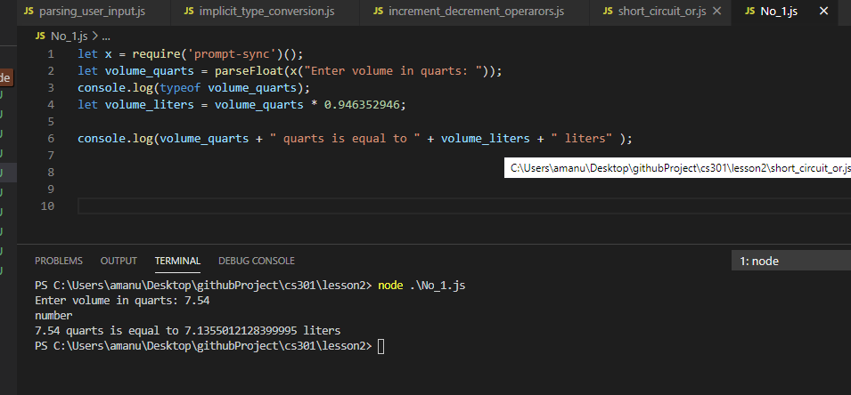

2-inpute: distance in kilometers

processing: miles = kilometers*0.62137119

output: values in miles

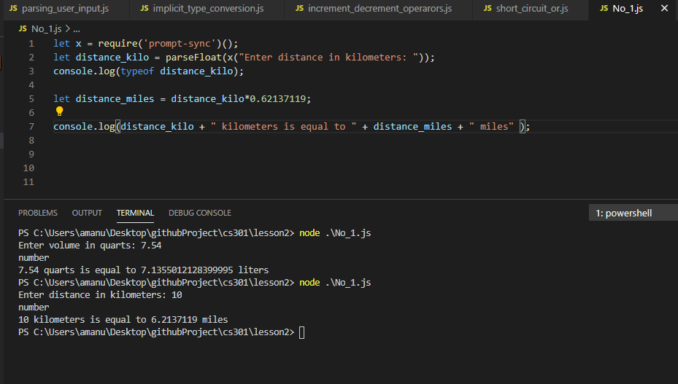

3- input: get total number of boxes

get number of boxes in each stack

processing: Math.ceil(divide total number of boxes by

number of boxes in each stack)

output: number of stacks needed

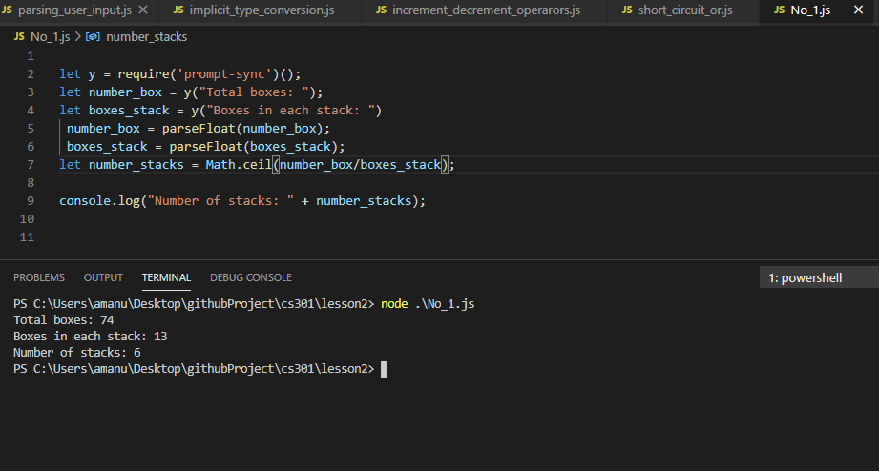

4- Input: number of students

Number of teams

Processing: divide number of students by Number of teams if the remainder is not zero

All teams have the same number of members and some have only one more than the rest

Output: number of team’s number and number of team members

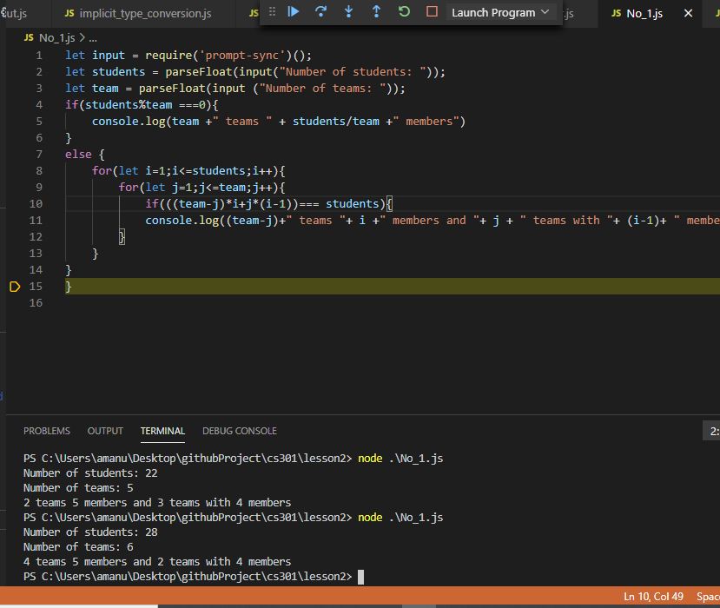

5-input: get the beginning of odometer reading

get the ending of odometer reading

get number of gallons of gasoline used

processing: subtract beginning odometer from

ending and divide the values by number of gallon

output: mileage in miles per gallon

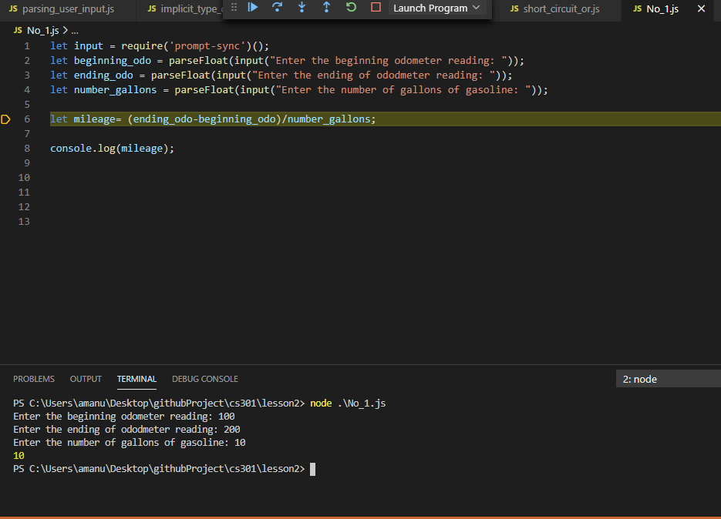

6- input: get person's age

processing: max hear rate per minutes=220-age

slowest = .65*max hear rate per minutes

fastest rate =.85 *max hear rate per minutes

output: the values of slowest and fastest rate

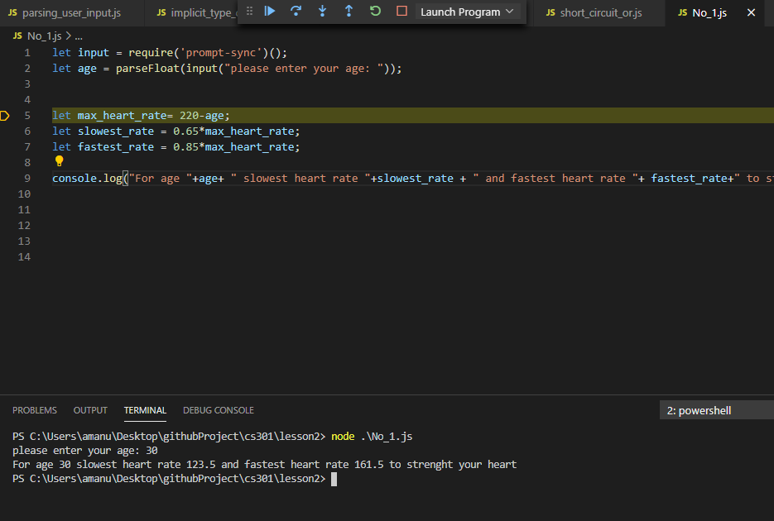

7- input: number of regular hours

employee's wage

processing: gross = multiply regular hours *employee's wage

tax= multiply .15*multiply regular hours *employee's wage

net= subtract the tax values from gross

output: net payment of the employee's

