**AMAN VERMA**

1033A Adarsh Nagar,Fatehpur

E-mail:[*19bcs2888@gmail.com*](mailto:19bcs2888@gmail.com)

Phone: +91 7355100911

LinkedIn: www.linkedin.com/in/aman-verma-aa69641bb

**PROFESSIONAL SUMMARY**

A well-organized, creative and goal-oriented graduate possessing excellent communication,problem-solving and leadership skills with a flair to explore suitable avenues in Computer Science Engineeringwhile developing advanced projects with efficiency and quality.

**TECHNICAL COMPETENCIES**

C | C++ | JAVA | PYTHON

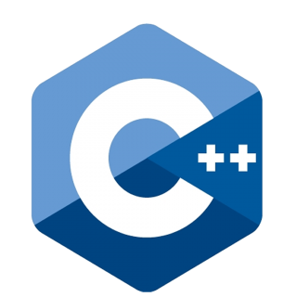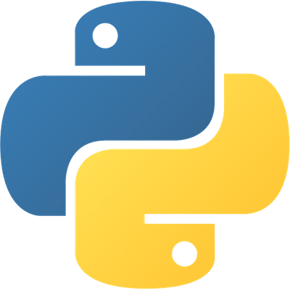

**INTERPERSONAL SKILLS**

Team Leadership **|** Management & Coordination **|** Decision Making

**INTERESTS & HOBBIES**

Programming **|** Software Development **|** Video games **|** Travelling **|** Reading

**LANGUAGES KNOWN**

English **|** Hindi

**PERSONAL DETAILS**

Mother’s Name: Neetu Verma

Father’s Name: Lakhan Kumar

D.O.B.:02-12-2001

**EDUCATION**

Bachelors in Computer Science Engineering | Chandigarh University, Gharuan

*Session: 2019-2023 | Score: 7.45 CGPA*

Intermediate (CBSE) |XYZ Public School, Delhi

*Session: 2018-2019 | Percentage: 67.6%*

Matriculation (CBSE) | XYZ Public School, Delhi

*Session: 2016-2017 | Percentage: 77.9%*

**TRAINING & PROJECTS**

Machine Learning - AZeotropy, IIT Bombay

June 2021 to Present

Training for Artificial Intelligence and Machine Learning Algorithms and projects related to AI/ML.

Training Datasets from Kaggle for detection and prediction of data.

Build a Project of Credit Card Fraud Detection

Extracting,Zipping and Reading ZIP(.zip) files.

May 2021

Designed a Software for extracting, Zippping and reading ZIP(.zip) files using Python and Tkinter. An offline software to run on Windows OS.

**ACADEMIC ACHIEVEMENTS**

* Participated in Science Olympiad 2015.

**CERTIFICATIONS &AWARDS**

Machine Learning - AZeotropy, IIT Bombay

June 2021 to Present

Training for Artificial Intelligence and Machine Learning Algorithms and projects related to AI/ML.

Coursera Introduction to Data Science In Python

April 2022 to Present

Introduction to Data Science In Python from University of Washington.

Android N Developer Course-Udemy

April 2021 to Present

Course on Android Development and building android applications.

**EXTRA CURRICULAR & CO-CURRICULAR ACHIEVEMENTS**

HackerRank 5 star coder at Problem Solving.

