Practical – 6
a: College Information Portal as PWA

AIM : To create a simple website for a College Information Portal and convert it into a Progressive Web Application (PWA) by adding a Service Worker and Web App Manifest.

STEPS
- Create an HTML/CSS website for the College Portal
- Create manifest.json with app metadata
- Create service-worker.js to cache assets
- Register the service worker in index.html

Index.html
<!DOCTYflE html>
<html lang="en">

<head>
<meta charset="UTF-8">

<meta name="viewport"
content="width=device-width, initial-scale=1.0">
<title>ABC College</title>

<!-- Connect CSS -->
<link rel="stylesheet" href="style.css">

<!-- Connect flWA Manifest -->
<link rel="manifest" href="manifest.json">

<!-- Browser theme color -->
<meta name="theme-color" content="1F4E79">
</head>

<body>

<header>
<h1>ABC College</h1>
<nav>

<a href="about">About</a>
<a href="courses">Courses</a>
<a href="contact">Contact</a>
</nav>
</header>
<main>

<section id="about">
<h2>About Us</h2>
<p>Excellence in Education since 1990.</p>
</section>
<section id="courses">
<h2>Courses Offered</h2>

<ul>

<li>BSc IT</li>
<li>BSc CS</li>
<li>BCA</li>
<li>MCA</li>

</ul>
</section>

<section id="contact">
<h2>Contact</h2>
<p>Email: info@abccollege.edu</p>
</section>

</main>

<script>

// Register Service Worker
if ('serviceWorker' in navigator) {
navigator.serviceWorker
.register('/service-worker.js')
.then(() => {
console.log("Service Worker Registered");
})

.catch(error => { console.log(
"Service Worker Registration Failed:", error

}
</script>

</body>
</html>
);
});

style.css
body {
font-family: Arial, sans-serif; margin: 0;
background-color: f5f5f5;
}

header {
background-color: 1F4E79; color: white;
padding: 20px;
text-align: center;
}
nav a {
color: white; margin: 15px;
text-decoration: none;
}
main {
width: 80%; margin: auto;
}

section {
background-color: white; margin-top: 20px; padding: 20px;
border-radius: 8px;
}

h2 {
}

color: 1F4E79;

manifest.json

{
"name": "ABC College flortal", "short_name": "ABC College",
"description": "College Information flortal flWA", "start_url": "/",
"display": "standalone", "background_color": "ffffff", "theme_color": "1F4E79", "orientation": "portrait",
"icons": [
{
"src": "/icons/icon-192.png", "sizes": "192x192",
"type": "image/png"
},
{
"src": "/icons/icon-512.png", "sizes": "512x512",
"type": "image/png"

}
]
}

Service-worker.js
const CACE_AME = 'college-portal-v1';
const ASSETS = [ '/',
'/index.html', '/style.css', '/manifest.json', '/icons/icon-192.png', '/icons/icon-512.png'
];

// Install Service Worker self.addEventListener('install', event => {

event.waitUntil( caches.open(CACE_AME)
.then(cache => {

return cache.addAll(ASSETS);
})

);
});

// Fetch files from cache self.addEventListener('fetch', event => {
event.respondWith( caches.match(event.request)
.then(response => {

return response || fetch(event.request);

})
);

});

Program.cs
var builder = WebApplication.CreateBuilder(args); var app = builder.Build();

app.UseDefaultFiles(); app.UseStaticFiles(); app.Run();

Output:

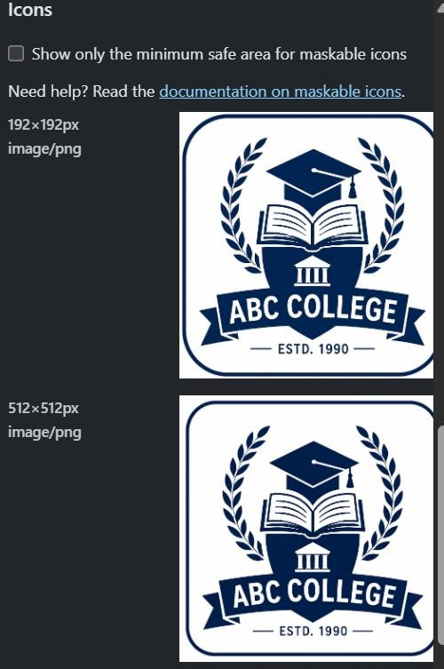
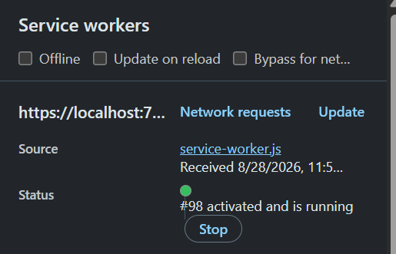

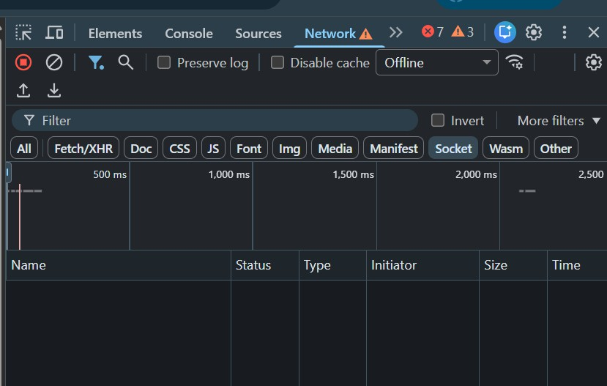

Practical-6B
AIM: To create a Progressive Web Application (PWA) that displays a custom offline page when the user is not connected to the internet.

Step 1: Create a project in Visual Studio
Open Visual Studio → click Create a new project. Choose:

ASP.NET Core Empty
Then click Next.
Give the project a name such as:
PWAOfflineDemo Click Next.
Choose the current installed .NET version, keep other settings default, and click Create.

Step 2: Click on the wwwroot folder
In Solution Explorer:
Right-click your project → Add → New Folder
wwwroot

├── index.html
├── offline.html
├── style.css
└── service-worker.js

Step 3: Create index.html
Right-click wwwroot → Add → New Item. Select HTML Page and name it:

index.html

<!DOCTYPE html>
<html>

<head>
<title>PWA Offline Demo</title>
<link rel="stylesheet" href="style.css">
</head>

<body>

<div class="box">
<h1>📱 PWA Application</h1>

<p>Welcome to my PWA website.</p>
<p>This page is currently online.</p>
</div>

<script>
if ('serviceWorker' in navigator) {
navigator.serviceWorker.register('/service-worker.js');
}
</script>

</body>

</html>
Step 4: Create offline.html
Right-click wwwroot → Add → New Item → HTML Page.

offline.html
<!DOCTYPE html>
<html>

<head>
<title>You are Offline</title>
<link rel="stylesheet" href="style.css">
</head>

<body>

<div class="box">

<h1>📡</h1>

<h1>You are Offline</h1>

<p>
No internet connection found.
Please check your network settings.
</p>

<p>
Some content may still be available from cache.
</p>

<button onclick="location.reload()">
Try Again
</button>

</div>

</body>

</html>

Step 5: Create style.css
Right-click wwwroot → Add → New Item.

style.css
body {
font-family: Arial, sans-serif;
text-align: center;
background-color: #f2f2f2;
padding-top: 100px;
}

.box {
background: white;
width: 400px;
margin: auto;
padding: 30px;
border-radius: 10px;
}

button {
padding: 10px 20px;
cursor: pointer;
}

Step 7: Configure Program.cs
Open:
Program.cs

var builder = WebApplication.CreateBuilder(args);

var app = builder.Build();

app.UseDefaultFiles();
app.UseStaticFiles();

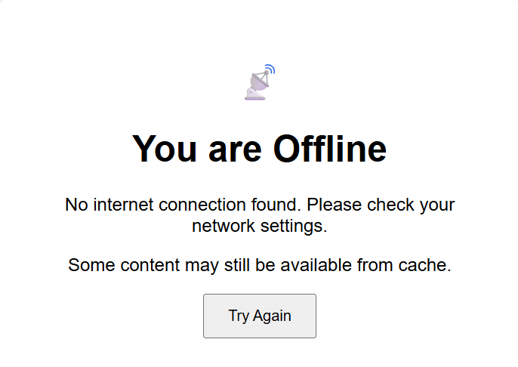
app.Run();

