Practical-8
8a: HTML Page with Link to manifest.json
AIM : To create an HTML page as the starting point of a PWA application and link it to a manifest.json file for app configuration.

Step 1: Create Project in Visual Studio
Open Visual Studio. Choose:
Create a new project → ASP.NET Core Web App(MVC)
Project name:
MyPWA
Click Create.

Index.html
<!DOCTYflE html>
<html>
<head>
<meta charset="UTF-8">
<title>My flWA</title>
<!-- Link manifest file -->
<link rel="manifest" href="manifest.json">
</head>

<body>
<h1>Welcome to My flWA</h1>
<p>This app works online and offline!</p>

<p id="status">Checking connection...</p>

<script>
function checkConnection() { if (navigator.onLine) {
document.getElementById("status").innerTML = "🟢 Online";
} else {
document.getElementById("status").innerTML = "🔴 Offline";
}
}
checkConnection();

window.addEventListener("online", checkConnection); window.addEventListener("offline", checkConnection);
</script>

</body>
</html>

manifest.json
{
"name": "My flrogressive Web App", "short_name": "MyflWA",
"description": "A sample flWA application by Bilal Salmani", "start_url": "/index.html",
"display": "standalone", "background_color": "ffffff", "theme_color": "1F4E79", "lang": "en",
"orientation": "any", "scope": "/"
}

Program.cs
var builder = WebApplication.CreateBuilder(args); builder.Services.AddControllers();
var app = builder.Build(); app.UsettpsRedirection(); app.MapControllers(); app.Run();

Output:
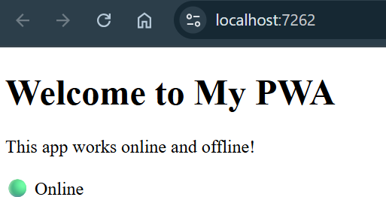

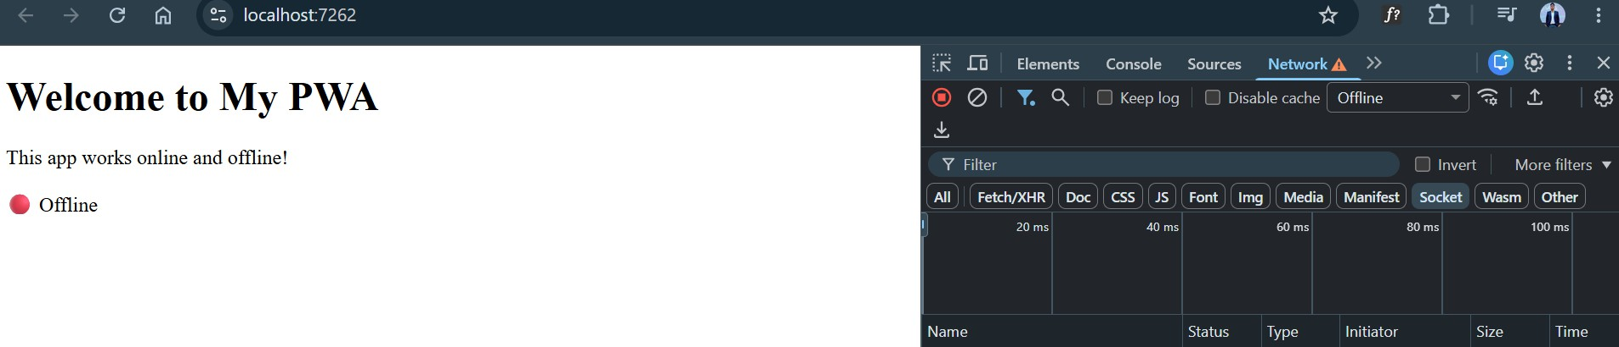

8b AIM : To create a simple ASP.NET Core Web API that returns Student data in JSON format.

Step 1: Create a new project Open Visual Studio Community. Go to:
File → New → Project
In the search box, type:

ASP.NET Core Web API
Select ASP.NET Core Web API and click Next. Set the project name:
StudentAPI
Choose your location and click Next. Click Create.

Step 2: Create the Models folder
Look at Solution Explorer on the right. Right-click:
StudentAPI → Add → New Folder

Name it:
Models
Step 3: Create Student.cs Right-click the Models folder: Add → Class
Enter:
Student.cs Click Add.

Student.cs
namespace StudentAflI.Models
{
public class Student
{
public int Id { get; set; } public string ame { get; set; }
public string Course { get; set; } public int Age { get; set; }
public double flercentage { get; set; }
}
}

Step 4: Create Students Controller
Right-click the Controllers folder. Choose:
Add → Controller
Select:

API Controller - Empty
Click Add. Name it:

StudentsController

StudentsController.cs
using Microsoft.AspetCore.Mvc; using StudentAflI.Models;

namespace StudentAflI.Controllers
{
[ApiController] [Route("api/[controller]")]
public class StudentsController : ControllerBase
{
private static List<Student> students = new List<Student>
{
new Student
{
Id = 1,
ame = "Bilal", Course = "BSc IT", Age = 20,
flercentage = 85.5
},

new Student
{
Id = 2,
ame = "Sana", Course = "BCA", Age = 21,
flercentage = 78.0
},

new Student
{
Id = 3,
ame = "ina", Course = "BSc CS", Age = 19,
flercentage = 91.2
}
};

// GET: api/students [ttpGet]
public ActionResult<IEnumerable<Student>> GetAll()
{
return Ok(students);
}
// GET: api/students/1 [ttpGet("{id}")]
public ActionResult<Student> GetById(int id)
{
var s = students.FirstOrDefault(x => x.Id == id);
if (s == null)
{

return otFound(new { message = "Student not found" });
}

return Ok(s);
}
}
}

Program.cs
var builder = WebApplication.CreateBuilder(args); builder.Services.AddControllers();
var app = builder.Build(); app.UsettpsRedirection(); app.MapControllers(); app.Run();

Output:
Go to Chrome and Open this link: https://localhost:7076/api/students
