CMPE 273

ENTERPRISE DISTRIBUTIVE SYSTEMS

TEAM PROJECT

TEAM 11

AMAN OJHA

ANKIT BHARADIYA

MAULIK BHATT

PALASH HEDAU

PRATEEK SHARMA

Contents

CONTRIBUTION 3

ABOUT THE PROJECT 4

1. Object Management Policy 4

2. Resource Handling 4

3. Policy of writing data into the Database 4

# CONTRIBUTION

1. AMAN OJHA
2. ANKIT BHARADIYA
3. MAULIK BHATT
4. PALASH HEDAU
5. PRATEEK SHARMA

# ABOUT THE PROJECT

## Object Management Policy

## Resource Handling

## Policy of writing data into the Database

# ADMIN APPLICATION

## Admin Section

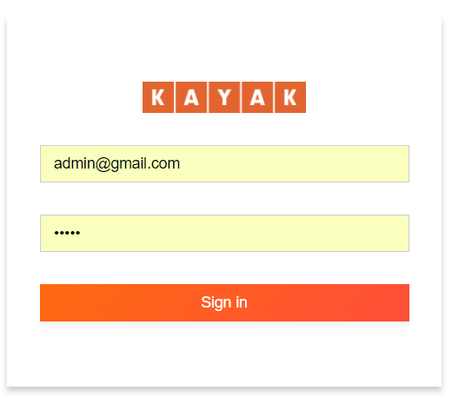

An admin application is made which can be only accessed by the admin credentials. Admin application has all the special privileges of adding, deleting, editing a flight, hotel or car. All the data added by the admin will be stored in MongoDB and will be displayed in the main customer application based on the search results.

A customer will not have any option to add, delete or modify the flights, hotels or cars data.

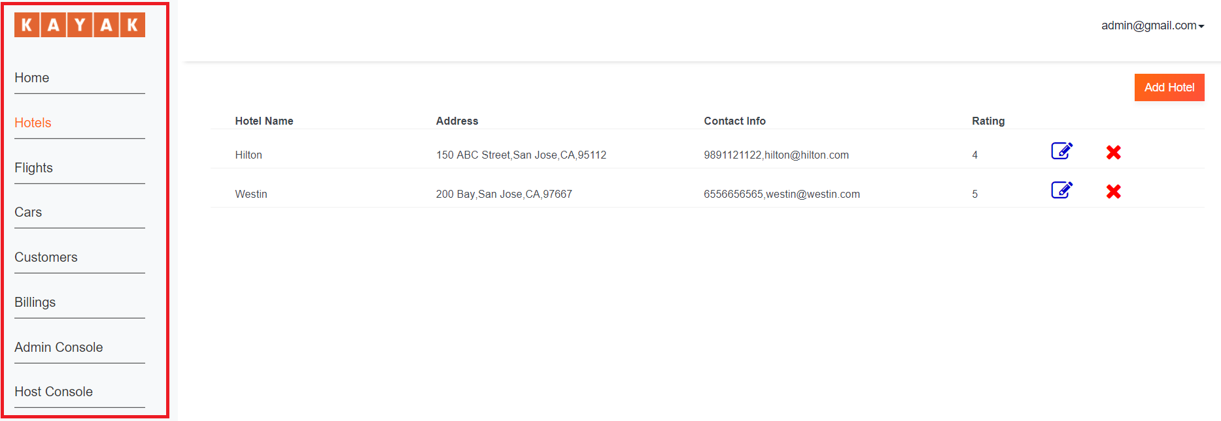

After login, a admin will get various options in the side bar (marked in red), Admin can use the links to go to different tabs and access data accordingly.

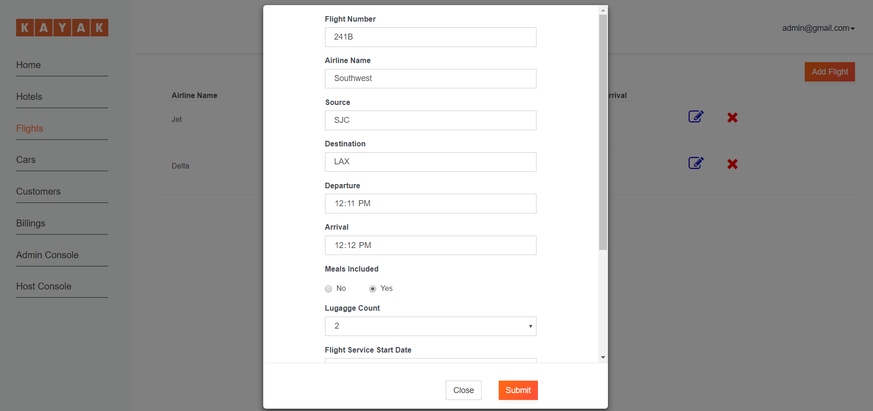

All the pages have options to add data, above is an example to add a flight details.

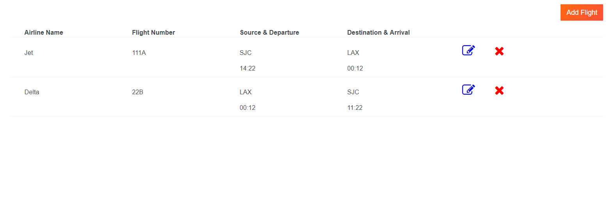

After adding data, the details are shown as above. Admin will also have an option to edit or delete any of the entries.

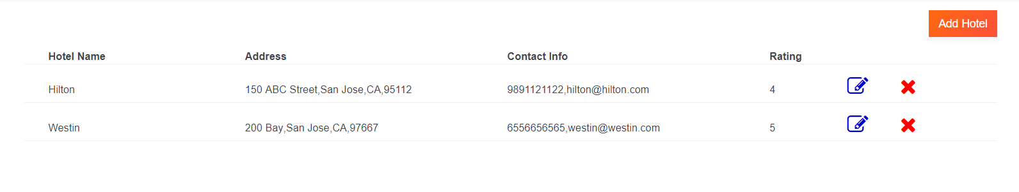

Hotel entries in admin section.

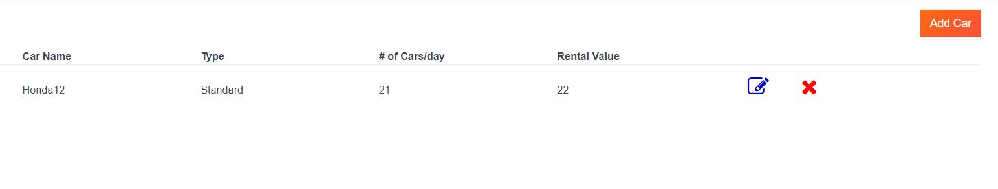

Car entries in admin section.

# CUSTOMER APPLICATION

# CODE LISTING

# TEST CLASS

# DATABASE SCHEMA

# OBSERVATIONS & LESSONS LEARNED