Customer Support Workflow (n8n)

An n8n automation that reads incoming Gmail messages, classifies them, and uses an AI Agent with a Pinecone knowledge base to draft and send replies automatically.

Workflow Overview
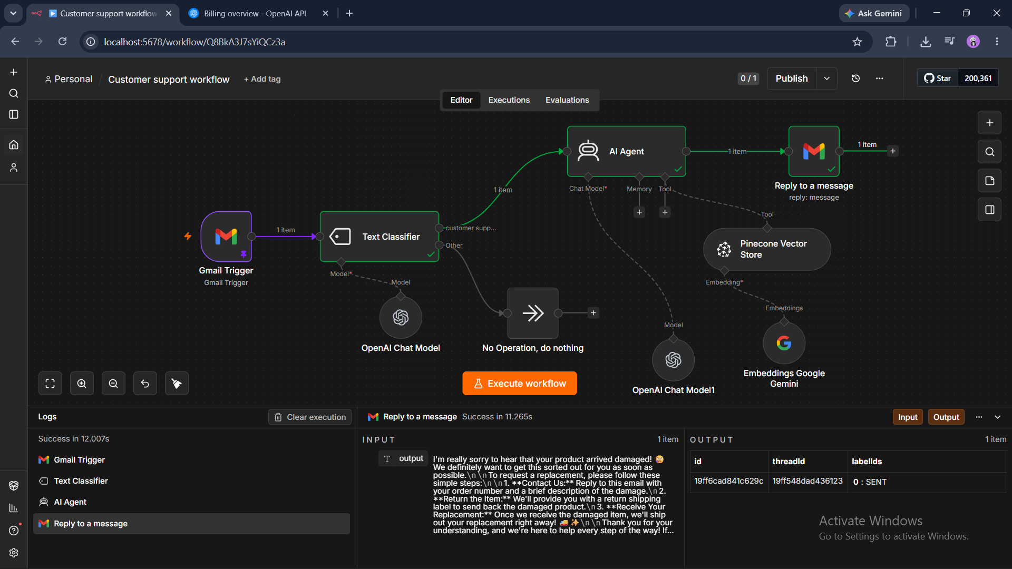

2. AI Agent Output
