**Capstone Project - The Battle of Neighbourhoods (Part-1)**

**Introduction:**

The City of New York, is the most populous city in the United States. It is diverse and is the financial capital of USA. It is multicultural. It provides lot of business oppourtunities and business friendly environment. It has attracted many different players into the market. It is a global hub of business and commerce. The city is a major center for banking and finance, retailing, world trade, transportation, tourism, real estate, new media, traditional media, advertising, legal services, accountancy, insurance, theater, fashion, and the arts in the United States.

New York City has also been a major point of entry for immigrants; the term "melting pot" was coined to describe densely populated immigrant neighbourhoods on the Lower East Side. As many as 800 languages are spoken in New York, making it the most linguistically diverse city in the world. English remains the most widely spoken language, although there are areas in the outer boroughs in which up to 25% of people speak English as an alternate language, and/or have limited or no English language fluency. English is least spoken in neighbourhoods such as Flushing, Sunset Park, and Corona.

**Problem:**

A restaurant is a business which prepares and serves food and drink to customers in return for money, either paid before the meal, after the meal, or with an open account. The City of New York is famous for its excelllent cuisine. It's food culture includes an array of international cuisines influenced by the city's immigrant history.

1. Central and Eastern European immigrants, especially Jewish immigrants - bagels, cheesecake, hot dogs, knishes, and delicatessens
2. Italian immigrants - New York-style pizza and Italian cuisine
3. Jewish immigrants and Irish immigrants - pastrami and corned beef
4. Chinese and other Asian restaurants, sandwich joints, trattorias, diners, and coffeehouses are ubiquitous throughout the city
5. mobile food vendors - Some 4,000 licensed by the city
6. Middle Eastern foods such as falafel and kebabs examples of modern New York street food
7. It is famous for not just Pizzerias, Cafe's but also for fine dining Michelin starred restaurants.The city is home to "nearly one thousand of the finest and most diverse haute cuisine restaurants in the world", according to Michelin.

**To find the answers to the following questions:**

1. List and visualize all major parts of New York City that has great Indian restaurants.
2. what is best location in New York City for Indian Cuisine?
3. which areas have potential Indian Restaurant Market?
4. which all areas lack Indian Restaurants?
5. which is the best place to stay if you prefer Indian Cuisine?

**Data Section:**

New York City's demographics show that it is a large and ethnically diverse metropolis. With its diverse culture, comes diverse food items. There are many restaurants in New York City, each belonging to different categories like Chinese, Indian, and French etc.

For this project we need the following data:

• **New York City data that contains list Boroughs, Neighbourhoods along with their latitude and longitude.**

Data source : <https://cocl.us/new_york_dataset>

Description: Newyork city geographical coordinates data will be utilized as input for the Foursquare API, that will be leveraged to provision venues information for each neighborhood.We will use the Foursquare API to explore neighborhoods in New York City. The below is image of the Foursquare API data.

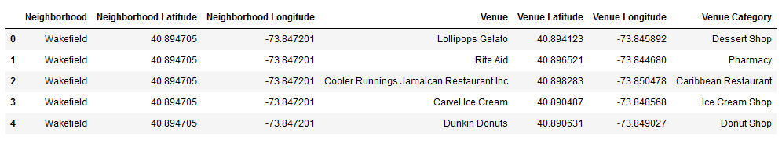

**Indian restaurants in each neighbourhood of New York City**.

Data source : Foursquare API

Description: By using this API we will get all the venues in each neighbourhood. We can filter these venues to get only Indian restaurants.

**GeoSpace data**



Data source : [https://data.cityofnewyork.us/City-Government/Borough-](https://data.cityofnewyork.us/City-Government/Borough-Boundaries/tqmj-j8zm)

[Boundaries/tqmj-j8zm](https://data.cityofnewyork.us/City-Government/Borough-Boundaries/tqmj-j8zm)

Description: By using this geo space data we will get the New York Borough boundaries that will help us visualize choropleth map.