**FINAL REPORT**

**Capstone Project - The Battle of Neighbourhoods**

**INTRODUCTION:**

Where would you recommend an art adventurer to visit in order to fulfill her/his hunger for various art pieces? The world is full of wonders and maybe the most ambiguous ones are considered as art. Many people dedicated themselves to travel around the world and discover these ambiguities.

The data used in this project is provided by Foursquare location data. The data are grouped by landscape area, and each area included the information about this area and all information about restaurants, cafes, and stores which in this area.

**DATA:**

In order to accomplish this goal, latitudes and longitudes of the hotels,restaurants, cafes, and stores are required. The "simplemaps.com" offers a simple, accurate and up-to-date database of the world's cities and their locations. From this data, I need to select the 'Toronto' cities and using their latitude and longitude values, I need to explore the venues with "art" section around these places by utilizing Foursquare API.

The "simplemap" data contains name, corresponding latitude, longitude, postal code,address,state and categoey along with many other features for all place in the Toronto. I only use the features that I mentioned in this data and then filtered the for each places.

Then I used the acquired location data to explore the nearby art venues from the Foursquare API. Using the "explore" option, I look for top 25 art venues in 10 km radius for each city center and I get "Venue", "Venue Latitude", "Venue Longitude" and "Venue Category" columns with 3316 row in total.

**METHODOLOGY:**

After pivoting and groping the data at hand, we get a new version of the data which includes 41 unique categories as columns. The cells contains the numbers of the corresponding category in the city. Visulizing this data, I applied Folium Library to show different places of city in map with clustring. After the tuning of the parameters of the model the result contains 2 different clusters Maps.

**RESULT:**

## **map to visualize Park, Restaurant and Cafeteria and how they cluster together**

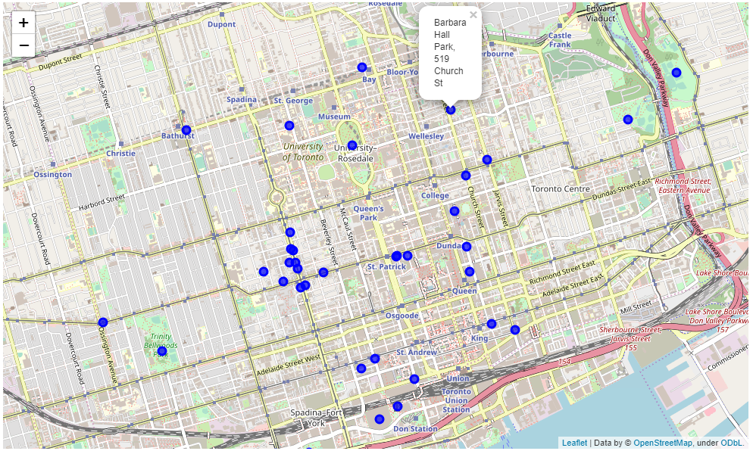

# **map to visualize hotels, shopping stores and Cafeteria and how they cluster together**

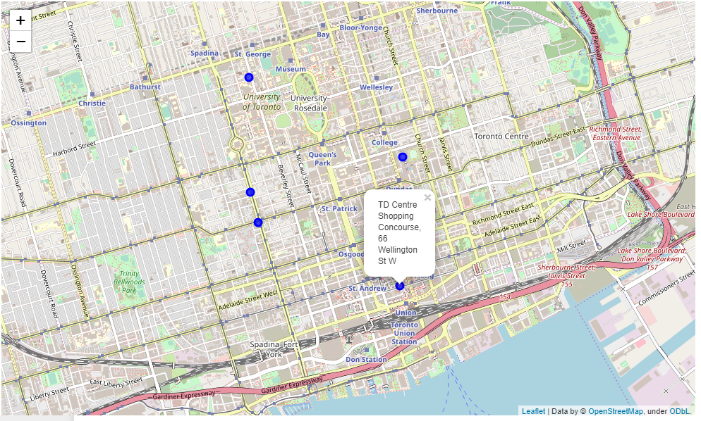

**DECESION:**

This project is used the map visulizing technique and clustring of data return different number of clusters with similar results. The best result is as presented. However I believe that the results are quite satisfying.

**CONCLUSION:**

To sum up, the adventurer can go to first map shows the different park restaurant and cafeteria and second is show the hotels and shopping stores..