Cairo University  
Faculty of Computers and Information



**CS251**

**Software Engineering I**

Code Morning

Software Design

Sara Sabry

Heba Ahmed

Aya Mahmoud

Amany Tarek

December 2016

Contents

Team 3

Document Purpose and Audience 3

System Models 4

I. Class diagrams 4

II. Sequence diagrams 5

Class - Sequence Usage Table 8

Git repository: 8

Ownership Report 8

Authors 8

# Team

|  |  |  |  |
| --- | --- | --- | --- |
| **ID** | **Name** | **Email** | **Mobile** |
| 20130075 | Amany Tarek Ahmed | Amany.mony_94@yahoo.com | 01004027284 |
| 20140300 | Heba Ahmed | heba_ahmed_eng@yahoo.com | 01114217325 |
| 20140090 | Aya Mahmoud Mohamed | Ayaelhawary14@gmail.com | 01116591620 |
| 20140133 | Sara Sabry Saad | Sara.sabry.1924@gmail.com | 01099329814 |

# Document Purpose and Audience

This document is a web application proposal. Here we state all the needed information about our project and how it works. Our project is a web application that serves both students and teachers for educational use. Students will learn about some concepts while playing, because with us learning can be fun.

The audience we try to reach here is the CEO of Computek company, to help us carry out this project.

# System Models

## I. Class diagrams

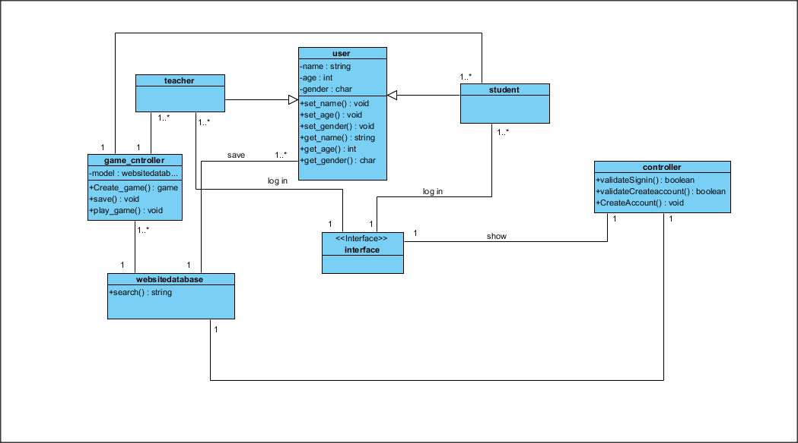

| **Class ID** | **Class Name** | **Description & Responsibility** |
| --- | --- | --- |
| 1 | User | Acts as an account that holds users information (student, teacher), ex: name, age, gender, score |
| 2 | Teacher | User who can create games |
| 3 | Student | User who can play games |
| 4 | website_db | Model that maintains data of the application. Takes instructions from controller and updates data (users, games) |
| 5 | Interface | Presents data |
| 6 | Controller | Manage the interaction between users and website database. Enables users to create accounts and validates their actions |
| 7 | game_controller | Manage the interaction between users and games database. Enables teachers to create games |

## II. Sequence diagrams

1. **Create account**

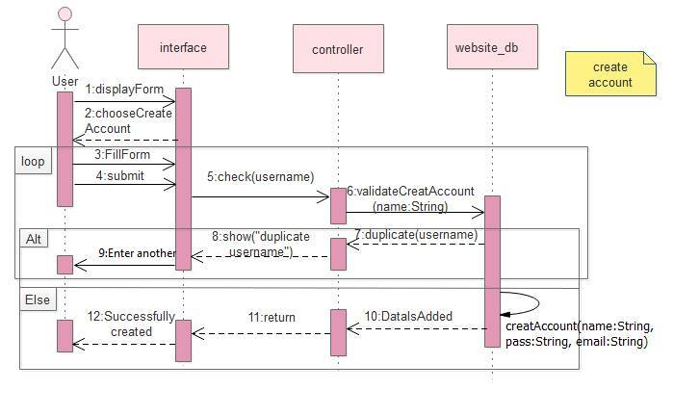

1. **Play game**

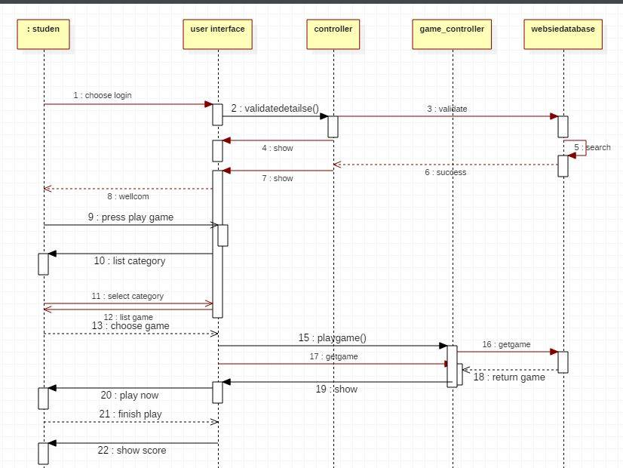

1. **Create game**

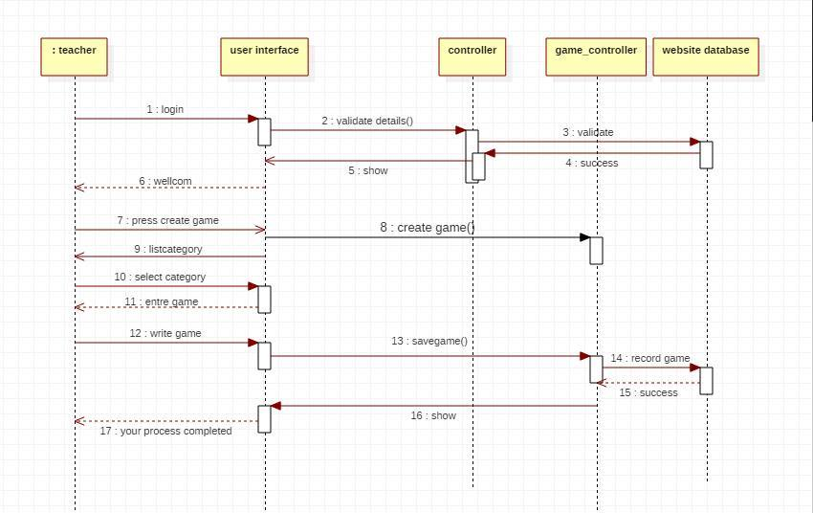

### Class - Sequence Usage Table

| **Class Name** | **Sequence Diagrams** | **Overall used methods** |
| --- | --- | --- |
| User | 1 | create_acc |
| Student | 2 | login,play_game |
| Teacher | 3 | create_game, login |
| Interface | 1,2,3 |  |
| Game_controller | 2,3 | Create_game, play_game,save |
| Controller | 2,3 | validateSign  in, validateCreateAccount |
| WebsiteDatabase | 2 | Search |

# Git repository:

Code: <https://github.com/amanyamany/SWE1/tree/master/website>

SRS Document:

# Ownership Report

|  |  |
| --- | --- |
| **Item** | **Owners** |
| Sequence diagram | *Heba-Aya* |
| Class diagram | *Sara-Amany* |

# Authors

* Mostafa Saad and Mohammad El-Ramly (Edited by Mohamed Samir)