SQLServer Lab
Note: Use ITI DB
- Create a view that displays student full name, course name if the student has a grade more than 50.

- Create an Encrypted view that displays manager names and the topics they teach.

- Create a view that will display Instructor Name, Department Name for the ‘SD’ or ‘Java’ Department

- Create a view “V1” that displays student data for student who lives in Alex or Cairo.
Note: Prevent the users to run the following query
Update V1 set st_address=’tanta’
Where st_address=’alex’;
- Create a view that will display the project name and the number of employees work on it. “Use Company DB”

- Create index on column (Hiredate) that allow u to cluster the data in table Department. What will happen?
- Create index that allow u to enter unique ages in student table. What will happen?
- Using Merge statement between the following two tables [User ID, Transaction Amount] (Daily Amount) , (User Balance)

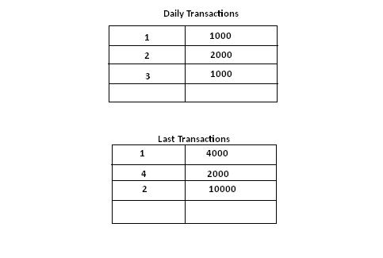

- Display Course Name , Student Full Name with Grade
In each course with name of leading student and lag student in each course

