Penta Demo report

## Aim of Penta Demo report

This report is meant to demonstrate how routine analysis of routine immunisation data can be made more quickly, without consuming a lot of time for data managers and also gives an edge with the power of open-source technology. Data managers can make appealing visualisations if you can easily export data from dhis2 using dhis2r package by GEEKS Uganda project

## Data visualistaion using accross different districts

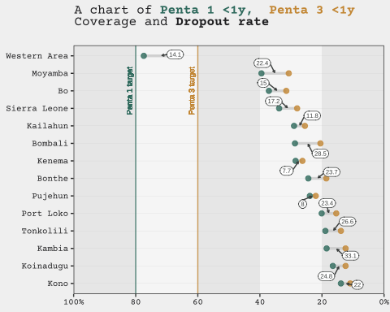

You can put all your explanations here of the current period.

These explanation can easily be made by Epidiemologist in MS word

## Data visualistaion using different periods

# A tibble: 12 × 4  
 analytic org_unit period value  
 <fct> <fct> <chr> <dbl>  
 1 Penta 1 Coverage <1y Sierra Leone January 2021 33.7  
 2 Penta 1 Coverage <1y Sierra Leone February 2021 39   
 3 Penta 1 Coverage <1y Sierra Leone March 2021 32.6  
 4 Penta 1 Coverage <1y Sierra Leone April 2021 35.6  
 5 Penta 1 Coverage <1y Sierra Leone May 2021 35.7  
 6 Penta 1 Coverage <1y Sierra Leone June 2021 37.5  
 7 Penta 1 Coverage <1y Sierra Leone July 2021 35.2  
 8 Penta 1 Coverage <1y Sierra Leone August 2021 38.4  
 9 Penta 1 Coverage <1y Sierra Leone September 2021 36.9  
10 Penta 1 Coverage <1y Sierra Leone October 2021 31.2  
11 Penta 1 Coverage <1y Sierra Leone November 2021 34.3  
12 Penta 1 Coverage <1y Sierra Leone December 2021 25.4

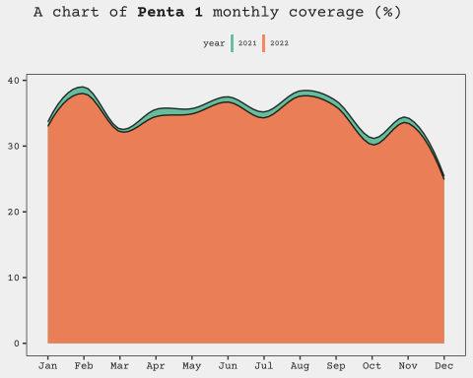

More explanations of the second plot