Report

# Ijumangabo and Kyakuterekera Zero Dose activity summary report

2024-08-08

There are 1015 children in our eligible category (4 to 59 months) whose care givers were interviewed

We reached 1380 households

## Number of House holds per village

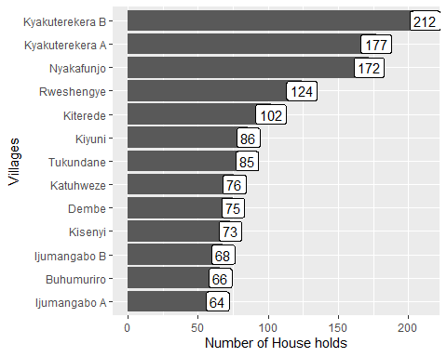

## Number of Zero Dose children per village

There are 59 Zero dose children in identified

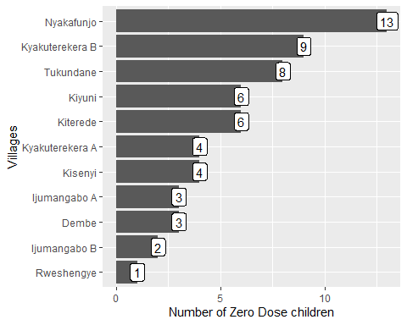

# How about underimmunised children?

To determine under-immunized children, we shall only focus on 751 children who had child health cards

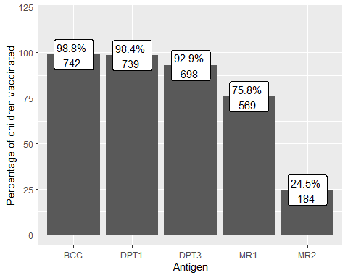

## Reasons for Zero dose and under-immunised

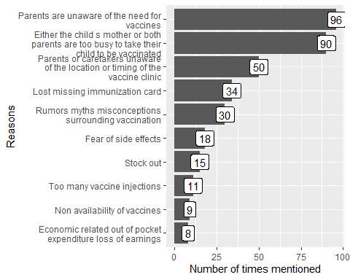

## How many Zero dose and under-immunised have been vaccinated during the H2H registeration (Saturady to Tuesday)

**(If not what are reasons for those who have not yet vaccinated)**

## Recommendations

## Action plan