Parish Report

## Report for Ijumangabo

## Cleaning

[1] 699

## Number of House holds per village

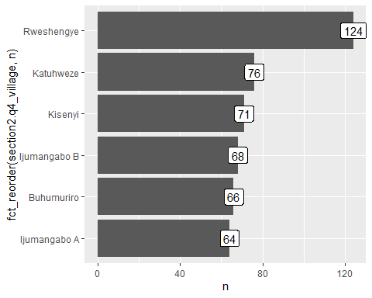

## Number of children in eligible children per villages

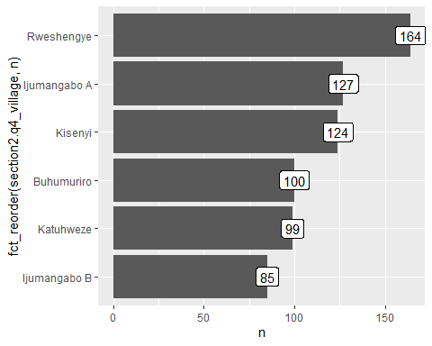

## Get Zero dose child

## Says No

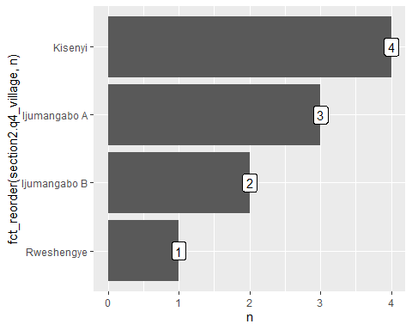

| parish | village | gps | lat | lon | HHnum | HHhead | HHtel | caregivers_name | caregivers_tel | caregivers_common | childs_name | childs_sex | childs_age | place_of_birth | place_of_birth_other |
| --- | --- | --- | --- | --- | --- | --- | --- | --- | --- | --- | --- | --- | --- | --- | --- |
| Ijumangabo | Ijumangabo B | 1.0307638 31.3310225 1165.6 4.933 | 1.030764 | 31.33102 | 009 | Ahimbisibwe Alex |  | Natukunda Annah |  | Nyina wa Sharon | Ahimbisibwe | male |  | traditional birth attendants |  |
| Ijumangabo | Ijumangabo A | 1.0360644 31.3335928 1140.6 4.9 | 1.036064 | 31.33359 | 017 | Byamukama denis |  | Turyashemererwa jolly |  |  | Nabasa kelvin | male | 10 | other | Home |
| Ijumangabo | Ijumangabo B | 1.032275 31.3303537 1148.3 5.0 | 1.032275 | 31.33035 | 040 | Ndahayo Daniel |  | Kobusinge Bradina |  | Kobusinge | Ayesiga Byaruhanga | male | 42 | traditional birth attendants |  |
| Ijumangabo | Kisenyi | 1.0254421 31.3282669 1130.1 4.834 | 1.025442 | 31.32827 | 046 | Ndabaharuye Jerome | 0788411572 | Mukabalasi Anonsiyata |  | Jerome | Kipaye Dorika | female | 30 | health facility setting |  |
| Ijumangabo | Kisenyi | 1.0242587 31.3255548 1209.4 4.4 | 1.024259 | 31.32555 | 064 | Abomugisha Julius |  | Natulinda moreen | 0772971487 |  | Tumuramye Ester | female | 38 | other | Home |
| Ijumangabo | Kisenyi | 1.02425 31.3254583 1208.4 4.8 | 1.024250 | 31.32546 | 064 | Ahebwaomugisha Julius |  | Natulinda moreen |  |  | Musa Tumukude | male | 37 | health facility setting |  |
| Ijumangabo | Rweshengye | 1.064753 31.3395778 1100.5 3.45 | 1.064753 | 31.33958 | 022 | Musimenta jane | 0778974896 | Musimenta jane | 0778974896 | Nalongo | Nuwagaba Richard | male | 37 | health facility setting |  |
| Ijumangabo | Kisenyi | 1.0250778 31.3257113 1128.2 4.05 | 1.025078 | 31.32571 | 054 | Nabasa Silver | 0774347398 | Ayebale Lilian |  | Silver | Katusiime Princess | female | 37 | health facility setting |  |
| Ijumangabo | Ijumangabo A | 1.0392684 31.3314123 1133.0 4.716 | 1.039268 | 31.33141 | 023 | Ibra bizimana |  | Nalyiso zam |  |  | Natukunda shmira | female | 1 | health facility setting |  |
| Ijumangabo | Ijumangabo A | 1.0391367 31.3301596 1129.0 9.0 | 1.039137 | 31.33016 | 035 | Rukundo brain |  | Tusingwire jairet |  |  | Ainembabazi brender | female | 1 | health facility setting |  |

## Under-immunised

[1] 1

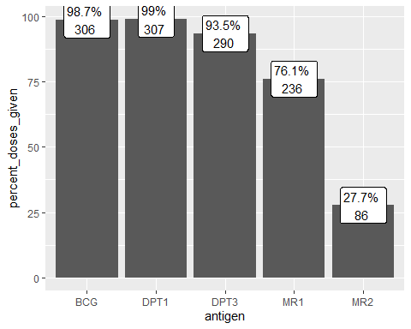

## Reasons for defaulters

