Report

# Kiterede village report

2024-07-30

There are 61 children in Kiterede village in our eligible category (4 to 59 months) whose care givers were interviewed.

We reached 102 households

## Number of Zero Dose children per village

There are 6 Zero dose children in Kiterede village

# How about underimmunised children?

To determine under-immunized children, we shall only focus on 44 children who had child health cards

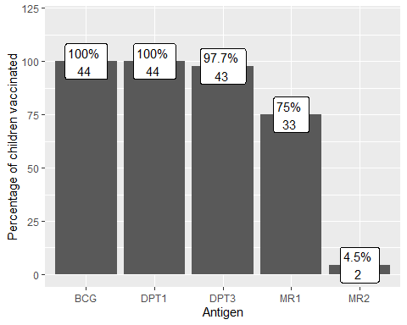

## Reasons for Zero dose and under-immunised

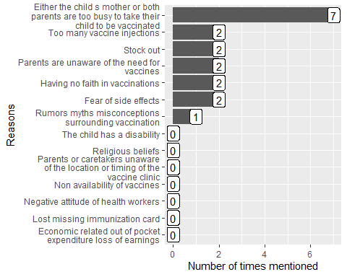

## How many Zero dose and under-immunised have been vaccinated during the H2H registeration (Saturady to Tuesday)

**(If not what are reasons for those who have not yet vaccinated)**

## Recommendations

## Action plan