**EE360A: Assignment 1**

1. A voltage divider is to be designed to provide a 5 V output from a 12 V input. The nominal load is 5 W (assume load has a resistive property). Design a divider to provide 5 V ± 5 % for loads ranging from 3 W to 5 W, assuming that the line input line is perfectly regulated at 12 V. What is the no-load output?
2. If Iin=20 A, R=1 Ohms, and C=10 uF and the switch is moved between 1 and 2 continuously at an interval of 0.25 us, what is the approximate steady state output voltage?

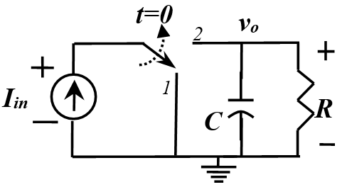

1. If C=100 uF, R=1 Ohm, Iin=30 A for the following circuit. In this circuit, S1 and S3 are turned-on together and S2 and S4 are turned-on together. If the S1/S3 and S2/S4 are on for 0.5 us each in a periodic manner, what is the output voltage under steady state?

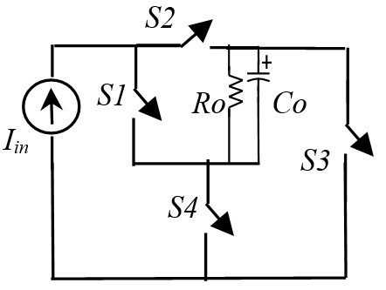

1. The voltage across an ideal inductor is shown in the figure below. For the following cases, plot the instantaneous current through the inductor for 2 cycles starting from t=0.

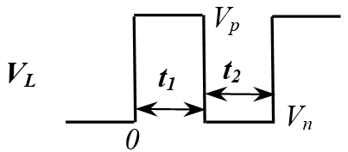

* 1. Vp=10 V, Vn=-10 V and t1=t2=1us, L=100 uH
  2. Vp=10 V, Vn=-11 V and t1=t2=1us, L=100 uH
  3. Vp=11 V, Vn=-10 V and t1=t2=1us, L=100 uH

1. Determine the power transfer from V1 to V2 under steady-state, if the voltages are as follows: **V1**: VH=10 V, VL=-5 V, ton=1 us, ts=2 us and **V2**: VH=10.5 V, VL=-5 V, ton=1 us, ts=2 us.

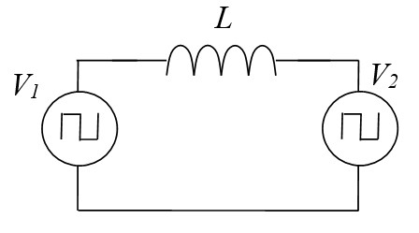 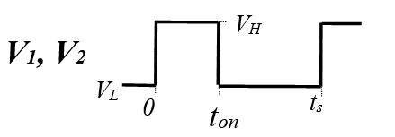

***Question 6 needs to be submitted as Assignment 1***

1. Submit the simulation results. Only use Orcad PSPICE 9.0 or Orcad PSPICE lite. To be submitted as group of 3 (max).

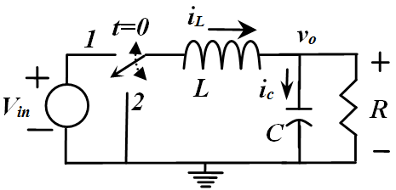

Fig. 1 shows a linear switching network. For this circuit, answer the following

(a) If at t=0, the switch is moved from 2 to 1, find an expression for the inductor current and output voltage for t>0. If Vin=10 V, L=20 uH, C=300 uF, and R=0.5 Ω, plot the iL and vo as a function of time using Matlab or Mathcad.

(b) At t=5us, the switch is moved back to 2 from 1. Plot iL and vo for t>10 us using Matlab or Mathcad.

(c) If (a) and (b) repeats for 10 cycles, with a switching cycle of 10 us, plot the iL and vo using Matlab or Mathcad.

(d) Verify your results in (c) using PSPICE simulation. Use ideal switch (ron=10 mOhm and roff=1 meg Ohm) for your simulation.