**31/8/202**

**The Dispose method is meant to provide the user to control the garbage collection. The Finalize method frees the resources used by the class, but not the object itself.**

* A Destructor is unique to its class i.e. there cannot be more than one destructor in a class.
* A Destructor has no return type and has exactly the same name as the class name (Including the same case).
* It is distinguished apart from a [constructor](https://www.geeksforgeeks.org/c-sharp-constructors/)because of the *Tilde symbol (~)* prefixed to its name.
* A Destructor does not accept any parameters and modifiers.
* It cannot be defined in Structures. It is only used with classes.
* It cannot be overloaded or inherited.
* It is called when the program exits.
* Internally, Destructor called the Finalize method on the base class of object.

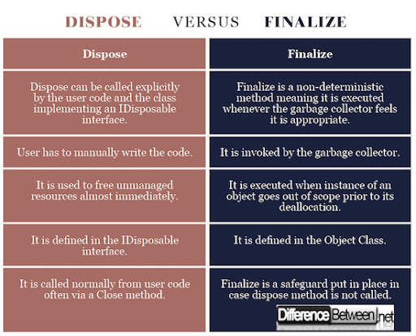

**Example from the same link:**

class Car

{

~Car() // destructor

{

// cleanup statements...

}

}

**The Destructor's code is implicitly translated to the following code:**

protected override void Finalize()

{

try

{

// Cleanup statements...

}

finally

{

base.Finalize();

}

}