**Assignment on 3rd Sep**

1. Write difference between Truncate and delete

Delete is a DML command whereas truncate is DDL command. Truncate can be used to delete the entire data of the table without maintaining the integrity of the table. On the other hand , delete statement can be used for deleting the specific data.

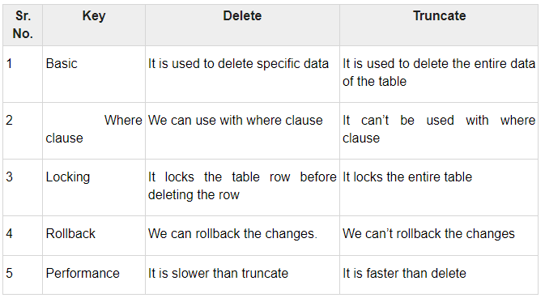

### Example of Truncate and Delete

//TRUNCATE Query

TRUNCATE TABLE tableName;

//Delete

DELETE FROM tableName WHERE condition;

1. Write down difference between Truncate and drop
2. Write down the among truncate, Delete and drop

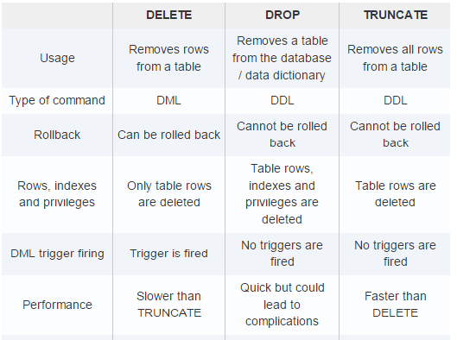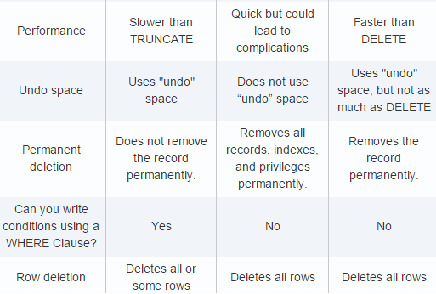

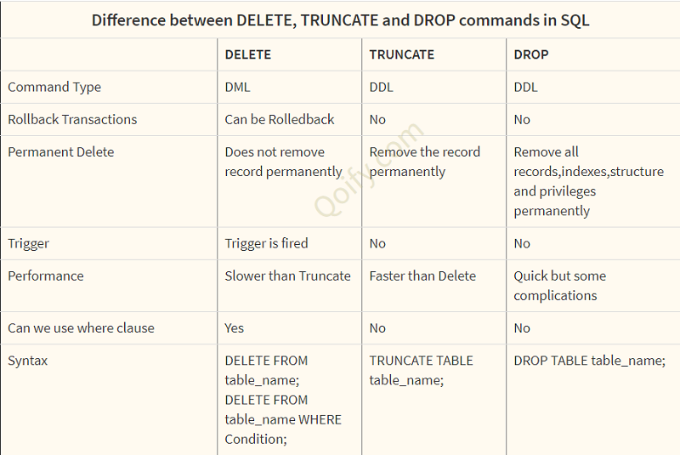

1. **Find out the range of data types**

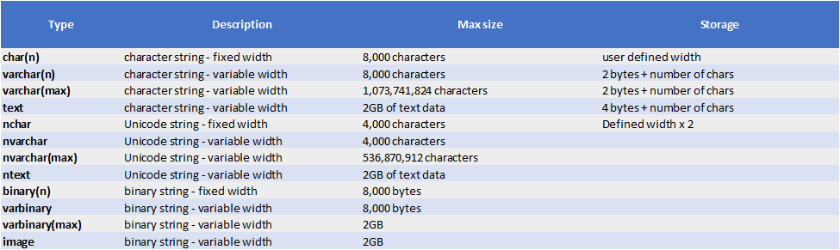

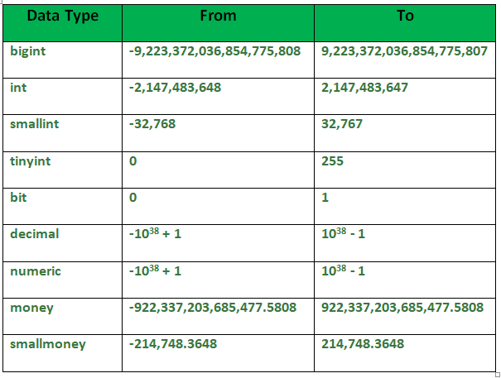

SQL Server Editions- Definition

1) Enterprise

2) Standard

3) Developer

4) Express

