Analysis Of Gradient Descent and Normal Equation

(Without Regularizer, Assignment # 1)



**Amarjeet Yadav**

**MIT2018053**

**RESULTS**

**1. Gradient Descent**

**Parameters Obtained : For Alpha = 0.1, Epochs = 1000**

[[-0.61091344 0.39245601 0.18560983 0.18659032 0.19251586 0.17920666

0.18069675 0.17988942 0.17798045 0.18438004 0.18434518 0.18103322]]

**Parameters Obtained : For Alpha = 0.03, Epochs = 1000**

[[-0.61606843 0.39144044 0.18042739 0.18116219 0.18277396 0.17905148

0.17965533 0.17931572 0.17883456 0.18075424 0.1807737 0.17975492]]

**The Squared error for (alpha = 0.1) :** 0.35637255518437705  
  
**The Squared error for (alpha = 0.03) :** 0.3563890015813656

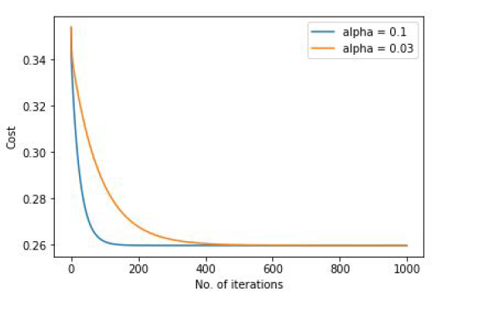

We can see that here when alpha large then it converge faster as compare to when alpha is small.

**Accuracy : 65%**

**2. Normal Equation**

**Parameters Obtained :** [[1.37658095e+03] [2.15081916e-01] [1.11110315e+02] [8.69446180e+02][3.97676252e+02] [4.05611325e+02] [2.73607675e+02] [3.30685115e+02] [7.78220072e+02] [7.66180033e+02] [2.57447260e+02] [5.68257433e+02]]

**Total squared error is :** 0.32687637935855013

**Accuracy Obtained: 68%**

**CONCLUSION**

Let we have m training examples and n features.

Disadvantages of gradient descent:

* we need to choose the learning rate, so we may need to run the algorithm at least a few times to figure that out.
* It needs many more iterations, so, that could make it slower

Compared to the normal equation:

* we don't need to choose any learning rate
* we don't need to iterate

Disadvantages of the normal equation:

* Normal Equation is computationally expensive when we have a very large number of features ( n features ), because we will ultimately need to take the inverse of a n x n matrix in order to solve for the parameters data.TC O(n^3).

Compared to gradient descent:

* It will be reasonably efficient and will do something acceptable when we have a very large number ( millions ) of features.

So if n is large then use gradient descent.

If n is relatively small ( on the order of a hundred ~ ten thousand ), then the normal equation