Analysis Of Logistic Regression

(With Regularizer, Assignment # 3)



**Amarjeet Yadav**

**MIT2018053**

**RESULTS**

**1. Logistic Regression + Regularizer + Data set (Examination)**

**1. I . 70 % Training and 30 % Testing**

**Parameters Obtained : For Alpha = 0.1, Epochs = 800**

parameters after gradient descent= [[-0.0170849 0.11274206 0.10827063]]

**Parameters Obtained : For Alpha = 0.03, Epochs = 800**

parameters after gradient descent= [[-0.0170849 0.11274206 0.10827063]]

Correct predictions out of **36** test points is (For alpha = 0.1) = **21**  
**Accuracy achieved**= 70.0 %  
  
Correct predictions out of **36** test points is (For alpha = 0.03) **= 21**  
**Accuracy achieved**= 70.0 %

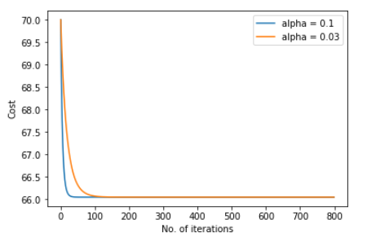

**2. Logistic Regression + Regularizer + Data set (Microchip)**

**2. I . 70 % Training and 30 % Testing**

**Parameters Obtained : For Alpha = 0.1, Epochs = 800**

parameters after gradient descent= [[-0.01967876 -0.03632053 0.01005665]]

**Parameters Obtained : For Alpha = 0.03, Epochs = 800**

parameters after gradient descent= [[-0.01967876 -0.03632053 0.01005665]]

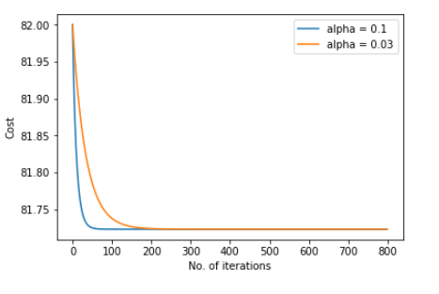

Correct predictions out of **36** test points is (For alpha = 0.03) = **30**

**Accuracy achieved**= 83.3 %

Here we get nonlinear elliptic curve which separate the microchips.

**CONCLUSION**

1. A linear fit for this data set will result in high bias or underfitting.
2. By adding extra features of higher order polynomial a better fit can be realised. But we may end up getting into high variance or overfitting
3. Regularization prevents the learning algorithm to overfit the training data or from picking arbitrarily large parameter values.
4. By adding features of higher polynomial and proper regularization rate the classification model with performing with an accuracy of 83%.