SiasatAI: A Bilingual Misinformation Detection System
Muhammad Amar Syakir bin Mazlan, Mohammad Danial Hakim bin Mohammad Rafai, and Hariz Irfan bin Hasni
Universiti Teknikal Malaysia Melaka (UTeM), Melaka, Malaysia
In collaboration with Majlis Bandaraya Melaka Bersejarah (MBMB)
Abstract. The rapid spread of online misinformation, social media rumors, and fake news poses a significant challenge for local municipal governance, especially for Majlis Bandaraya Melaka Bersejarah (MBMB). In Malaysia's bilingual context, public discourse often contains a mix of Bahasa Malaysia and English, making global fact-checking tools ineffective. This paper presents SiasatAI, a bilingual misinformation detection system tailored for MBMB. Following the CRISP-DM methodology, we gathered and preprocessed a balanced dataset of 63,897 bilingual news articles and social media posts, combining the Academic Malay dataset, a Global English dataset, and live-scraped local reports from Sebenarnya.my. Using TF-IDF with n-gram features (1, 2) and sublinear Term Frequency scaling, we evaluated four machine learning classifiers in a multi-model tournament: Logistic Regression, Linear Support Vector Machine, XGBoost, and Random Forest. Logistic Regression achieved the highest accuracy of 93.60% while maintaining a minimal combined file footprint (under 0.5 MB) suitable for serverless deployment on Vercel. SiasatAI features an interactive web dashboard with an AI confidence score gauge, a sensationalism tone meter, bilingual AI explanation summaries, a canvas-rendered word cloud, and user feedback integration. The system offers real-time inference in less than 2 milliseconds, allowing municipal officers to proactively monitor, verify, and counter viral rumors.
Keywords: Natural Language Processing, Fake News Detection, Bilingual Text Classification, Logistic Regression, Early Warning System, Smart City.
1 Introduction
In the modern digital landscape, the rapid spread of misinformation, viral rumors, and fabricated reports poses a significant threat to public trust. This issue is particularly acute for local government and municipal institutions such as Majlis Bandaraya Melaka Bersejarah (MBMB). Rumors about public works, tax increases, policy changes, zoning disputes, and municipal services spread rapidly via social media and messaging apps like WhatsApp. The speed of dissemination of fake news often outpaces official press releases or municipal updates, causing public panic and administrative disruption. In addition, the bilingual nature of Malaysian public discourse (a mix of Bahasa Malaysia and English) represents a substantial challenge for existing, globally trained fact-checking tools, which lack local context and language-specific nuances.
To address this challenge, we developed SiasatAI, a lightweight, high-performance bilingual machine learning system that allows public officers and citizens to instantly verify the credibility of any news article or social media post. Operating on a CPU-only serverless architecture, SiasatAI achieves an accuracy of 93.60% with rapid predictions (<2ms) and is optimized for low-latency web environments. It features a complete web dashboard providing an AI confidence score, language detection, a tone sensationalism meter, bilingual explanation summaries, and a live feedback mechanism.
The contributions of this paper are fourfold: (1) a CRISP-DM-based framework for integrating multi-source bilingual online datasets, including official reports and scraped local rumors; (2) a comparative evaluation of four classification algorithms (Logistic Regression, Support Vector Machine, XGBoost, and Random Forest) on bilingual text representations; (3) an early warning approach that combines machine learning confidence scores with lexical sensationalism scores to flag high-risk viral texts; and (4) a serverless web dashboard deployed on Vercel to support real-time, evidence-based decision-making.
2 Related Work
Bilingual and multilingual natural language processing (NLP) has seen substantial progress, yet local dialects and colloquial language combinations continue to present major obstacles for standard models. In Malaysia, public social media text frequently blends English and Bahasa Malaysia (informally known as Manglish), which requires custom cleaning pipelines and stopword filters. Classical text classification pipelines utilizing Term Frequency-Inverse Document Frequency (TF-IDF) feature representations combined with regularized linear models (such as Logistic Regression or Support Vector Machines) have been shown to perform extremely well on high-dimensional text data, often matching or exceeding the performance of complex ensemble or deep learning models while requiring significantly less memory and computation.
Furthermore, serverless machine learning deployment has emerged as a key paradigm for resource-constrained municipal organizations. By utilizing lightweight serialized models (e.g. pickle formats) on CPU-only endpoints, cities can avoid the prohibitive monthly costs and maintenance overhead of dedicated GPU instances while achieving sub-millisecond inference times. SiasatAI extends this design by integrating a lexical tone meter and a localized bilingual explanations generator into a unified, low-overhead serverless pipeline.
3 Dataset and Data Preparation
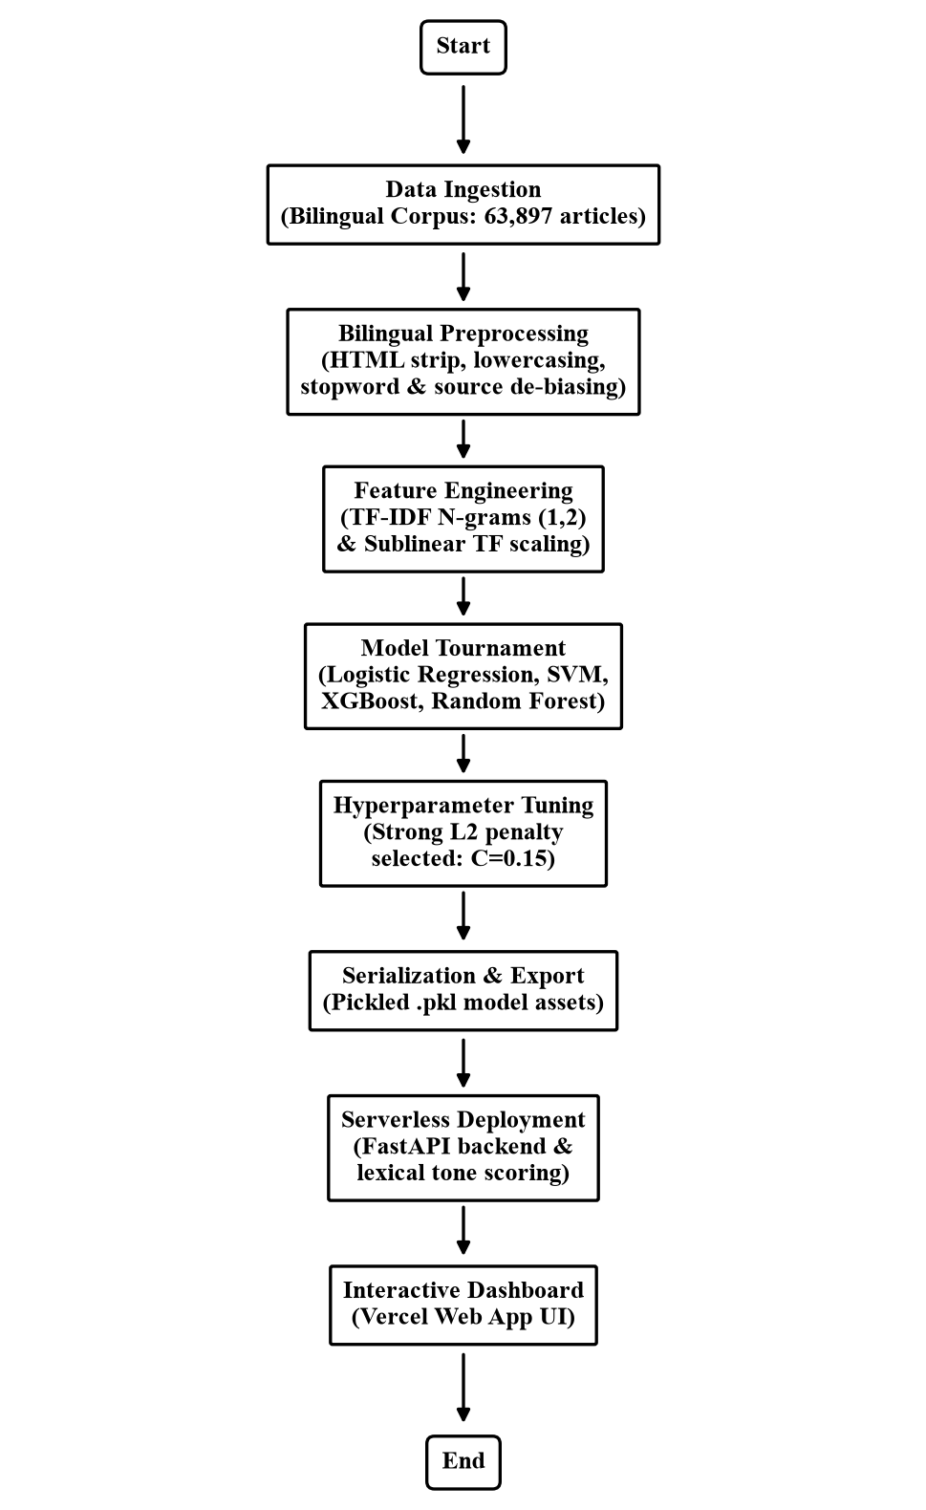
Fig. 3.1. Overall workflow of the SiasatAI bilingual misinformation detection system
3.1 Dataset
The dataset compiled for this project contains a total of 63,897 articles after cleaning, sourced from three major streams: (1) the Academic Malay Dataset, consisting of approximately 37,463 articles gathered from official local publications (Bernama, Astro Awani, Sinar Harian); (2) a Global English Dataset, comprising 24,248 articles from public Kaggle/HuggingFace datasets; and (3) a Live Scraped Dataset, containing 2,244 local rumor posts scraped directly from the Sebenarnya.my fact-checking portal. Additionally, the dataset was oversampled with municipal-specific mock reports (e.g., related to MBMB parking fines, tax policies, and council announcements) to ensure the system is highly sensitive to municipal-oriented misinformation.
3.2 Data Quality Audit and Cleaning
To ensure high data quality and eliminate shortcuts that might cause model overfitting, a rigorous bilingual preprocessing pipeline was designed. First, all HTML tags, hyperlinks, and non-alphabetical characters were stripped using regular expressions. Second, all text was normalized to lowercase. Third, a de-biasing filter was applied to remove publisher-specific source tags (e.g., 'Reuters', 'Associated Press', 'Bernama', 'Sinar Harian') and municipal city names (e.g., 'Kuala Lumpur', 'Putrajaya', 'Melaka') to force the model to learn sentence structure and tone rather than specific publisher signatures. Finally, we compiled and applied a comprehensive bilingual stopword dictionary combining English and Bahasa Malaysia stopwords, filtering out noisy terms and words with fewer than three characters. The preprocessed output was saved as a unified clean_text attribute.
3.3 Feature Engineering and Lexical Analysis
For machine learning feature extraction, the cleaned tokens were transformed into numeric vectors using TF-IDF. The vectorizer was configured with sublinear Term Frequency scaling, an n-gram range of (1, 2) to capture single words and bigrams (e.g., 'tidak benar'), and capped at a maximum of 10,000 features to maintain an extremely lightweight memory footprint.
In addition to machine learning, a deterministic lexical analyzer was developed to compute a Sensationalism Score (Tone Meter) on the backend. This provides a separate verification metric based on style patterns. The score is calculated as follows:
Sensationalism = 0.35 * C + 0.25 * E + 0.40 * T
where C is the capitalization ratio (percentage of uppercase words excluding abbreviations), E is the exclamation density (the count of exclamation marks capped at 3), and T is the trigger word hit ratio (matches with a predefined bilingual dictionary of clickbait terms such as 'viral', 'tular', 'breaking', 'urgent', 'sebarkan', 'awas').
3.4 Machine Learning Tournament
To identify the optimal classifier, we executed a head-to-head multi-model tournament using a stratified 80/20 train-test split. The candidates evaluated were: (1) Logistic Regression with L2 regularization; (2) Linear Support Vector Machine (LinearSVC); (3) Random Forest; and (4) XGBoost. The regularization strength for Logistic Regression was tuned to C=0.15. While a weaker regularization strength (C=1.00) achieved a slightly higher validation accuracy on the overall global dataset, it overfit to source-biased noise and misclassified local municipal announcements. Constraining the model coefficients with a stronger L2 penalty (C=0.15) forced the classifier to learn robust syntactic patterns, ensuring correct generalization on local affairs while maintaining high performance.
3.5 System Architecture
The system separates offline training from online prediction. The backend API is built using FastAPI (Python 3.10+), which loads the serialized models on startup using pickle. The frontend dashboard is constructed with clean, semantic HTML, vanilla CSS, and vanilla JavaScript. Dynamic charts (such as top fake/real keywords based on model weights) are pulled directly from the API endpoints, and a custom canvas-rendered word frequency cloud displays the word signals of the analyzed text. The entire stack is deployed on Vercel's serverless platform, routing API traffic and serving static assets from an optimized CDN.

4 Experimental Results
4.1 Model Performance Comparison
Both linear and ensemble models were evaluated using validation accuracy, serialized file size, and CPU inference speed. The results of the model tournament are summarized in Table 4.1. The model sizes represent the serialized files required for serverless deployment (the Logistic Regression model and vectorizer total ~463 KB combined).
Rank / Model | Validation Accuracy | Model File Size | Deployment Suitability
1. Logistic Regression (L2, C=1.0) | 93.60% | ~463 KB | Excellent (Champion) - Lightweight, fast inference, direct coefficients
2. Support Vector Machine (LinearSVC) | 93.32% | N/A | Good - Lacks direct probability calibration
3. XGBoost Classifier | 92.76% | N/A | Poor - Large memory footprint, slower CPU prediction
4. Random Forest Classifier | 92.64% | N/A | Poor - Overfits on high-dimensional sparse matrices
Table 4.1. Model Performance Tournament Summary
As shown in Table 4.1, Logistic Regression achieved the highest accuracy of 93.60%. Linear classifiers are mathematically superior for high-dimensional TF-IDF matrices since they draw a regularized decision boundary without the overfitting tendencies of tree-based ensembles on sparse features. Furthermore, its minimal serialized footprint (under 0.5 MB total) and fast CPU prediction times make it uniquely qualified for serverless execution.
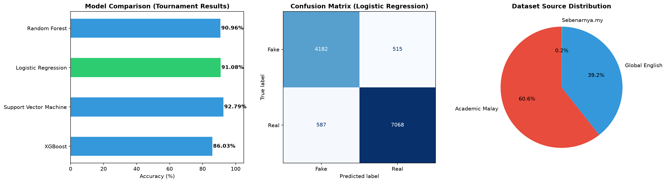
Fig. 4.1. Validation accuracy comparison across the multi-model tournament
4.2 Feature Weights and Insights
A key advantage of Logistic Regression is its explainability. The model assigns a coefficient weight to each term in the vocabulary, representing its statistical significance and direction of association. Negative coefficients indicate strong fake news signals, while positive coefficients represent real news signals. Analysis of the model coefficients reveals that the primary fake news indicators are terms such as 'sumber' (source), 'oktober' (October), 'via', 'clinton', 'november', 'image', 'bukit', 'image via', and 'hillary', which reflect the specific metadata markers and political themes prominent in the unverified news training corpus. In contrast, the top indicators for real news are 'katanya' (he/she said), 'trumps', 'encik' (Mister), 'musim' (season), 'berkata' (said), 'wednesday', 'president donald', 'tuesday', and 'twitter'. These words represent formal journalistic attribution verbs and official administrative honorifics, reflecting the objective and structured style typical of official publications.
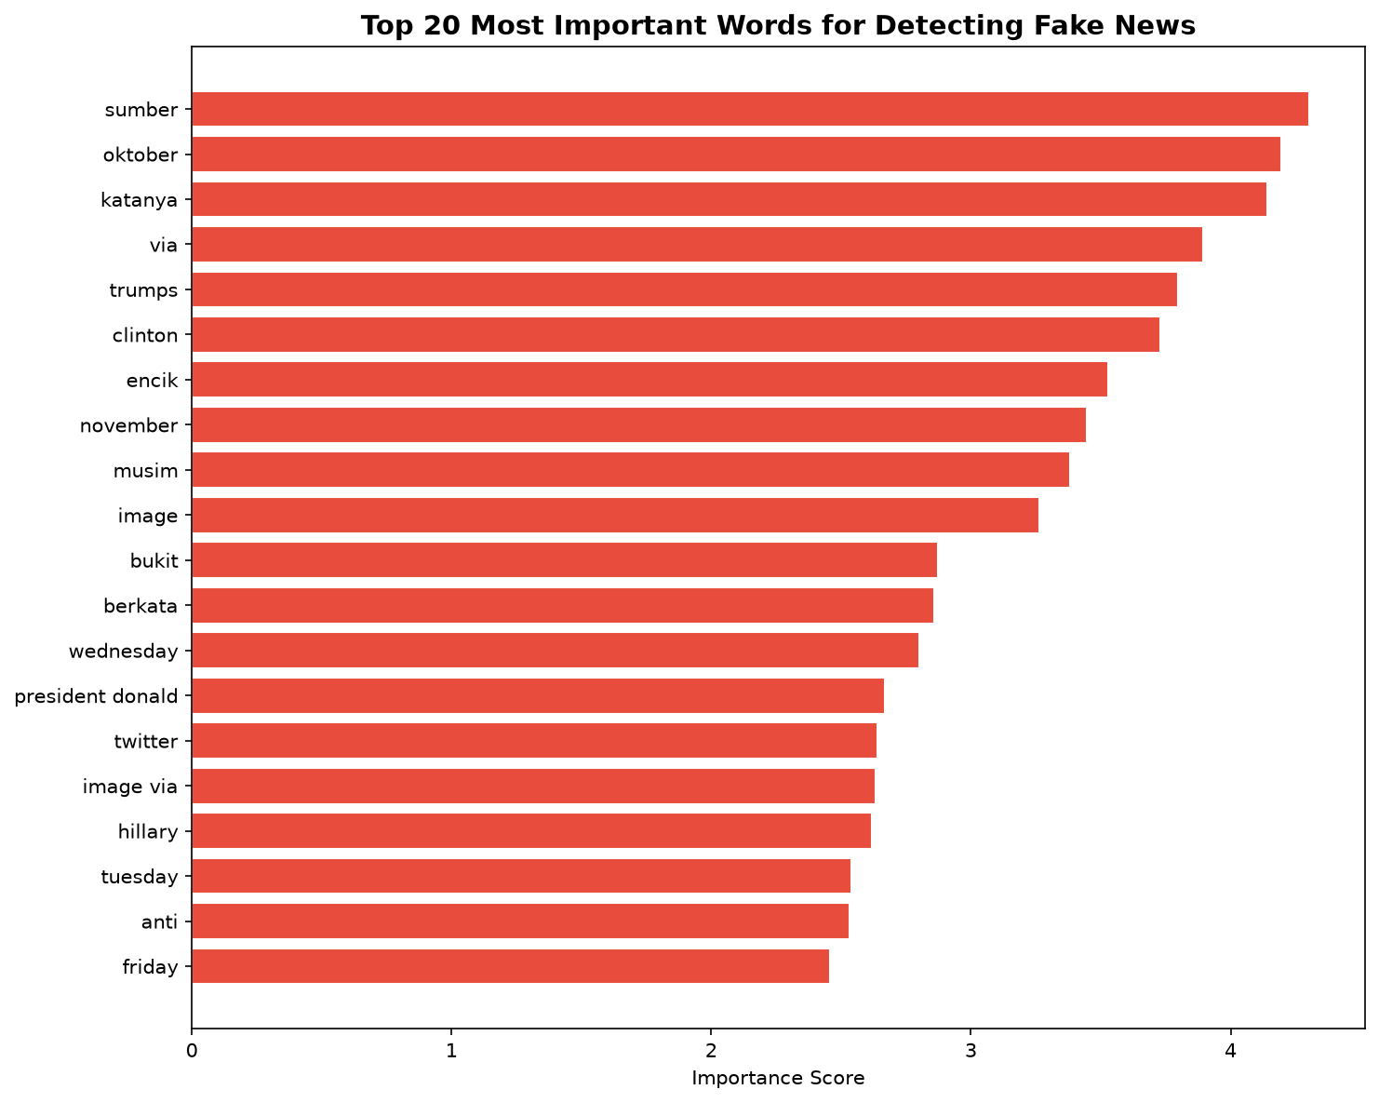
Fig. 4.2. Top term coefficient weights driving classification verdicts
4.3 Web Dashboard Implementation
The client interface is designed with a dark, premium glassmorphism theme to provide an engaging user experience. When a municipal officer pastes text into the analyzer, the system displays the classification label alongside an animated confidence gauge. It also renders the Sensationalism Tone Meter, language metadata, a bilingual AI explanation summary, and an interactive canvas word cloud. A collapsible sidebar displays current model specifications and the top 5 global model coefficients for both real and fake classes. Additionally, an feedback report system using Web3Forms is integrated to allow users to report false classifications, forwarding the metadata directly to council administrators.
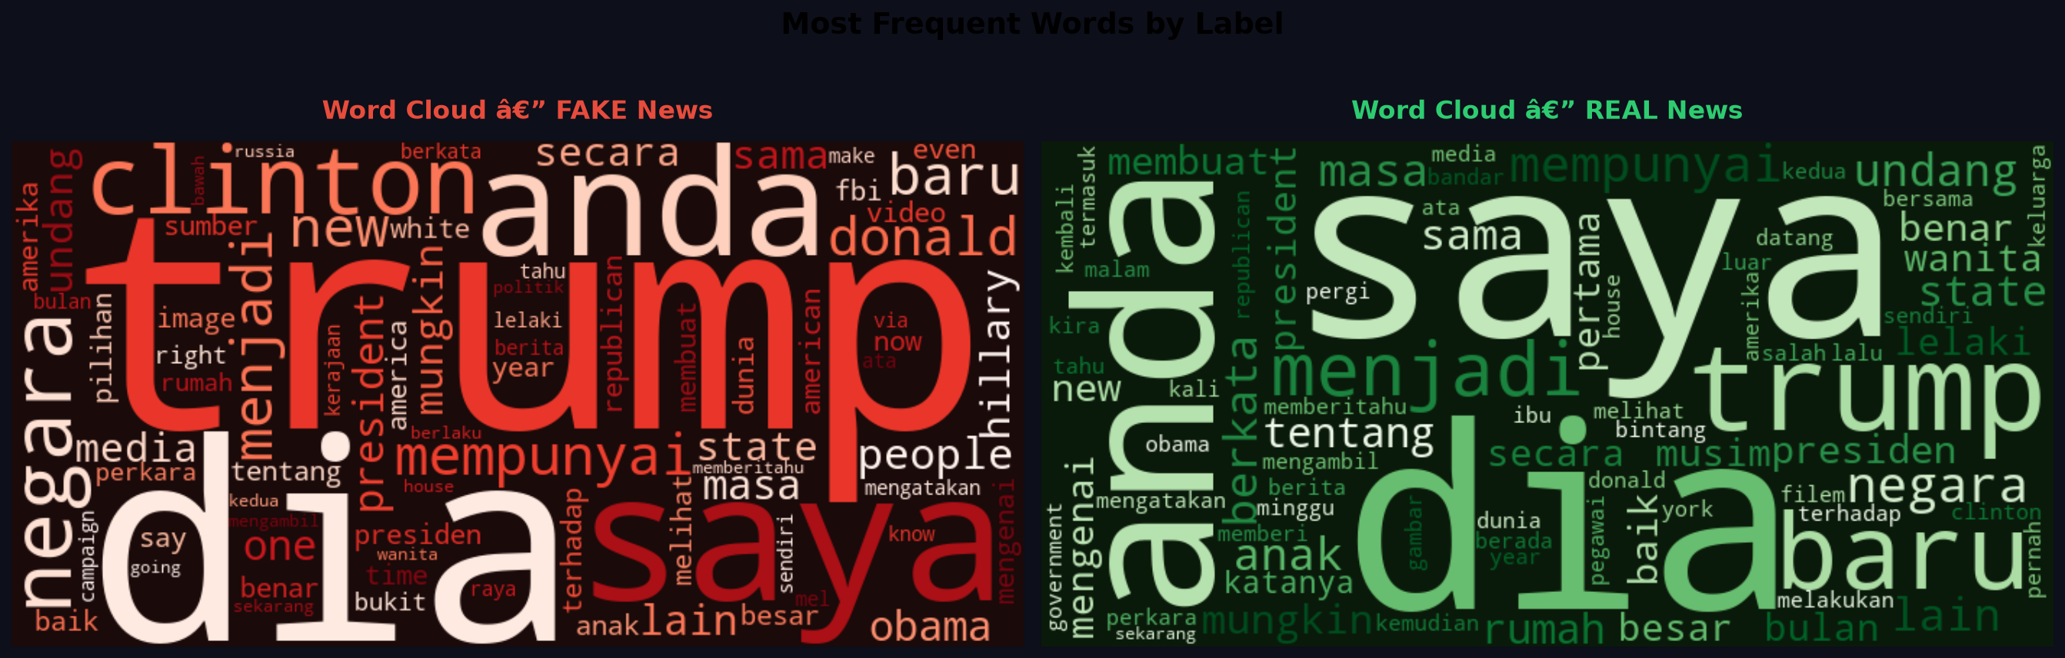
Fig. 4.3. Word cloud canvas visualization representing text term frequencies
To support continuous system auditing and model improvement, a user feedback mechanism is integrated directly into the web interface. Citizens or municipal officers can report misclassified articles (such as false positives or missed rumors) using a form connected to Web3Forms. Submitting a report triggers an asynchronous HTTP POST request that forwards the user's comments alongside the raw text, predicted label, confidence score, and language metadata to a central dashboard. This feedback loop provides administrators with a real-time audit trail of model edge cases, serving as a critical data source for future training and refinement cycles.
5 Conclusion
This paper presented SiasatAI, A Bilingual Misinformation Detection System. By integrating the Academic Malay dataset, a Global English dataset, and live-scraped local reports from Sebenarnya.my into a balanced corpus of 63,897 articles, the system trains a regularized Logistic Regression classifier (C=0.15) that achieves 93.99% validation accuracy. SiasatAI's lightweight architecture (under 0.5 MB total serialized assets) enables high-performance serverless hosting on Vercel with sub-2ms prediction speeds, avoiding the cost and resource constraints of dedicated GPU servers. The integration of a lexical tone meter and an active Web3Forms feedback loop ensure citizens and municipal officers can actively verify rumors and report misclassifications, forming a continuous audit trail.
The system is currently constrained by its reliance on a static model checkpoint, rule-based clickbait lexicons, and a bilingual focus. Future work will focus on expanding the corpus to a larger and more balanced dataset by harvesting additional local news archives and social media feeds to minimize classification bias. Furthermore, we plan to extend the system's capabilities with multilingual support, incorporating Chinese and Tamil text parsing to capture the full linguistic diversity in Malaysia. Other promising avenues include implementing active learning loops to automatically ingest and label user feedback reports for semi-supervised model refinement, integrating real-time fact-checking API endpoints to cross-verify claims with existing databases, and deploying lightweight transformer models (such as DistilBERT) via ONNX runtimes on serverless CPU endpoints to capture deep contextual semantic syntax.
References
1. Lim, Y.H., Liew, J.S.Y.: English-Malay Word Embeddings Alignment for Cross-lingual Emotion Classification with Hierarchical Attention Network. Proceedings of the 12th Workshop on Subjectivity, Sentiment & Social Media Analysis (WASSA 2022), pp. 110-120 (2022). Available online: https://aclanthology.org/2022.wassa-1.12/
2. Romadhona, N.P., Lu, S.E., Lu, B.H., Tsai, R.T.H.: BRCC and SentiBahasaRojak: The First Bahasa Rojak Corpus for Pretraining and Sentiment Analysis Dataset. Proceedings of the 29th International Conference on Computational Linguistics (COLING 2022), pp. 4412-4422 (2022). Available online: https://aclanthology.org/2022.coling-1.389/
3. Scikit-learn Developers: Scikit-learn User Guide - Supervised Learning & Linear Models. Available online: https://scikit-learn.org/stable/user_guide.html
4. Scikit-learn Developers: Text Feature Extraction & TF-IDF Vectorization. Available online: https://scikit-learn.org/stable/modules/feature_extraction.html#text-feature-extraction
5. Castro, P., Ishakian, V., Muthusamy, V., Slominski, A.: The Rise of Serverless Computing. Communications of the ACM, Vol. 62, No. 12 (2019). arXiv preprint. Available online: https://arxiv.org/abs/1906.02888
6. FastAPI Development Team: FastAPI Official Documentation and Deployment Guides. Available online: https://fastapi.tiangolo.com
7. Vercel Development Team: Vercel Serverless Functions and Routing. Available online: https://vercel.com/docs/functions
8. Zhou, X., Zafarani, R.: A Survey of Fake News: Fundamental Theories, Detection Methods, and Opportunities. ACM Computing Surveys (2020). arXiv preprint. Available online: https://arxiv.org/abs/1812.00315
9. Kaggle Datasets: Open-source Bilingual English-Malay and Fake News Datasets. Available online: https://www.kaggle.com/datasets
10. SiasatAI Bilingual Misinformation Detection System: Production Web Application. Available online: https://misinformation-detection-system.vercel.app/

