LECTURING

LOGO 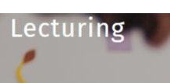

Report File

Proposal

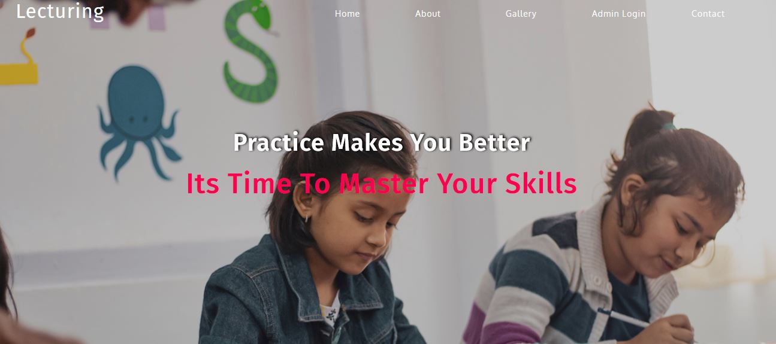

Introduction :

Lecturing offers students about the learning online easily with lot of different syllabus that will help students to achieve good grades because the staff is quite experienced and also offers job opportunity to the students with digital library

About us:

Lecturing provide all educational services with experienced staff and good books library that help students to achieve good grades in their school

After succesfull completition of the course 100% grantee of job placement and these courses are available online

Admin Login

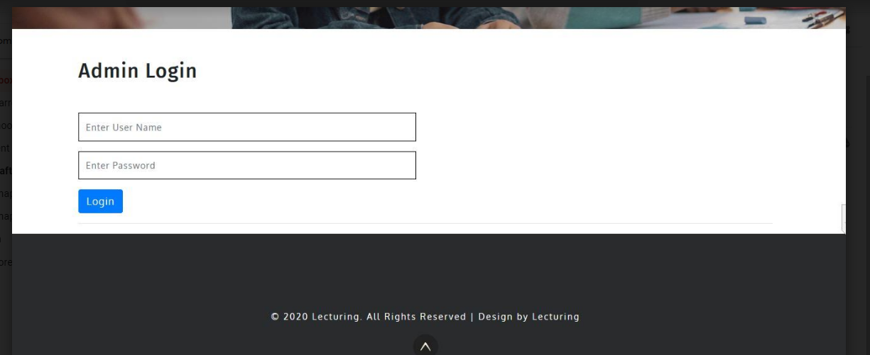

After clicking on login at the menu bar admin can securely login in to the admin area and login into it for adding the details

Username: admin

Password: admin

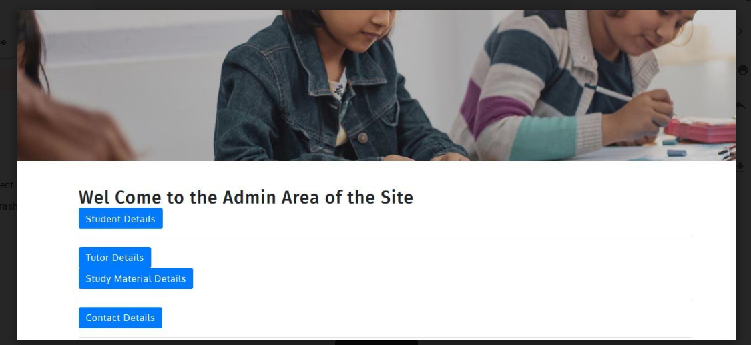

Index Page:

Index page is made attractive for the creating eye catch effect among the students or viewers



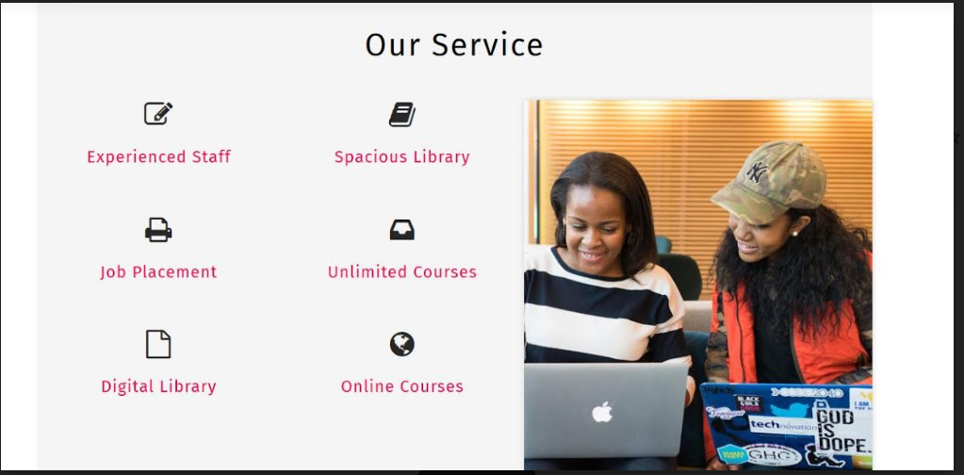

About Page :

About page is defining about the website that what they are providing to the students

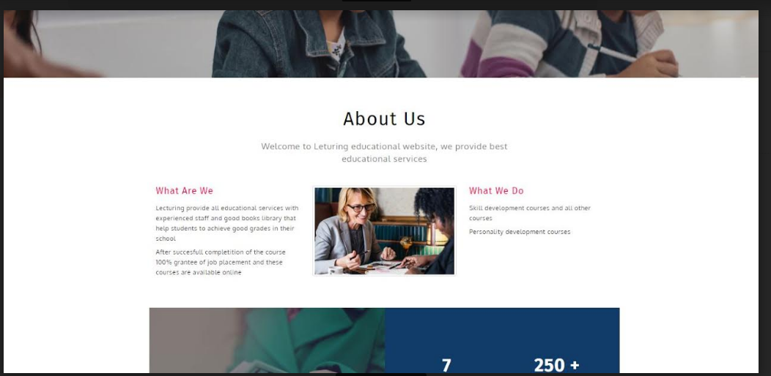

Gallery Page:

Gallery page is giving knowledge of all done projects

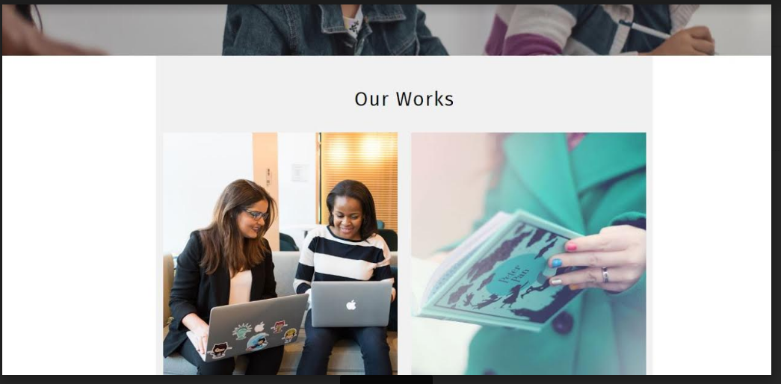

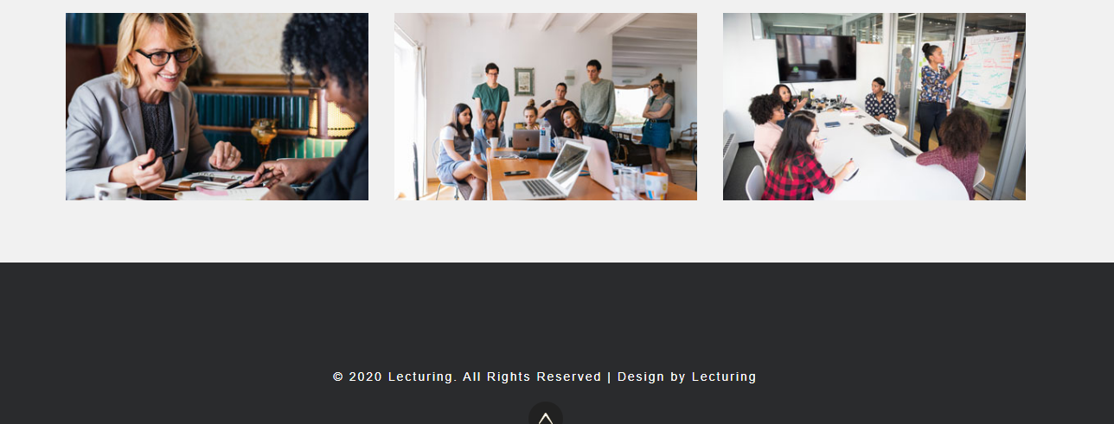

Contact Us

This page allows users to send messages to admin

