Supplementary Material

Appendix Table S1: Sporocarp species identified across different burn severity classes from the 2000 Pumpkin Fire, their ecology (S= saprotrophic, M = mycorrhizal, P = parasitic), presence in severity class (UB = unburned, M = moderate-severity, HE = high-severity edge, and HI = high-severity interior), and phylum (A = Ascomycete or B = Basidiomycete). Species were either identified morphologically or based on the best BLAST match to ITS sequences (score is an evaluation of query and reference sequence alignment based on their length and number of gaps, % is percentage similarity of query to published reference sequence).

Sporocarp ID or best BLAST match | Ecology | Presence in burn severity classes | Substrate collected from | Substrate preference | Phylum | % Identity | % Query | Accession number
Amanita breckonii* | M | UB, M | litter/ bareground |  | B | 96% | 97% | KJ535439.1
Amanita caesarea | M | UB, M | litter/ bareground |  | B
Amanita hallingiana | M | UB, M | litter/ bareground |  | B | 99% | 96% | KY924833.1
Amanita muscaria var. muscaria | M | UB, M | litter/ bareground |  | B
Astraeus hygrometricus | M | HE, HI | litter/ bareground |  | B
Clavariadelphus truncatus | M | UB, M | litter/ bareground |  | B
Clavulina cristata | M | UB | litter/ bareground |  | B
Clavulina rugosa* | M | UB, HE | litter/ bareground |  | B | 99% | 92% | EU862224.1
Coltricia cinnamomea | M | M, HE, HI | litter/ bareground |  | B
Cortinarius caninus | M | UB, M, HE | litter/ bareground |  | B | 100% | 98% | KT447178.1
Cortinarius sp. | M | UB | litter/ bareground |  | B | 100% | 99% | JQ393045.1
Cortinarius leucopus | M | UB, M | litter/ bareground |  | B | 99% | 95% | JN133921.1
Helvella crispa | M | UB, M, HE | litter/ bareground |  | A
Hygrocybe conica var. conicoides | M | M | litter/ bareground |  | B | 96% | 98% | EU784300.1
Hygrophorus chrysodon | M | UB, M | litter/ bareground |  | B
Hygrophorus sp. | M | UB | litter/ bareground |  | B | 99% | 98% | FJ553725.1
Hygrophorus speciosus | M | UB, M | litter/ bareground |  | B
Inocybe breviterincarnata | M | UB | litter/ bareground |  | B | 98% | 100% | JQ408753.1
Inocybe chelanensi | M | UB, M | litter/ bareground |  | B | 96% | 98% | HQ604403.1
Inocybe geophylla var. lilacina | M | UB, M | litter/ bareground |  | B | 99% | 98% | HQ604296.1
Inocybe glabrescens* | M | HI | litter/ bareground |  | B | 99% | 96% | HQ604513.1
Inocybe nitidiuscula | M | UB, M, HE | litter/ bareground |  | B | 95% | 100% | HE862959.1
Inocybe sp.* | M | UB, M, HE | litter/ bareground |  | B | 99% | 90% | FJ196929.1
Lactarius barrowsii | M | M, HE | litter/ bareground |  | B
Pseudolaccaria pachyphylla | M | M | litter/ bareground |  | B | 98% | 97% | KF291251.1
Russula brevipes | M | UB, M | litter/ bareground |  | B
Russula brevipes + Hypomyces lactifluorum | M | UB, M | litter/ bareground | Known parasite of Russula brevipes | A
Russula sanguinea | M | UB | litter/ bareground |  | B | 98% | 99% | FJ845434.1
Russula xerampelina | M | UB, M, HE | litter/ bareground |  | B | 97% | 100% | KT875107.1
Suillus kaibabensis | M | UB, M | litter/ bareground |  | B | 97% | 100% | MG491500.1
Tricholoma sp. | M | UB | litter/ bareground |  | B
Agaricus sp. 1* | S | UB | litter | litter | B | 93% | 87% | KJ755646.1
Agaricus sp. 2 | S | M, HI | litter | litter | B | 99% | 99% | EF460356.1
Agrocybe sp. | S | HE | log | litter or logs; white-rot | B | 99% | 99% | DQ421093.1
Armillaria ostoyae | S, P | HI | log | logs; white-rot; parasitic to some trees | B | 99% | 97% | KT822292.1
Bovista sp. | S | HE, HI | litter/ bareground | litter; grass roots | B | 99% | 99% | DQ421081.1
Calocybe naucoria | S | UB, M | litter | grass roots | B | 98% | 96% | KP885642.1
Clavicorona pyxidata | S | UB, M, HE | log | logs; white-rot | B
Clitocybe sp. | S | UB, HE | litter | litter | B | 98% | 99% | KJ680984.1
Crassisporium sp.^{F} | S | UB, M, HE, HI | litter | litter | B | 88% | 98% | KF830096.1
Cyathus striatus | S | HI | litter | litter | B
Cystoderma sp. | S | HE | litter | litter | B | 99% | 98% | GU234151.1
Entoloma brunneosericeum | S | HE, HI | log | logs; white-rot | B | 99% | 99% | KY820057.1
Entoloma iodiolens | S | HE | log | logs; white-rot | B | 93% | 99% | KJ001429.1
gloeophyllum sepiarium^{F} | S | UB, HE | log | logs; white-rot | B
Gymnopilus sapineus | S | HE, HI | log | logs; brown-rot | B
Gymnopilus spectabilis | S | HE | log | logs; white-rot | B
Gyromitra perlata | S | HE, HI | litter | litter | A
Hygrophoropsis aurantiaca* | S | UB | log | logs; brown-rot | B | 100% | 91% | KT875014.1
Leucopaxillus gentianeus | S | UB | litter | litter | B
Lycoperdon sp. 1 | S | HI | litter | litter | B | 86% | 95% | EU833664.1
Lycoperdon sp. 2 | S | HI | litter | litter | B | 99% | 100% | FM999653.1
Lyophyllum fumosum | S | UB | litter | litter | B | 99% | 98% | KT875066.1
Mycena sp. | S | UB | litter | litter | B | 99% | 99% | GU328622.1
Panaeolus sp. | S | M, HI | litter and dung | litter and dung | B | 98% | 99% | HG936444.1
Pluteus sp.* | S | UB, HE, HI | log | logs; white-rot | B | 99% | 95% | JX136310.1
Psathyrella sp. | S | HE, HI | log | logs; brown-rot | B | 99% | 98% | KC992877.1
Rhodocollybia sp. | S | UB | litter | litter | B | 99% | 99% | GU328571.1
Trametes versicolor | S | UB, HI | log | logs; white-rot | B
Tricholomopsis rutilans | S | M, HI | log | logs; white-rot | B | 99% | 97% | HE649946.1
Vascellum curtisii | S | UB, M, HE, HI | litter | litter | B
Xeromphalina sp. | S | HE, HI | log | logs; white-rot | B | 99% | 99% | AB711999.1

*Both NCBI and UNITE databases list the same species, but we are somewhat uncertain about species based % query/identity results.
^{F}May prefer post-fire condition, associated with burnt plant matter.

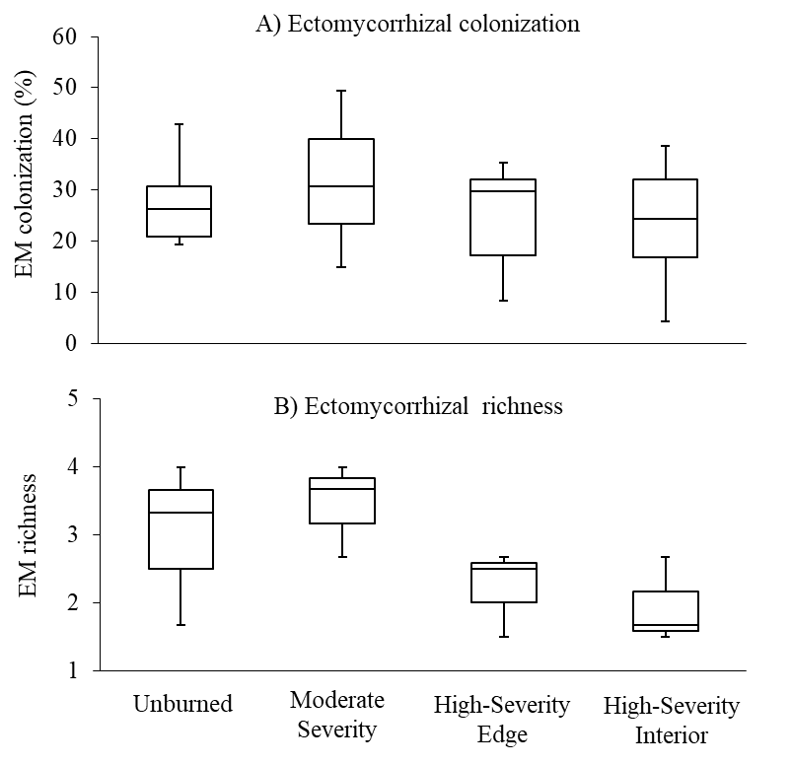
Appendix Figure S2: No significant differences were found among different burn severity classes for ectomycorrhizal root tip A) colonization, or B) richness. Boxplots represent the variation between sites, and span the first to the third quartile. A center line represents the median, and the “whiskers” above and below the box represent the minimum and maximum values.

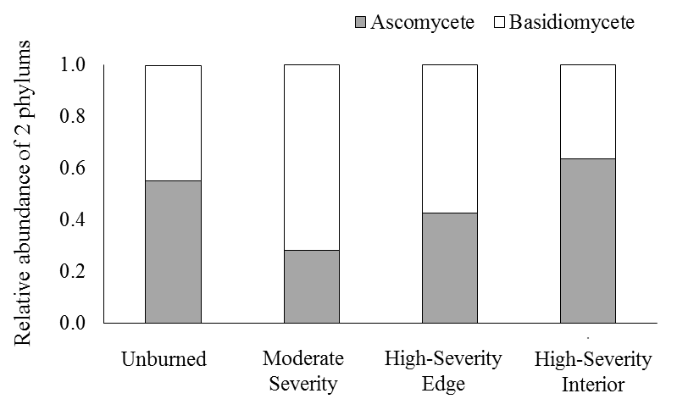

Appendix Figure S3: Mean relative abundance (proportion) of ascomycetes and basidiomycetes colonizing regenerating ponderosa pine seedlings in unburned, moderate-severity, high-severity edge and high-severity interior plots.
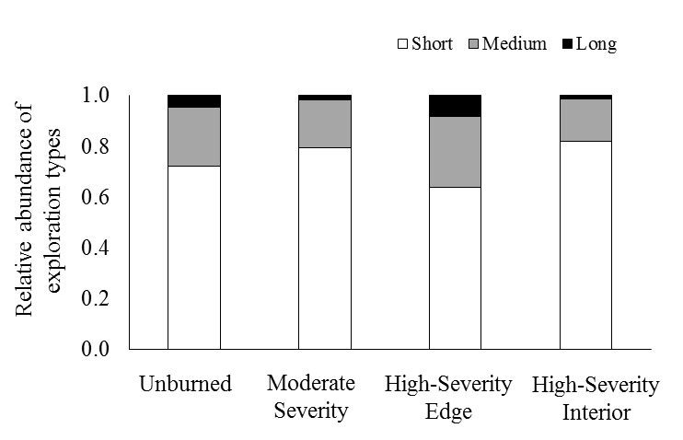
Appendix Figure S4: Mean relative abundance (proportion) of short, medium and long distance hyphal exploration types colonizing regenerating ponderosa pine seedlings in unburned, moderate-severity, high-severity edge, and high-severity interior plots.

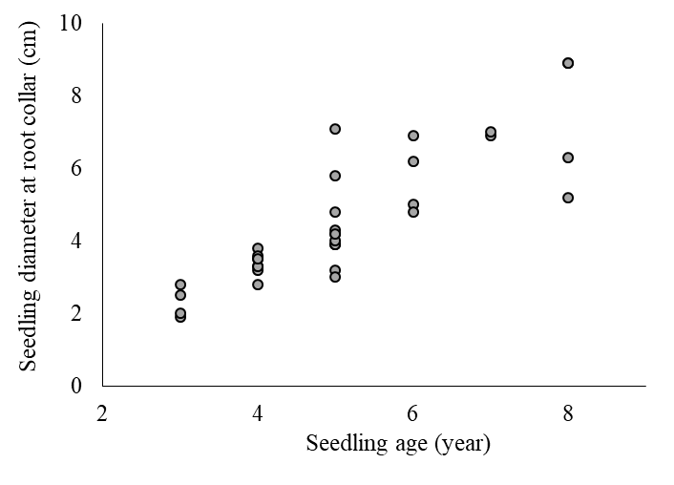
Appendix Figure S5: Regenerating ponderosa pine seedling age was correlated with growth, measured by diameter at root collar (DCR).

