Table S1 Locations and characteristics of the eight study sites in eastern Washington, consisting of four high severity burned Ponderosa pine sites, matched with four unburned sites. Fires: Tripod Complex (2006), Table Mountain (2012), Carlton Complex (2014), and North Star (2015). Three subplots were sampled at each site. Site and subplot descriptions, elevation, and slope measurements are based on the average of four separate measurements taken at each subplot. TSF: time since fire in years from the year the fire occurred to sampling year (2017).
Site | Plot | Latitude (W), | Parent Soil Type | Aspect | Avg Elev. (m) | Avg Slope (degrees) | TSF (years) | Area burned
Site | Plot | Longitude (N) |  |  |  |  |  | HSª/ Total burned(ha)ª
Tripod Complex Burned (2006) | 1 | 120˚05’53.620” 48˚34’14.544” | Series: Wapalp-Brevco Complex Parent: Mixed volcanic wash over glacial outwash Soil Txt: Stony ashy coarse, sandy loam | SE | 1200 | 18.84 | 11 | 28,210/ 69841
Tripod Complex Burned (2006) | 2 | 120˚05’52.279” 48˚34’13.209” |  | SE | 1184 | 17.14 | 11 | 28,210/ 69841
Tripod Complex Burned (2006) | 3 | 120˚05’50.768” 48˚34’14.375” |  | SE | 1181 | 19.62 | 11 | 28,210/ 69841
Tripod Complex Unburned (2006) | 1 | 120˚07’23.873” 48˚35’59.928” | Series: Wapal Parent: Mixed volcanic ash over glacial outwash Soil Txt: very stony, ashy coarse sandy loam | S | 1233 | 16.15 | n/a | n/a
Tripod Complex Unburned (2006) | 2 | 120˚07’24.750” 48˚35’58.362” |  | SW | 1218 | 21.89 | n/a | n/a
Tripod Complex Unburned (2006) | 3 | 120˚07’22.624” 48˚35’58.239” |  | S | 1224 | 13.15 | n/a | n/a
Table Mountain Burned (2012) | 1 | 120˚28’52.974” 47˚15’28.455” | Series: Jumpe Parent: Volc. Ash over igneous bedrock Soil Text: Stony Loam | S | 1322 | 9.22 | 5 | 5,592/ 26611
Table Mountain Burned (2012) | 2 | 120˚28’50.787” 47˚15’29.234” |  | S | 1325 | 10.75 | 5 | 5,592/ 26611
Table Mountain Burned (2012) | 3 | 120˚28’51.621” 47˚15’30.769” |  | S | 1334 | 13.35 | 5 | 5,592/ 26611
Table Mountain Unburned (2012) | 1 | 120˚26’ 8.108” 47˚13’30.940” | Series: Loneridge Parent: Volc. Ash over igneous bedrock Soil Text: Stony Loam | S | 1107 | 14.35 | n/a | n/a
Table Mountain Unburned (2012) | 2 | 120˚26’10.089” 47˚13’31.147” |  | S | 1115 | 13.9 | n/a | n/a
Table Mountain Unburned (2012) | 3 | 120˚26’12.108” 47˚13’31.431” |  | S | 1115 | 23.27 | n/a | n/a
Carlton Complex Burned (2014) | 1 | 119˚54’43.769” 48˚18’44.140” | Series: Merkel Parent: Mixed volcanic ash over glacial till (drift) Soil Text: Ashy sandy loam | S | 1177 | 14.27 | 3 | 13,287/ 115184
Carlton Complex Burned (2014) | 2 | 119˚54’41.470” 48˚18’44.624” |  | S | 1175 | 12.83 | 3 | 13,287/ 115184
Carlton Complex Burned (2014) | 3 | 119˚54’42.069” 48˚18’42.791” |  | E | 1162 | 12.84 | 3 | 13,287/ 115184
Carlton Complex Unburned (2014) | 1 | 119˚57’1.858” 48˚13’53.687” | Series: Katar Parent: Volacanic ash over glacial drift Soil Text: Stony sandy loam | E | 1063 | 4.18 | n/a | n/a
Carlton Complex Unburned (2014) | 2 | 119˚57’1.812” 48˚13’54.708” |  | SE | 1161 | 6.18 | n/a | n/a
Carlton Complex Unburned (2014) | 3 | 119˚57’3.872” 48˚13’56.541” |  | S | 1161 | 6.45 | n/a | n/a
North Star Burned (2015) | 1 | 118˚59’38.975” 48˚21’33.506” | Series: Republic loam Parent: Alluvium and glacial till mix, loes and volcanic ash Soil Text: Ashy loam | S | 1074 | 12.48 | 2 | 13,223/ 87735
North Star Burned (2015) | 2 | 118˚59’41.607” 48˚21’31.352” |  | SW | 1058 | 12.1 | 2 | 13,223/ 87735
North Star Burned (2015) | 3 | 118˚59’40.221” 48˚21’30.312” |  | S | 1056 | 11.67 | 2 | 13,223/ 87735
North Star Unburned (2015) | 1 | 119˚06’20.255” 48˚26’52.655” | Series: Nevine rock-outcrop Parent: Glacial till w a mantle of volcanic ash Soil Text: Ashy silt loam | S | 1181 | 14.83 | n/a | n/a
North Star Unburned (2015) | 2 | 119˚06’22.668" 48˚26’54.181” |  | SW | 1176 | 11.14 | n/a | n/a
North Star Unburned (2015) | 3 | 119˚06’23.988” 48˚26’51.962” |  | S | 1173 | 12.13 | n/a | n/a
^{9a} County and hectares burned at high severity (HS) and total area burned per fire. Area was modified from MTBS datasets.
Table S2 Mean summer temperature and precipitation (cm) of the eight study sites in eastern Washington, consisting of four high severity burned Ponderosa pine sites, matched with four unburned sites. Fires: Tripod Complex (2006), Table Mountain (2012), Carlton Complex (2014), and North Star (2015). Temperature and precipitation are based on the summer months (June-Sept 30 from the decade spanning the study 2006-2015).
Site | Fire Year | TSF (Yrs) | Summer Temp (˚C) | Summer Precip (cm)
Tripod Complex | 2006 | 11 | 13.8 | 11
Table Mountain | 2012 | 5 | 19.9 | 1.65
Carlton Comples | 2014 | 3 | 18.2 | 2.95
Northstar | 2015 | 2 | 19.4 | 2.62

Table S3 Results of Mantel correlograms for total fungi, ectomycorrhizal and saprobic fungal communities per site (Tripod, Carlton, Table Mountain, and Northstar) and respective treatments (B=burned, Un =unburned). P=adjusted is based on Mantel's r (p < 0.05) is based on Bonferroni corrected for a distance.
 | Dist (m) | Ndist | Mantel.cor | Pr(Mantel) | P-adj
Total Fungi
Tripod (B) | 2.93 | 184 | 0.09 | 0.028 | 0.03
Tripod (Un) | 2.93 | 184 | 0.09 | 0.03 | 0.03
Carlton (B) | 2.90 | 200 | 0.22 | 0.001 | <0.01
Carlton (Un) | 4.88 | 216 | 0.24 | 0.001 | <0.01
TableMountain (B) | 3.85 | 200 | 0.17 | 0.002 | <0.01
TableMountain (Un) | 4.27 | 216 | 0.36 | 0.001 | <0.01
NorthStar (B) | 5.09 | 216 | 0.21 | 0.001 | <0.01
NorthStar (Un) | 3.98 | 216 | 0.36 | 0.001 | <0.01
Ectomycorrhizal
Tripod (B) | 3.26 | 148 | 0.27 | 0.003 | <0.01
Tripod (Un) | 3.26 | 148 | 0.27 | 0.002 | <0.01
Carlton (B) | 3.23 | 128 | 0.30 | 0.001 | <0.01
Carlton (Un) | 4.88 | 216 | 0.07 | 0.063 | 0.06
TableMountain (B) | 4.27 | 128 | 0.10 | 0.025 | 0.03
TableMountain (Un) | 4.27 | 200 | 0.33 | 0.001 | <0.01
NorthStar (B) | 5.09 | 216 | 0.07 | 0.057 | 0.06
NorthStar (Un) | 3.98 | 216 | 0.28 | 0.001 | <0.01
Saprobes
Tripod (B) | 2.93 | 184 | 0.04 | 0.169 | 0.169
Tripod (Un) | 2.93 | 184 | 0.04 | 0.174 | 0.174
Carlton (B) | 2.90 | 216 | 0.17 | 0.003 | <0.01
Carlton (Un) | 4.88 | 186 | 0.24 | 0.001 | <0.01
TableMountain (B) | 3.85 | 216 | 0.11 | 0.003 | <0.01
TableMountain (Un) | 4.75 | 154 | 0.34 | 0.001 | <0.01
NorthStar (B) | 5.09 | 216 | 0.13 | 0.004 | <0.01
NorthStar (Un) | 3.98 | 186 | 0.31 | 0.001 | <0.01

Table S4 Descriptive statistics of all soil nutrients and depth of organic matter (OM) between treatments (burned vs. unburned) and time since fire for all wildfires and their percent change. Percentage of change with time since fire was based on comparisons to two years post-fire.
 | Treatment |  |  |  |  | Time Since Fire |  |  |  |  |  |  |  | Percentage of Change (time since fire)
 | Burned |  | Unburned |  | % change | 2yrs (2015) |  | 3yrs (2014) |  | 5yrs (2012) |  | 11yrs (2006) |  | 2yrs (2015) | 3yrs (2014) | 5yrs (2012) | 11yrs (2006)
 | Mean | SD | Mean | SD | % change | Mean | SD | Mean | SD | Mean | SD | Mean | SD
Total Carbon (C) | 2.27 | 1.22 | 2.35 | 1.13 | -3 | 3.15 | 1 | 2.86 | 0.76 | 1.93 | 1.37 | 1.12 | 0.2 | 0 | -9 | -39 | -65
Total Nitrogen (N) | 0.21 | 0.38 | 0.11 | 0.05 | 87 | 0.15 | 0.04 | 0.14 | 0.04 | 0.50 | 0.69 | 0.06 | 0.01 | 0 | -9 | 228 | -63
Total Phosphorus (TP) | 0.13 | 0.06 | 0.08 | 0.02 | 69 | 0.16 | 0.07 | 0.08 | 0.04 | 0.09 | 0.01 | 0.19 | 0.02 | 0 | -48 | -44 | 16
TC:TN Ratio | 18.46 | 5.91 | 20.62 | 2.67 | -10 | 20.56 | 2.33 | 20.90 | 1.76 | 12.48 | 8.82 | 19.97 | 2.44 | 0 | 88 | -5 | -73
TC:TP Ratio | 23.28 | 19 | 37 | 30.84 | -37 | 22.55 | 9.97 | 42.48 | 22.52 | 21.44 | 13.36 | 6 | 1.18 | 0 | 2 | -39 | -3
Organic depth | 0.86 | 0.87 | 4.71 | 2.64 | -82 | 0.27 | 0.42 | 1.01 | 1.12 | 1.07 | 0.63 | 1.12 | 0.89 | 0 | 271 | 295 | 312

Table S5 Generalized linear regression of the effect of treatment (burned versus unburned) on soil nutrients and depth of organic matter (OM) with site as random effect. Significance p<0.05 shown in bold. The base level for treatment set to burn sites.

Nutrient | Variable | Estimate | Std. Error | t value | P-value
Total Carbon | (Intercept) | 2.3462 | 0.1134 | 20.692 | <0.01
Total Carbon | Treatment | -0.0713 | 0.1607 | -0.444 | 0.66
Total Nitrogen | (Intercept) | 0.1145 | 0.0263 | 4.35 | <0.01
Total Nitrogen | Treatment | 0.0999 | 0.0373 | 2.676 | <0.01
Total Phosphorus | (Intercept) | 0.0767 | 0.0044 | 17.274 | <0.01
Total Phosphorus | Treatment | 0.0526 | 0.0063 | 8.358 | <0.01
TC: TN | (Intercept) | 20.6185 | 0.4403 | 46.826 | <0.01
TC: TN | Treatment | -2.156 | 0.6242 | -3.454 | <0.01
TC: TP | (Intercept) | 36.997 | 2.467 | 14.995 | <0.01
TC: TP | Treatment | -13.72 | 3.497 | -3.923 | <0.01
Depth OM | (Intercept) | 4.7076 | 0.1893 | 24.87 | <0.01
Depth OM | Treatment | -3.8439 | 0.2683 | -14.33 | <0.01

Table S6 Generalized linear regression of the effect of time since fire (years) on soil nutrients and depth of organic matter (OM) with site as random effect. Bold: p<0.05. X¹, X^{2,} and X³ represent the polynomial order of time since fire.
Nutrient | Coefficients | Estimate | Std. Error | t-value | P-value | R²
Total Carbon (TC) | Intercept | 4.3438 | 0.4189 | 10.37 | <0.01 | 0.41
Total Carbon (TC) | X¹ | -0.6220 | 0.1700 | -3.66 | <0.01 | 0.41
Total Carbon (TC) | X² | 0.0298 | 0.0125 | 2.39 | 0.02 | 0.41
 | Intercept | -0.3648 | 0.1582 | -2.31 | <0.01
Total Nitrogen (TN) | X¹ | 0.2676 | 0.0642 | 4.17 | <0.01 | 0.15
Total Nitrogen (TN) | X² | -0.0208 | 0.0047 | -4.41 | <0.01 | 0.15
 | Intercept | 0.5570 | 0.0767 | 7.26 | <0.01
Total Phosphorus (TP) | X¹ | -0.2964 | 0.0561 | -5.29 | <0.01 | 0.51
Total Phosphorus (TP) | X² | 0.0545 | 0.0114 | 4.77 | <0.01 | 0.51
Total Phosphorus (TP) | X³ | -0.0028 | 0.0006 | -4.38 | <0.01 | 0.51
 | Intercept | 31.9821 | 2.2609 | 14.15 | <0.01
TC: TN | X¹ | -5.8239 | 0.9177 | -6.35 | <0.01 | 0.27
TC: TN | X² | 0.4294 | 0.0675 | 6.37 | <0.01 | 0.27
 | Intercept | 115.3600 | 25.4320 | -4.54 | <0.01
TC: TP | X¹ | 109.0640 | 18.5870 | 5.87 | <0.01 | 0.45
TC: TP | X² | -22.5310 | 3.7950 | -5.94 | <0.01 | 0.45
TC: TP | X³ | 1.2380 | 0.2110 | 5.87 | <0.01 | 0.45
 | Intercept | 0.5413 | 0.1475 | 3.67 | <0.01
Depth OM | X¹ | 0.0620 | 0.0236 | 2.63 | <0.01 | 0.05

Table S7 Descriptive statistics of total fungal, ectomycorrhizal (EcM) and saprobic species richness between treatments (burned vs. unburned) and with time since fire for all four fires—Tripod Complex fire (2006, 11-years); Table Mountain fire (2012, 5 years); and Carlton Complex fire (2014, 3 years) and the North Star fire (2015, 2 years) and their percent change. Percentage of change with time since fire was based on comparisons to two years post-fire.

 | Total Fungi |  |  | EcM |  |  | Saprobes
Treatment | Mean | SD | % Change | Mean | SD | % Change | Mean | SD | % Change
Burned | 204 | 1.23 | -12.5 | 7.30 | 3.25 | -43.4 | 91.82 | 21.79 | -12.2
Unburned | 233 | 1.14 | -12.5 | 12.89 | 5.10 | -43.4 | 104.61 | 25.56 | -12.2
Time Since Fire (Years)
2yrs | 202 | 1 | 0 | 8.04 | 3.63 | 0.0 | 93.41 | 25.79 | 0.0
3yrs | 229 | 0.77 | 12.9 | 7.71 | 2.94 | -4.0 | 98.15 | 26.50 | 5.1
5yrs | 200 | 1.39 | -1.4 | 7.48 | 3.14 | -7.0 | 89.19 | 15.00 | -4.5
11yrs | 183 | 0.2 | -9.55 | 5.82 | 2.86 | -27.6 | 86.12 | 16.22 | -7.8

Table S8 Linear mixed effect model results for total fungi, ectomycorrhizal, and saprobic species richness and treatment effect. Significance, p<0.05 (Bold). The plot was used as a random effect for total fungi and saprobic species richness, and site for EcM species richness.
 | Fixed effect | Estimate | Std. Error | Df | t-value | Pr(>|t|)
Total Fungi | (Intercept) | 234.02 | 12.52 | 21.86 | 18.69 | <0.01
Total Fungi | Treatment (Burned) | -30.32 | 17.72 | 21.91 | -1.71 | 0.10
EcM | (Intercept) | 3.51 | 0.15 | 4.41 | 23.52 | <0.01
EcM | Treatment (Burned) | -0.88 | 0.13 | 18.68 | -6.72 | <0.01
Saprobe | Intercept) | 10.15 | 0.34 | 6.03 | 29.92 | <0.01
Saprobe | Treatment (Burned) | -0.64 | 0.48 | 5.98 | -1.33 | 0.23

Table S9 Results of the negative binomial regression for total fungi and ectomycorrhizal (EcM) species richness and Poisson regression for saprobic fungal species richness and time since fire (years). EcM richness contained site as a random effect, and total fungi and saprobic species richness included plot as a random effect. Significance p<0.05 shown in bold.
 | Coefficients |  | Estimate |  | Std. Error |  | z value |  | Pr(>|z|)
 | Total Fungi
(Intercept) |  | 5.308 |  | 0.051 |  | 104.48 |  | <0.01
TimeSinceFire-3 |  | 0.122 |  | 0.072 |  | 1.69 |  | 0.09
TimeSinceFire-5 |  | -0.012 |  | 0.072 |  | -0.17 |  | 0.86
TimeSinceFire-11 |  | -0.098 |  | 0.073 |  | -1.35 |  | 0.18
 | Ectomycorrhizal
 | (Intercept) |  | 2.08038 |  | 0.09645 |  | 21.57 |  | <0.01
 | TimeSinceFire-3 |  | -0.04797 |  | 0.14374 |  | -0.334 |  | 0.74
 | TimeSinceFire-5 |  | -0.07196 |  | 0.14406 |  | -0.5 |  | 0.62
 | TimeSinceFire-11 |  | -0.31887 |  | 0.14901 |  | -2.14 |  | 0.03
 | Saprobes
 | (Intercept) |  | 4.53697 |  | 0.01991 |  | 227.845 |  | <0.01
 | TimeSinceFire-3 |  | 0.04951 |  | 0.02782 |  | 1.78 |  | 0.08
 | TimeSinceFire-5 |  | -0.04626 |  | 0.02849 |  | -1.623 |  | 0.10
 | TimeSinceFire-11 |  | -0.08123 |  | 0.02934 |  | -2.768 |  | 5.63E-03

Table S10 Percentage of change in mean relative abundance in taxa between treatment (burned and unburned) for both ectomycorrhizal (EcM) and saprobic (Sap) fungi (Guild), and Kruskal-Wallis comparison of the relative abundant taxa. Significance p<0.05 shown in bold.
 |  | Mean Relative Abundance |  |  | Kruskal-Wallis
Genus | # of unique ASVs | Unburned | Burned | % Percent | χ² | DF | P-value
Ectomycorrhizal
Amphinema | 17 | 0.02 | 0.01 | -73.12 | 26.75 | 1 | 2.3E-07
Cenococcum | 9 | 0.01 | 0.07 | 659.8 | 3.09 | 1 | 0.08
Chromelosporium | 11 | 0 | 0.16 | Inf | 72.98 | 1 | 1.3E-17
Cortinarius | 31 | 0.05818 | 0.058987 | 1.39
Hygrophorus | 9 | 0.04 | 0 | -100 | 17.04 | 1 | 3.7E-05
Inocybe | 112 | 0.21 | 0.12 | -42.72 | 21.52 | 1 | 3.5E-06
Peziza | 5 | 1.7E-04 | 0.03 | 18853.76 | 17.12 | 1 | 3.5E-05
Piloderma | 25 | 0.08 | 0.00 | -96.26 | 21.67 | 1 | 3.2E-06
Pustularia | 9 | 2.8E-03 | 0.15 | 5244.46 | 63.10 | 1 | 2.0E-15
Rhizopogon | 23 | 0.03 | 0.02 | -45.79 | 8.08 | 1 | 0.004
Russula | 45 | 0.17 | 0.01 | -91.33 | 60.99 | 1 | 5.7E-15
Thelephora | 24 | 0.03 | 0.01 | -53.15 | 13.65 | 1 | 0.0002
Tuber | 2 | 0.03 | 4.0E-04 | -98.6 | 5.70 | 1 | 0.02
Wilcoxina | 15 | 0.19 | 0.24 | 29 | 0.45 | 1 | 0.50
Saprobes
Archaeorhizomyces | 239 | 0.22 | 0.15 | -30.27 | 15.01 | 1 | 1.1E-04
Basidioascus | 9 | 7.9E-04 | 0.04 | 4896.7 | 82.21 | 1 | 1.2E-19
Calyptrozyma | 1 | 3.2E-03 | 0.03 | 806.91 | 108.86 | 1 | 1.7E-25
Cladophialophora | 111 | 0.03 | 0.00 | -84.04 | 115.65 | 1 | 5.7E-27
Geminibasidium | 47 | 0.14 | 0.16 | 11.3 | 0.48 | 1 | 0.49
Hygrocybe | 69 | 0.11 | 0.03 | -76.36 | 19.70 | 1 | 9.1E-06
Mortierella | 125 | 0.03 | 0.02 | -47.64 | 38.70 | 1 | 5.0E-10
Penicillium | 96 | 0.09 | 0.11 | 19.69 | 2.56 | 1 | 0.11
Pseudeurotium | 26 | 0.03 | 0.01 | -52.27 | 42.84 | 1 | 6.0E-11
Rasamsonia | 3 | 5.0E-06 | 0.03 | 553540 | 46.72 | 1 | 8.2E-12
Sagenomella | 14 | 0.03 | 0.02 | -48.18 | 1.92 | 1 | 0.17
Solicoccozyma | 9 | 0.05 | 0.03 | -48.19 | 7.71 | 1 | 0.01
Umbelopsis | 36 | 0.06 | 0.06 | 9.86 | 0.61 | 1 | 0.44

Table S11 Deseq log2fold analysis for ectomycorrhizal and saprobicfungi enriched in the burned sites. Only taxa, which were significantly differentially abundant, EcM: p<0.05, Sap: p <0.001, are listed. A total of 32 ectomycorrhizal taxa were shown at p<0.05 and 106 saprobes at p <0.05 (not shown) and 61 at p<0.001. Significance shown in bold.

Phylum | Genus | Species | Base Mean | log2fold Change | P-adj
Ectomycorrhizal
Ascomycota | Chromelosporium | Chromelosporium carneum | 49.52 | 9.94 | <0.01
Basidiomycota | Hygrophorus | Hygrophorus chrysodon | 5.83 | -24.34 | <0.01
Basidiomycota | Hygrophorus | Hygrophorus gliocyclus | 3.89 | -23.75 | <0.01
Basidiomycota | Piloderma | Piloderma Sp. | 4.27 | -23.91 | <0.01
Ascomycota | Pustularia | Pustularia Sp. | 62.18 | 4.14 | <0.01
Basidiomycota | Russula | Russula cuprea | 80.20 | -6.25 | <0.01
Basidiomycota | Cortinarius | Cortinarius vernus | 35.54 | -4.65 | <0.01
Ascomycota | Morchella | Morchella elata | 2.66 | 5.46 | <0.01
Basidiomycota | Tricholoma | Tricholoma triste | 7.92 | -6.84 | <0.01
Ascomycota | Geopyxis | Geopyxis delectans | 3.48 | 6.43 | <0.01
Basidiomycota | Inocybe | Inocybe nitidiuscula | 64.33 | -5.17 | <0.01
Basidiomycota | Tomentella | Tomentella Sp. | 5.32 | -4.57 | <0.01
Basidiomycota | Cortinarius | Cortinarius diasemospermus | 12.79 | -6.03 | <0.01
Ascomycota | Peziza | Peziza nivalis | 3.95 | 6.46 | <0.01
Basidiomycota | Rhizopogon | Rhizopogon salebrosus | 5.14 | -4.11 | <0.01
Ascomycota | Cenococcum | Cenococcum Sp. | 5.38 | 4.88 | <0.01
Basidiomycota | Amphinema | Amphinema Sp. | 4.02 | -4.10 | <0.01
Ascomycota | Trichophaea | Trichophaea hybrida | 1.88 | 5.52 | <0.01
Basidiomycota | Thelephora | Thelephora caryophyllea | 5.01 | -4.14 | <0.01
Basidiomycota | Piloderma | Piloderma Sp. | 10.07 | -4.34 | <0.01
Basidiomycota | Rhizopogon | Rhizopogon salebrosus | 7.50 | -2.70 | <0.01
Basidiomycota | Tylospora | Tylospora Sp. | 4.36 | -3.86 | <0.01
Ascomycota | Tuber | Tuber whetstonense | 7.92 | -7.59 | <0.01
Basidiomycota | Thelephora | Thelephora Sp. | 3.06 | -3.77 | <0.01
Basidiomycota | Inocybe | Inocybe egenula | 13.58 | -3.44 | <0.01
Basidiomycota | Cortinarius | Cortinarius sp. aff. belleri | 2.79 | -3.64 | <0.01
Basidiomycota | Cortinarius | Cortinarius Sp. | 7.40 | -4.09 | <0.01
Basidiomycota | Inocybe | Inocybe nitidiuscula | 8.71 | -3.97 | <0.01
Ascomycota | Wilcoxina | Wilcoxina rehmii | 416.87 | -1.34 | <0.01
Ascomycota | Chromelosporium | Chromelosporium carneum | 1.54 | 4.86 | <0.01
Saprobes
Ascomycota | Ochrocladosporium | Ochrocladosporium elatum | 38.33 | 26.30 | <0.01
Mucoromycota | Umbelopsis | Umbelopsis dimorpha | 32.37 | -25.12 | <0.01
Basidiomycota | Tephrocybe | Tephrocybe anthracophila | 21.73 | 26.03 | <0.01
Basidiomycota | Geminibasidium | Geminibasidium donsium | 11.41 | 24.96 | <0.01
Ascomycota | Anthracobia | Anthracobia macrocystis | 38.26 | 7.96 | <0.01
Ascomycota | Pyronema | Pyronema domesticum | 50.96 | 11.11 | <0.01
Ascomycota | Rasamsonia | Rasamsonia brevistipitata | 31.19 | 11.19 | <0.01
Ascomycota | Penicillium | Penicillium fellutanum | 175.99 | 2.45 | <0.01
Basidiomycota | Cotylidia | Cotylidia undulata | 21.25 | 7.50 | <0.01
Basidiomycota | Basidioascus | Basidioascus magus | 99.71 | 5.76 | <0.01
Ascomycota | Calyptrozyma | Calyptrozyma Sp. | 125.10 | 3.45 | <0.01
Ascomycota | Warcupia | Warcupia terrestris | 16.79 | 5.46 | <0.01
Basidiomycota | Lyophyllum | Lyophyllum Sp. | 15.95 | 8.71 | <0.01
Basidiomycota | Leucosporidium | Leucosporidium Sp. | 62.65 | 6.04 | <0.01
Basidiomycota | Geminibasidium | Geminibasidium hirsutum | 15.00 | 7.86 | <0.01
Ascomycota | Cladophialophora | Cladophialophora Sp. | 4.71 | -5.75 | <0.01
Basidiomycota | Basidioascus | Basidioascus magus | 38.00 | 9.09 | <0.01
Ascomycota | Coniochaeta | Coniochaeta hoffmannii | 6.24 | 6.01 | <0.01
Ascomycota | Gymnostellatospora | Gymnostellatospora alpina | 10.56 | 4.68 | <0.01
Ascomycota | Herpotrichiellaceae | Herpotrichiellaceae Sp. | 12.97 | -4.62 | <0.01
Mucoromycota | Umbelopsis | Umbelopsis dimorpha | 83.06 | 6.21 | <0.01
Basidiomycota | Geminibasidium | Geminibasidium Sp. | 123.70 | 3.29 | <0.01
Ascomycota | Penicillium | Penicillium arenicola | 39.99 | 2.56 | <0.01
Ascomycota | Cladophialophora | Cladophialophora Sp. | 20.97 | -4.04 | <0.01
Ascomycota | Archaeorhizomyces | Archaeorhizomyces Sp. | 8.84 | -6.58 | <0.01
Ascomycota | Coniochaeta | Coniochaeta Sp. | 6.78 | -5.94 | <0.01
Ascomycota | Penicillium | Penicillium Sp. | 4.55 | -4.20 | <0.01
Ascomycota | Talaromyces | Talaromyces aculeatus | 8.55 | -2.72 | <0.01
Ascomycota | Penicillium | Penicillium Sp. | 5.20 | 5.75 | <0.01
Ascomycota | Coniochaeta | Coniochaeta cipronana | 18.13 | 3.88 | <0.01
Ascomycota | Coniochaeta | Coniochaeta cipronana | 4.46 | -5.50 | <0.01
Ascomycota | Trichosporiella | Trichosporiella cerebriformis | 25.36 | 3.07 | <0.01
Mortierellomycota | Mortierella | Mortierella alpina | 5.63 | -6.01 | <0.01
Ascomycota | Penicillium | Penicillium Sp. | 9.06 | -5.46 | <0.01
Ascomycota | Tetracladium | Tetracladium Sp. | 11.10 | 2.34 | <0.01
Ascomycota | Trichoderma | Trichoderma sulphureum | 20.09 | 2.60 | <0.01
Mucoromycota | Umbelopsis | Umbelopsis Sp. | 4.42 | -4.61 | <0.01
Ascomycota | Sagenomella | Sagenomella verticillata | 4.36 | 5.49 | <0.01
Ascomycota | Penicillium | Penicillium chermesinum | 99.80 | 1.20 | <0.01
Basidiomycota | Geminibasidium | Geminibasidium Sp. | 446.95 | 0.74 | <0.01
Ascomycota | Tricharina | Tricharina praecox | 3.08 | 4.94 | <0.01
Basidiomycota | Holtermanniella | Holtermanniella takashimae | 47.26 | 1.49 | <0.01
Ascomycota | Coniochaeta | Coniochaeta fodinicola | 3.74 | 5.27 | <0.01
Ascomycota | Leohumicola | Leohumicola Sp. | 19.45 | 4.69 | <0.01
Ascomycota | Cladophialophora | Cladophialophora Sp. | 3.41 | -5.29 | <0.01
Basidiomycota | Geminibasidium | Geminibasidium hirsutum | 6.84 | 6.14 | <0.01
Ascomycota | Selenophoma | Selenophoma mahoniae | 3.96 | 3.50 | <0.01
Ascomycota | Glarea | Glarea lozoyensis | 5.52 | 3.13 | <0.01
Ascomycota | Cladophialophora | Cladophialophora chaetospira | 2.78 | -4.82 | <0.01
Ascomycota | Trichocladium | Trichocladium opacum | 5.29 | 4.60 | <0.01
Ascomycota | Un. Melanommataceae | Melanommataceae Sp. | 21.64 | 2.24 | <0.01
Ascomycota | Cladophialophora | Cladophialophora Sp. | 13.40 | -2.53 | <0.01
Ascomycota | Cladophialophora | Cladophialophora chaetospira | 3.34 | -4.75 | <0.01
Ascomycota | Strattonia | Strattonia minor | 3.59 | 4.87 | <0.01
Ascomycota | Un. Herpotrichiellaceae | Herpotrichiellaceae Sp. | 10.90 | -3.47 | <0.01
Mucoromycota | Umbelopsis | Umbelopsis Sp. | 34.85 | -1.63 | <0.01
Basidiomycota | Pachylepyrium | Pachylepyrium carbonicola | 1.59 | 4.05 | <0.01
Ascomycota | Leohumicola | Leohumicola Sp. | 10.85 | 4.78 | <0.01
Ascomycota | Archaeorhizomyces | Archaeorhizomyces Sp. | 16.16 | -3.72 | <0.01
Ascomycota | Capnobotryella | Capnobotryella Sp. | 4.00 | -5.11 | <0.01
Ascomycota | Ochrocladosporium | Ochrocladosporium elatum | 3.97 | 4.06 | <0.01
Ascomycota | Hyaloscypha | Hyaloscypha Sp. | 4.46 | -4.58 | <0.01

Table S12 Results of PERMANOVA full model analysis for ectomycorrhizal (EcM) and saprobic species richness and soil nutrients- total phosphorus, total carbon, total nitrogen, and the ratio between total carbon and total phosphorus and total carbon to total nitrogen, and site variables -depth of organic matter, distance to nearest P. ponderosa (m) and slope, elevation (m), time since fire (years) and treatment (burned vs. unburned) . Significance p<0.05 (bold).
Variable | Df | SumOfSqs | R² | F | Pr(>F)
Ectomycorrhizal
Treatment | 1 | 4.771 | 0.053 | 12.616 | <0.01
Time Since Fire (years) | 3 | 5.791 | 0.064 | 5.104 | <0.01
Depth Organic matter | 1 | 1.024 | 0.011 | 2.709 | <0.01
Aspect | 3 | 2.647 | 0.029 | 2.333 | <0.01
Total Phosphorus | 1 | 0.775 | 0.009 | 2.050 | <0.01
Total Carbon: Total Phosphorus | 1 | 1.446 | 0.016 | 3.824 | <0.01
Total Carbon | 1 | 0.640 | 0.007 | 1.693 | <0.01
Slope | 1 | 1.158 | 0.013 | 3.063 | <0.01
Elevation | 1 | 0.782 | 0.009 | 2.068 | <0.01
Treatment: Time Since Fire | 3 | 3.029 | 0.034 | 2.670 | <0.01
Treatment: Depth Organic matter | 1 | 0.481 | 0.005 | 1.271 | 0.08
Residual | 178 | 67.315 | 0.749
Saprobes
Treatment | 1 | 5.050 | 0.070 | 20.037 | <0.01
Time Since Fire | 3 | 8.017 | 0.110 | 10.604 | <0.01
Aspect | 3 | 4.091 | 0.056 | 5.410 | <0.01
Depth Organic matter | 1 | 0.871 | 0.012 | 3.458 | <0.01
TP | 1 | 0.874 | 0.012 | 3.469 | <0.01
TC.TP | 1 | 1.311 | 0.018 | 5.203 | <0.01
TC | 1 | 0.541 | 0.007 | 2.145 | <0.01
TN | 1 | 0.514 | 0.007 | 2.039 | <0.01
Elevation | 1 | 0.941 | 0.013 | 3.733 | <0.01
Slope | 1 | 0.976 | 0.013 | 3.871 | <0.01
Treatment: Time Since Fire | 3 | 2.436 | 0.034 | 3.222 | <0.01
Treatment: Depth Organic matter | 1 | 0.397 | 0.005 | 1.573 | 0.02
Residual | 185 | 46.624 | 0.642

Table S13 Correlations of soil nutrient and site variables with the NMDS ordinations of ectomycorrhizal (EcM) and saprobic fungal communities. Significance of the correlation based on the envfit function (9999 permutations) with the site as a random effect.
 | NMDS1 | NMDS2 | r2 | Pr(>r)
Ectomycorrhizal
Depth organic matter | 0.50853 | -0.86104 | 0.383 | <0.01
Distance Tree | -0.3614 | 0.93241 | 0.1485 | <0.01
Total phosphorus | -0.59612 | 0.8029 | 0.1084 | <0.01
Total carbon: total phosphorus | 0.98424 | -0.17684 | 0.143 | <0.01
Slope | 0.8317 | 0.55522 | 0.0855 | 0.04
Saprobes
Total carbon: total phosphorus | 0.48793 | 0.87288 | 0.3949 | 0.03
Total carbon | 0.04208 | 0.99911 | 0.2695 | 0.02

Table S14 Percentage of change in the mean relative abundance of ectomycorrhizal and saprobic fungi with time since fire, based on fires burned in 2006 (11 years); 2012 (5 years); 2014 (3 years) and 2015 (2 years). All values were calculated in comparison to 2 years post-fire. A negative value indicates a decrease in relative abundance and a positive value indicates and increase in relative abundance.
Ectomycorrhizal |  |  |  | Saprobes
Genus | TSF | Mean Rel. Abund | % Change | Genus | TSF |  | Mean Rel. Abund | % Change
Cenococcum | 2 | 0.013 | 0 | Archaeorhizomyces |  | 2 | 0.095 | 0
Cenococcum | 3 | 0.127 | 894.71 |  |  | 3 | 0.024 | -74.75
Cenococcum | 5 | 0.139 | 982.67 |  |  | 5 | 0.130 | 36.61
Cenococcum | 11 | 0.012 | -2.87 |  |  | 11 | 0.375 | 293.4
Chromelosporium | 2 | 0.143 | 0 | Basidioascus |  | 2 | 0.049 | 0
Chromelosporium | 3 | 0.103 | -28.17 |  |  | 3 | 0.054 | 10.49
Chromelosporium | 5 | 0.413 | 187.66 |  |  | 5 | 0.052 | 6.15
Chromelosporium | 11 | 0.006 | -95.9 |  |  | 11 | 0.001 | -98.44
Clitocybe | 2 | 0 | NA | Calyptrozyma |  | 2 | 0.031 | 0
Clitocybe | 3 | 0 | NA |  |  | 3 | 0.044 | 42.1
Clitocybe | 5 | 0.020 | Inf |  |  | 5 | 0.018 | -42.6
Clitocybe | 11 | 0 | NA |  |  | 11 | 0.024 | -21.11
Cortinarius | 2 | 0.030 | 0 | Clavaria |  | 2 | 0.002 | 0
Cortinarius | 3 | 0.099 | 226.37 |  |  | 3 | 0.009 | 318.01
Cortinarius | 5 | 0.020 | -34.29 |  |  | 5 | 0.002 | -12.07
Cortinarius | 11 | 0.093 | 208.18 |  |  | 11 | 0.032 | 1366.04
Geopyxis | 2 | 0.044 | 0 | Coniochaeta |  | 2 | 0.023 | 0
Geopyxis | 3 | 0 | -100 |  |  | 3 | 0.007 | -70.03
Geopyxis | 5 | 0.008 | -82.47 |  |  | 5 | 0.020 | -13.49
Geopyxis | 11 | 0 | -100 |  |  | 11 | 0.009 | -58.95
Hebeloma | 2 | 0.001 | 0 | Geminibasidium |  | 2 | 0.199 | 0
Hebeloma | 3 | 0 | -100 |  |  | 3 | 0.198 | -0.81
Hebeloma | 5 | 0 | -100 |  |  | 5 | 0.120 | -40
Hebeloma | 11 | 0.042 | 6162.85 |  |  | 11 | 0.110 | -44.94
Inocybe | 2 | 0.059 | 0 | Holtermanniella |  | 2 | 0.007 | 0
Inocybe | 3 | 0.261 | 345.98 |  |  | 3 | 0.004 | -34.65
Inocybe | 5 | 0.043 | -27.33 |  |  | 5 | 0.022 | 220.7
Inocybe | 11 | 0.136 | 132.76 |  |  | 11 | 0.003 | -51.06
Morchella | 2 | 0.003 | 0 | Hygrocybe |  | 2 | 0.012 | 0
Morchella | 3 | 0.002 | -48.56 |  |  | 3 | 0.023 | 97.17
Morchella | 5 | 0.027 | 714.64 |  |  | 5 | 0.016 | 33.57
Morchella | 11 | 0.022 | 563.65 |  |  | 11 | 0.053 | 347.64
Peziza | 2 | 0.001 | 0 | Leohumicola |  | 2 | 0.014 | 0
Peziza | 3 | 0.091 | 6656.42 |  |  | 3 | 0.035 | 148.14
Peziza | 5 | 0.047 | 3370.9 |  |  | 5 | 0.014 | -4.08
Peziza | 11 | 0.002 | 84.04 |  |  | 11 | 0.000 | -100
Pustularia | 2 | 0.386 | 0 | Leucosporidium |  | 2 | 0.016 | 0
Pustularia | 3 | 0.026 | -93.31 |  |  | 3 | 0.000 | -99.9
Pustularia | 5 | 0.100 | -74.12 |  |  | 5 | 0.009 | -45.31
Pustularia | 11 | 0.019 | -95.06 |  |  | 11 | 0.039 | 139.12
Rhizopogon | 2 | 0.003 | 0 | Lyophyllum |  | 2 | 0.020 | 0
Rhizopogon | 3 | 0.049 | 1716.26 |  |  | 3 | 0.024 | 20.83
Rhizopogon | 5 | 0.008 | 189.24 |  |  | 5 | 0.011 | -44.57
Rhizopogon | 11 | 0.017 | 514.7 |  |  | 11 | 0.001 | -95.47
Russula | 2 | 0.032 | 0 | Mortierella |  | 2 | 0.010 | 0
Russula | 3 | 0.003 | -91.79 |  |  | 3 | 0.026 | 165.49
Russula | 5 | 0.017 | -45.29 |  |  | 5 | 0.019 | 101.08
Russula | 11 | 0.002 | -92.17 |  |  | 11 | 0.018 | 86.08
Sistotrema | 2 | 0 | NA | Neurospora |  | 2 | 0 | 0
Sistotrema | 3 | 0.011 | Inf |  |  | 3 | 0.001 | 6558.82
Sistotrema | 5 | 0.023 | Inf |  |  | 5 | 0.033 | 192800
Sistotrema | 11 | 0.022 | Inf |  |  | 11 | 0 | -100
Thelephora | 2 | 0.001 | 0 | Ochrocladosporium |  | 2 | 0.029 | 0
Thelephora | 3 | 0.024 | 3504.61 |  |  | 3 | 0.008 | -71.17
Thelephora | 5 | 0.003 | 285.88 |  |  | 5 | 0.001 | -98.19
Thelephora | 11 | 0.024 | 3461.22 |  |  | 11 | 0.0005 | -98.45
Trichophaea | 2 | 0.025 | 0 | Penicillium |  | 2 | 0.105 | 0
Trichophaea | 3 | 0 | -100 |  |  | 3 | 0.157 | 49.09
Trichophaea | 5 | 0.022 | -13.13 |  |  | 5 | 0.095 | -9.46
Trichophaea | 11 | 0 | -100 |  |  | 11 | 0.060 | -42.67
Wilcoxina | 2 | 0.213 | 0 | Pseudeurotium |  | 2 | 0.008 | 0
Wilcoxina | 3 | 0.155 | -27.04 |  |  | 3 | 0.031 | 300.3
Wilcoxina | 5 | 0.040 | -81.08 |  |  | 5 | 0.012 | 60.5
Wilcoxina | 11 | 0.552 | 159.27 |  |  | 11 | 0.006 | -29.04
 |  |  |  | Pyronema |  | 2 | 0.031 | 0
 |  |  |  |  |  | 3 | 0.025 | -19.36
 |  |  |  |  |  | 5 | 0.002 | -94.75
 |  |  |  |  |  | 11 | 0.001 | -98.19
 |  |  |  | Rasamsonia |  | 2 | 0.092 | 0
 |  |  |  |  |  | 3 | 0.017 | -81.92
 |  |  |  |  |  | 5 | 0.000 | -99.98
 |  |  |  |  |  | 11 | 0 | -100
 |  |  |  | Rutstroemia |  | 2 | 0.001 | 0
 |  |  |  |  |  | 3 | 0.027 | 4341.97
 |  |  |  |  |  | 5 | 0.014 | 2275.08
 |  |  |  |  |  | 11 | 0.002 | 191.15
 |  |  |  | Sagenomella |  | 2 | 0.008 | 0
 |  |  |  |  |  | 3 | 0.008 | 1.35
 |  |  |  |  |  | 5 | 0.023 | 169.8
 |  |  |  |  |  | 11 | 0.033 | 291.77
 |  |  |  | Solicoccozyma |  | 2 | 0.011 | 0
/ |  |  |  |  |  | 3 | 0.027 | 141.8
 |  |  |  |  |  | 5 | 0.064 | 461.46
 |  |  |  |  |  | 11 | 0.008 | -28.98

Table S15 Generalized linear regression of ectomycorrhizal and saprobic genera and time since fire. m Bold: p<0.05.

Genus | Df | Sum Sq | Mean Sq | F value | Pr(>F)
Ectomycorrhizal
Cenococcum | 3 | 0.329 | 0.109 | 5.32 | 0.002
Chromelosporium | 3 | 1.937 | 0.646 | 13.04 | <0.01
Cortinarius | 3 | 0.114 | 0.038 | 1.67 | 0.2
ClitocybeB | 3 | 0.006 | 0.002 | 1.46 | 0.2
EntolomaB | 3 | 0.013 | 0.004 | 0.98 | 0.4
Geopyxis | 3 | 0.034 | 0.011 | 6.55 | <0.01
Hebeloma | 3 | 0.029 | 0.010 | 1.52 | 0.2
Inocybe | 3 | 0.653 | 0.22 | 5.22 | <0.01
Morchella | 3 | 0.011 | 0.004 | 1.67 | 0.2
Peziza | 3 | 0.122 | 0.041 | 1.93 | 0.1
Pustularia | 3 | 2.256 | 0.752 | 18.49 | <0.01
Rhizopogon | 3 | 0.029 | 0.010 | 2.34 | 0.1
Russula | 3 | 0.014 | 0.005 | 1.16 | 0.3
Sistotrema | 3 | 0.009 | 0.003 | 0.95 | 0.4
Thelephora | 3 | 0.012 | 0.004 | 0.98 | 0.4
Trichophaea | 3 | 0.013 | 0.004 | 1.499 | 0.2
Wilcoxina | 3 | 3.146 | 1.049 | 13.32 | <0.01
Saprobes
Anthracobia | 3 | 0.010 | 0.003 | 10.25 | <0.01
Archaeorhizomyces | 3 | 1.786 | 0.595 | 23.72 | <0.01
Basidioascus | 3 | 0.049 | 0.016 | 4.50 | <0.01
Calyptrozyma | 3 | 0.010 | 0.003 | 3.31 | 0.02
Clavaria | 3 | 0.016 | 0.005 | 11.98 | <0.01
Coniochaeta | 3 | 0.005 | 0.002 | 2.79 | 0.04
Geminibasidium | 3 | 0.187 | 0.062 | 6.30 | <0.01
Holtermanniella | 3 | 0.006 | 0.002 | 8.88 | <0.01
Hygrocybe | 3 | 0.026 | 0.009 | 2.10 | 0.105
Leohumicola | 3 | 0.016 | 0.005 | 3.73 | 0.01
Leucosporidium | 3 | 0.022 | 0.007 | 10.52 | <0.01
Mortierella | 3 | 0.004 | 0.001 | 4.96 | <0.01
Neurospora | 3 | 0.021 | 0.007 | 2.55 | 0.06
Ochrocladosporium | 3 | 0.015 | 0.005 | 13.14 | <0.01
Penicillium | 3 | 0.125 | 0.042 | 11.10 | <0.01
Pseudeurotium | 3 | 0.011 | 0.004 | 6.55 | <0.01
Pyronema | 3 | 0.020 | 0.007 | 5.86 | <0.01
Rasamsonia | 3 | 0.155 | 0.052 | 5.94 | <0.01
Rutstroemia | 3 | 0.012 | 0.004 | 0.84 | 0.48
Sagenomella | 3 | 0.011 | 0.004 | 13.70 | <0.01
SolicoccozymaB | 3 | 0.052 | 0.017 | 4.09 | <0.01
TephrocybeB | 3 | 0.021 | 0.007 | 3.70 | 0.01
Umbelopsis | 3 | 0.129 | 0.043 | 16.94 | <0.01

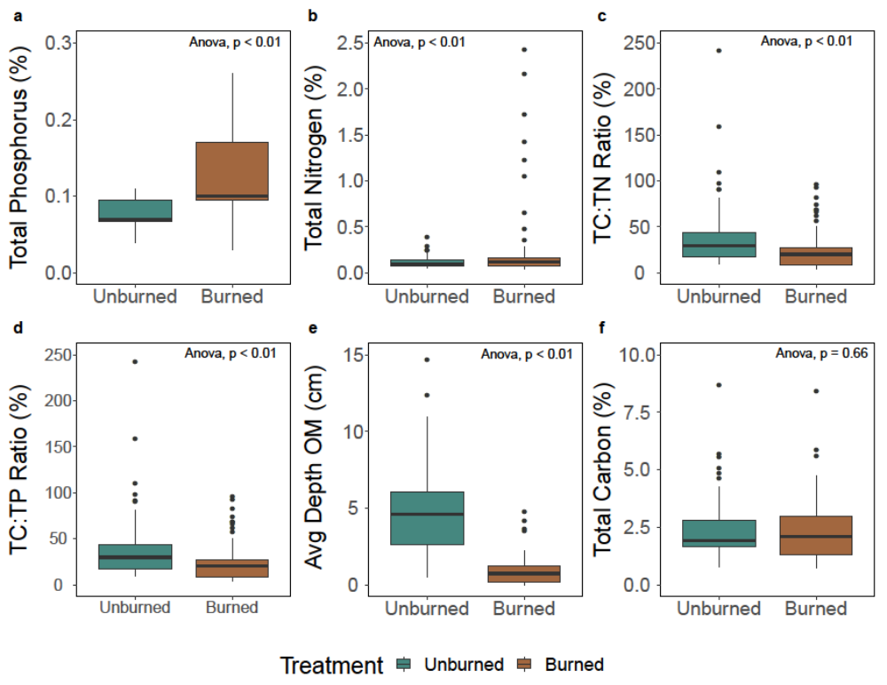
Fig. S1 Differences between treatments (Burned, Unburned) in soil nutrients and percentage of nutrients. (a) Total phosphorus (TP), (b) Depth of organic matter (OM), (c) TC:TP ratio, (d) TC:TN ratio, (e) total carbon (TC), (f) total nitrogen (TN). Significance based on p<0.05.

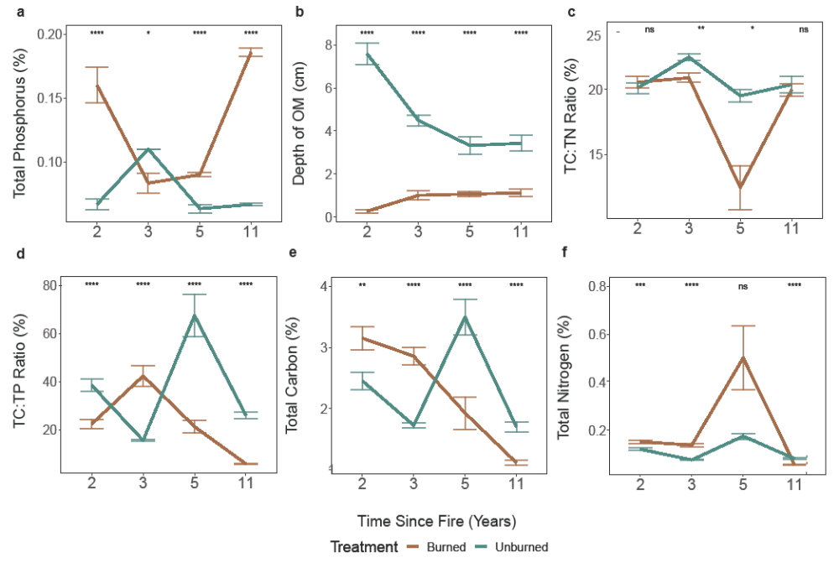
Fig. S2 Differences between treatments (Burned, Unburned) in soil nutrients and depth of organic matter (OM) with time since fire (years). (a) Total phosphorus (TP), (b) Depth of organic matter, (c) TC:TP ratio, (d) TC:TN ratio, (e) total carbon (TC), and (f) total nitrogen (TN). Significance is based on Kruskal-Wallis (KW) comparing treatment effects per time since fire at p<0.05.

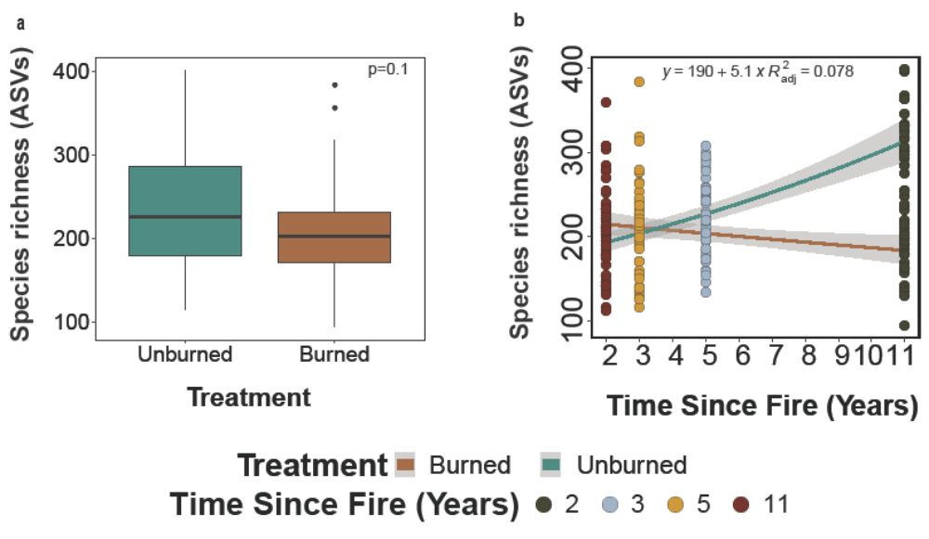
Fig. S3 Total fungal species richness based on observed amplicon sequence variants (AVSs) (a) between treatments (burned and unburned sites) and (b) with time since fire (years). ANOVA, significance at p<0.05 based on log-transformed data. Significance for time since fire is based on comparison between time since fire for burned sites only.

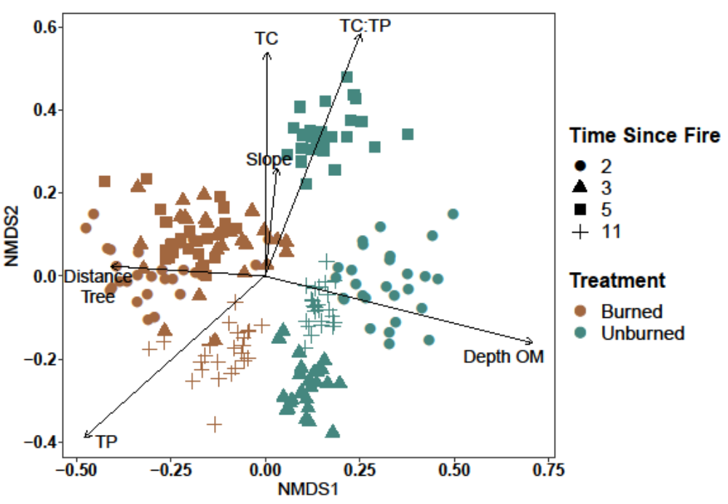
Fig. S4 NMDS plot of total fungal community assemblages per treatment (burned (brown), and unburned (blue-green), on 3-dimensions. Based on Bray-Curtis dissimilarity matrix, stress level. Points closer together in the ordination space have more similar community assemblages (significance at p<0.05).

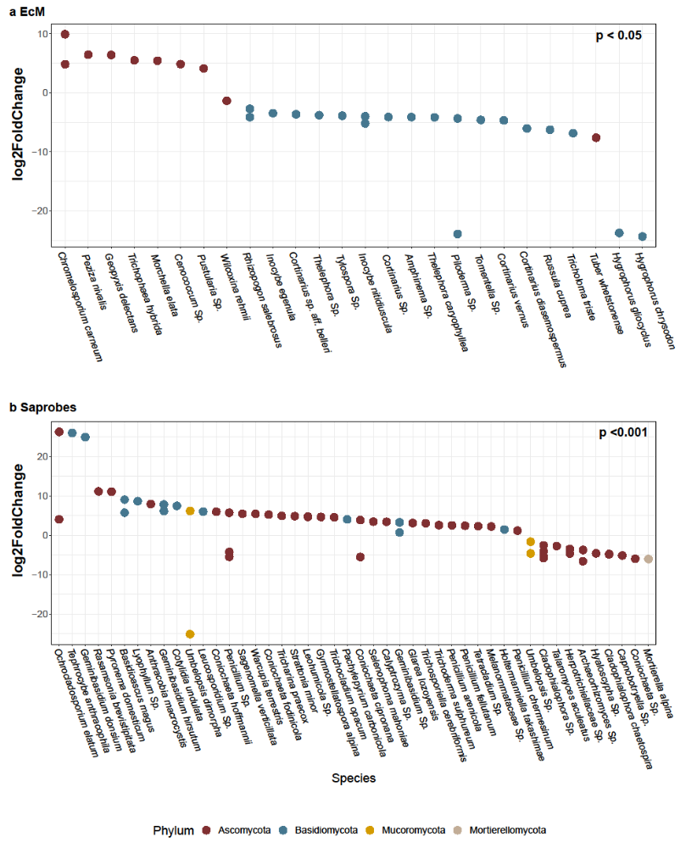
Fig. S5 Differential representation of ASVs between burned and unburned sites and (a)
ectomycorrhizal (EcM) and (b) saprobic fungi, based on a negative binomial regression at the species level. Significance based on nwald, likelihood ratio. Dots represent the taxa, colored by phylum and labeled by species. Positive values indicate a positive response to fire. Negative values represent a negative response to fire in the burned sites and higher representation in the unburned sites. Only probabilities with a differential abundance at p.adj <0.05 and a log2fold change above zero are included.

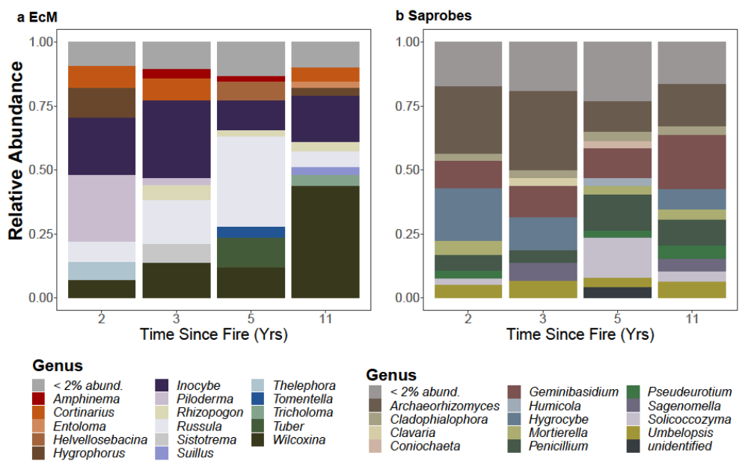

Fig. S6 The relative abundance of fungi at the genus level with time since fire for the (a) ectomycorrhizal (EcM) and (b) saprobic communities in unburned sites matched to the four burned treatment sites (Fig. 8). Time Since Fire: 2 years (2015 North Star Fire); 3 years (2014 Carlton Complex Fire), 5 years (2012 Table Mountain Fire), and 11 years (2006 Tripod Complex Fire).

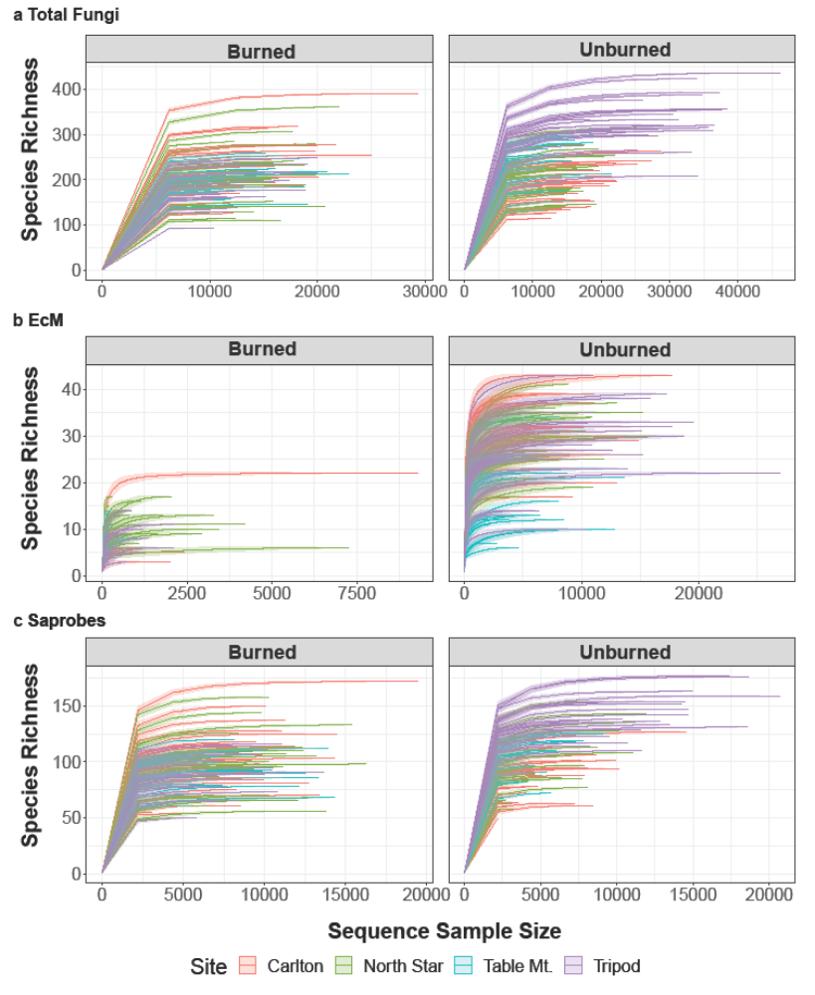
Fig. S7 Rarefaction curves describing observed species richness for (a) total fungi, (b) ectomycorrhizal (EcM) fungi, and (c) saprobic fungi between treatments (burned, unburned). Rarefaction curves indicate the observed number of Amplicon Sequence Variants (ASVs) related to the sequence samples size for each of the four burned sites from high-severity wildfires (2006 Tripod Complex Fire, 2012 Table Mountain Fire, 2014 Carlton Complex Fire, and 2015 North Star Fire) and their matched unburned controls.

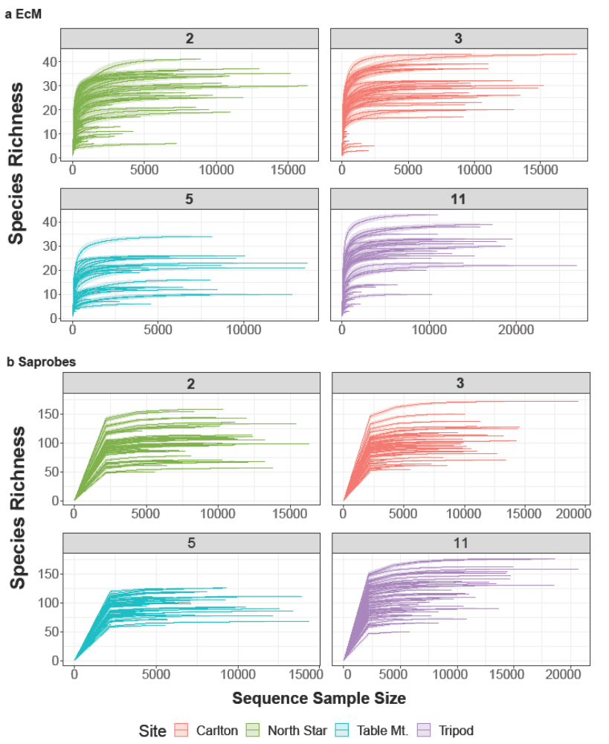

Fig. S8 Rarefaction curves describing observed species richness for (a) ectomycorrhizal fungi and (b) saprobic fungi for time since fire (years). Rarefaction curves indicating the observed number of amplicon sequence variants (ASVs), related to the sequence sample size per each of the post-fire years (time since fire: Tripod Complex (2006, 11 years); Table Mountain (2012, 5 years); Carlton Complex (2014, 3 years); North Star (2015, 2 years).

