Supplemental Information for:


Rapid bacterial and fungal successional dynamics in first year after Chaparral wildfire

M. Fabiola Pulido-Chavez, James W. J. Randolph, Cassandra Zalman, Loralee Larios, Peter M. Homyak, and Sydney I. Glassman

Table of Contents:
Figure S1. Alpha diversity metrics for bacteria and fungi between treatments | Page 1
Figure S2. Change in average bacterial and fungal biomass between treatments | Page 2
Figure S3. Change in average richness for the fungal guilds | Page 3
Figure S4. Changes in bacterial and fungal species richness over time | Page 4
Figure S5. NMDS plots for bacterial community composition at each time point | Page 5
Figure S6. NMDS plots for fungal community composition at each time point | Page 6
Figure S7. Ash depth vs. BAER soil burn severity metric comparison | Page 7
Table S1. Holy Fire Site-specific characteristics for the nine sampling plots | Page 8
Table S2. Average sequences and ASVs per control samples | Page 9
Table S3. Descriptive statistic and percent change in biomass and species richness | Page 10
Table S4. Negative binomial generalized mixed effect models for bacteria and fungi | Page 11
Table S5. Negative binomial generalized mixed effect models for the fungal guilds | Page 12
Table S6. PERMANOVA of bacterial and fungal community composition and treatment | Page 13
Table S7. Measures of successional dynamics for bacterial and fungal communities | Page 14

Figure S1. Comparison of alpha diversity metrics for bacteria and fungi between burned (brown) and unburned (blue-green) plots for A) observed species richness (ASVs), B) Simpson, C) Chao1, D) ACE, E) Inverse Simpson (dominance), and E) Shannon. Significance based on negative binomial regression with plots and time since fire as random effects for all alpha metrics except for bacteria inverse Simpson which was based on a generalized mixed effect model. Percent value represents the percent change in alpha diversity from the unburned to burned communities, where the negative value represents a decrease in alpha diversity.

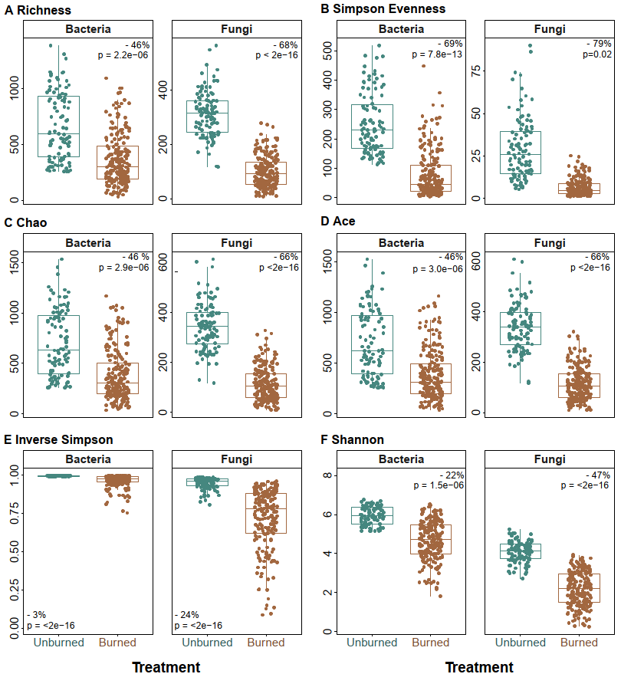

Figure S2. Change in average A) bacterial and B) fungal estimated biomass (per gram of soil) between the burned (brown) and unburned (blue-green) communities across all time points. Boxes represent the 25th and 75th quartiles, and the horizontal line is the median of the data—significance based on negative binomial regressions with plot and time since fire as random effects. Percent value represents the percent change in biomass from the unburned to burned communities, where the negative value represents a decrease in biomass.

Figure S3. Change in average richness for A) arbuscular mycorrhizal fungi (AMF), B) ectomycorrhizal fungi (EMF), C) pathogenic, and D) saprobic fungi between burned (brown) and unburned (blue-green) plots across all time points. Boxes represent the 25th and 75th quartiles, and the horizontal line is the median of the data. Significance based on negative binomial regressions with plot, subplot, and time since fire as random effects. Percent value represents the percent change in species richness from the unburned to burned communities, where the negative value represents a decrease in richness.

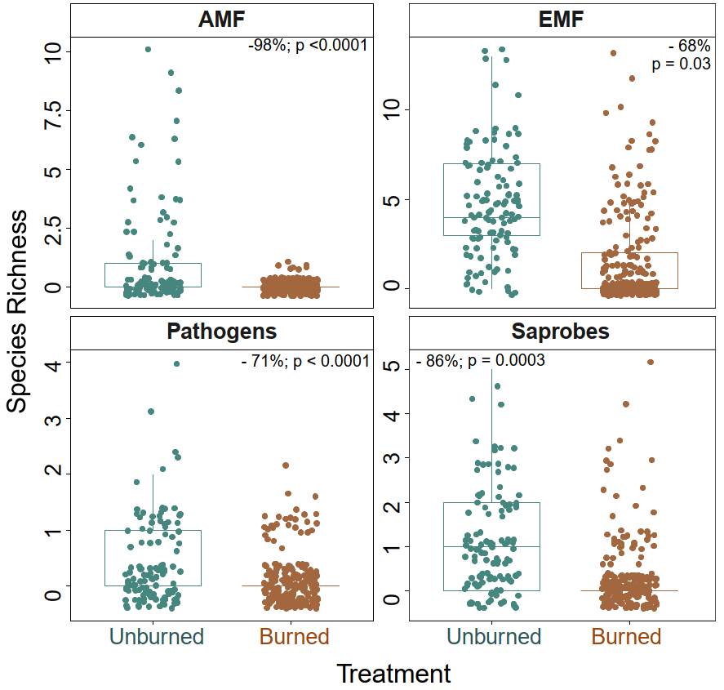

Figure S4. Change of species richness in burned (brown) versus unburned (blue-green) plots at each of the 9-time points for all four fungal guilds (arbuscular mycorrhizal fungi (AMF); ectomycorrhizal fungi (EMF), pathogens, and saprobes). Points represent the mean, and bars represent the standard error of the mean.

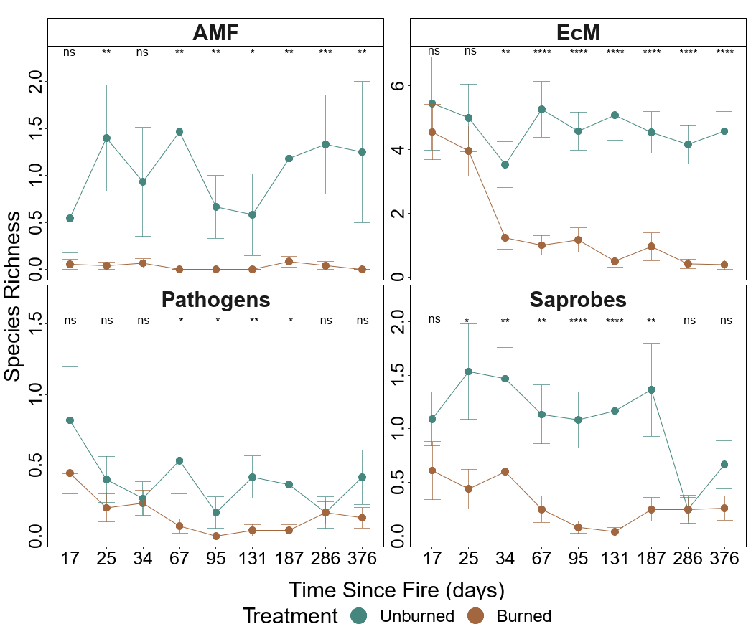

Figure S5. NMDS plots for bacterial community composition in burned (brown) versus unburned (blue-green) plots at each of the 9-time points with R², significance, and stress (S) based on ADONIS. NMDS is based on the Bray-Curtis dissimilarity matrix on 3-dimensions.

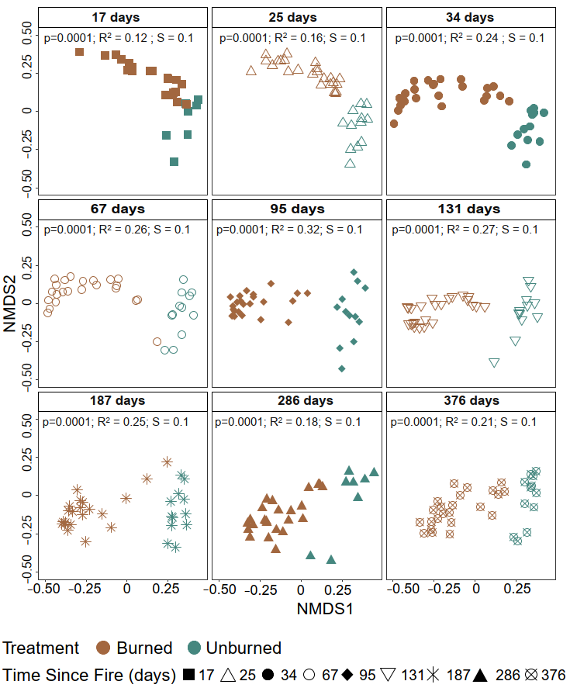
Figure S6. NMDS plots for fungal community composition in burned (brown) versus unburned (blue-green) plots at each of the 9-time points with R², significance, and stress (S) based on ADONIS. NMDS is based on the Bray-Curtis dissimilarity matrix on 3-dimensions.

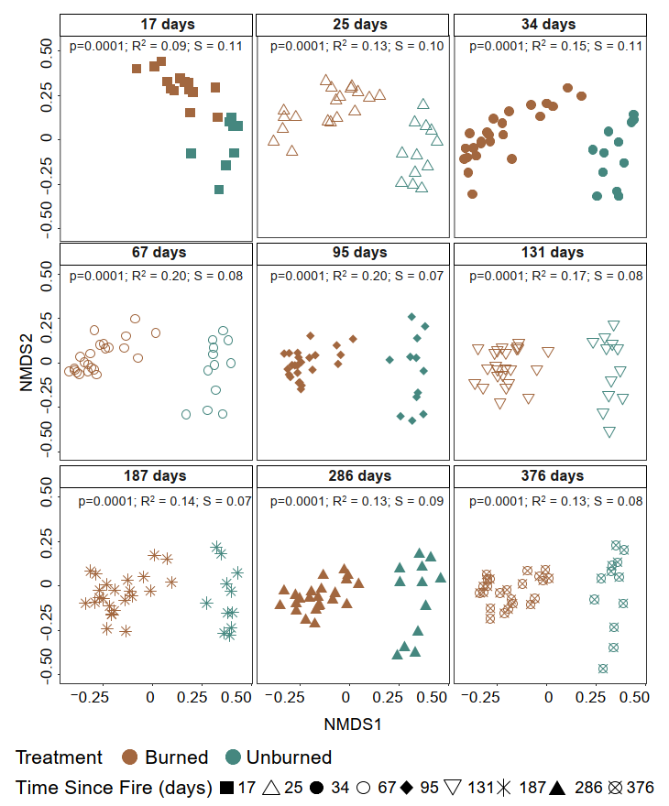

Figure S7. Soil burn severity effect on species richness. Severity categories were based on initial ash depth (cm) following Parson et al., 2010 (unburned = 0 cm; Low = 0.1-1.49 cm; Moderate = 1.5-2.9cm; and High => 3.0cm) and compared to BAER soil burn severity categories.

Table S1. Holy Fire Site-specific characteristics for the nine sampling plots (6 burned, 3 unburned) located within the 2018 Holy Fire.

 |  |  |  |  |  | Soil pH |  | Soil Taxonomic Class
Site ID |  | Treatment | Latitude | Longitude | Elevation | 25 days | 376 days | Soil Taxonomic Class
CNF01 | Burned |  | 33.6901 | -117.463 | 1228 | 7.25 | 6.33 | Cieneba series; Loamy, mixed, superactive, nonacid, thermic, shallow Typic Xerorthents  (Entisols)
CNF02 | Burned |  | 33.69537 | -117.471 | 1260 | 6.71 | 6.74
CNF03 | Burned |  | 33.69326 | -117.467 | 1237 | 6.79 | 7.1
CNF04 | Burned |  | 33.68456 | -117.457 | 1260 | 7.11 | 6.84 | Friant series; Loamy, mixed, superactive, thermic Lithic Haploxerolls  (Mollisols)
CNF05 | Burned |  | 33.67809 | -117.457 | 1195 | 6.94 | 7.17
CNF06 | Burned |  | 33.67168 | -117.459 | 1285 | 6.92 | 7.48
CNF07 | Unburned |  | 33.67135 | -117.459 | 1283 | 6.1 | 6.85
CNF08 | Unburned |  | 33.66813 | -117.456 | 1250 | 6.12 | 6.88
CNF09 | Unburned |  | 33.6678 | -117.455 | 1240 | 6.18 | 6.18

Table S2. Total sequences and ASVs per control (positive mock communities and negative DNA extraction and PCR controls) based on Qiime2 data. Note rarefying removed all negative controls. Mock communities were manually removed after verification of taxonomy with Zymo Mock information.

Organism | Sample Type | Seq/Sample | ASVs | ASVs After Rarefaction
Fungi | All | 78,202 | 11,480 | 7,445
Bacteria | All | 31,052 | 33,078 | 24,874
Fungi | Mock | 2997* | 5* | removed
Fungi | Neg DNA Extraction | 235* | 9* | removed
Fungi | Neg PCR control | 183* | 5* | removed
Bacteria | Mock | 33533* | 10* | removed
Bacteria | Neg DNA Extraction | 1668* | 12* | removed
Bacteria | Neg PCR control | 194* | 5* | removed
* Denotes: average sequence per sample

Table S3. Descriptive statistics and percent change in estimated biomass (per gram soil) and species richness (observed ASV’s) between treatment (unburned (burned)) and time since fire for bacteria and fungi. The mean copy number is based on the 16S rRNA for bacteria and 18S rRNA for fungi.

 |  | Biomass |  |  |  |  | Richness
 | Time since fire (days) | Mean Copy Num. (g⁻¹ soil) | % Change |  | Mean ASVs |  |  | % Change
Bacteria | 17 | 243,288,300 (39,632,680) | -84 |  |  | 462 (604) |  | 31
Bacteria | 25 | 235,169,333 (36,530,267) | -84 |  |  | 688 (486) |  | -29
Bacteria | 34 | 252,455,133 (107,186,067) | -58 |  |  | 962 (313) |  | -67
Bacteria | 67 | 293,834,733 (132,186,480) | -55 |  |  | 621 (250) |  | -60
Bacteria | 95 | 329,736,333 (245,489,900) | -26 |  |  | 302 (180) |  | -41
Bacteria | 131 | 276,979,018 (167,983,317) | -39 |  |  | 972 (378) |  | -61
Bacteria | 187 | 291,303,200 (241,265,883) | -17 |  |  | 933 (244) |  | -74
Bacteria | 286 | 323,115,100 (169,881,567) | -47 |  |  | 368 (411) |  | 12
Bacteria | 376 | 283,013,818 (160,504,850) | -43 |  |  | 533 (411) |  | -23
Fungi | 17 | 83,624,650 (2,345,940) | -97 |  |  | 292(161) |  | -45
Fungi | 25 | 75,569,867 (3,067,448) | -96 |  |  | 369(117) |  | -68
Fungi | 34 | 90,105,000 (10,755,267) | -88 |  |  | 305(77) |  | -75
Fungi | 67 | 71,132,133 (14,439,620) | -80 |  |  | 328(60) |  | -82
Fungi | 95 | 54,003,967 (10,113,017) | -81 |  |  | 335(85) |  | -75
Fungi | 131 | 43,502,333 (4,985,833) | -89 |  |  | 312(93) |  | -70
Fungi | 187 | 53,313,133 (11,076,350) | -79 |  |  | 344(118) |  | -66
Fungi | 286 | 86,949,156 (16,557,783) | -81 |  |  | 268(119) |  | -55
Fungi | 376 | 73,025,167(14,810,867) | -80 |  |  | 257(99) |  | -61

Table S4. Model summary results of the effect of treatment (burned vs. unburned), time since fire (TSF in days), precipitation (mm), and soil burn severity measured as ash depth (cm) at day 17 on bacterial and fungal estimated biomass (per gram soil) and richness (observed ASV’s). Significance is based on the negative binomial generalized mixed effect models with plot, subplot, and time since fire as the random effect for richness and plot and time since fire as random effect for estimated biomass (gram per soil)—significance at p<0.05 (bold).

 | Bacteria |  |  |  | Fungi
 | Est. | z value | P value |  | Est. | z value | P value
Biomass
(Intercept) | 19.45 | 91.46 | < 2e-16 |  | 18.01 | 79.91 | < 2e-16
Treatment (Burned) | -0.82 | -3.29 | 0.001 |  | -2.11 | -7.62 | 2.47E-14
TSF | 0.15 | 1.17 | 0.24 |  | -0.02 | -0.16 | 0.87
Precipitation | 0.05 | 0.39 | 0.70 |  | -0.16 | -1.06 | 0.29
Soil burn severity (ash depth) | -0.01 | -0.50 | 0.62 |  | -0.0004 | -0.01 | 0.99
Treatment (Burned): Precip | 0.30 | 3.02 | 0.003 |  | 0.20 | 1.61 | 0.11
TSF x Soil burn severity (ash depth) | 0.06 | 3.72 | 0.0002 |  | - | - | -
Treatment (Burned) x TSF | - | - | - |  | 0.44 | 3.46 | 0.001
Random Effects
Variance/Std.Dev | 0.08/0.29_{Plot;} 0.11/0.33_{TSF} |  |  |  | 0.08/0.29_{Plot;} 0.11/0.33_{TSF}
Mar. R² / Cond. R² (delta) | 0.30/0.46 |  |  |  | 0.47/0.56
Richness
(Intercept) |  | 47.27 | <0.0001 |  | 5.8 | 54.69 | <0.0001
Treatment (Burned) |  | -2.56 | 0.01 |  | -0.9 | -5.76 | <0.0001
TSF |  | -0.84 | 0.4 |  | 0.19 | 2.13 | 0.03
Precipitation |  | 1.38 | 0.17 |  | -0.01 | -0.36 | 0.72
Soil burn severity (ash depth) |  | -3.83 | 0.0001 |  | -0.07 | -3.48 | 0.001
TSF x Precipitation |  | -4.64 | <0.0001 |  | 0.34 | 3.27 | 0.001
TSF x Soil burn severity (ash depth) |  | 2.38 | 0.02 |  | 0.03 | 3.82 | 0.0001
Random Effects
Variance/Std.Dev | 0.02/0.13Plot 0.02/0.14Subplot 0.08/0.28 TSF |  |  |  | 0.02/0.12_{Plot} 0.04/0.20_{Subplot} 0.01/0.08_{TSF}
Mar R² / Cond. R² (delta) | 0.32/0.57 |  |  |  | 0.63/0.74

Table S5. Model summary results of the effect of treatment (burned vs. unburned), time since fire (TSF in days), precipitation (mm), and ash depth (cm) on arbuscular fungi (AMF), ectomycorrhizal fungi (EMF), Saprobes and Pathogens. Significance based on the negative binomial generalized mixed effect models with plot, subplot, and time since fire as random effect—significance at p<0.05 (bold).

 | AMF |  |  |  | EMF
 | Est. | z value | P value |  | Est. | z value | P value
(Intercept) | -0.98 | -1.71 | 0.09 |  | 1.52 | 4.57 | <0.0001
Treatment (Burned) | -4.10 | -4.34 | <0.0001 |  | -1.09 | -2.18 | 0.03
TSF | - | - | - |  | -0.09 | -1.25 | 0.21
Soil burn severity (ash depth) | - | - | - |  | -0.19 | -2.77 | 0.01
Precipitation | - | - | - |  | 0.00 | -0.06 | 0.95
Treatment (Burned) x Precipitation | - | - | - |  | -0.37 | -3.92 | <0.0001
Treatment (Burned) x TSF | - | - | - |  | -0.68 | -7.04 | <0.0001
Random Effects
Variance/Std.Dev | 0.23/0.48_{Plot} 0.45/0.67_{Subplot} 0.03/0.17_{TSF} |  |  |  | 6.3e⁻¹⁰/2.5e⁻⁰⁵_{Plot} 3.06/1.75_{Subplot} 0.06/0.25_{TSF}
Mar R² / Cond. R² | 0.55/0.81 |  |  |  | 0.20/0.37
 | Saprobes |  |  |  | Pathogens
 | Est. | z value | P value |  | Est. | z value | P value
(Intercept) | -0.06 | -0.35 | 0.73 |  | -1.28 | -4.83 | <0.0001
Treatment (Burned) | -1.96 | -7.37 | <0.0001 |  | -1.48 | -3.63 | 0.0003
TSF | -0.36 | -3.07 | 0.002 |  | - | - | -
Precipitation | - | - | - |  | 0.09 | 0.52 | 0.60
Treatment (Burned) x Precipitation | - | - | - |  | -0.88 | -2.16 | 0.03
Treatment (Burned) x TSF | 0.68 | 3.42 | 0.001 |  | - | - | -
Random Effects
Variance/Std.Dev | 1.01e⁻¹¹/3.2e⁻⁰⁶_{Plot} 0.18/0.42_{Subplot} 0.01/0.08_{TSF} |  |  |  | 7.2e⁻¹²/2.7e⁻⁰⁶_{Plot} 0.34/0.58_{Subplot} 3.9e⁻¹³/6.3e⁻⁰⁷_{TSF}
Mar R² / Cond. R² | 0.21/0.25 |  |  |  | 0.11/0.16

Table S6. Permutational multivariate analysis of variance (PERMANOVA) of bacterial and fungal community composition and the effects of treatment (burned vs. unburned), time since fire (TSF) in days, Initial ash depth (soil burn severity), and total precipitation (mm) and their respective interactions. Significance p<0.05 (bold).

 | Variable | Sum of Sqs. | R2 | F | P value
Bacteria | Treatment | 14.34 | 0.13 | 50.47 | 0.0001
Bacteria | Time since fire | 4.33 | 0.04 | 15.25 | 0.0001
Bacteria | Total Precipitation | 3.20 | 0.03 | 11.26 | 0.0001
Bacteria | Initial Ash Depth | 1.98 | 0.02 | 6.97 | 0.0001
Bacteria | Treatment x Initial Ash Depth | 2.27 | 0.02 | 8.00 | 0.0001
Bacteria | Treatment x Total Precipitation | 1.53 | 0.01 | 5.39 | 0.0001
Bacteria | Time since fire x Initial Ash Depth | 0.52 | 0.005 | 1.82 | 0.03
Fungi | Treatment | 12.49 | 0.10 | 34.52 | 0.0001
Fungi | TSF | 1.80 | 0.01 | 4.98 | 0.0001
Fungi | Total Precipitation | 1.12 | 0.01 | 3.10 | 0.0001
Fungi | Initial Ash Depth | 2.32 | 0.02 | 6.40 | 0.0001
Fungi | Treatment x Time Since Fire | 1.16 | 0.01 | 3.21 | 0.0005
Fungi | Treatment x Total Precipitation | 0.66 | 0.01 | 1.82 | 0.02
Fungi | Time since fire x Initial Ash Depth | 0.43 | 0.003 | 1.17 | 0.23

Table S7. Measures of successional dynamics for bacterial and fungal communities between treatments (burned vs. unburned) where the unburned values are inside the parenthesis. Turnover rates (proportion of species that differ between time points), appearance (relative species appearance between time points) and disappearance (relative species disappearance between time points), rates of change (rate of directional change in community composition over time), Stability (of total species abundance as a measure of equilibrium) and Synchrony (a measure of whether abundance fluctuations are homo- or heterogeneous over time). Higher values represent a higher rate for each category.

Microbe | TSF days | Turnover Rate | Appearance | Disappearance | Rate of change | Stability | Synchrony
Bacteria | 25 | 0.59 (0.54) | 0.25 (0.40) | 0.34 (0.14) | 0.16 (0.12) | 8.35 (5.36) | 0.03 (0.22)
Bacteria | 34 | 0.51 (0.50) | 0.15 (0.21) | 0.36 (0.29) | 0.16 (0.12) | 8.35 (5.36) | 0.03 (0.22)
Bacteria | 67 | 0.45 (0.43) | 0.21 (0.27) | 0.24 (0.16) | 0.16 (0.12) | 8.35 (5.36) | 0.03 (0.22)
Bacteria | 95 | 0.50 (0.56) | 0.15 (0.14) | 0.35 (0.42) | 0.16 (0.12) | 8.35 (5.36) | 0.03 (0.22)
Bacteria | 131 | 0.37 (0.40) | 0.19 (0.16) | 0.19 (0.24) | 0.16 (0.12) | 8.35 (5.36) | 0.03 (0.22)
Bacteria | 187 | 0.50 (0.58) | 0.31 (0.21) | 0.19 (0.38) | 0.16 (0.12) | 8.35 (5.36) | 0.03 (0.22)
Bacteria | 286 | 0.50 (0.64) | 0.28 (0.32) | 0.22 (0.32) | 0.16 (0.12) | 8.35 (5.36) | 0.03 (0.22)
Bacteria | 376 | 0.50 (0.35) | 0.26 (0.25) | 0.24 (0.10) | 0.16 (0.12) | 8.35 (5.36) | 0.03 (0.22)
Fungi | 25 | 0.61 (0.50) | 0.26 (0.37) | 0.34 (0.13) | 0.49 (0.08) | 6.42 (8.58) | 0.04  (0.05)
Fungi | 34 | 0.52 (0.43) | 0.14 (0.30) | 0.38 (0.13) | 0.49 (0.08) | 6.42 (8.58) | 0.04  (0.05)
Fungi | 67 | 0.52 (0.53) | 0.28 (0.28) | 0.24 (0.25) | 0.49 (0.08) | 6.42 (8.58) | 0.04  (0.05)
Fungi | 95 | 0.42 (0.47) | 0.27 (0.25) | 0.15 (0.23) | 0.49 (0.08) | 6.42 (8.58) | 0.04  (0.05)
Fungi | 131 | 0.52 (0.57) | 0.29 (0.27) | 0.23 (0.30) | 0.49 (0.08) | 6.42 (8.58) | 0.04  (0.05)
Fungi | 187 | 0.55 (0.53) | 0.40 (0.24) | 0.15 (0.29) | 0.49 (0.08) | 6.42 (8.58) | 0.04  (0.05)
Fungi | 286 | 0.53 (0.53) | 0.15 (0.24) | 0.38 (0.29) | 0.49 (0.08) | 6.42 (8.58) | 0.04  (0.05)
Fungi | 376 | 0.42 (0.58) | 0.19 (0.31) | 0.23 (0.27) | 0.49 (0.08) | 6.42 (8.58) | 0.04  (0.05)

