Freight Rate Prediction — Validation & Modeling Report
Machine Learning Engineer Assessment

1. What the Data Showed
The labeled data (train_test.csv) covers 48,000 loads from January through October 2025; the 12,000 loads to predict are from November and December 2025. The task is therefore forecasting the future from the past, and every decision below follows from that framing. Key findings:
- Prices drift with the seasons — The market index averages 0.93 in January, peaks at 1.30 in May, and drops to 0.89 by September; average price-per-mile follows the same curve ($2.10 up to $2.33 and back). Any evaluation that ignores time would miss this.
- A small number of prices are clearly wrong — 103 loads (0.2%) were priced below $0.50 per mile on trips over 100 miles — below the cost of fuel and contradicted by their own quote_signal. These were removed from training as data errors. Very high total rates were kept: per mile they are normal short-haul and expedited pricing.
- Some values are missing — 300 loads were missing weight (filled with the median) and 374 were missing market_index (which the final model does not use).
- quote_signal is noisy — quote_signal correlates with the realized per-mile price at only 0.05 per load — it is a rough estimate, not an answer. Testing confirmed the model performs better without it.
- Routes repeat — Only 0.2% of the loads to predict are on routes absent from the training data, so route-history features are available for nearly every prediction.

2. Features: Ten Inputs, Each With a Reason
The features are the questions a freight broker would ask when pricing a load, and — by design — every one can be computed from columns present in all three input files:
- Distance — the number one cost driver: more miles means more fuel, driver hours, and wear.
- Weight — heavier loads burn more fuel and exclude some carriers, nudging price up modestly.
- Equipment type — three indicator columns. A refrigerated trailer runs about 14% above a dry van; flatbeds sit between.
- Month and day-of-week — month captures the yearly cycle found above; day-of-week captures the weekly rhythm (shippers move freight midweek), which produces the wave in the December chart.
- Route history (3 features) — what this route has typically sold for (median rate and median rate-per-mile) and how many past loads back that estimate up (so the model knows when to trust it). This is the broker's memory, and per SHAP it is the model's strongest signal.
Features tested and deliberately removed: market_index and quote_signal (noisy; removing them improved holdout accuracy), latitude/longitude coordinates, and raw city categoricals (100+ levels each caused mild overfitting — the route-history aggregates carry the same information more robustly). Simplifying the feature set improved holdout error from $119 to $109 MAE. A welcome side effect: the December input file, which lacks the removed columns, needs no special handling at all.

3. How the Model Was Tested (Train/Test Split)
Because the real job is forecasting November–December from January–October history, the model was tested the same way: trained only on January–August (38,397 loads after cleaning) and evaluated on September–October (9,500 loads) — two future months it had never seen, matching the two-month horizon of the real task. A random split was deliberately avoided: shuffling months together would let the model see each month's market level during training and overstate its true forecasting ability. Route-history features were computed only from the training months, so the test set never contributes to its own features. After all decisions were made, the final model was retrained on the full January–October data.

4. Model Comparison and Selection
Six models were trained on the identical ten features and the identical temporal split, alongside two non-ML baselines:
Approach (tested on unseen Sep–Oct) | MAE | MAPE
Naive quote (quote_signal × distance) | $241.77 | 11.22%
Route's historical median price | $193.58 | 7.54%
Linear Regression | $279.45 | 11.43%
Ridge Regression | $279.46 | 11.43%
Decision Tree (depth 8) | $148.29 | 5.80%
Random Forest | $123.04 | 4.75%
HistGradientBoosting | $120.23 | 4.59%
LightGBM (selected) | $109.50 | 4.10%
The table tells the story of the problem. Linear models do worse than simply quoting each route's usual price — proof that the relationships are non-linear and interactive. A single decision tree captures some structure; ensembles of trees do much better; and gradient boosting — where each tree corrects the errors of the previous ones — wins. LightGBM was selected over the alternatives because it was the most accurate, trains its trees leaf-wise (fitting the strongest patterns first), directly optimizes the reported metric (MAE) via its L1 objective, and runs 6x faster than Random Forest. The selected model is off by $109.50 on a typical ~$2,400 load (4.1%), a 43% improvement over the strongest simple baseline. The model predicts the logarithm of the rate, which handles the wide price range ($57–$25,533) better than the raw scale.
SHAP analysis (below) confirms the model reasons like a broker: route history dominates, then distance, then load specifics — with each feature's direction matching economic intuition.
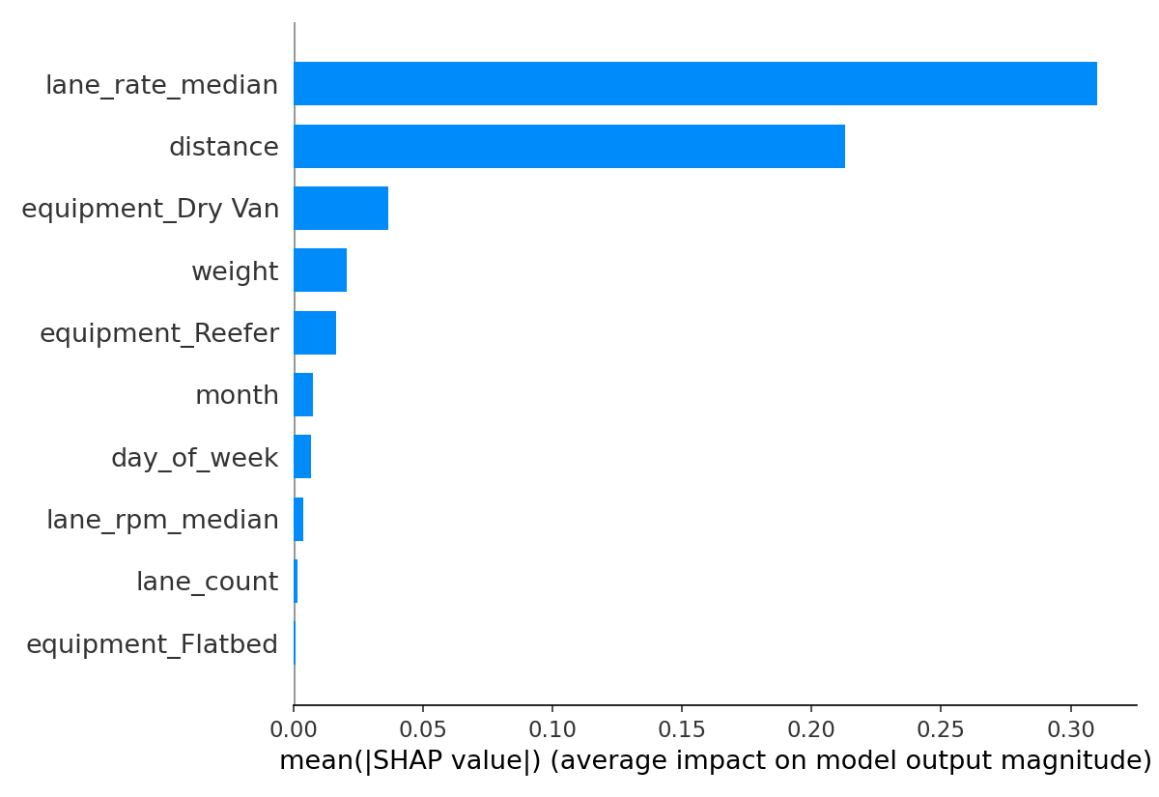

5. The December Predictions
Because every feature exists natively in the December file's seven columns, the December predictions required no imputation or special handling — the same trained model simply runs on those rows. Predictions average $836 per day (range $828–$840). That is a sensible answer: this exact route (Lexington → Fort Wayne) has 32 loads of real history with a median of $849, and the model prices slightly below it, consistent with the softer late-year market it observed in September–October. The weekly wave is the day-of-week effect: rates peak midweek and dip around weekends.
One known limitation, stated openly: the training data contains no November or December, so the model has never observed those specific months (or holiday effects). Tree models cannot extrapolate to unseen month values and effectively treat them like the latest month seen (October). This is acceptable here because observed Nov–Dec market conditions (index ≈ 0.92–0.94) closely resemble September–October (0.89–0.96), but with a second year of data, prior-December behavior would be the first improvement to add.
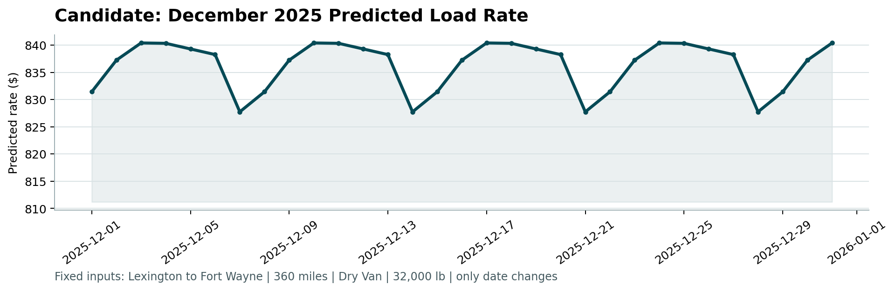

6. Reproducibility
The repository contains src/pipeline.py (cleaning and the 10-feature builder), src/validate.py (reproduces the comparison table above), src/train_predict.py (final training and both prediction files), and src/explain.py (SHAP plots). Running python src/train_predict.py followed by the provided score.py regenerates validation_predictions.csv, the completed December file, and the chart. Random seeds are fixed.

