**Amazon Simple Notification Service (SNS)**

# What is Amazon Simple Notification Service?

* Amazon Simple Notification Service (SNS) is a highly available, durable, secure, fully managed pub/sub messaging service that enables you to decouple microservices, distributed systems, and serverless applications.
* Amazon SNS provides topics for high-throughput, **push-based**, many-to-many messaging.
* Amazon Simple Notification Service (Amazon SNS) is a web service that coordinates and manages the delivery or sending of messages to subscribing endpoints or clients.
* In Amazon SNS, there are two types of clients:
  + Publishers (or) producers
  + Subscribers (or) consumers.
* Using Amazon SNS topics, your publisher systems can fan out messages to a large number of subscriber endpoints for parallel processing, including [Amazon SQS](https://aws.amazon.com/sqs/) queues, [AWS Lambda](https://aws.amazon.com/lambda/) functions, and HTTP/S webhooks.
* Additionally, SNS can be used to fan out notifications to end users using mobile push, SMS, and email.
* The Amazon Simple Notification Service (SNS) makes it easy for you to build an application in this way. You’ll need to know the following terms in order to understand how SNS works:
  + **Topics** are named groups of events or access points, each identifying a specific subject, content, or event type. Each topic has a unique identifier (URI) that identifies the SNS endpoint for publishing and subscribing.
  + **Owners** create topics and control all access to the topic. The owner can define the permissions for all of the topics that they own.
  + **Subscribers** are clients (applications, end-users, servers, or other devices) that want to receive notifications on specific topics of interest to them.
  + **Publishers** send messages to topics. SNS matches the topic with the list of subscribers interested in the topic, and delivers the message to each and every one of them. Here’s how it all fits together:
* Publishers communicate asynchronously with subscribers by producing and sending a message to a topic, which is a logical access point and communication channel.
* Subscribers (that is, web servers, email addresses, Amazon SQS queues, AWS Lambda functions) consume or receive the message or notification over one of the supported protocols (that is, Amazon SQS, HTTP/S, email, SMS, Lambda) when they are subscribed to the topic.

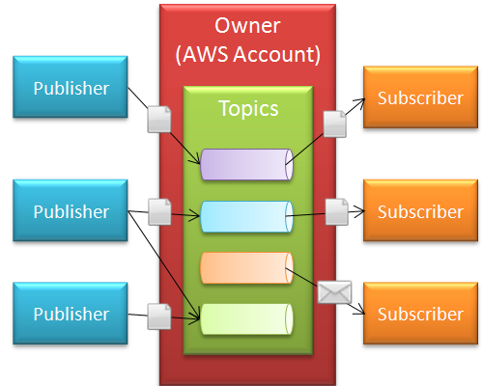 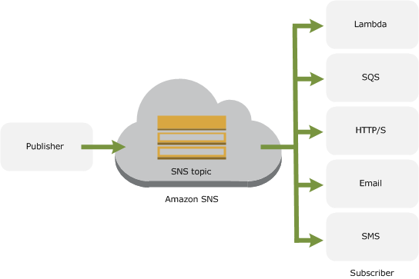

* The SNS API is, as the name should imply, clean and simple. Here’s what it takes to get started:

1. Call the **CreateTopic** function to create a new topic. Topic names can be made up of upper and lower case letters, numbers, and hyphens and can be up to 256 characters long.
2. Call the **AddPermission** function to establish the set of publishers and subscribers with access to the topic.
3. Subscribers call the **Subscribe** function to express their interest in receiving messages on a particular topic. As part of their request each subscriber must specify a topic, a protocol (HTTP, HTTPS, Email, or Email-JSON), and an endpoint (a URL for HTTP or HTTPS, an email address for either flavor of Email). SNS is also integrated with other AWS services for example, you can have the notifications delivered to an [SQS](http://aws.amazon.com/sqs/) queue. A single subscriber can subscribe to the same topic more than once if desired.
4. As part of the subscription process, SNS will deliver a confirmation message with an embedded token to the endpoint. The subscriber must confirm the subscription by clicking a link in an email or using the **ConfirmSubscription** function in order to initiate message delivery.
5. Publishers call the **Publish** function to post messages to a topic which will immediately trigger delivery of the message to each of the topic’s subscribers.

* Here are some ideas to get you started:

1. **Monitoring Alert Notification System** – Watch for failure events in a complex system and route information about them to appropriate people based on the type and complexity of the failure. The events could be at the system level (e.g. a process on an EC2 instance is consuming an excessive amount of memory or CPU time) or at the application level (e.g. an application was not able to communicate with an outside data provider).
2. **News Distribution** – Watch a web site, a Twitter topic, search results, or an RSS feed for changes. Publish the changes to a series of topics (one per news topic) and allow subscribers to choose the topics that they find to be of interest to them.
3. **Control EC2 Instances** – Subscribe a large array of EC2 instances to a single topic and publish messages to the topic to control the array. This could be system level, with messages used to tell each instance to update its installed software, report on free disk space. Or, it could be application level, with messages to start and stop application processes, change policies, or update reference data tables.

* When using Amazon SNS, you (as the owner) **create a topic** and control access to it by **defining policies** that determine *which publishers and subscribers can communicate with the topic*.
* A publisher sends messages to topics that they have created or to topics they have permission to publish to. Instead of including a specific destination address in each message, a publisher sends a message to the topic.
* Amazon SNS matches the topic to a list of subscribers who have subscribed to that topic, and delivers the message to each of those subscribers.
* Each topic has a unique name that identifies the **Amazon SNS endpoint for publishers** to post messages and subscribers to register for notifications.
* Subscribers receive all messages published to the topics to which they subscribe, and all subscribers to a topic receive the same messages.

1. **Setting Up Access for Amazon SNS**
   * To use Amazon SNS, you (user) must have permission. Need to attach the policy as **AmazonSNSFullAccess** to the user.
2. **How to manage topics, subscriptions, and messages**

## **Step 1: Create a Topic**

1. Sign in to the [Amazon SNS console](https://console.aws.amazon.com/sns/).
2. In the **Create topic** section, enter a **Topic name**, for example *SNS-Demo*.

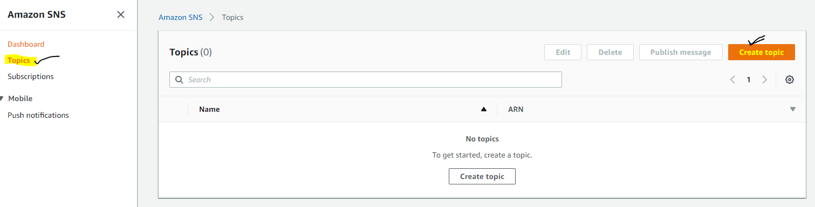

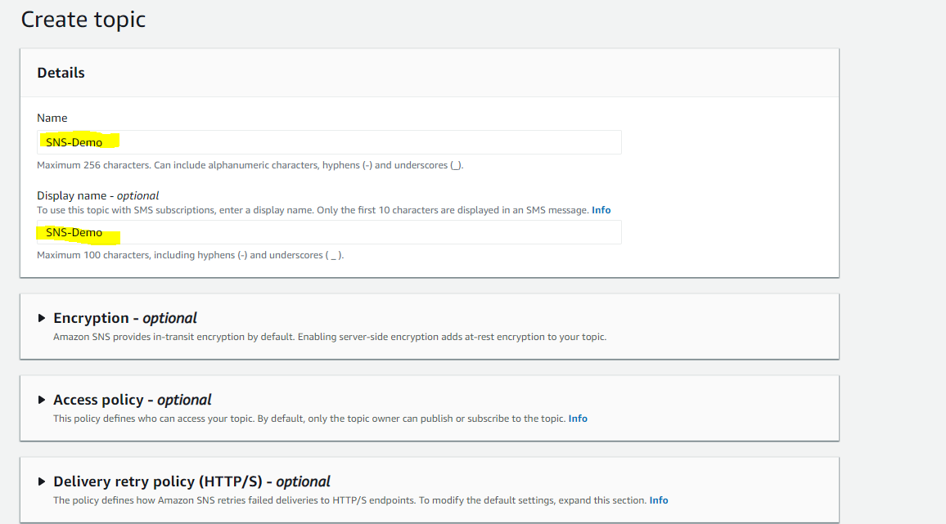

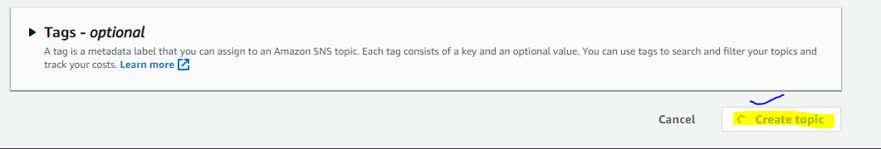

1. Choose **Create topic**.

The topic is created and the ***SNS-Demo*** page is displayed.

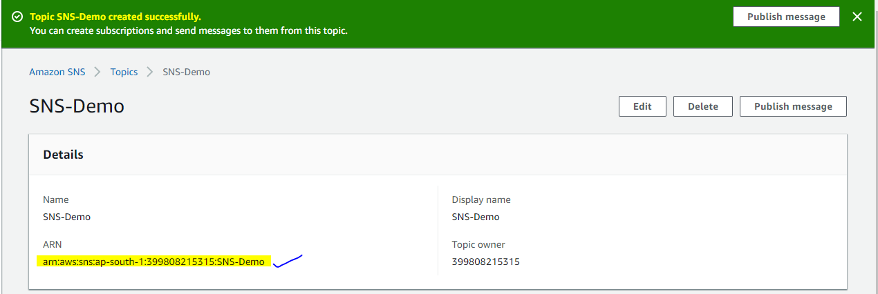

1. Copy the topic ARN to the clipboard, for example:

arn:aws:sns:ap-south-1:399808215315:SNS-Demo

## **Step 2: Create a Subscription for an Endpoint to the Topic**

1. On the navigation panel, choose **Subscriptions**.
2. On the **Subscriptions** page, choose **Create subscription**.

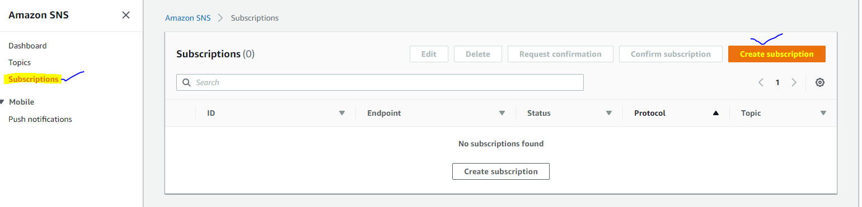

1. On the **Create subscription** page, do the following:
   1. Enter the **Topic ARN** of the topic you created earlier, for example:

arn:aws:sns:ap-south-1:399808215315:SNS-Demo

* 1. For **Protocol**, choose an endpoint type, for example **Email**.
  2. For **Endpoint**, enter an email address that can receive notifications, for example: name@example.com

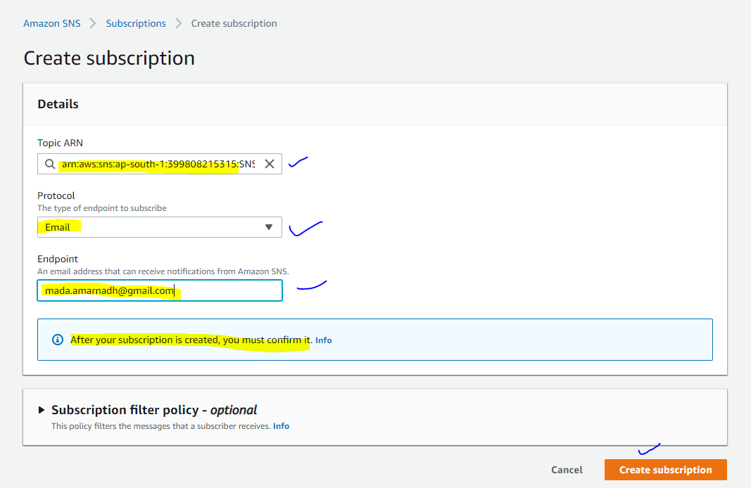

**Note:** After your subscription is created, you must confirm it. Only HTTP/S endpoints, email addresses, and AWS resources in other AWS accounts require confirmation. (Amazon SQS queues and Lambda functions in the same AWS account—as well as mobile endpoints —don't require confirmation.)

* 1. Choose **Create subscription**.

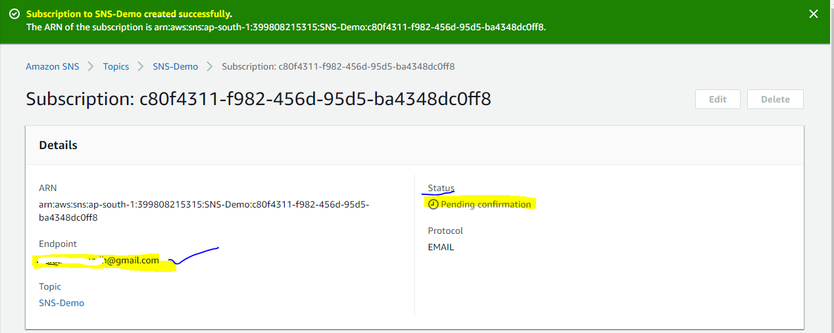

1. In your email client, check the email address that you specified and choose **Confirm subscription** in the email from Amazon SNS.

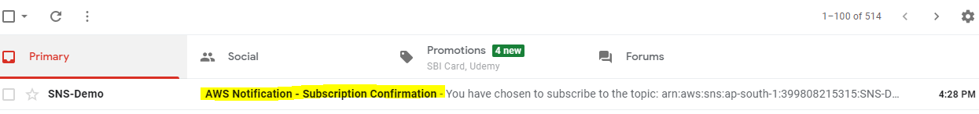

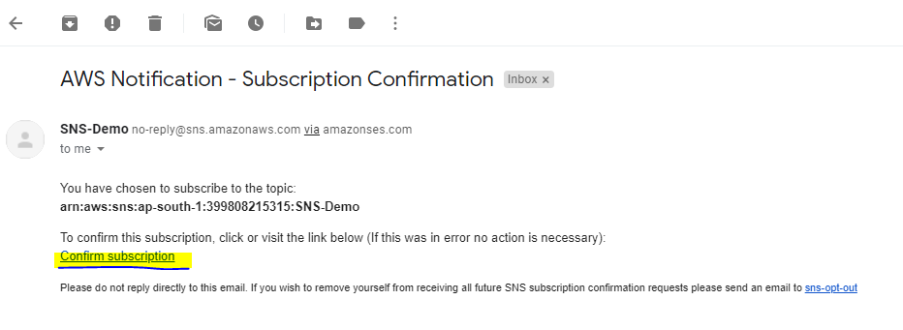

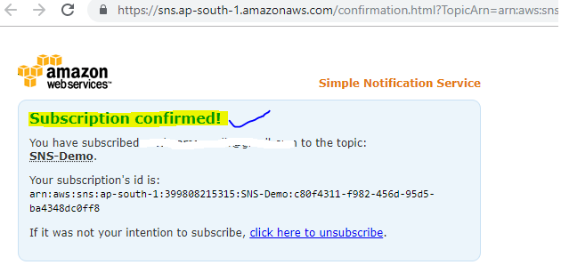

1. In your web browser, a subscription confirmation with your subscription ID is displayed.

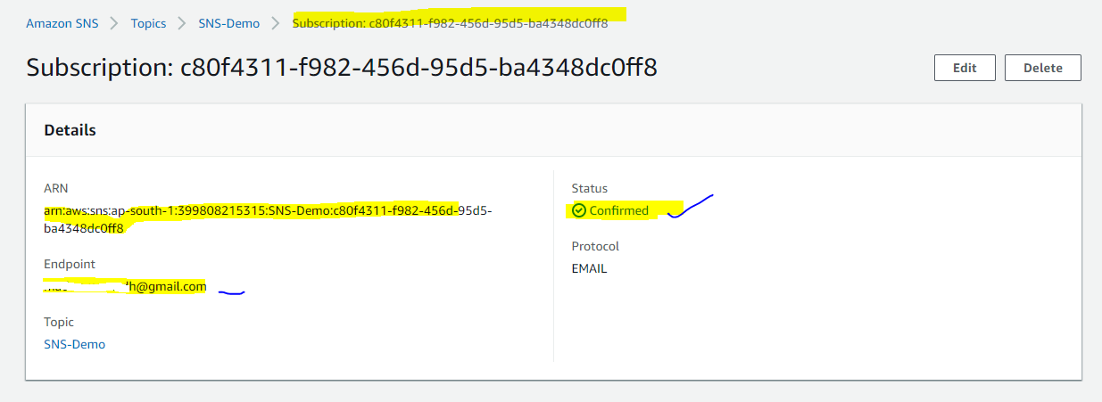

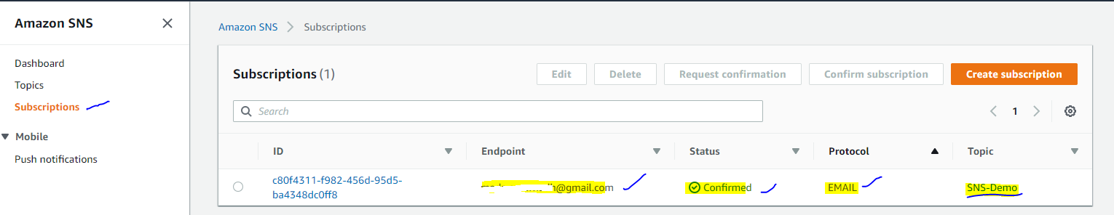

## **Step 3: Publish a Message to the Topic**

1. On the navigation panel, choose **Topics**.
2. On the **Topics** page, choose the topic you created earlier and then choose **Publish message**.

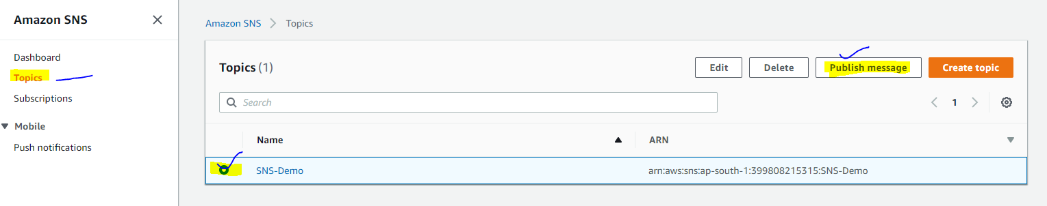

1. On the **Publish message to topic** page, do the following:
   1. (Optional) In the **Message details** section, enter the **Subject**, for example:

Hello from Amazon SNS!

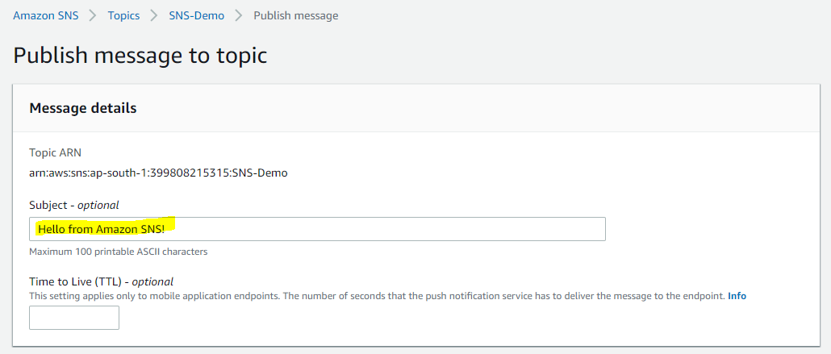

* 1. In the **Message body** section, do one of the following:
     + Choose **Identical payload for all delivery protocols** and then enter the message, for example:

If you receive this message, publishing a message to an Amazon SNS topic works

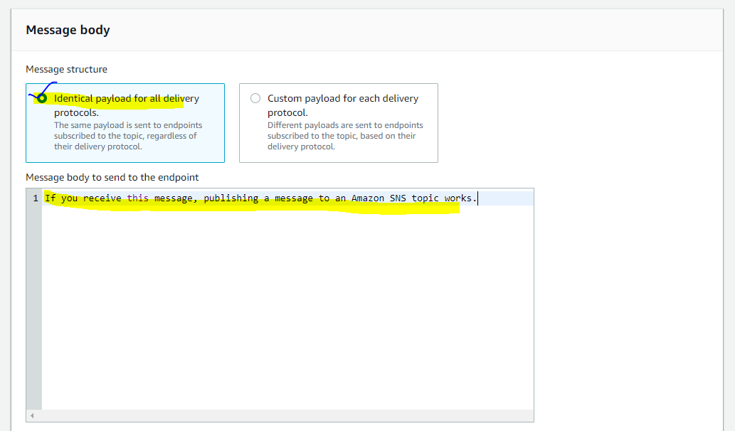

* + - Choose **Custom payload for each delivery protocol** and then use a JSON object to define the message to send to each protocol, for example:

{

"default": "Sample fallback message",

"email": "Sample message for email endpoints",

"sqs": "Sample message for Amazon SQS endpoints",

"lambda": "Sample message for AWS Lambda endpoints",

"http": "Sample message for HTTP endpoints",

"https": "Sample message for HTTPS endpoints",

"sms": "Sample message for SMS endpoints",

"APNS": "{\"aps\":{\"alert\": \"Sample message for iOS endpoints\"} }",

"APNS_SANDBOX": "{\"aps\":{\"alert\":\"Sample message for iOS development endpoints\"}}",

"APNS_VOIP": "{\"aps\":{\"alert\":\"Sample message for Apple VoIP endpoints\"}}",

"APNS_VOIP_SANDBOX": "{\"aps\":{\"alert\": \"Sample message for Apple VoIP development endpoints\"} }",

"MACOS": "{\"aps\":{\"alert\":\"Sample message for MacOS endpoints\"}}",

"MACOS_SANDBOX": "{\"aps\":{\"alert\": \"Sample message for MacOS development endpoints\"} }",

"GCM": "{ \"data\": { \"message\": \"Sample message for Android endpoints\" } }",

"ADM": "{ \"data\": { \"message\": \"Sample message for FireOS endpoints\" } }",

"BAIDU": "{\"title\":\"Sample message title\",\"description\":\"Sample message for Baidu endpoints\"}",

"MPNS": "<?xml version=\"1.0\" encoding=\"utf-8\"?><wp:Notification xmlns:wp=\"WPNotification\"><wp:Tile><wp:Count>ENTER COUNT</wp:Count><wp:Title>Sample message for Windows Phone 7+ endpoints</wp:Title></wp:Tile></wp:Notification>",

"WNS": "<badge version=\"1\" value=\"42\"/>"

}

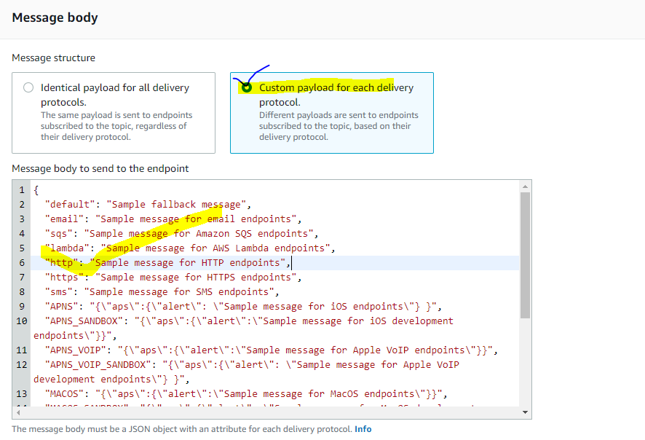

* 1. In the **Message attributes** section, add any attributes that you want Amazon SNS to match with the subscription attribute FilterPolicy to decide whether the subscribed endpoint is interested in the published message.

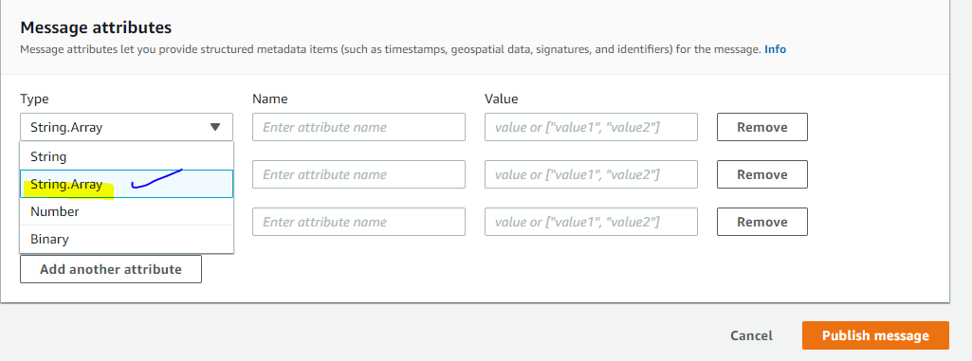

* + - Select an attribute **Type**, for example **String.Array**.

**Note**

If the attribute type is **String.Array**, enclose the array in square brackets ([]). Within the array, enclose string values in double quotation marks. You don't need quotation marks for numbers or for the keywords true, false, and null.

* + - Enter a **Name** for the attribute, for example customer_interests.
    - Enter a **Value** for the attribute, for example ["soccer", "rugby", "hockey"].

If the attribute type is **String**, **String.Array**, or **Number**, Amazon SNS evaluates the message attribute against a subscription's filter policy (if present) before sending the message to the subscription.

* 1. Choose **Publish message**.

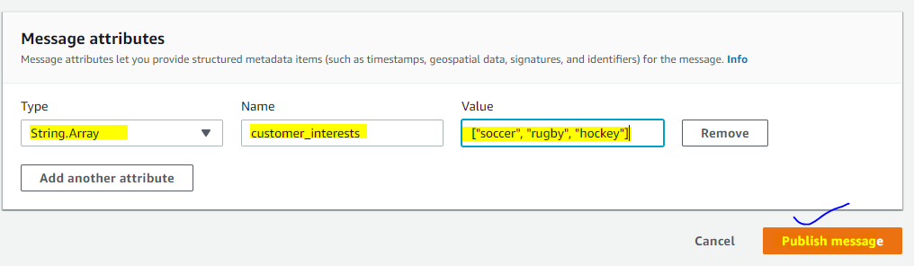

The message is published to the topic and the ***Demo-SNS*** page is displayed.

1. In your email client, check the email address that you specified earlier and read the email from Amazon SNS.

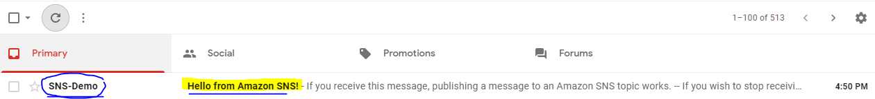

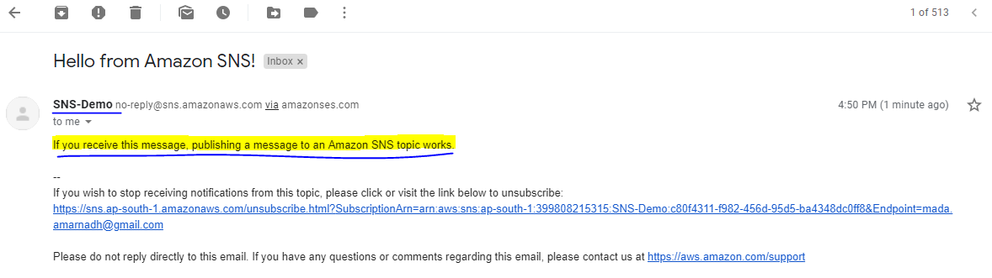

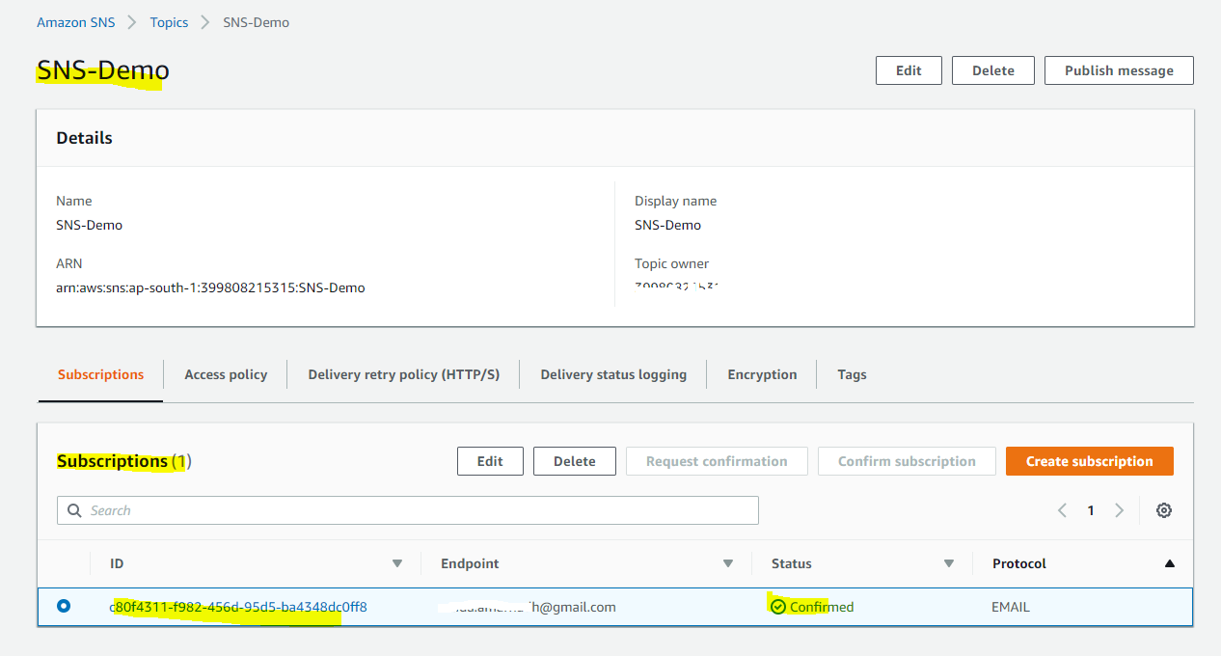

## **Step 4: Delete the Subscription and Topic**

1. On the navigation panel, choose **Subscriptions**.
2. On the **Subscriptions** page, choose a confirmed subscription and then choose **Delete**.

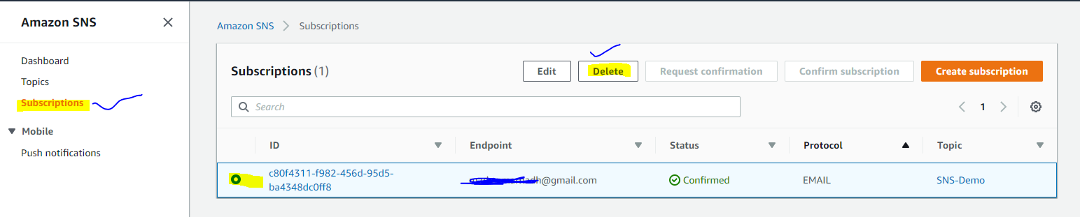

**Note**

You can't delete a pending confirmation. **After 3 days**, Amazon SNS deletes it automatically.

1. In the **Delete subscription** dialog box, choose **Delete**.

The subscription is deleted.

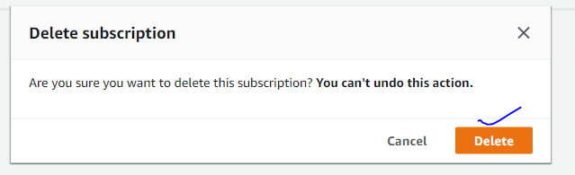

1. On the navigation panel, choose **Topics**.
2. On the **Topics** page, choose a topic and then choose **Delete**.

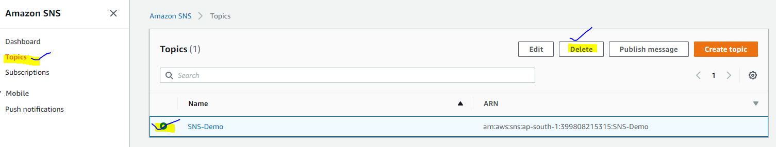

**Important**

When you delete a topic, you also delete all subscriptions to the topic.

1. On the **Delete topic *SNS-Democ*** dialog box, enter delete me and then choose **Delete**.

The topic is deleted.

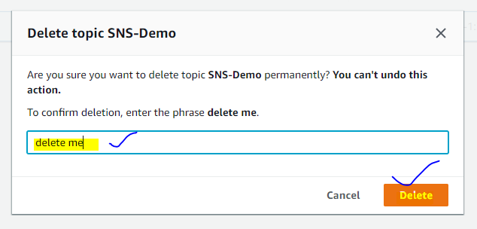

# Creating an Amazon SNS Topic

* An Amazon SNS topic is a logical access point which acts as a *communication channel*. A topic lets you group multiple *endpoints*(such as AWS Lambda, Amazon SQS, HTTP/S, or an email address).

1. Sign in to the [Amazon SNS console](https://console.aws.amazon.com/sns/).
2. Do one of the following:
   * If no topics have ever been created under your AWS account before, read the description of Amazon SNS on the home page.
   * If topics have been created under your AWS account before, on the navigation panel, choose **Topics**.
3. In the **Create topic** section, enter a **Topic name**, for example *Demo-SNS*.

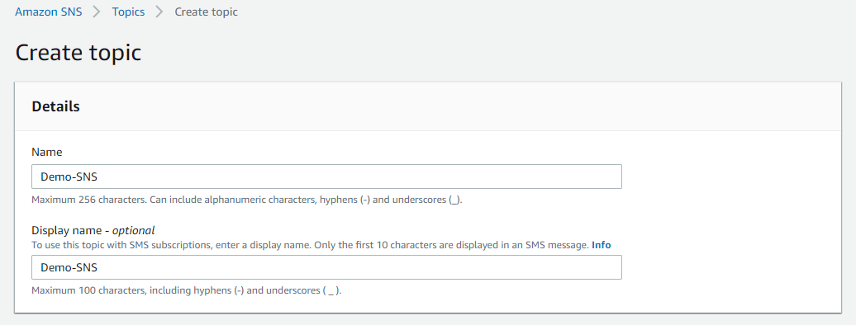

1. (Optional) Expand the **Encryption** section and do the following.
   * Choose **Enable encryption**.
   * Specify the customer master key (CMK).

For each CMK type, the **Description**, **Account**, and **CMK ARN** are displayed.

**Important**

If you aren't the owner of the CMK, or if you log in with an account that doesn't have the ***kms:ListAliasesand kms:DescribeKey*** permissions, you won't be able to view information about the CMK on the Amazon SNS console.

* + - The AWS managed CMK for Amazon SNS **(Default) alias/aws/sns** is selected by default.

**Note**

Keep the following in mind:

* + - * The first time you use the AWS Management Console to specify the AWS managed CMK for Amazon SNS for a topic, AWS KMS creates the AWS managed CMK for Amazon SNS.
      * Alternatively, the first time you use the Publish action on a topic with SSE enabled, AWS KMS creates the AWS managed CMK for Amazon SNS.
    - To use a custom CMK from your AWS account, choose the **Customer master key (CMK)** field and then choose the custom CMK from the list.

**Note:** For instructions on creating custom CMKs, see [Creating Keys](https://docs.aws.amazon.com/kms/latest/developerguide/create-keys.html) in the *AWS Key Management Service Developer Guide*

* + - To use a custom CMK ARN from your AWS account or from another AWS account, enter it into the **Customer master key (CMK)** field.

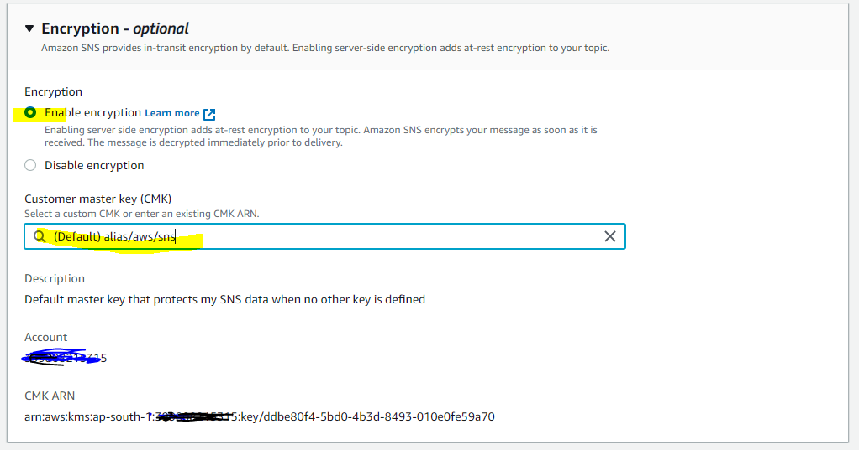

1. (Optional) To configure access permissions for your topic, expand the **Access policy** section.

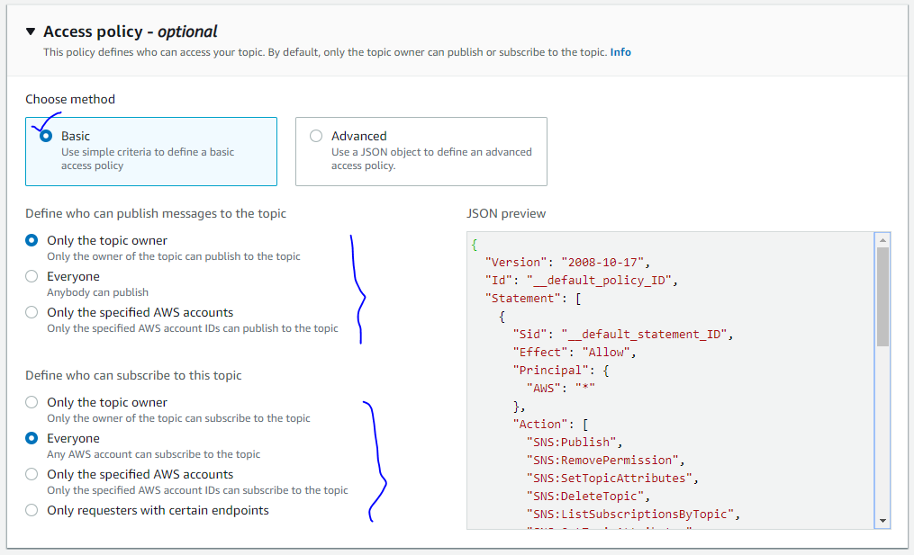

1. (Optional) To configure how Amazon SNS retries failed message delivery attempts, expand the **Delivery retry policy (HTTP/S)** section.

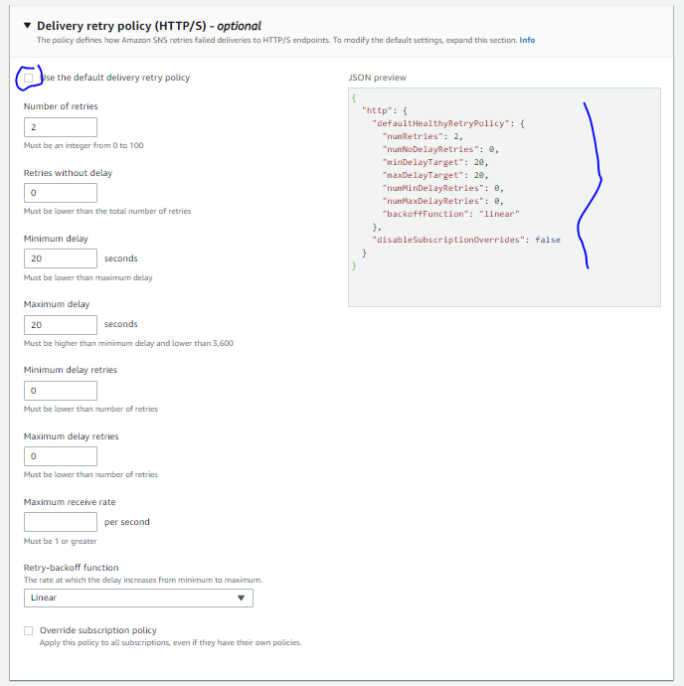

1. (Optional) To configure how Amazon SNS logs the delivery of messages to CloudWatch, expand the **Delivery status logging** section.

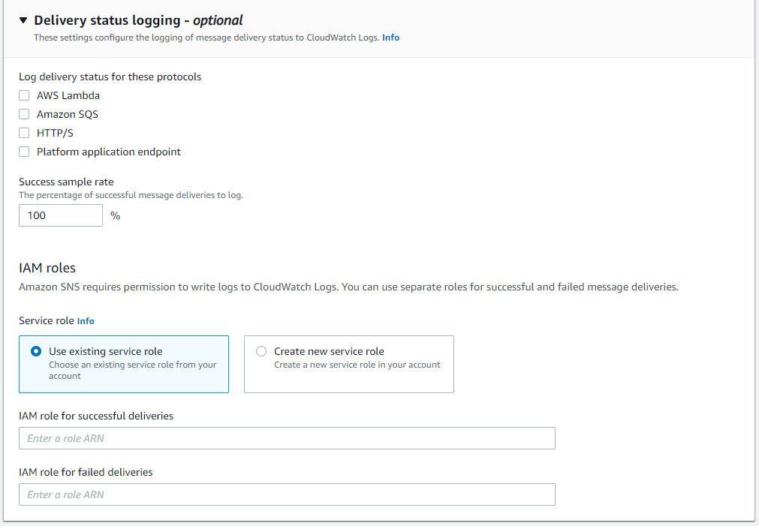

1. (Optional) To add metadata tags to the topic, expand the **Tags** section, enter a **Key** and a **Value** (optional) and choose **Add tag**.

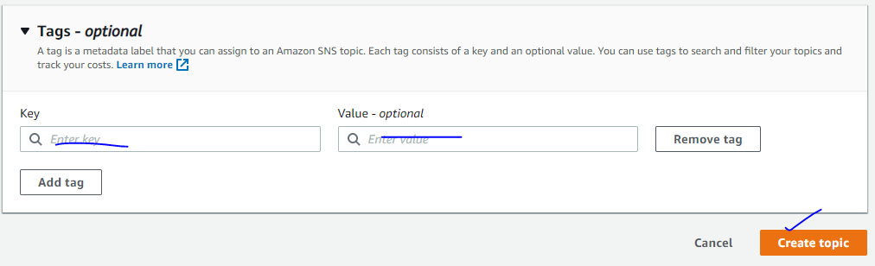

1. Choose **Create topic**.

The topic is created and the ***Demo-SNS*** page is displayed.

1. Copy the topic ARN to the clipboard, for example:

arn:aws:sns:ap-south-1:399808215315:SNS-Demo

# Protecting Amazon SNS Data Using Server-Side Encryption (SSE) and AWS KMS

* Server Side Encryption (SSE) protects the contents of messages in Amazon SNS topics using keys managed in AWS Key Management Service (AWS KMS).
* The messages are stored in encrypted form and Amazon SNS decrypts messages only when they are sent.
* All requests to topics with SSE enabled must use HTTPS and [Signature Version 4](https://docs.aws.amazon.com/general/latest/gr/signature-version-4.html).
* **Signature Version 4:** 
  + It is the process to add authentication information to AWS requests sent by HTTP.
  + How Signature Version 4 works by creating a **canonical request**.
* **AWS KMS** combines secure, highly available hardware and software to provide a key management system scaled for the cloud.
* When you use Amazon SNS with AWS KMS, the [data keys](https://docs.aws.amazon.com/sns/latest/dg/sns-server-side-encryption.html#sse-key-terms) that encrypt your message data are also encrypted and stored with the data they protect.
* The following are benefits of using AWS KMS:
  + You can create and manage [**customer master keys (CMKs)**](https://docs.aws.amazon.com/sns/latest/dg/sns-server-side-encryption.html#sse-key-terms) yourself.
  + You can also use the AWS managed CMK for Amazon SNS, which is unique for each account and region.
  + The AWS KMS security standards can help you meet encryption-related compliance requirements.
* SSE encrypts the body of a message in an Amazon SNS topic.
* SSE doesn't encrypt the following:
  + Topic metadata (topic name and attributes)
  + Message metadata (subject, message ID, timestamp, and attributes)
  + Per-topic metrics
* A message is encrypted only if it is sent after the encryption of a topic is enabled. Amazon SNS doesn't encrypt backlogged messages.
* Any encrypted message remains encrypted even if the encryption of its topic is disabled.

## 5.1 Configuring AWS KMS Permissions

* Before you can use SSE, you must configure AWS KMS key policies to allow encryption of topics and encryption and decryption of messages.

### 5.1.1 Allow a User to Send Messages to a Topic with SSE

The publisher must have the kms:GenerateDataKey and kms:Decrypt permissions for the customer master key (CMK).

{

"Version": "2012-10-17",

"Statement": [{

"Effect": "Allow",

"Action": [

"kms:GenerateDataKey",

"kms:Decrypt"

],

"Resource": "arn:aws:kms:default-regionus-east-2:123456789012:key/1234abcd-12ab-34cd-56ef-1234567890ab"

}, {

"Effect": "Allow",

"Action": [

"sns:Publish"

],

"Resource": "arn:aws:sns:*:123456789012:MyTopic"

}]

}

### 5.1.2 Enable Compatibility between Event Sources from AWS Services and Encrypted Topics

Several AWS services publish events to Amazon SNS topics. To allow these event sources to work with encrypted topics, you must perform the following steps.

1. Use the AWS managed CMK for Amazon SNS.
2. To allow the AWS service to have the kms:GenerateDataKey* and kms:Decrypt permissions, add the following statement to the CMK policy.

{

"Version": "2012-10-17",

"Statement": [{

"Effect": "Allow",

"Principal": {

"Service": "service.amazonaws.com"

},

"Action": [

"kms:GenerateDataKey*",

"kms:Decrypt"

],

"Resource": "*"

}]

}

NOTE: Here Service will be very based on the event source (ex: Cloudwatch, S3 Glacier, DynamoDB & etc)

1. [Enable SSE for your topic](https://docs.aws.amazon.com/sns/latest/dg/sns-tutorial-enable-encryption-for-topic.html) using your CMK.
2. Provide the ARN of the encrypted topic to the event source.

# Access Control

* [Amazon SNS](https://aws.amazon.com/sns/) supports other protocols beside email. You can use HTTP, HTTPS, and Amazon SQS queues.
* You have detailed control over which endpoints a topic allows, who is able to publish to a topic, and under what conditions.
* Use case of Access Control:
  + You want to grant another AWS account a particular type of topic action (for example, Publish)
  + You want to limit subscriptions to your topic to only the HTTPS protocol.
  + You want to allow Amazon SNS to publish messages to your Amazon SQS queue.
* Key Concepts of Access Control:
  + **Permission:** A permission is the concept of allowing or disallowing some kind of access to a particular resource.
  + **Statement**: A statement is the formal description of a single permission, written in the access policy language.
  + **Policy**: A policy is a document that acts as a container for one or more statements.
  + **Issuer**: The issuer is the person who writes a policy to grant permissions for a resource. The issuer (by definition) is always the resource owner. AWS does not permit AWS service users to create policies for resources they don't own.
  + **Principle**: The principal is the person or persons who receive the permission in the policy.
  + **Action**: The action is the activity the principal has permission to perform. (Ex: Action=Subscribe)
  + **Resource**: The resource is the object the principal is requesting access to.
  + **Conditions and Keys**: The conditions are any restrictions or details about the permission. A key is the specific characteristic that is the basis for access restriction.
  + **Requester:** The requester is the person who sends a request to an AWS service and asks for access to a particular resource.
  + **Evaluation**: Evaluation is the process the AWS service uses to determine if an incoming request should be denied or allowed based on the applicable policies
  + **Effect**: The effect is the result that you want a policy statement to return at evaluation time.
  + **Default Deny**: A default deny is the default result from a policy in the absence of an allow or explicit deny
  + **Allow**: An allow results from a statement that has effect=allow, assuming any stated conditions are met.
  + **Explicit Deny**: An explicit deny results from a statement that has effect=deny, assuming any stated conditions are met.

* **Architectural Overview:**


            Architectural Overview
          

* **Using the Access Policy Language**:


            Basic flow for access control with the access policy language
          

* + - 1. You write a policy to specify permissions for your Amazon SNS topics.
      2. You use the Amazon SNSSetTopicAttributes action to upload a policy for a particular Amazon SNS topic.
      3. A user sends a request to Amazon SNS to use one of your topics.
      4. Amazon SNS looks at all the available Amazon SNS policies and determines which ones are applicable
      5. Amazon SNS evaluates the policies and determines if the requester is allowed to use your topic or not.
      6. Based on the policy evaluation result, the service either returns an "Access denied" error to the requester or continues to process the request.

## Amazon SNS Keys

* **sns:Endpoint—**The URL, email address, or ARN from a Subscribe request or a previously confirmed subscription. (for example, *@example.com).
* **sns:Protocol—**The protocol value from a Subscribe request or a previously confirmed subscription. Use with string conditions (for example, https).

# Example Cases for Amazon SNS Access Control

## 7.1. Grant AWS Account Access to a Topic

* You want to allow one or more AWS accounts access to a specific topic action (for example, Publish).
* Ex: if you called AddPermission on the topic arn:aws:sns:us-east-2:444455556666:MyTopic, with AWS account ID 1111-2222-3333, the Publish action, and the label give-1234-publish,

{

"Version": "2012-10-17",

"Id": "AWSAccountTopicAccess",

"Statement": [{

"Sid": "give-1234-publish",

"Effect": "Allow",

"Principal": {

"AWS": "111122223333"

},

"Action": ["sns:Publish"],

"Resource": "arn:aws:sns:us-east-2:444455556666:MyTopic"

}]

}

* Once this statement is added, the user with AWS account 1111-2222-3333 can publish messages to the topic.

## 7.2. Limit Subscriptions to HTTPS

* You limit the notification delivery protocol to HTTPS.
* Example of a full policy gives the AWS account ID 1111-2222-3333 the ability to subscribe to notifications from a topic.

{

"Version": "2012-10-17",

"Id": "SomePolicyId",

"Statement": [{

"Sid": "Statement1",

"Effect": "Allow",

"Principal": {

"AWS": "111122223333"

},

"Action": ["sns:Subscribe"],

"Resource":"arn:aws:sns:us-east-2:444455556666:MyTopic",

"Condition": {

"StringEquals": {

"sns:Protocol": "https"

}

}

}]

}

## 7.3. Publish Messages to an Amazon SQS Queue

* You want to publish messages from your topic to your Amazon SQS queue.

{

"Version": "2012-10-17",

"Id": "MyQueuePolicy",

"Statement": [{

"Sid": "Allow-SNS-SendMessage",

"Effect": "Allow",

"Principal": "*",

"Action": ["sqs:SendMessage"],

"Resource": "arn:aws:sqs:us-east-2:444455556666:MyQueue",

"Condition": {

"ArnEquals": {

"aws:SourceArn":"arn:aws:sns:us-east-2:444455556666:MyTopic"

}

}

}]

}

* This policy uses the aws:SourceArn condition to restrict access to the queue based on the source of the message being sent to the queue.
* You can use this type of policy to allow Amazon SNS to send messages to your queue only if the messages are coming from one of your own topics.

## 7.4. Allow Any AWS Resource to Publish to a Topic

* You want to configure a topic's policy so that another AWS account's resource (for example, Amazon S3 bucket, Amazon EC2 instance, or Amazon SQS queue) can publish to your topic.
* Example statement, the topic owner in these policies is 1111-2222-3333 and the AWS resource owner is 4444-5555-6666. The example gives the AWS account ID 4444-5555-6666 the ability to publish to My-Topic from any AWS resource owned by the account.

{

"Version": "2012-10-17",

"Id": "MyAWSPolicy",

"Statement": [{

"Sid": "My-statement-id",

"Effect": "Allow",

"Principal": "*",

"Action": "sns:Publish",

"Resource": "arn:aws:sns:us-east-2:111122223333:MyTopic",

"Condition": {

"StringEquals": {

"AWS:SourceAccount": "444455556666"

}

},

{

"Effect": "Deny",

"NotAction": "sns:Publish",

"NotResource": "arn:aws:sns:*:123456789012:WidgetPartnerTopic"

}

}]

}

* If you publish messages directly (rather than having an AWS resource publish messages on your behalf), a policy in which you specify an empty Principal and use AWS:SourceAccount as a condition will not work.

## 7.5. Allow an Amazon S3 Bucket to Publish to a Topic

* You want to configure a topic's policy so that another AWS account's Amazon S3 bucket can publish to your topic.

{

"Version": "2012-10-17",

"Id": "MyAWSPolicy",

"Statement": [{

"Sid": "My-statement-id",

"Effect": "Allow",

"Principal": "*",

"Action": "sns:Publish",

"Resource": "arn:aws:sns:us-east-2:111122223333:MyTopic",

"Condition": {

"StringEquals": {

"AWS:SourceAccount": "444455556666"

},

"ArnLike": {

"AWS:SourceArn": "arn:aws:s3:*:*:*"

}

}

}]

}

* Example statement uses the ArnLike condition to make sure the ARN of the resource making the request (the AWS:SourceARN) is an Amazon S3 ARN.

## 7.6. Allow a CloudWatch Alarm in an AWS Account to Publish to an Amazon SNS Topic in a Different AWS Account

* Ex:  the CloudWatch alarm in account 111122223333 is allowed to publish to an Amazon SNS topic in account 444455556666.\

{

"Version": "2012-10-17",

"Statement": [{

"Effect": "Allow",

"Principal": "*",

"Action": "SNS:Publish",

"Resource": "arn:aws:sns:us-east-2:444455556666:MyTopic",

"Condition": {

"ArnLike": {

"aws:SourceArn": "arn:aws:cloudwatch:us-east-2:111122223333:alarm:MyAlarm"

}

}

}]

}

# Setting Amazon SNS Delivery Retry Policies for HTTP/HTTPS Endpoints

* A successful Amazon SNS delivery to an HTTP/HTTPS endpoint sometimes requires more than one attempt.
* For example, if the web server that hosts the subscribed endpoint is down for maintenance or is experiencing heavy traffic. If an initial delivery attempt doesn't result in a successful response from the subscriber, Amazon SNS attempts to deliver the message again. We call such an attempt a retry.
* You can use delivery policies to control not only the total number of retries, but also the time delay between each retry. You can specify up to 100 total retries distributed among **four discrete phases**. The maximum lifetime of a message in the system is one hour. This one hour limit cannot be extended by a delivery policy.


          Graphic of the four Amazon SNS delivery policy phases.
        

1. [**Immediate Retry Phase**](https://docs.aws.amazon.com/sns/latest/dg/DeliveryPolicies.html#delivery-policy-immediate-retry-phase)**—**Also called the **no delay phase**, this phase occurs immediately after the initial delivery attempt. The value you set for **Retries with no delay** determines the number of retries immediately after the initial delivery attempt. There is no delay between retries in this phase.
2. [**Pre-Backoff Phase**](https://docs.aws.amazon.com/sns/latest/dg/DeliveryPolicies.html#delivery-policy-pre-backoff-phase)**—**The pre-backoff phase follows the immediate retry phase. Use this phase to create a set of retries that occur before a backoff function applies to the retries. Use the **Minimum delay retries** setting to specify the number of retries in the Pre-Backoff Phase. You can control the time delay between retries in this phase using the **Minimum delay** setting.
3. [**Backoff Phase**](https://docs.aws.amazon.com/sns/latest/dg/DeliveryPolicies.html#delivery-policy-backoff-phase)**—**This phase is called the backoff phase because you can control the delay between retries in this phase using the retry backoff function. Set the **Minimum delay** and the **Maximum delay**, and then choose a **Retry backoff function** to define how quickly the delay increases from the minimum delay to the maximum delay.
4. [**Post-Backoff Phase**](https://docs.aws.amazon.com/sns/latest/dg/DeliveryPolicies.html#delivery-policy-post-backoff-phase)**—**The post-backoff phase follows the backoff phase. Use the **Maximum delay retries** setting to specify the number of retries in the post-backoff phase. You can control the time delay between retries in this phase using the **Maximum delay** setting.

## 8.1. Setting the Maximum Receive Rate

1. Sign in to the [Amazon SNS console](https://console.aws.amazon.com/sns/).
2. On the navigation panel, choose **Topics** and then chose the name of a topic.
3. On the ***MyTopic*** page, choose the **Edit**.
4. On the **Edit *MyTopic*** page, expand the **Delivery retry policy (HTTP/S)** section and specify the **Maximum retry rate**.
5. Choose **Save changes**.

## 8.2. Immediate Retry Phase

1. Sign in to the [Amazon SNS console](https://console.aws.amazon.com/sns/).
2. On the navigation panel, choose **Topics** and then choose a topic ARN.
3. In the **Topic Details** section, choose **Edit topic delivery policy** from the **Other topic actions** drop-down list.
4. In the **Retries with no delay** box, type an integer value.
5. Choose **Update policy** to save your changes.

## 8.3. Pre-Backoff Phase

1. Sign in to the [Amazon SNS console](https://console.aws.amazon.com/sns/).
2. On the navigation panel, choose **Topics** and then choose a topic ARN.
3. In the **Topic Details** section, choose **Edit topic delivery policy** from the **Other topic actions** drop-down list.
4. In the **Minimum delay retries** box, type an integer value.
5. In the **Minimum delay** box, type an integer value to set the delay between messages in this phase.

The value you set must be less than or equal to the value you set for **Maximum delay**.

1. Choose **Update policy** to save your changes.

## 8.4. Backoff Phase

The backoff phase is the only phase that applies by default. You can control the number of retries in the backoff phase using **Number of retries**.

You can choose from four retry backoff functions.

* Linear
* Arithmetic
* Geometric
* Exponential

## 8.4. Post-Backoff Phase

1. Sign in to the [Amazon SNS console](https://console.aws.amazon.com/sns/).
2. On the navigation panel, choose **Topics** and then choose a topic ARN.
3. In the **Topic Details** section, choose **Edit topic delivery policy** from the **Other topic actions** drop-down list.
4. In the **Maximum delay retries** box, type an integer value.
5. In the **Maximum delay** box, type an integer value to set the delay between messages in this phase.

The value you set must be greater than or equal to the value you set for **Minimum delay**.

1. Choose **Update policy** to save your changes.

# Enabling Server-Side Encryption (SSE) for an Amazon SNS Topic with an Encrypted Amazon SQS Queue Subscribed

* To allow Amazon SNS to send messages to encrypted Amazon SQS queues, the customer master key (CMK) associated with the Amazon SQS queue must have a policy statement that grants Amazon SNS service-principal access to the AWS KMS API actions GenerateDataKey and Decrypt.

## **Step 1: To Create a Custom CMK**

1. Sign in to the [AWS KMS console](https://console.aws.amazon.com/kms/) with a user that has at least the AWSKeyManagementServicePowerUser  policy.
2. Choose **Create a key**.

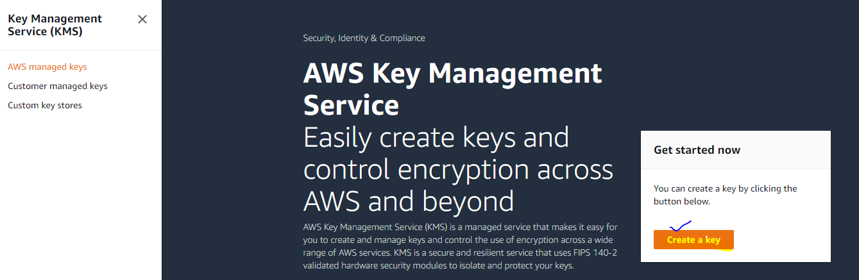

1. On the **Add alias and description** page, enter an **Alias** for your key (for example,  DemoMyCustomCMK) and then choose **Next**.

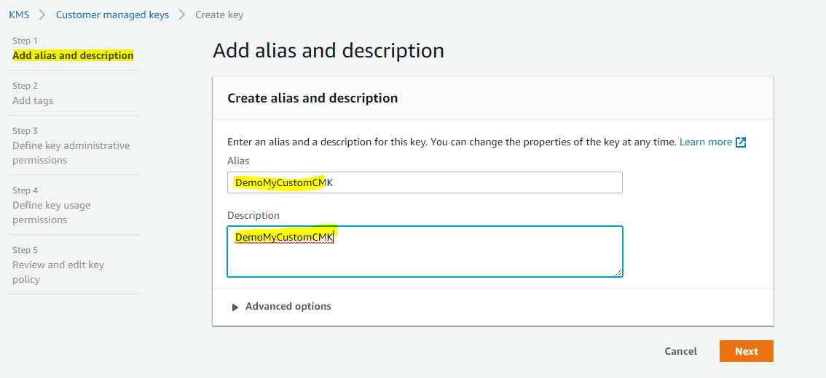

1. On the **Add tags** page, choose **Next**.

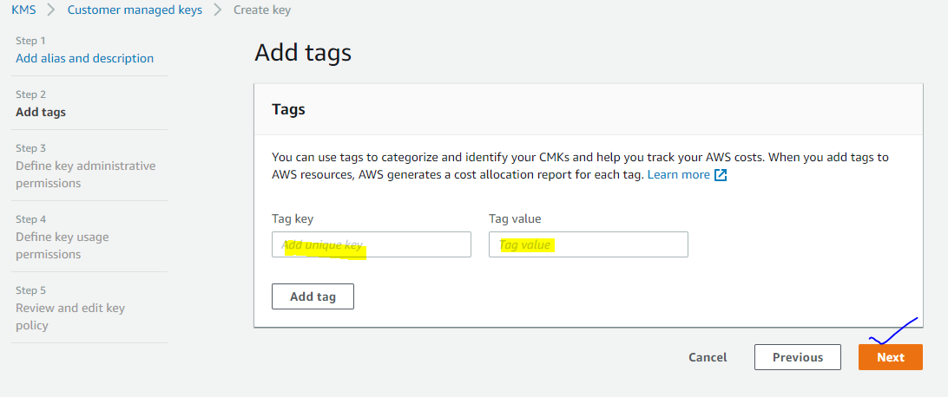

1. On the **Define key administrative permissions** page, in the **Key administrators** section, choose an IAM role or an IAM user and then choose **Next**.

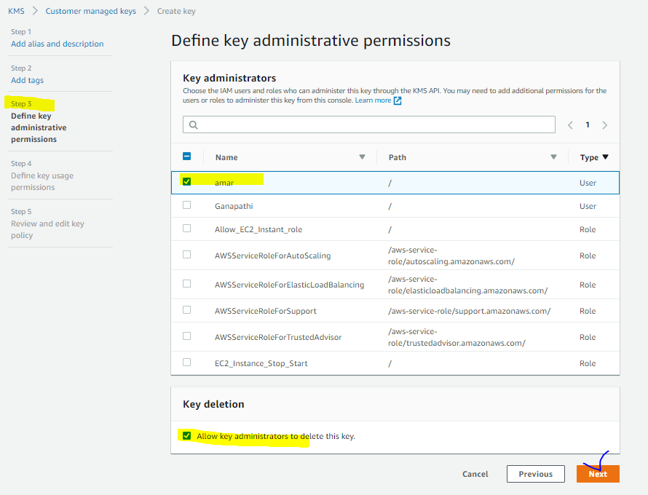

1. On the **Define key usage permissions** page, in the **This account** section, choose an IAM role or an IAM user and then choose **Next**.

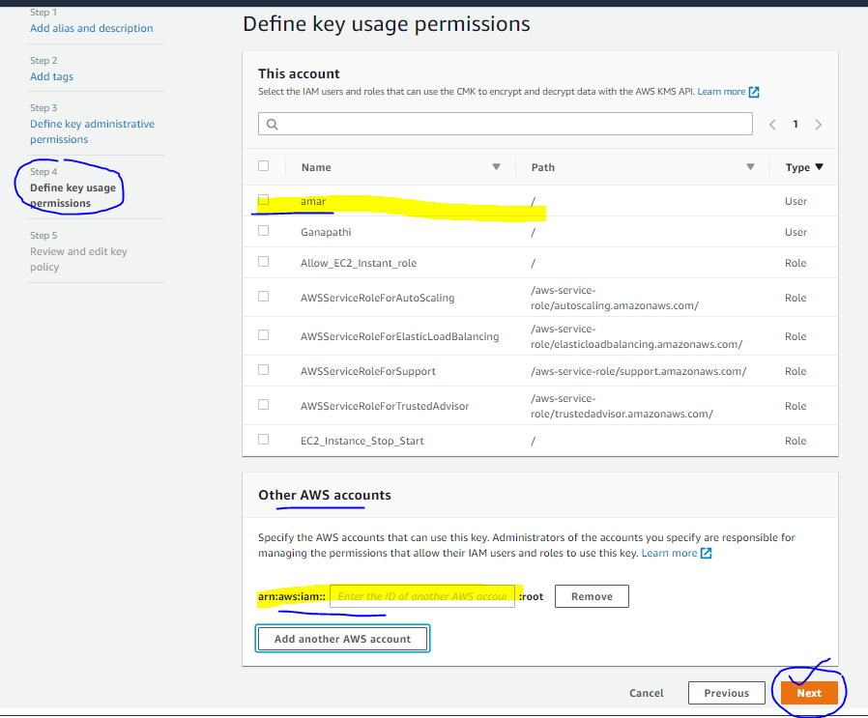

1. On the **Review and edit key policy** page, add the following statement to the key policy, and then choose **Finish**.

{

"Sid": "Allow Amazon SNS to use this key",

"Effect": "Allow",

"Principal": {

"Service": "sns.amazonaws.com"

},

"Action": [

"kms:Decrypt",

"kms:GenerateDataKey*"

],

"Resource": "*"

}

{

"Id": "key-consolepolicy-3",

"Version": "2012-10-17",

"Statement": [

{

"Sid": "Enable IAM User Permissions",

"Effect": "Allow",

"Principal": {

"AWS": "arn:aws:iam::399808215315:root"

},

"Action": "kms:*",

"Resource": "*"

},

{

"Sid": "Allow access for Key Administrators",

"Effect": "Allow",

"Principal": {

"AWS": "arn:aws:iam::399808215315:user/amar"

},

"Action": [

"kms:Create*",

"kms:Describe*",

"kms:Enable*",

"kms:List*",

"kms:Put*",

"kms:Update*",

"kms:Revoke*",

"kms:Disable*",

"kms:Get*",

"kms:Delete*",

"kms:TagResource",

"kms:UntagResource",

"kms:ScheduleKeyDeletion",

"kms:CancelKeyDeletion"

],

"Resource": "*"

},

{

"Sid": "Allow use of the key",

"Effect": "Allow",

"Principal": {

"AWS": "arn:aws:iam::399808215315:user/amar"

},

"Action": [

"kms:Encrypt",

"kms:Decrypt",

"kms:ReEncrypt*",

"kms:GenerateDataKey*",

"kms:DescribeKey"

],

"Resource": "*"

},

{

"Sid": "Allow attachment of persistent resources",

"Effect": "Allow",

"Principal": {

"AWS": "arn:aws:iam::399808215315:user/amar"

},

"Action": [

"kms:CreateGrant",

"kms:ListGrants",

"kms:RevokeGrant"

],

"Resource": "*",

"Condition": {

"Bool": {

"kms:GrantIsForAWSResource": "true"

}

}

},

{

"Sid": "Allow Amazon SNS to use this key",

"Effect": "Allow",

"Principal": {

"Service": "sns.amazonaws.com"

},

"Action": [

"kms:Decrypt",

"kms:GenerateDataKey*"

],

"Resource": "*"

}

]

}

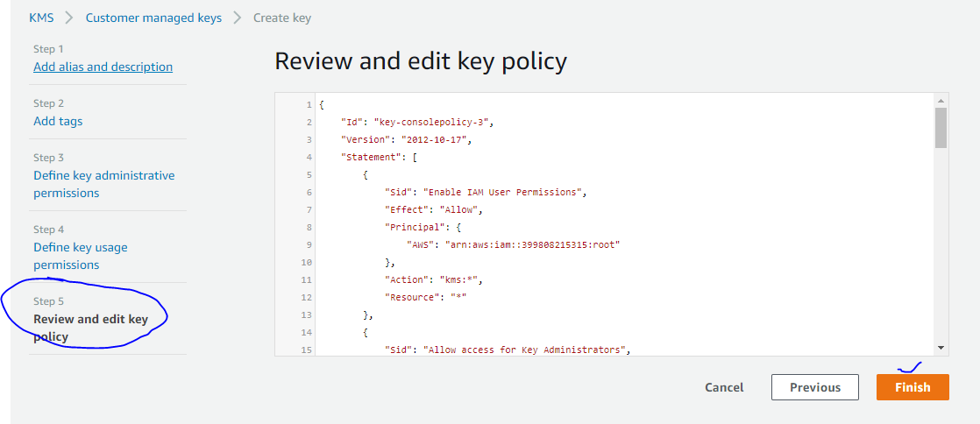

* Your new custom CMK appears in the list of keys.

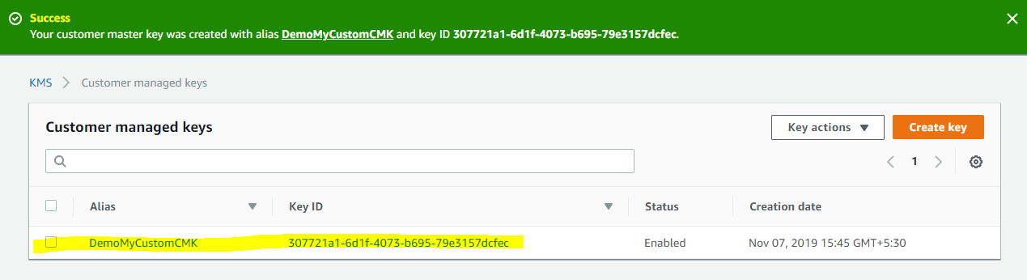

## **Step 2: To Create an Encrypted Amazon SNS Topic**

1. Sign in to the [Amazon SNS console](https://console.aws.amazon.com/sns/).
2. On the navigation panel, choose **Topics**.
3. Choose **Create topic**.
4. On the **Create new topic** page, for **Name**, enter a topic name (for example, Demo-SNS-MyEncryptedTopic) and then choose **Create topic**.

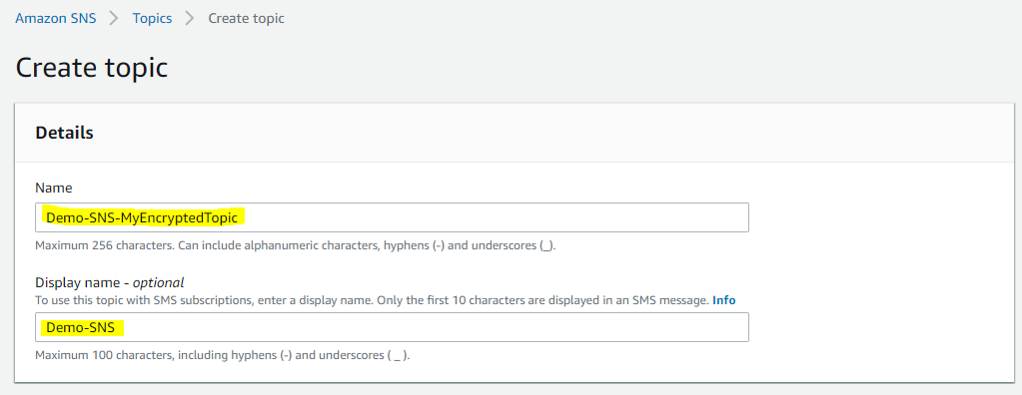

1. Expand the **Encryption** section and do the following:
   1. Choose **Enable server-side encryption**.
   2. Specify the customer master key (CMK).

For each CMK type, the **Description**, **Account**, and **CMK ARN** are displayed.

**Important:** If you aren't the owner of the CMK, or if you log in with an account that doesn't have the kms:ListAliases and kms:Describe Key permissions, you won't be able to view information about the CMK on the Amazon SNS console.

* 1. For **Customer master key (CMK)**, choose **DemoMyCustomCMK** [which you created earlier](https://docs.aws.amazon.com/sns/latest/dg/sns-tutorial-enable-encryption-for-topic-sqs-queue-subscriptions.html#create-custom-cmk) and then choose **Enable server-side encryption**.

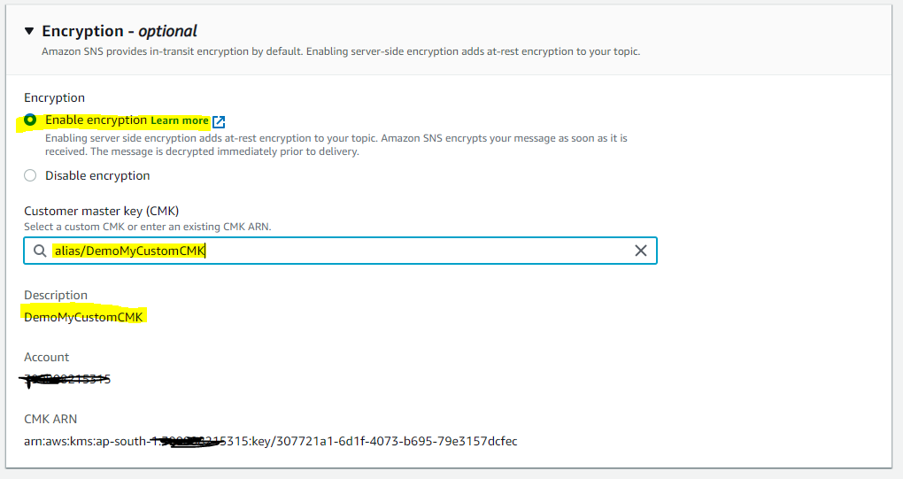

1. Choose **Save changes**.

SSE is enabled for your topic and the **MyTopic** page is displayed.

* Your new encrypted topic appears in the list of topics.

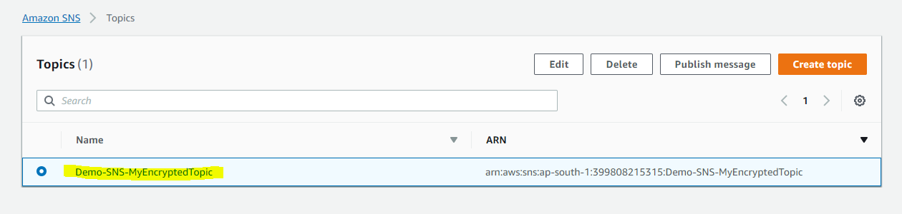

## **Step 3: To Create and Subscribe Encrypted Amazon SQS Queues**

1. Sign in to the [Amazon SQS console](https://console.aws.amazon.com/sqs/).
2. Choose **Create New Queue**.

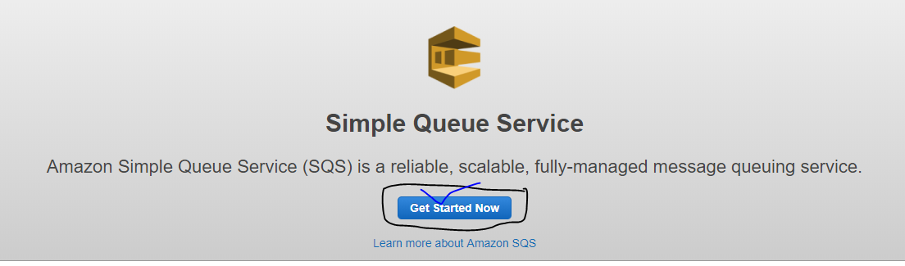

1. On the **Create New Queue** page, do the following:
   1. Enter a **Queue Name** (for example, Demo-MyEncryptedQueue1).
   2. Choose **Standard Queue**, and then choose **Configure Queue**.

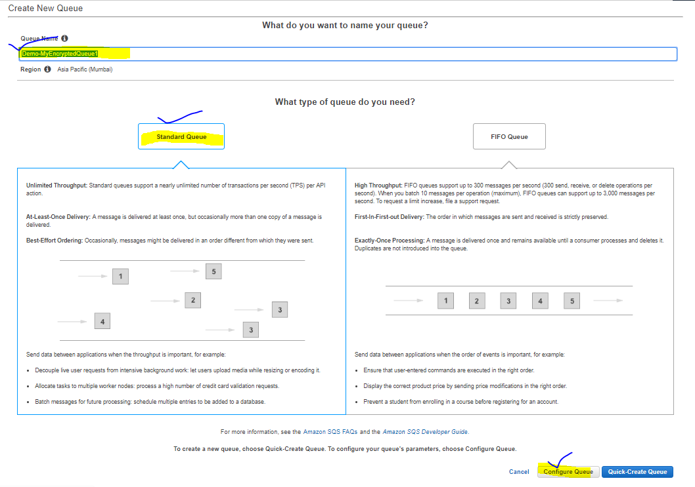

* 1. Choose **Use SSE**.
  2. For **AWS AWS KMS Customer Master Key (CMK)**, choose **DemoMyCustomCMK** [which you created earlier](https://docs.aws.amazon.com/sns/latest/dg/sns-tutorial-enable-encryption-for-topic-sqs-queue-subscriptions.html#create-custom-cmk), and then choose **Create Queue**.

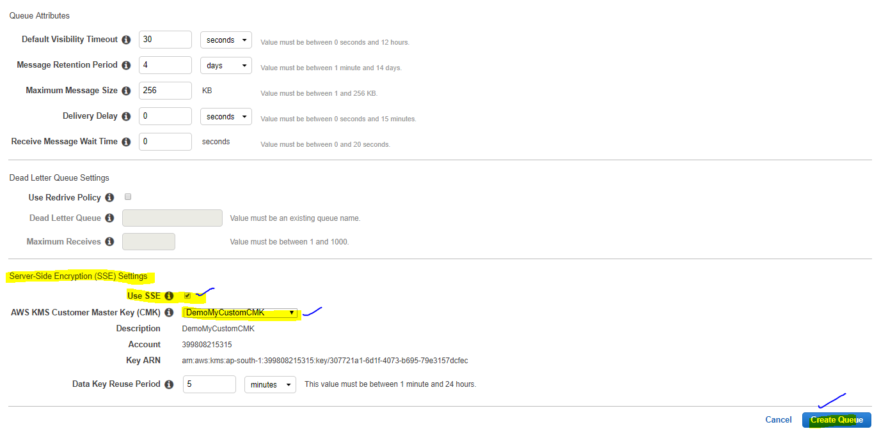

1. Repeat the process to create a second queue (for example, named Demo-MyEncryptedQueue2).

Your new encrypted queues appear in the list of queues.

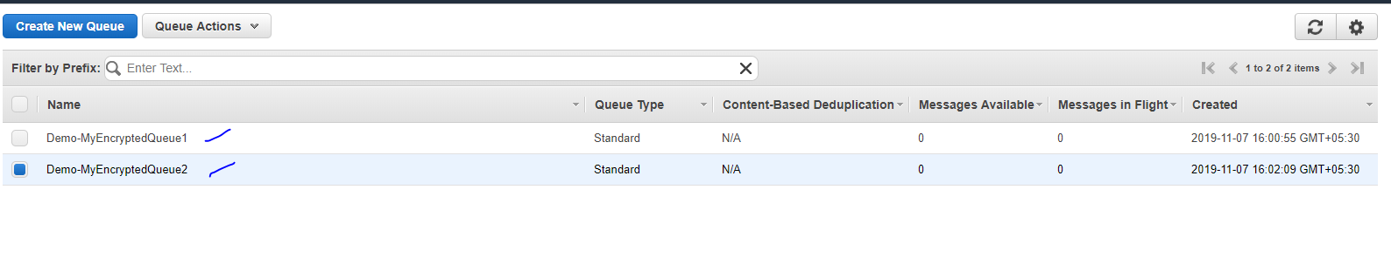

1. On the Amazon SQS console, choose Demo-MyEncryptedQueue1 and Demo-MyEncryptedQueue2 and then choose **Queue Actions**, **Subscribe Queues to SNS Topic**.

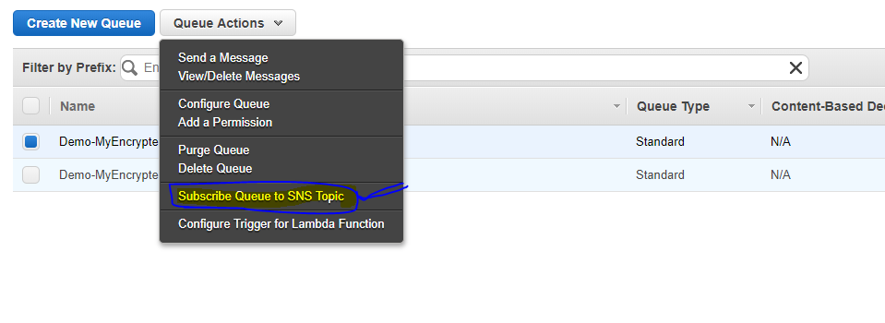

1. In the **Subscribe to a Topic** dialog box, for **Choose a Topic** select **Demo-SNS-MyEncryptedTopic**, and then choose **Subscribe**.

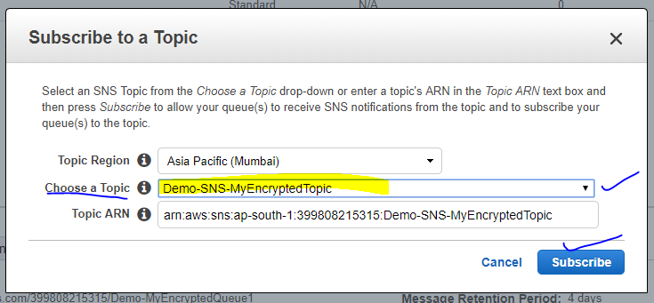

Your encrypted queues' subscriptions to your encrypted topic are displayed in the **Topic Subscription Result** dialog box.

1. Choose **OK**.

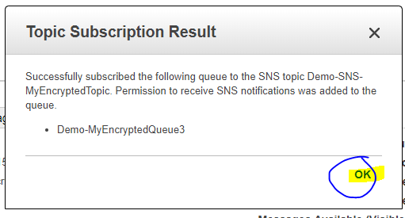

## **Step 4: To Publish a Message to Your Encrypted Topic**

1. Sign in to the [Amazon SNS console](https://console.aws.amazon.com/sns/).
2. On the navigation panel, choose **Topics**.
3. From the list of topics, choose **Demo-SNS-MyEncryptedTopic** and then choose **Publish message**.

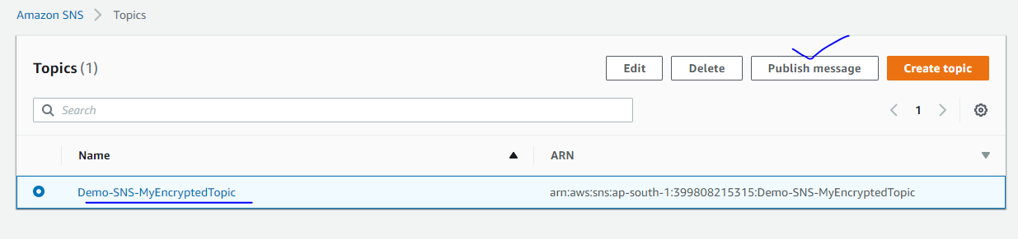

1. On the **Publish a message** page, do the following:
   1. (Optional) In the **Message details** section, enter the **Subject** (for example, Testing message publishing).
   2. In the **Message body** section, enter the message body (for example, My message body is encrypted at rest.).
   3. Choose **Publish message**.

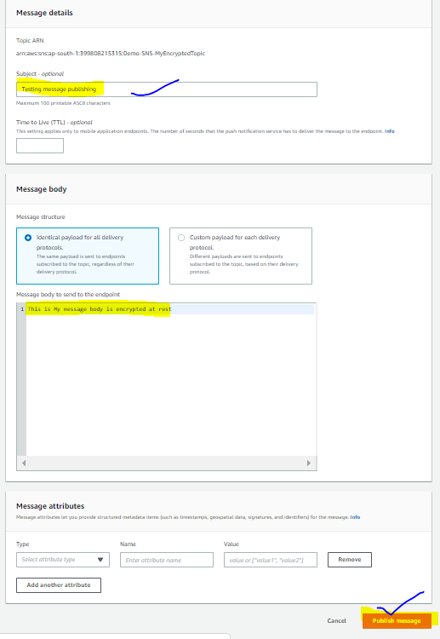

* Your message is published to your subscribed encrypted queues.

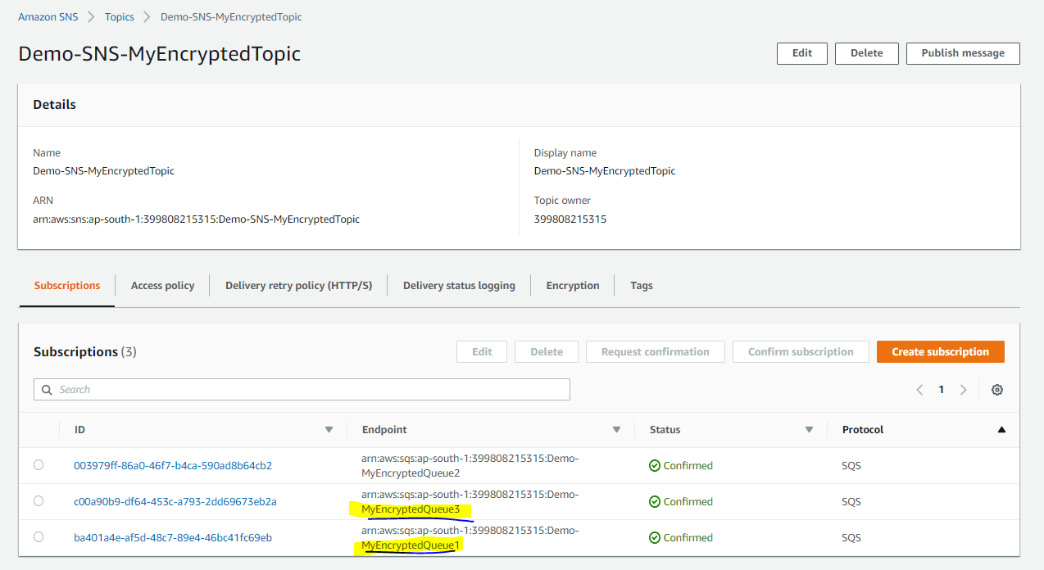

## **Step 5: To Verify Message Delivery**

1. Sign in to the [Amazon SQS console](https://console.aws.amazon.com/sqs/).
2. From the list of queues, choose **Demo-MyEncryptedQueue1** and then choose **Queue Actions**, **View/Delete Messages**.

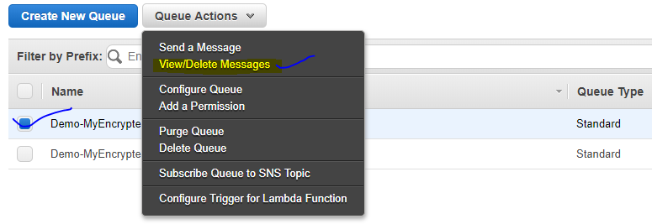

1. On the **View/Delete Messages in Demo-MyEncryptedQueue1** page, choose **Start polling for messages**.

The message [that you sent earlier](https://docs.aws.amazon.com/sns/latest/dg/sns-tutorial-enable-encryption-for-topic-sqs-queue-subscriptions.html#publish-to-encrypted-topic) is displayed.

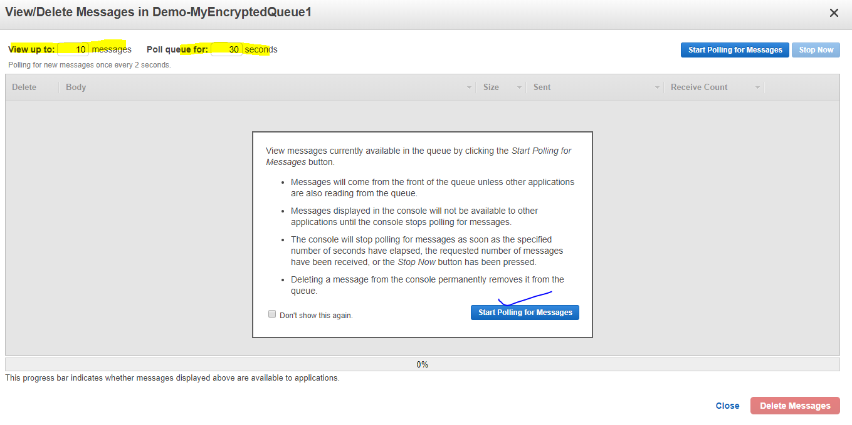

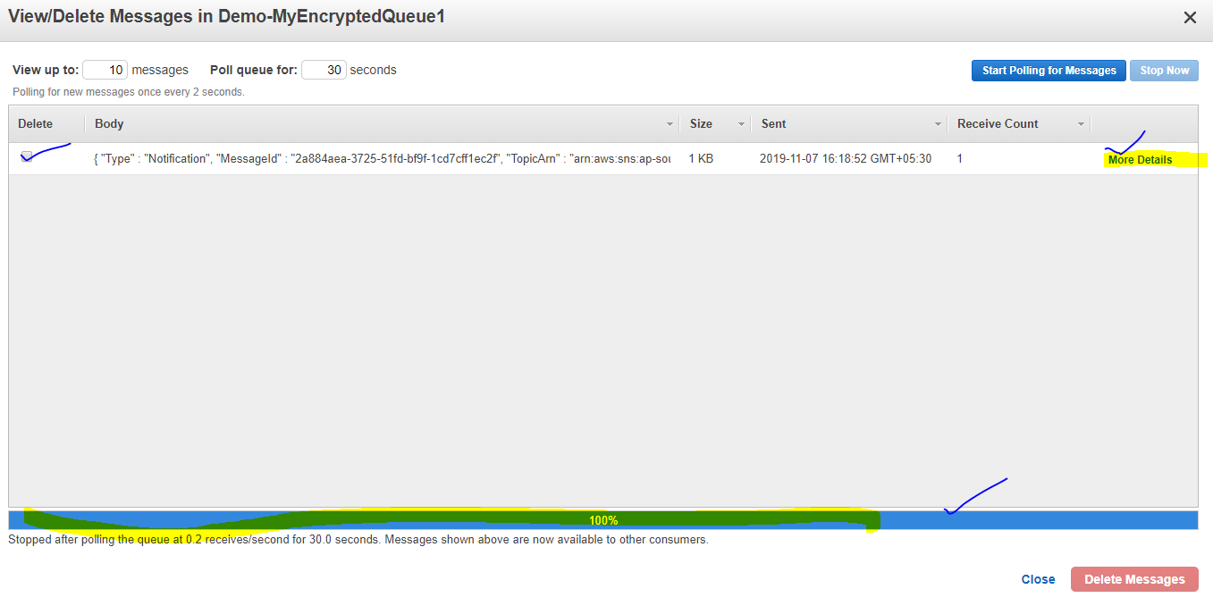

1. Choose **More Details** to view your message.

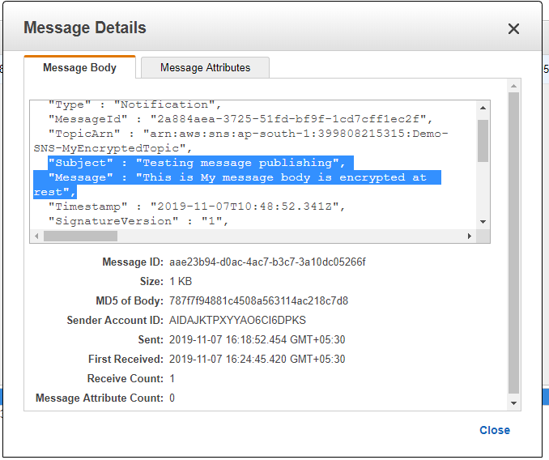

1. When you're finished, choose **Close**.
2. Repeat the process for **Demo-MyEncryptedQueue2**.

# Set CloudWatch Alarms for Amazon SNS Metrics

CloudWatch also allows you to set alarms when a threshold is met for a metric. For example, you could set an alarm for the metric,**NumberOfNotificationsFailed**, so that when your specified threshold number is met within the sampling period, then an email notification would be sent to inform you of the event.

1. Sign in to the AWS Management Console and open the CloudWatch console at <https://console.aws.amazon.com/cloudwatch/>.
2. Choose **Alarms**, and then choose the **Create Alarm** button. This launches the **Create Alarm** wizard.
3. Scroll through the Amazon SNS metrics to locate the metric you want to place an alarm on. Select the metric to create an alarm on and choose **Continue**.
4. Fill in the **Name**, **Description**, **Threshold**, and **Time** values for the metric, and then choose **Continue**.
5. Choose **Alarm** as the alarm state. If you want CloudWatch to send you an email when the alarm state is reached, choose either an existing Amazon SNS topic or choose **Create New Email Topic**. If you choose **Create New Email Topic**, you can set the name and email addresses for a new topic. This list will be saved and appear in the drop-down box for future alarms. Choose **Continue**.

**Note**

If you use **Create New Email Topic** to create a new Amazon SNS topic, the email addresses must be verified before they will receive notifications. Emails are sent only when the alarm enters an alarm state. If this alarm state change happens before the email addresses are verified, they will not receive a notification.

1. At this point, the **Create Alarm** wizard gives you a chance to review the alarm you’re about to create. If you need to make any changes, you can use the **Edit** links on the right. Once you are satisfied, choose **Create Alarm**.

# AWS Event Fork Pipelines to an Amazon SNS Topic

* AWS Event Fork Pipelines is a suite of open-source [nested applications](https://docs.aws.amazon.com/serverless-application-model/latest/developerguide/serverless-sam-template-nested-applications.html), based on the [AWS Serverless Application Model](https://aws.amazon.com/serverless/sam/) (**AWS SAM**), which you can deploy directly from the [AWS Event Fork Pipelines suite](https://serverlessrepo.aws.amazon.com/applications?query=aws-event-fork-pipelines) (choose **Show apps that create custom IAM roles or resource policies**) into your AWS account.

## **11.1. To Deploy and Subscribe the Event Storage and Backup Pipeline**

* How to deploy the [Event Storage and Backup Pipeline](https://docs.aws.amazon.com/sns/latest/dg/sns-fork-pipeline-as-subscriber.html#sns-fork-event-storage-and-backup-pipeline) and subscribe it to an Amazon SNS topic.
* This process automatically turns the **SAM template** associated with the pipeline **into** an **AWS CloudFormation stack**, and then **deploys** the stack into **your AWS account**.
* This process also creates and configures the set of resources which comprise the Event Storage and Backup Pipeline, including the following:
  + Amazon SQS queue
  + Lambda function
  + Kinesis Data Firehose delivery stream
  + Amazon S3 backup bucket

1. Sign in to the [AWS Lambda console](https://console.aws.amazon.com/lambda/).
2. On the navigation panel, choose **Functions** and then choose **Create function**.
3. On the **Create function** page, do the following:
   1. Choose **Browse serverless app repository**, **Public applications**, **Show apps that create custom IAM roles or resource policies**.
   2. Search for fork-event-storage-backup-pipeline and then choose the application.
4. On the **fork-event-storage-backup-pipeline** page, do the following:
   1. In the **Application settings** section, enter an **Application name** (for example, my-app-backup).

**Note:** For each deployment, the application name must be unique. If you reuse an application name, the deployment will update only the previously deployed AWS CloudFormation stack (rather than create a new one).

* 1. (Optional) For **BucketArn**, enter the ARN of the S3 bucket into which incoming events are loaded. If you don't enter a value, a new S3 bucket is created in your AWS account.
  2. (Optional) For **DataTransformationFunctionArn**, enter the ARN of the Lambda function through which the incoming events are transformed. If you don't enter a value, data transformation is disabled.
  3. (Optional) Enter one of the following **LogLevel** settings for the execution of your application's Lambda function:
     + DEBUG
     + ERROR
     + INFO (default)
     + WARNING
  4. For **TopicArn**, enter the ARN of the Amazon SNS topic to which this instance of the fork pipeline is to be subscribed.
  5. (Optional)For **StreamBufferingIntervalInSeconds** and **StreamBufferingSizeInMBs**, enter the values for configuring the buffering of incoming events. If you don't enter any values, 300 seconds and 5 MB are used.
  6. (Optional) Enter one of the following **StreamCompressionFormat** settings for compressing incoming events:
     + GZIP
     + SNAPPY
     + UNCOMPRESSED (default)
     + ZIP
  7. (Optional) For **StreamPrefix**, enter the string prefix to name files stored in the S3 backup bucket. If you don't enter a value, no prefix is used.
  8. (Optional) For **SubscriptionFilterPolicy**, enter the Amazon SNS subscription filter policy, in JSON format, to be used for filtering incoming events. The filter policy decides which events are stored in the S3 backup bucket. If you don't enter a value, no filtering is used (all events are stored).
  9. Choose **I acknowledge that this app creates custom IAM roles, resource policies and deploys nested applications.** and then choose **Deploy**.

1. On the **Deployment status for *my-app*** page, Lambda displays the **Your application is being deployed** status.
2. In the **Resources** section, AWS CloudFormation begins to create the stack and displays the **CREATE_IN_PROGRESS** status for each resource. When the process is complete, AWS CloudFormation displays the **CREATE_COMPLETE** status.
3. When the deployment is complete, Lambda displays the **Your application has been deployed** status.
4. Messages published to your Amazon SNS topic are stored in the S3 backup bucket provisioned by the Event Storage and Backup pipeline automatically.

## **11.2. To Deploy and Subscribe the Event Search and Analytics Pipeline**

* How to deploy the [Event Search and Analytics Pipeline](https://docs.aws.amazon.com/sns/latest/dg/sns-fork-pipeline-as-subscriber.html#sns-fork-event-search-and-analytics-pipeline) and subscribe it to an Amazon SNS topic.
* This process also creates and configures the set of resources which comprise the Event Search and Analytics Pipeline, including the following:
  + Amazon SQS queue
  + Lambda function
  + Kinesis Data Firehose delivery stream
  + Amazon Elasticsearch Service domain
  + Amazon S3 dead-letter bucket

1. Sign in to the [AWS Lambda console](https://console.aws.amazon.com/lambda/).
2. On the navigation panel, choose **Functions** and then choose **Create function**.
3. On the **Create function** page, do the following:
   1. Choose **Browse serverless app repository**, **Public applications**, **Show apps that create custom IAM roles or resource policies**.
   2. Search for fork-event-search-analytics-pipeline and then choose the application.
4. On the **fork-event-search-analytics-pipeline** page, do the following:
   1. In the **Application settings** section, enter an **Application name** (for example, my-app-search).

**Note:** For each deployment, the application name must be unique. If you reuse an application name, the deployment will update only the previously deployed AWS CloudFormation stack (rather than create a new one).

* 1. (Optional) For **DataTransformationFunctionArn**, enter the ARN of the Lambda function used for transforming incoming events. If you don't enter a value, data transformation is disabled.
  2. (Optional) Enter one of the following **LogLevel** settings for the execution of your application's Lambda function:
     + DEBUG
     + ERROR
     + INFO (default)
     + WARNING
  3. (Optional) For **SearchDomainArn**, enter the ARN of the Amazon ES domain, a cluster which configures the needed compute and storage functionality. If you don't enter a value, a new domain is created with the default configuration.
  4. For **TopicArn**, enter the ARN of the Amazon SNS topic to which this instance of the fork pipeline is to be subscribed.
  5. For **SearchIndexName**, enter the name of the Amazon ES index for event search and analytics.

**Note:** The following limits apply to index names:

* + - Can't include uppercase letters
    - Can't include the following characters: \ / * ? " < > | ` , #
    - Can't begin with the following characters: - + _
    - Can't be the following: . ..
    - Can't be longer than 80 characters
    - Can't be longer than 255 bytes
    - Can't contain a colon (from Amazon ES 7.0)
  1. (Optional) Enter one of the following **SearchIndexRotationPeriod** settings for the rotation period of the Amazon ES index:
     + NoRotation (default)
     + OneDay
     + OneHour
     + OneMonth
     + OneWeek

Index rotation appends a timestamp to the index name, facilitating the expiration of old data.

* 1. For **SearchTypeName**, enter the name of the Amazon ES type for organizing the events in an index.

**Note**

* + - Amazon ES type names can contain any character (except null bytes) but can't begin with _.
    - For Amazon ES 6.x, there can be only one type per index. If you specify a new type for an existing index that already has another type, Kinesis Data Firehose returns a runtime error.
  1. (Optional)For **StreamBufferingIntervalInSeconds** and **StreamBufferingSizeInMBs**, enter the values for configuring the buffering of incoming events. If you don't enter any values, 300 seconds and 5 MB are used.
  2. (Optional) Enter one of the following **StreamCompressionFormat** settings for compressing incoming events:
     + GZIP
     + SNAPPY
     + UNCOMPRESSED (default)
     + ZIP
  3. (Optional) For **StreamPrefix**, enter the string prefix to name files stored in the S3 dead-letter bucket. If you don't enter a value, no prefix is used.
  4. (Optional) For **StreamRetryDurationInSecons**, enter the retry duration for cases when Kinesis Data Firehose can't index events in the Amazon ES index. If you don't enter a value, then 300 seconds is used.
  5. (Optional) For **SubscriptionFilterPolicy**, enter the Amazon SNS subscription filter policy, in JSON format, to be used for filtering incoming events. The filter policy decides which events are indexed in the Amazon ES index. If you don't enter a value, no filtering is used (all events are indexed).
  6. Choose **I acknowledge that this app creates custom IAM roles, resource policies and deploys nested applications.**and then choose **Deploy**.

1. On the **Deployment status for *my-app-search*** page, Lambda displays the **Your application is being deployed** status.
2. In the **Resources** section, AWS CloudFormation begins to create the stack and displays the **CREATE_IN_PROGRESS** status for each resource. When the process is complete, AWS CloudFormation displays the **CREATE_COMPLETE** status.
3. When the deployment is complete, Lambda displays the **Your application has been deployed** status.
4. Messages published to your Amazon SNS topic are indexed in the Amazon ES index provisioned by the Event Search and Analytics pipeline automatically. If the pipeline can't index an event, it stores it in a S3 dead-letter bucket.

# Deploying and Testing the AWS Event Fork Pipelines Sample Application

<https://docs.aws.amazon.com/sns/latest/dg/sns-tutorial-deploy-test-fork-pipelines-sample-application.html?shortFooter=true>

# Reference Links:

* <https://docs.aws.amazon.com/sns/latest/dg/welcome.html?shortFooter=true>
* <https://aws.amazon.com/getting-started/tutorials/filter-messages-published-to-topics/>
* <https://aws.amazon.com/sns/?whats-new-cards.sort-by=item.additionalFields.postDateTime&whats-new-cards.sort-order=desc>
* AWS Simple Notification Service (SNS) | AWS Tutorial For Beginners: <https://www.youtube.com/watch?v=z0JADXyH8Kg>
* Using Mobile Push Notifications with Amazon SNS - Simply Notification Service on AWS <https://www.youtube.com/watch?v=qR4aCEEBKAI>
* AWS Monitoring - SNS and CloudWatch Introduction <https://www.youtube.com/watch?v=GPlQikruIIk>