Docker basic Commands:

1 Verify Docker Version
$ docker --version
Docker version 18.09.5, build e8ff056

2 View system wide Information
‘docker info‘ command is used to view the system wide information like Docker’s root Directory, OS version, Kernel Version, Docker Version, RAM, CPU and Docker Registry.

$ docker info
Containers: 20
Running: 18
Paused: 0
Stopped: 2
Images: 29
Server Version: 18.09.5
Storage Driver: overlay
Backing Filesystem: extfs
Supports d_type: true
Logging Driver: json-file
Cgroup Driver: cgroupfs
Plugins:
Volume: local
Network: bridge host macvlan null overlay
Log: awslogs fluentd gcplogs gelf journald json-file local logentries splunk syslog
Swarm: inactive
Runtimes: runc
Default Runtime: runc
Init Binary: docker-init
containerd version:
runc version: N/A
init version: v0.18.0 (expected: fec3683b971d9c3ef73f284f176672c44b448662)
Security Options:
apparmor
seccomp
Profile: default
Kernel Version: 4.15.0-51-generic
Operating System: Ubuntu 18.04.2 LTS
OSType: linux
Architecture: x86_64
CPUs: 2
Total Memory: 2.404GiB
Name: minikube
ID: Q4LA:3DP2:IBAP:ZUGR:MKR2:UJTL:HFGC:DL7O:RJVZ:WTLO:OWSS:KWRS
Docker Root Dir: /var/lib/docker
Debug Mode (client): false
Debug Mode (server): true
File Descriptors: 117
Goroutines: 113
System Time: 2019-07-01T05:57:48.500919883Z
EventsListeners: 0
Registry: https://index.docker.io/v1/
Labels:
Experimental: false
Insecure Registries:
registry.test.training.katacoda.com:4567
127.0.0.0/8
Live Restore Enabled: false

WARNING: No swap limit support
WARNING: the overlay storage-driver is deprecated, and will be removed in a future release.
$

3 Search Docker Images in its Registry Server
With help of ‘docker search‘ command we search the docker container images in registry server from the terminal, Let’s assume I want to search latest debian Docker Images.

$ docker search debian
NAME DESCRIPTION STARS OFFICIAL AUTOMATED
ubuntu Ubuntu is a Debian-based Linux operating sys… 9684 [OK]
debian Debian is a Linux distribution that's compos… 3127 [OK]
arm32v7/debian Debian is a Linux distribution that's compos… 58
itscaro/debian-ssh debian:jessie 25 [OK]
samueldebruyn/debian-git a minimal docker container with debian and g… 21 [OK]
arm64v8/debian Debian is a Linux distribution that's compos… 20
i386/debian Debian is a Linux distribution that's compos… 8
eboraas/debian Debian base images, for all currently-availa… 8 [OK]
multiarch/debian-debootstrap multiarch ports of debian-debootstrap 8
vergissberlin/debian-development Docker debian image to use for development, … 6 [OK]
debian/eol End of Life Debian versions (pointing at arc… 5
rockyluke/debian Docker images of Debian. 5
smartentry/debian debian with smartentry 4 [OK]
vicamo/debian Debian docker images for all versions/archit… 3
ppc64le/debian Debian is a Linux distribution that's compos… 3
vpgrp/debian Docker images of Debian. 2
s390x/debian Debian is a Linux distribution that's compos… 2
dockershelf/debian Repository for docker images of Debian. Test… 1 [OK]
1and1internet/debian-9-apache-php-7.1-shopware-5.4 Shopware on our Apache, PHP 7.1, Debian 9 ba… 1 [OK]
holgerimbery/debian debian multiarch docker base image 1
casept/debian-amd64 A debian image built from scratch. Mostly fo… 0
fleshgrinder/debian Debian base images for production and multis… 0 [OK]
spritsail/debian-builder A Docker image based on debian:slim ideal fo… 0 [OK]
jdub/debian-sources-resource Concourse CI resource to check for updated D… 0 [OK]
amd64/debian Debian is a Linux distribution that's compos… 0
$

4 Downloading Docker Container Images
With the help of ‘docker pull’ command we can download docker container images from its registry server or repository.
Syntax : # docker pull <Name-of-Image>
Docker pull command always download latest version of image, though we can specify the particular of image. Let’s assume I want to download latest version of Debian Docker image
[root@docker ~]# docker pull debian
Using default tag: latest
latest: Pulling from library/debian
10a267c67f42: Already exists
Digest: sha256:476959f29a17423a24a17716e058352ff6fbf13d8389e4a561c8ccc758245937
Status: Downloaded newer image for debian:latest
[root@docker ~]#
Downloading Specific OS version Docker Image
Let’s assume we want to download Ubuntu:14.04 Docker Image
[root@docker ~]# docker pull ubuntu:14.04
14.04: Pulling from library/ubuntu
cf0a75889057: Already exists
c8de9902faf0: Already exists
a3c0f7711c5e: Already exists
e6391432e12c: Already exists
624ce029a17f: Already exists
Digest: sha256:b2a55128abd84a99436157c2fc759cf0a525c273722460e6f8f9630747dfe7e8
Status: Downloaded newer image for ubuntu:14.04
[root@docker ~]#

5 List all Downloaded Docker Container Images
Whenever we download docker images using docker pull command, it save the docker images locally(/var/lib/docker) on your Docker Server. We can list all the downloaded docker images using the ‘docker images‘ command,

$ docker images
[root@docker ~]# docker images
REPOSITORY TAG IMAGE ID CREATED SIZE
wordpress latest ca96afcfa242 2 weeks ago 406 MB
xibosignage/xibo-xmr release_1.8.1 223afb5ecffe 2 weeks ago 269 MB
ubuntu 16.04 ebcd9d4fca80 2 weeks ago 118 MB
ubuntu 14.04 2ff3b426bbaa 2 weeks ago 188 MB
centos 7 8140d0c64310 2 weeks ago 193 MB
mysql 5.6 ed7b6c642b9d 3 weeks ago 299 MB
mysql 5.7 e799c7f9ae9c 3 weeks ago 407 MB
debian latest 3e83c23dba6a 3 weeks ago 124 MB
xibosignage/xibo-cms latest 9678c5299918 5 weeks ago 511 MB
xibosignage/xibo-cms release_1.8.1 c2767fdc7262 5 weeks ago 511 MB
[root@docker ~]#

6 Launching a container with ‘docker run’ command
Containers are launched with ‘docker run’ command, let assume I want to launch a container from the debian image.
[root@docker ~]# docker run -it -p 9000:80 --name=debian_container1 debian
root@9254e01fadad:/#

Above Command launch a container with the name “debian_container1” and we also set pat rule in such a way that if any request comes to 9000 port on docker host then that request will be redirected to debian container on 80 port. If you might have noticed that we directly get the console just after executing the command. Type exit to stop / shutdown the container and if want to get out from the container without exiting then type “ctrl+p+q”

7 Launching a Container in detach mode
We can launch a container in detach mode using –d option in ‘docker run’ command. Example is shown below
[root@docker ~]# docker run -it -d -p 9001:80 --name=web_container centos:7
258adf2f71fba82aa04e5f7e9ebba27b8ad87b0439e9bd7d2bcf7e3c40279d54
[root@docker ~]#

9 List Containers with ‘docker ps’ command
We can list all the running containers using ‘docker ps’ command.
$ docker ps
CONTAINER ID IMAGE COMMAND CREATED STATUSPORTS NAMES
73b3bea76d14 eb516548c180 "/coredns -conf /etc…" 16 minutes ago Up 16 minutes k8s_coredns_coredns-5c98db65d4-f2mzn_kube-system_52f4f63b-9e0b-4e1c-8b3d-096b74c3ed66_1
ef1e570fca3c eb516548c180 "/coredns -conf /etc…" 16 minutes ago Up 16 minutes k8s_coredns_coredns-5c98db65d4-bdcvh_kube-system_0e78854f-78b6-4a33-a73b-773e6da699b5_1
76d65319704a 4689081edb10 "/storage-provisioner" 17 minutes ago Up 17 minutes k8s_storage-provisioner_storage-provisioner_kube-system_dd46354a-2d3a-4e7a-be4f-51fbccc1d1ee_0
727f0f7d71b4 k8s.gcr.io/pause:3.1 "/pause" 17 minutes ago Up 17 minutes k8s_POD_storage-provisioner_kube-system_dd46354a-2d3a-4e7a-be4f-51fbccc1d1ee_0
65d9baec474e d235b23c3570 "/usr/local/bin/kube…" 17 minutes ago Up 17 minutes k8s_kube-proxy_kube-proxy-qzk6f_kube-system_b472f7a4-2a84-4516-84be-9e4d3c70ef84_0
7bcba18b6e72 k8s.gcr.io/pause:3.1 "/pause" 17 minutes ago Up 17 minutes k8s_POD_coredns-5c98db65d4-bdcvh_kube-system_0e78854f-78b6-4a33-a73b-773e6da699b5_0
518cfce849fd k8s.gcr.io/pause:3.1 "/pause" 17 minutes ago Up 17 minutes k8s_POD_coredns-5c98db65d4-f2mzn_kube-system_52f4f63b-9e0b-4e1c-8b3d-096b74c3ed66_0
2d0a1c24f1f0 k8s.gcr.io/pause:3.1 "/pause" 17 minutes ago Up 17 minutes k8s_POD_kube-proxy-qzk6f_kube-system_b472f7a4-2a84-4516-84be-9e4d3c70ef84_0
75f83bd6613d 8328bb49b652 "kube-controller-man…" 17 minutes ago Up 17 minutes k8s_kube-controller-manager_kube-controller-manager-minikube_kube-system_b57a53dbade90e266fa007fcac077bfa_0
2972c556d882 201c7a840312 "kube-apiserver --ad…" 17 minutes ago Up 17 minutes k8s_kube-apiserver_kube-apiserver-minikube_kube-system_7b11d6fa2675516b32cd42c8b82357e2_0
37e8be656de8 119701e77cbc "/opt/kube-addons.sh" 17 minutes ago Up 17 minutes k8s_kube-addon-manager_kube-addon-manager-minikube_kube-system_65a31d2b812b11a2035f37c8a742e46f_0
6e220717855b 2c4adeb21b4f "etcd --advertise-cl…" 17 minutes ago Up 17 minutes k8s_etcd_etcd-minikube_kube-system_aba52a5129793229aa0443acc930b29f_0
f239de5f027a 2d3813851e87 "kube-scheduler --bi…" 17 minutes ago Up 17 minutes k8s_kube-scheduler_kube-scheduler-minikube_kube-system_31d9ee8b7fb12e797dc981a8686f6b2b_0
15baa3a6b7b0 k8s.gcr.io/pause:3.1 "/pause" 17 minutes ago Up 17 minutes k8s_POD_kube-controller-manager-minikube_kube-system_b57a53dbade90e266fa007fcac077bfa_0
4ddee0ed9def k8s.gcr.io/pause:3.1 "/pause" 17 minutes ago Up 17 minutes k8s_POD_kube-scheduler-minikube_kube-system_31d9ee8b7fb12e797dc981a8686f6b2b_0
8381b8a2b5cf k8s.gcr.io/pause:3.1 "/pause" 17 minutes ago Up 17 minutes k8s_POD_etcd-minikube_kube-system_aba52a5129793229aa0443acc930b29f_0
40cf3e83680f k8s.gcr.io/pause:3.1 "/pause" 17 minutes ago Up 17 minutes k8s_POD_kube-apiserver-minikube_kube-system_7b11d6fa2675516b32cd42c8b82357e2_0
bc0773d2cd3f k8s.gcr.io/pause:3.1 "/pause" 17 minutes ago Up 17 minutes k8s_POD_kube-addon-manager-minikube_kube-system_65a31d2b812b11a2035f37c8a742e46f_0
$

To List all the containers including stop /shutdown, use ‘docker ps –a’

10 Start, Stop, Restart and Kill Containers
Just like virtual machines we can start, stop and restart docker containers.
Use below command to stop a running container
[root@docker ~]# docker stop db_container1
db_container1
[root@docker ~]#

In Place of container we can also use Container ID
Use below command to start a container.
[root@docker ~]# docker start db_container1
db_container1
[root@docker ~]#

Use below command to restart a container.
[root@docker ~]# docker restart db_container1
db_container1
[root@docker ~]#

Just like Process we can also kill a container, Use below command to kill a container.
[root@docker ~]# docker kill db_container2
db_container2
[root@docker ~]#

11 Delete / Remove a Container
‘docker rm‘ command is used to remove or delete a container. ‘docker rm’ will work only when docker is stopped / shutdown.
Syntax: # docker rm {container_name_OR_container_id}

[root@docker ~]# docker rm db_container2
db_container2
[root@docker ~]#

To remove a running container forcefully, use ‘-f’ option in docker rm command. Example is shown is below
[root@docker ~]# docker rm -f web_container2
web_container2
[root@docker ~]#

12 Delete / Remove Docker Container images
Just like containers we can also delete or remove docker images, ‘docker rmi‘ command is used to delete docker container images.
Let’s assume i want to delete a docker image ‘Ubuntu:14.04’
[root@docker ~]# docker rmi ubuntu:14.04
Untagged: ubuntu:14.04
Untagged: ubuntu@sha256:b2a55128abd84a99436157c2fc759cf0a525c273722460e6f8f9630747dfe7e8
Deleted: sha256:2ff3b426bbaafba63cae165e8f6a4955a24a53cdf6d25cce00353e97cda3df71
[root@docker ~]#

In above command in place of image name we also use image id
[root@docker ~]# docker rmi 2ff3b426bbaa

13 Save and Load Docker Container Image to/from a tar file
Let’s assume we have done some changes in debian image and we want to export it as tar file, this can be done with ‘docker save‘ command, example is shown below

[root@docker ~]# docker save debian -o mydebian.tar
[root@docker ~]# ls -l mydebian.tar
-rw-------. 1 root root 129394176 Jun 1 23:52 mydebian.tar
[root@docker ~]#

Load Docker Image from tar file.

[root@docker ~]# docker load -i mydebian.tar
Loaded image: debian:latest
[root@docker ~]#
Note: These commands become useful when we want to transfer docker image from one Docker Host to another.

14 Export and Import Container to / from tar archive
Container can be exported to a tar file using the ‘docker export’ command. Syntax is shown below
# docker export container_name_or_id
Let’s suppose I want to export web_container to a tar file.
[root@docker ~]# docker export web_container -o web_container.tar
[root@docker ~]#

Use ‘docker import‘ command to import container from a tar file, examples is shown below.

[root@docker ~]# docker import web_container.tar
sha256:254b1bdba79775191d33d221eb547e9caca161363639273103193919db71778d
[root@docker ~]#

15 Display History of Docker Image
History of Docker image here means what commands are being executed while building docker images, we can list these commands using ‘docker history‘
Syntax : # docker history {Image_Name_OR_Image_id}

[root@docker ~]# docker history ubuntu:16.04
IMAGE CREATED CREATED BY SIZE COMMENT
ebcd9d4fca80 2 weeks ago /bin/sh -c #(nop) CMD ["/bin/bash"] 0 B
<missing> 2 weeks ago /bin/sh -c mkdir -p /run/systemd && echo '... 7 B
<missing> 2 weeks ago /bin/sh -c sed -i 's/^#\s*\(deb.*universe\... 2.76 kB
<missing> 2 weeks ago /bin/sh -c rm -rf /var/lib/apt/lists/* 0 B
<missing> 2 weeks ago /bin/sh -c set -xe && echo '#!/bin/sh' >... 745 B
<missing> 2 weeks ago /bin/sh -c #(nop) ADD file:d14b493577228a4... 118 MB
[root@docker ~]#

16 Fetching Logs from the Container
We can fetch the logs from the containers without login into it, Use ‘docker logs’ command
Syntax : docker logs {container_name_or_container_id}

[root@docker ~]# docker logs xibodocker_cms-web_1

To fetch the live logs use ‘-f’ option in docker logs command

[root@docker ~]# docker logs -f xibodocker_cms-web_1

17 Containers’ resource usage statistics
To Display CPU, memory, and network I/O usage of all the containers use ‘docker stats‘

[root@docker ~]# docker stats

CONTAINER ID NAME CPU % MEM USAGE / LIMIT MEM % NET I/O BLOCK I/O PIDS73b3bea76d14 k8s_coredns_coredns-5c98db65d4-f2mzn_kube-system_52f4f63b-9e0b-4e1c-8b3d-096b74c3ed66_1 0.14% 7.836MiB / 170MiB 4.61% 1.03MB / 271kB 2.05MB / 0B 10ef1e570fca3c k8s_coredns_coredns-5c98db65d4-bdcvh_kube-system_0e78854f-78b6-4a33-a73b-773e6da699b5_1 0.14% 7.781MiB / 170MiB 4.58% 1.03MB / 272kB 3.19MB / 0B 1076d65319704a k8s_storage-provisioner_storage-provisioner_kube-system_dd46354a-2d3a-4e7a-be4f-51fbccc1d1ee_0 0.03% 13.69MiB / 2.404GiB 0.56% 0B / 0B 99.2MB / 8.19kB 8
727f0f7d71b4 k8s_POD_storage-provisioner_kube-system_dd46354a-2d3a-4e7a-be4f-51fbccc1d1ee_0 0.00% 460KiB / 2.404GiB 0.02% 0B / 0B 0B / 0B 1
65d9baec474e k8s_kube-proxy_kube-proxy-qzk6f_kube-system_b472f7a4-2a84-4516-84be-9e4d3c70ef84_0 0.10% 12.02MiB / 2.404GiB 0.49% 0B / 0B 60.9MB / 0B 8

Above command will show live streaming of resource usage statistics of all the Containers.

Resource usage statistics without live streaming
$ docker stats --no-stream
CONTAINER ID NAME CPU % MEM USAGE / LIMIT MEM % NET I/O BLOCK I/O PIDS73b3bea76d14 k8s_coredns_coredns-5c98db65d4-f2mzn_kube-system_52f4f63b-9e0b-4e1c-8b3d-096b74c3ed66_1 3.88% 7.84MiB / 170MiB 4.61% 1.1MB / 288kB 2.05MB / 0B 10ef1e570fca3c k8s_coredns_coredns-5c98db65d4-bdcvh_kube-system_0e78854f-78b6-4a33-a73b-773e6da699b5_1 3.44% 7.789MiB / 170MiB 4.58% 1.1MB / 289kB 3.19MB / 0B 10
76d65319704a k8s_storage-provisioner_storage-provisioner_kube-system_dd46354a-2d3a-4e7a-be4f-51fbccc1d1ee_0 0.06% 13.6MiB / 2.404GiB 0.55% 0B / 0B 99.2MB / 8.19kB 8727f0f7d71b4 k8s_POD_storage-provisioner_kube-system_dd46354a-2d3a-4e7a-be4f-51fbccc1d1ee_0 0.00% 460KiB / 2.404GiB 0.02% 0B / 0B 0B / 0B 165d9baec474e k8s_kube-proxy_kube-proxy-qzk6f_kube-system_b472f7a4-2a84-4516-84be-9e4d3c70ef84_0 0.06% 11.98MiB / 2.404GiB 0.49% 0B / 0B 60.9MB / 0B 8
7bcba18b6e72 k8s_POD_coredns-5c98db65d4-bdcvh_kube-system_0e78854f-78b6-4a33-a73b-773e6da699b5_0 0.00% 568KiB / 2.404GiB 0.02% 1.1MB / 289kB 0B / 0B 1518cfce849fd k8s_POD_coredns-5c98db65d4-f2mzn_kube-system_52f4f63b-9e0b-4e1c-8b3d-096b74c3ed66_0 0.00% 536KiB / 2.404GiB 0.02% 1.1MB / 288kB 0B / 0B 1
2d0a1c24f1f0 k8s_POD_kube-proxy-qzk6f_kube-system_b472f7a4-2a84-4516-84be-9e4d3c70ef84_0 0.00% 488KiB / 2.404GiB 0.02% 0B / 0B 0B / 0B 1
75f83bd6613d k8s_kube-controller-manager_kube-controller-manager-minikube_kube-system_b57a53dbade90e266fa007fcac077bfa_0 3.00% 42.2MiB / 2.404GiB 1.71% 0B / 0B 135MB / 0B 9
2972c556d882 k8s_kube-apiserver_kube-apiserver-minikube_kube-system_7b11d6fa2675516b32cd42c8b82357e2_0 51.67% 201.1MiB / 2.404GiB 8.17% 0B / 0B 154MB / 0B 11
37e8be656de8 k8s_kube-addon-manager_kube-addon-manager-minikube_kube-system_65a31d2b812b11a2035f37c8a742e46f_0 0.00% 2.66MiB / 2.404GiB 0.11% 0B / 0B 77.5MB / 1.31GB 2
6e220717855b k8s_etcd_etcd-minikube_kube-system_aba52a5129793229aa0443acc930b29f_0 56.22% 28.46MiB / 2.404GiB 1.16% 0B / 0B 65.9MB / 122MB 13
f239de5f027a k8s_kube-scheduler_kube-scheduler-minikube_kube-system_31d9ee8b7fb12e797dc981a8686f6b2b_0 1.81% 10.5MiB / 2.404GiB 0.43% 0B / 0B 63.1MB / 0B 10
15baa3a6b7b0 k8s_POD_kube-controller-manager-minikube_kube-system_b57a53dbade90e266fa007fcac077bfa_0 0.00% 528KiB / 2.404GiB 0.02% 0B / 0B 0B / 0B 1
4ddee0ed9def k8s_POD_kube-scheduler-minikube_kube-system_31d9ee8b7fb12e797dc981a8686f6b2b_0 0.00% 564KiB / 2.404GiB 0.02% 0B / 0B 1.46MB / 0B 1
8381b8a2b5cf k8s_POD_etcd-minikube_kube-system_aba52a5129793229aa0443acc930b29f_0 0.00% 384KiB / 2.404GiB 0.02% 0B / 0B 0B / 0B 1
40cf3e83680f k8s_POD_kube-apiserver-minikube_kube-system_7b11d6fa2675516b32cd42c8b82357e2_0 0.00% 528KiB / 2.404GiB 0.02% 0B / 0B 0B / 0B 1
bc0773d2cd3f k8s_POD_kube-addon-manager-minikube_kube-system_65a31d2b812b11a2035f37c8a742e46f_0 0.00% 592KiB / 2.404GiB 0.02% 0B / 0B 0B / 0B 1
$ c^C
$

We can display the running processes of a container with ‘docker top‘ command.
Syntax: # docker top {Container_Name_OR_ID}

[root@docker ~]# docker top xibodocker_cms-web_1

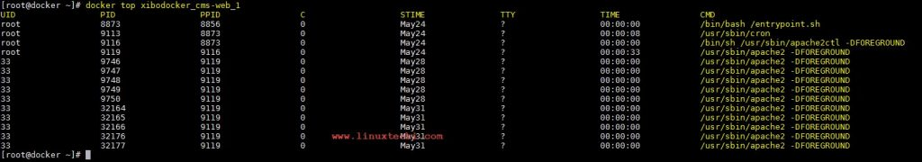

18 Display Container IP address
Container low-level information is displayed with ‘docker inspect‘ command. We can fetch the ip address of a container from command output. Example is shown below

[root@docker ~]# docker inspect web_container | grep IPAddress | cut -d '"' -f 4
172.17.0.3
172.17.0.3
[root@docker ~]#
or
[root@docker ~]# docker inspect -f "{{.NetworkSettings.IPAddress}}" web_container

19. Build Docker Container Images with Docker file
With ‘docker build‘ command we can build our own docker image with DockerFile.

[root@docker ~]# docker build -t mycentos:web1 /path/the/DockerFile

20 Set Tag / Name to Docker Image
‘docker tag’ command is used to set tag or name of docker image into a repository.
Syntax : # docker tag source_image{:tag} target_image{:tag}
Let’s suppose I want set tag of source image ‘centos:7’ as ‘MyCentOS7:v1’
$ docker images
REPOSITORY TAG IMAGE ID CREATED SIZE
k8s.gcr.io/kube-proxy v1.15.0 d235b23c3570 11 days ago 82.4MBk8s.gcr.io/kube-apiserver v1.15.0 201c7a840312 11 days ago 207MB
k8s.gcr.io/kube-controller-manager v1.15.0 8328bb49b652 11 days ago 159MBk8s.gcr.io/kube-scheduler v1.15.0 2d3813851e87 11 days ago 81.1MB
redis latest 3c41ce05add9 2 weeks ago 95MBubuntu latest 7698f282e524 6 weeks ago 69.9MB
alpine latest 055936d39205 7 weeks ago 5.53MBweaveworks/scope 1.10.2 d9ece03f45e7 4 months ago 75.8MB
k8s.gcr.io/kube-addon-manager v9.0 119701e77cbc 5 months ago 83.1MBk8s.gcr.io/coredns 1.3.1 eb516548c180 5 months ago 40.3MB
k8s.gcr.io/kubernetes-dashboard-amd64 v1.10.1 f9aed6605b81 6 months ago 122MBk8s.gcr.io/etcd 3.3.10 2c4adeb21b4f 7 months ago 258MB
weaveworks/scope 1.10.1 b0d8090d0e91 7 months ago 75.7MBgcr.io/hello-minikube-zero-install/hello-node latest 14f0c79cd094 8 months ago 655MB
gcr.io/kubernetes-helm/tiller v2.10.0 0cccc6576d01 10 months ago 68.9MB
weaveworks/scope 1.9.1 4b07159e407b 11 months ago 68MB
k8s.gcr.io/heapster-amd64 v1.5.3 f57c75cd7b0a 14 months ago 75.3MB
k8s.gcr.io/pause 3.1 da86e6ba6ca1 18 months ago 742kB
gcr.io/k8s-minikube/storage-provisioner v1.8.1 4689081edb10 20 months ago 80.8MB
k8s.gcr.io/heapster-influxdb-amd64 v1.3.3 577260d221db 22 months ago 12.5MB
k8s.gcr.io/heapster-grafana-amd64 v4.4.3 8cb3de219af7 22 months ago 152MB
quay.io/munnerz/keepalived-cloud-provider 0.0.1 e099e9cd14a0 22 months ago 127MB
redis 3.0.7-alpine 856249f48b0c 2 years ago 12.6MB
gcr.io/google_containers/kube-keepalived-vip 0.9 959a1b4b8b0f 2 years ago 142MB
jocatalin/kubernetes-bootcamp v2 b6556396ebd4 2 years ago 211MB
jocatalin/kubernetes-bootcamp v1 8fafd8af70e9 2 years ago 211MB
gcr.io/google-samples/kubernetes-bootcamp v1 8fafd8af70e9 2 years ago 211MB
gcr.io/google_containers/echoserver 1.4 a90209bb39e3 3 years ago 140MB
gcr.io/google-samples/gb-frontend v3 c038466384ab 3 years ago 510MB
gcr.io/google_samples/gb-redisslave v1 5f026ddffa27 3 years ago 109MB
$
$
$ docker tag redis:3.0.7-alpine redis:v0.0.1
$
$

Let’s verify the new tag name of docker image

$ docker images
REPOSITORY TAG IMAGE ID CREATED SIZE
k8s.gcr.io/kube-proxy v1.15.0 d235b23c3570 11 days ago 82.4MB
k8s.gcr.io/kube-apiserver v1.15.0 201c7a840312 11 days ago 207MB
k8s.gcr.io/kube-scheduler v1.15.0 2d3813851e87 11 days ago 81.1MB
k8s.gcr.io/kube-controller-manager v1.15.0 8328bb49b652 11 days ago 159MB
redis latest 3c41ce05add9 2 weeks ago 95MB
ubuntu latest 7698f282e524 6 weeks ago 69.9MB
alpine latest 055936d39205 7 weeks ago 5.53MB
weaveworks/scope 1.10.2 d9ece03f45e7 4 months ago 75.8MB
k8s.gcr.io/kube-addon-manager v9.0 119701e77cbc 5 months ago 83.1MB
k8s.gcr.io/coredns 1.3.1 eb516548c180 5 months ago 40.3MB
k8s.gcr.io/kubernetes-dashboard-amd64 v1.10.1 f9aed6605b81 6 months ago 122MB
k8s.gcr.io/etcd 3.3.10 2c4adeb21b4f 7 months ago 258MB
weaveworks/scope 1.10.1 b0d8090d0e91 7 months ago 75.7MB
gcr.io/hello-minikube-zero-install/hello-node latest 14f0c79cd094 8 months ago 655MB
gcr.io/kubernetes-helm/tiller v2.10.0 0cccc6576d01 10 months ago 68.9MB
weaveworks/scope 1.9.1 4b07159e407b 11 months ago 68MB
k8s.gcr.io/heapster-amd64 v1.5.3 f57c75cd7b0a 14 months ago 75.3MB
k8s.gcr.io/pause 3.1 da86e6ba6ca1 18 months ago 742kB
gcr.io/k8s-minikube/storage-provisioner v1.8.1 4689081edb10 20 months ago 80.8MB
k8s.gcr.io/heapster-influxdb-amd64 v1.3.3 577260d221db 22 months ago 12.5MB
k8s.gcr.io/heapster-grafana-amd64 v4.4.3 8cb3de219af7 22 months ago 152MB
quay.io/munnerz/keepalived-cloud-provider 0.0.1 e099e9cd14a0 22 months ago 127MB
redis 3.0.7-alpine 856249f48b0c 2 years ago 12.6MB
redis v0.0.1 856249f48b0c 2 years ago 12.6MB
gcr.io/google_containers/kube-keepalived-vip 0.9 959a1b4b8b0f 2 years ago 142MB
jocatalin/kubernetes-bootcamp v2 b6556396ebd4 2 years ago 211MB
jocatalin/kubernetes-bootcamp v1 8fafd8af70e9 2 years ago 211MB
gcr.io/google-samples/kubernetes-bootcamp v1 8fafd8af70e9 2 years ago 211MB
gcr.io/google_containers/echoserver 1.4 a90209bb39e3 3 years ago 140MB
gcr.io/google-samples/gb-frontend v3 c038466384ab 3 years ago 510MB
gcr.io/google_samples/gb-redisslave v1 5f026ddffa27 3 years ago 109MB
$

How to build Docker Container Images with Dockerfile
In our previous, we have discussed how to Install and setup Docker on CentOS 7.x and Ubuntu Server 16.04. We have also learn how to pull Docker images from Docker Hub / registry. There are some circumstances and use cases that we want to make changes in the Docker images and that changes should be available whenever we launch or provision a Docker container. This can be achieved by three different ways:
- Commit
- Dockerfile
- Docker Compose
Commit is an option in docker command which allows us to save the changes of a container to a Docker image. One of the limitations of commit is that it is not scaleable and very difficult to automate the tasks. In our last article we have also learn how to use Docker commit command. Apart from Docker Commit we can build the Docker images using “Dockerfile“.
Dockerfile is a text file or a script which contains Keywords and set of Linux commands which are executed automatically whenever we build the Docker Image. Creating Docker images using Docker file is similar to template concept of Virtualization world. In this article we will discuss how to create docker images from the Docker file. Some of the Keywords that are generally used in a Dockerfile are listed below:

FROM
From Keyword specify the name of image that will be used as base image while building the Docker Image, Docker command will search this image from local image repository if it is not available in local repository then it will fetch from Registry server
Example:
FROM Ubuntu:14.04

MAINTAINER
Name of the Community or Guy who maintains docker image is specified under MAINTAINER Keyword.
Example:
MAINTAINER Linuxtechi Team info@linuxtechi.com

RUN
Commands mentioned after RUN keyword will be executed during creation of Docker image
Example :
RUN apt-get update
RUN apt-get install apache2 -y
RUN echo 'Web site Hosted inside a container' > /var/ww/html/index.html
RUN echo 'apache2ctl start' >> /root/.bashrc

CMD
Commands mentioned after CMD keyword will executed when a container is launched from a docker image
Example:
CMD /bin/bash
CMD wget {url}

Whenever we use multiple CMD keywords then the latest one will get the preference. If you have noticed when we launch a container we get a bash shell this because of CMD keyword (CMD /bin/bash).

ENTRYPOINT
ENTRYPOINT is similar to CMD, Commands after entrypoint will take arguments from CMD or in other words we can say that CMD is the argument for ENTRYPOINT. Commands in ENTRYPOINT will always be executed.
Example:
ENTRYPIONT ["curl"]
CMD ["www.google.com"]

ENV
With ENV keyword we can set the environmental or shell variables as per requirement, let’s suppose I want build Docker image where I will install java and need to set JAVA path, this can be achieved by using ENV keyword.
Example:
ENV JAVA_HOME= /usr/jdk/jdk{version}

VOLUME
With VOLUME keyword we can attach a folder from Docker engine host to a container.
Example:
VOLUME /mnt/dock_storage /data

EXPOSE
With EXPOSE keyword we can expose application port from Container
Example:
EXPOSE 8080

COPY
Using COPY keyword we can copy the files from Docker Host to a container.
Example:
COPY /my.txt /etc

ADD
With ADD keyword we can specify the name of our cloud qcow2 image, which we want to use to build the docker image from the scratch.
Example :
FROM scratch
ADD centos-7-3.qcow2

To view the keywords and command that are being used for building docker image use “docker history” command. Let’s see the keywords and commands of a docker image Ubuntu:14.04

# docker history ubuntu:14.04
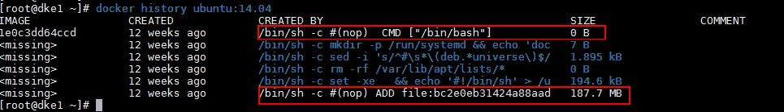

In the above output if Keyword is not mentioned in the commands then these commands will be executed in RUN keyword.

Refer the following steps to build the Docker Image using above discussed Keywords.

Step:1 Create a Dockerfile
Let’s first create a folder with the name mycode under / file system and then create Dockerfile under this folder

[root@dke1 ~]# mkdir /mycode
[root@dke1 ~]# cd /mycode/
[root@dke1 mycode]# touch Dockerfile
[root@dke1 mycode]#

Note : Name of docker file must be “Dockerfile”, if we don’t follow this convention our docker build command will not work.

Step:2 Add Keywords and Commands to Dockerfile
Open the Dockerfile with vi editor and the following keywords
[root@dke1 mycode]# vi Dockerfile
FROM mycentos:v2

MAINTAINER Linuxtechi Team <amar@gmail.com>

RUN yum -y install httpd php

RUN echo "Website is hosted inside a container" > /var/www/html/index.html

EXPOSE 80

VOLUME /mnt/docker_vol /data

RUN echo "httpd" >> /root/.bashrc

CMD ["/bin/bash"]

Save and Exit the file.

Step:3 Build the image using ‘docker build command’
Go to the /mycode folder and run the beneath command, in the below command -t option is used to set tag name of docker image, in my case i am setting docker image name and tag as “mycentos:apachev1”

[root@dke1 mycode]# docker build -t mycentos:apachev1 .

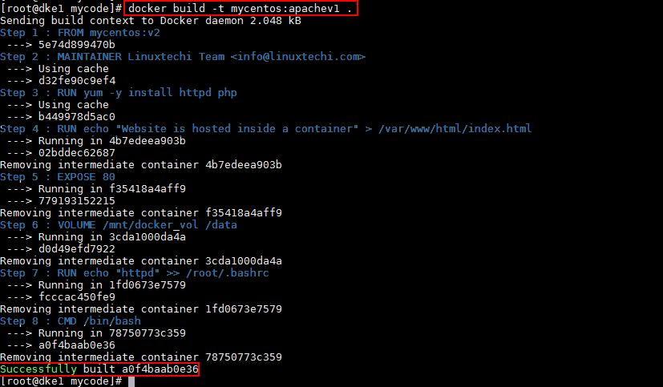

Step:4 Verify the new Docker Image and launch a container
Let’s first see whether new docker image is available in local image repository using following command
[root@dke1 ~]# docker images

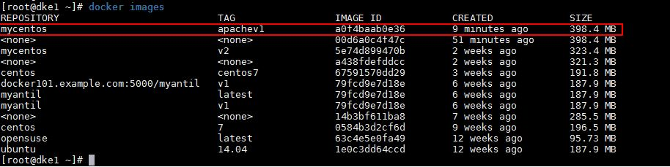

Now launch a container and see whether apache web server server is running or not and also verify whether the volume is mounted or not.

[root@dke1 ~]# docker run -it -p 80:80 --name=web_container1 mycentos:apachev1

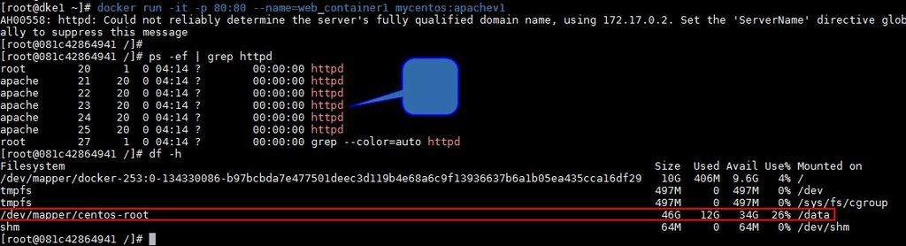

In the above scenario I have used already downloaded docker image as a base for building new Docker image. In case you want to use your own cloud image (qcow2) as base image for docker then it is also possible with ADD keyword. Make sure you copy the qcow2 file in same folder where your “Dockerfile” resides. Repeat all the above steps and the only change is in the Dockerfile.
Contents of Sample Dockerfile is list below
FROM scratch

MAINTAINER Linuxtechi Team <info@linuxtechi.com>

ADD CentOS-7-x86_64.qcow2 /

RUN yum -y install httpd php

RUN echo "Website is hosted inside a container" > /var/www/html/index.html

EXPOSE 80

VOLUME /mnt/docker_vol /data

RUN echo "httpd" >> /root/.bashrc

CMD ["/bin/bash"]

