**Example:**

1. Paste GPCR sequence in FASTA or plain format. Sequence file can be uploaded from the file as well.

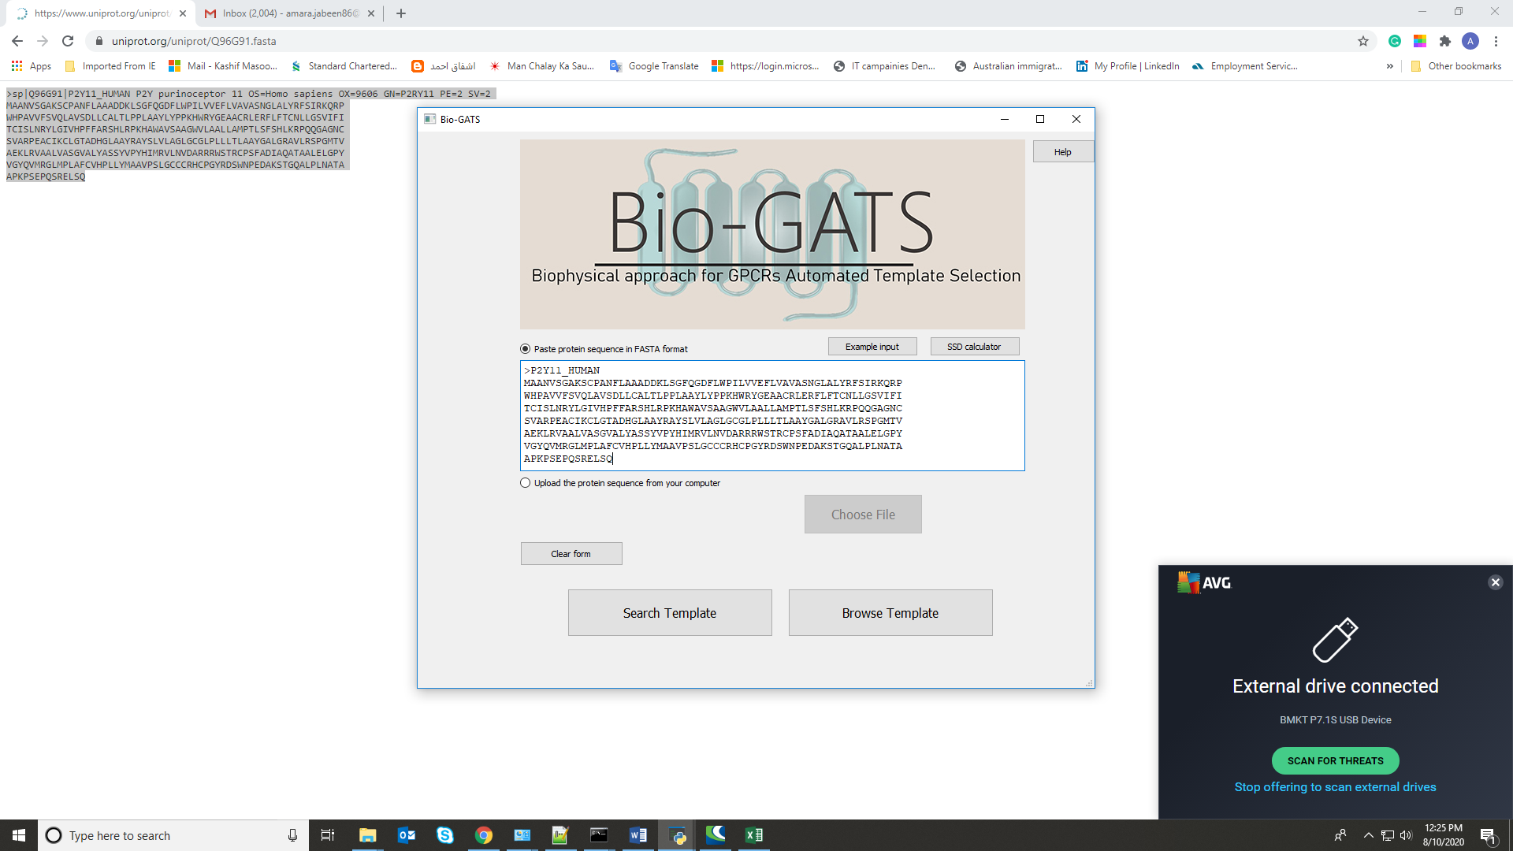

1. Search template option will retrieve top 3 templates for the query sequence

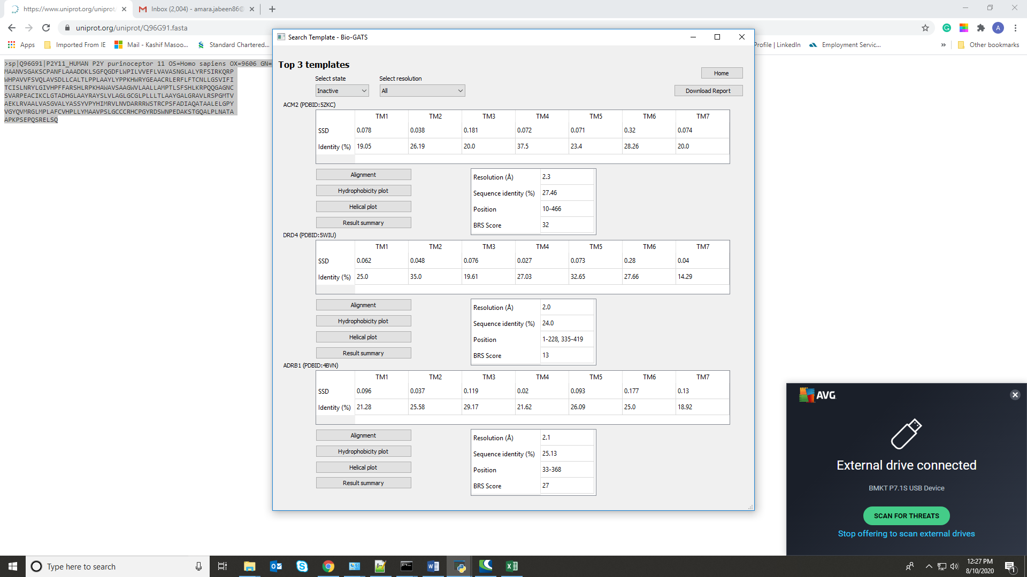

1. By clicking on Alignment button, TM-wise alignment can be visualized. The TM-wise alignment as well as full-length alignment can also be downloaded.

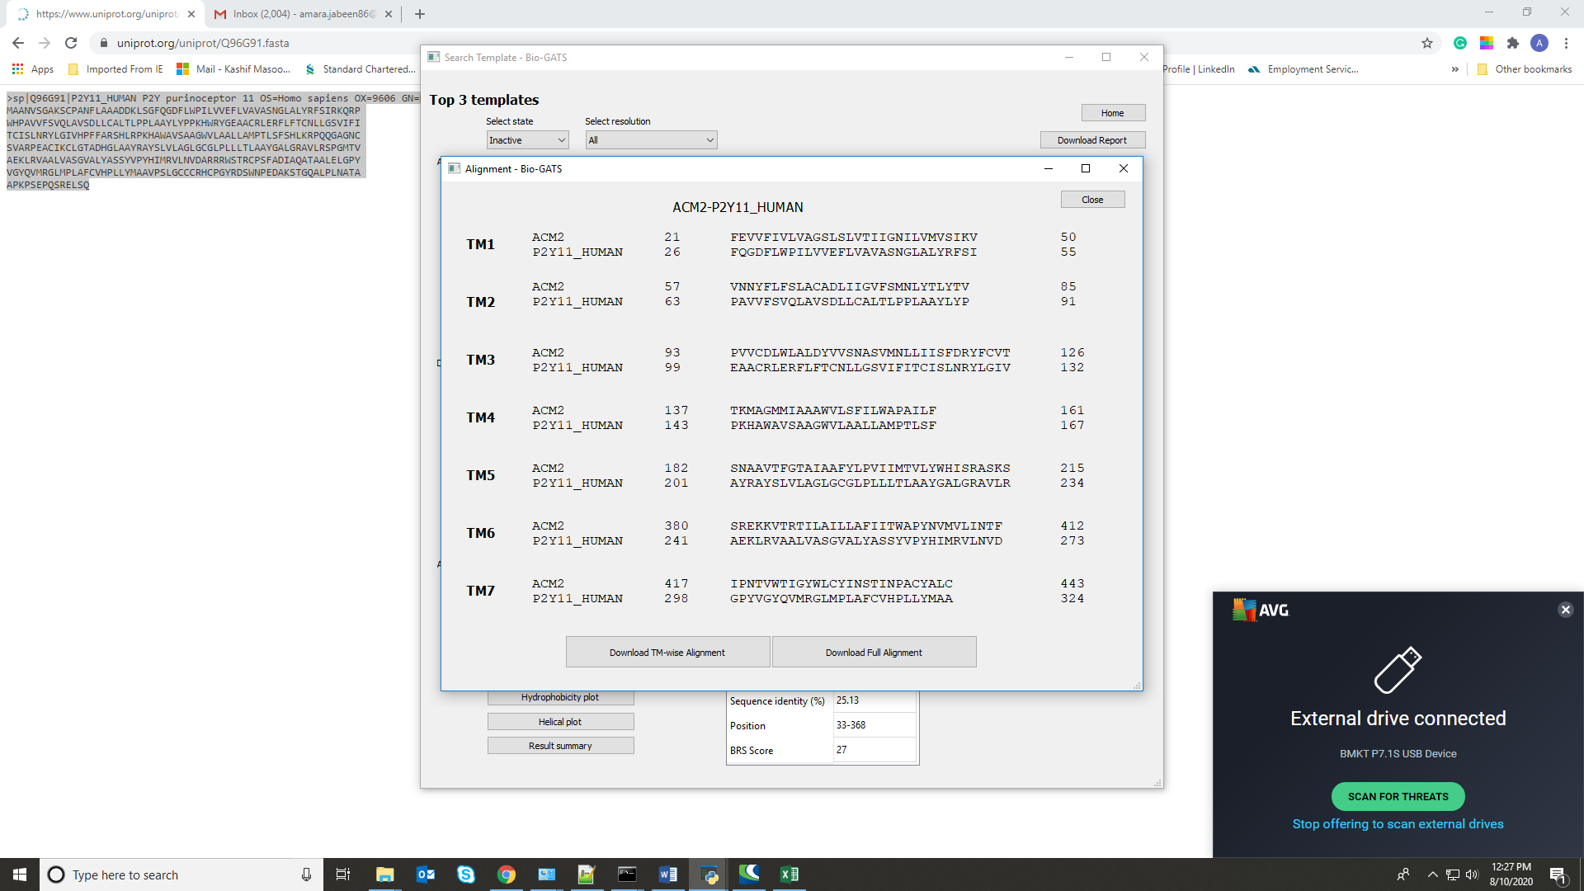

1. For advance users, multiple parameters such as global sequence identity, TM-wise sequence identity, hydrophobicity correspondence, and BRS score within browse template functionality. Users can select template of their own choice after detailed analysis of listed parameters.

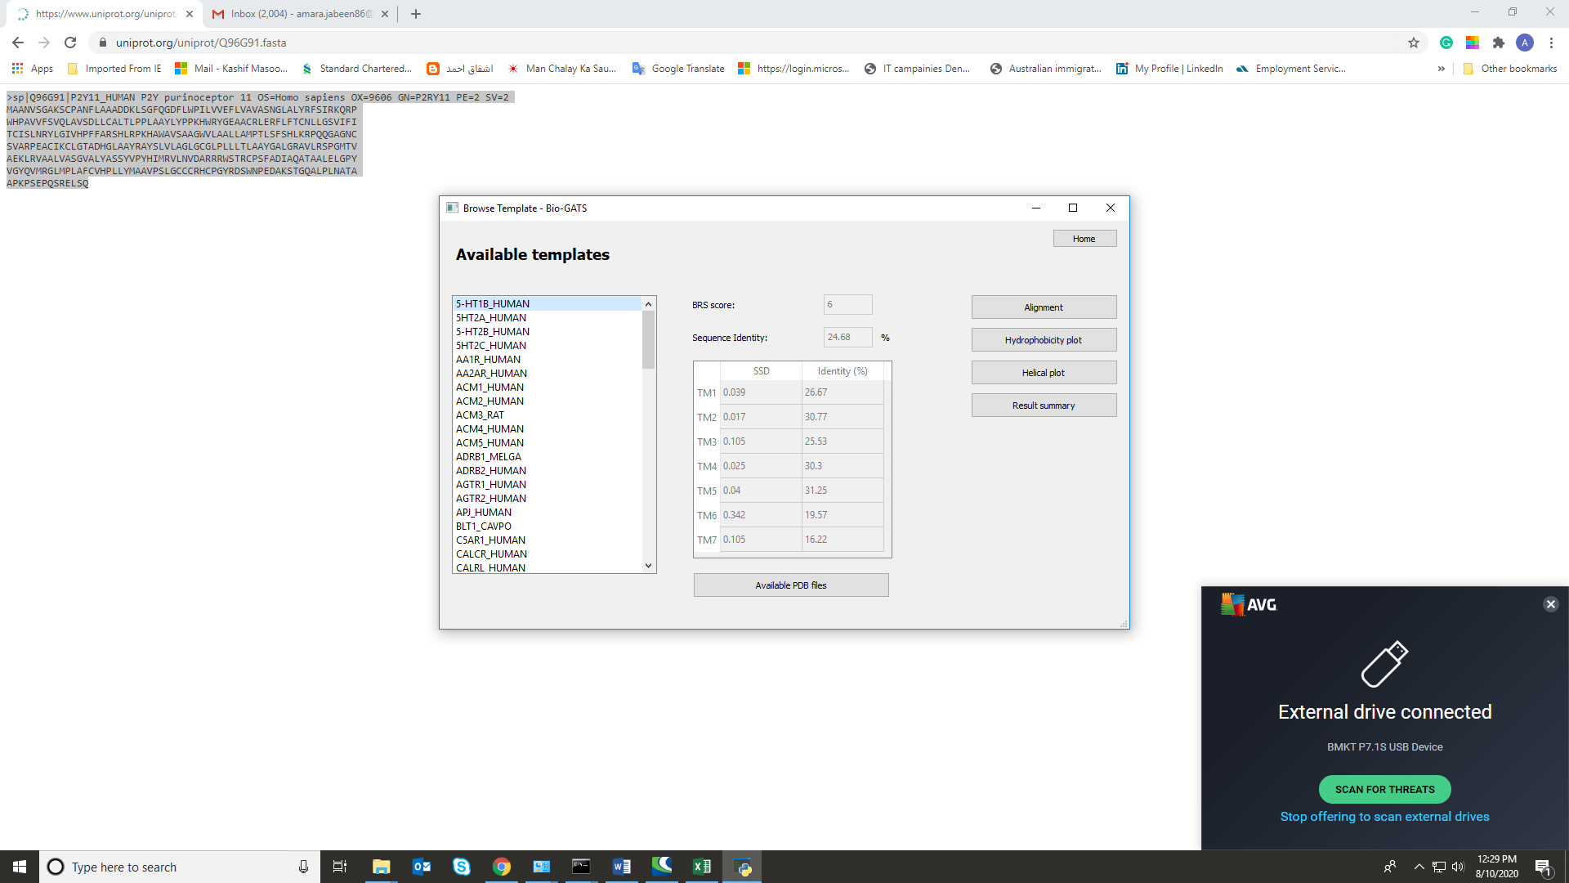

1. The resolution and completeness of the available structure can be tracked by looking at available PDBs

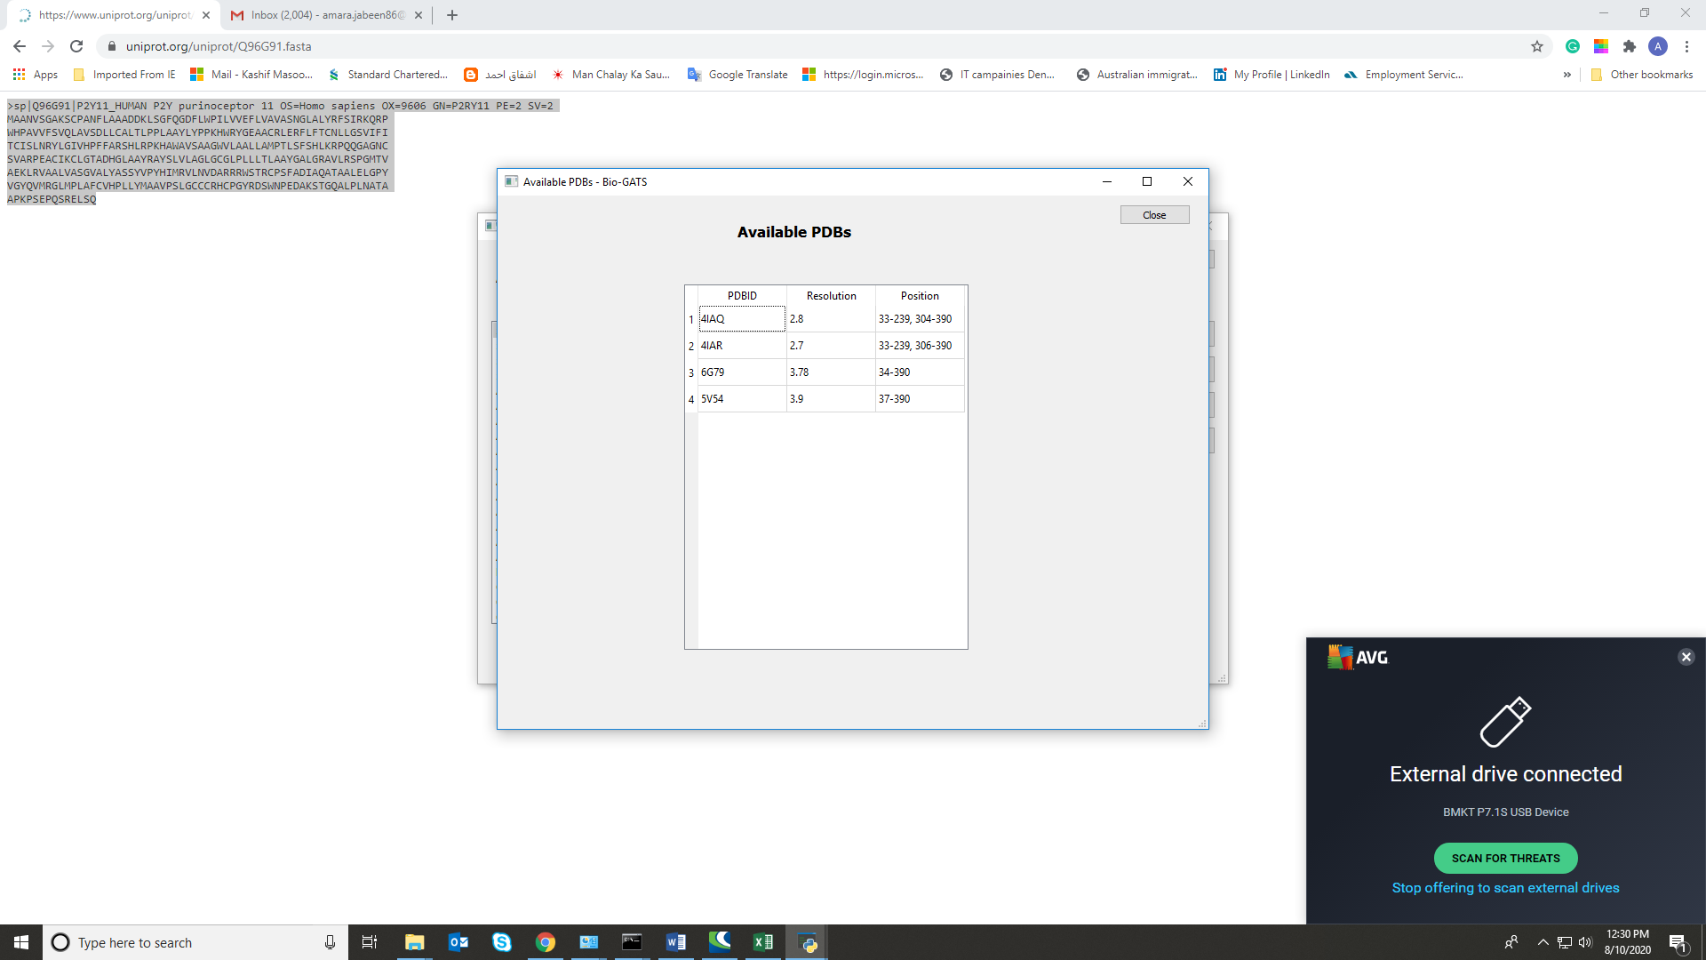

1. The hydrophobic correspondence can be visualized graphically

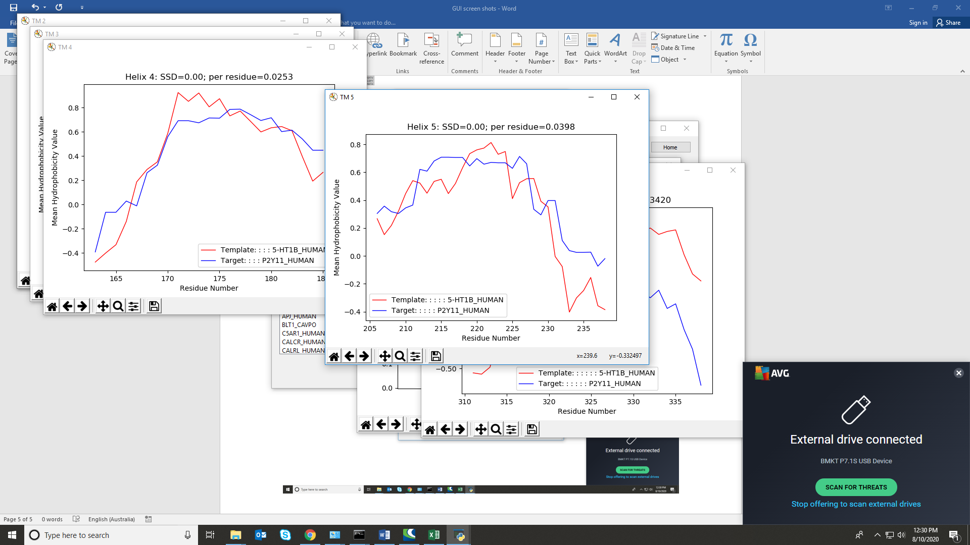

1. Helical wheel plot visualization might provide an idea of helices orientation during model building.

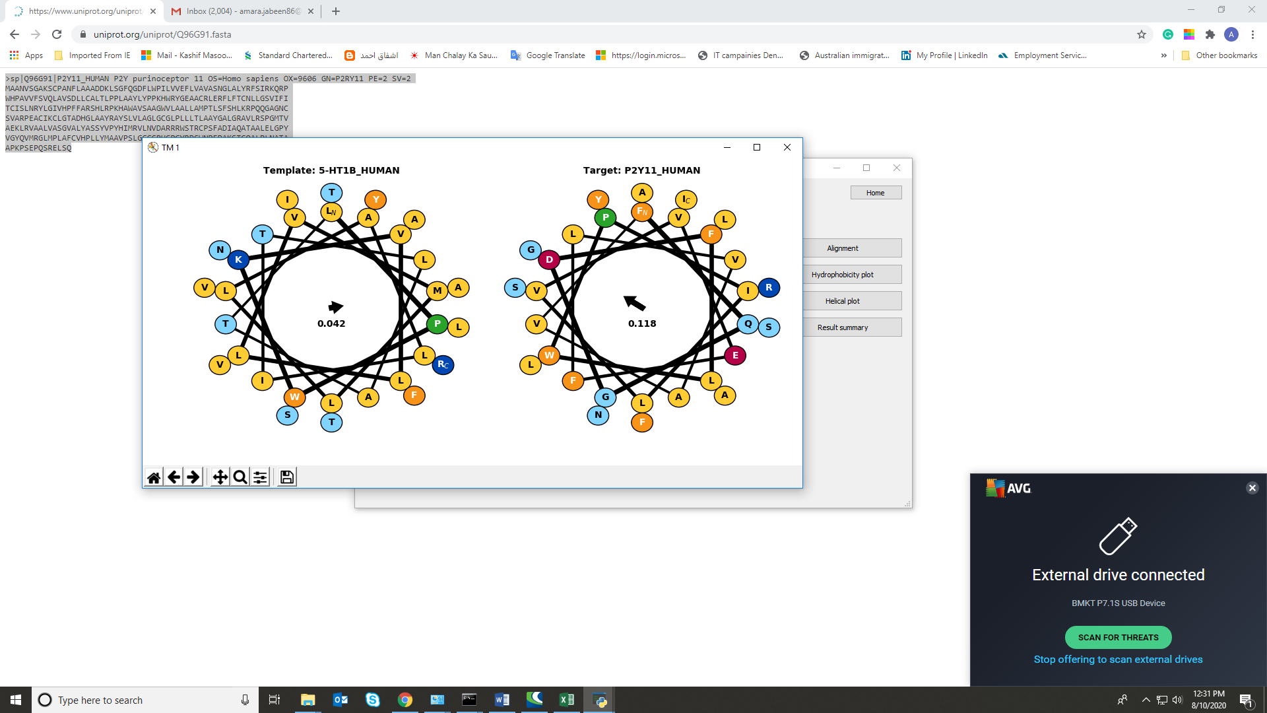

1. If the query/template GPCR sequence is not present within the excel file linked to the Bio-GATS or user needs wants to use the customized transmembrane definition, SSD calculator can be used.

