# Output from OPSD-OR1A1_HUMAN

Please cite: Jabeen A, Vijayram R and Ranganathan S (2021) BIO-GATS: A Tool for Automated GPCR Template Selection Through a Biophysical Approach for Homology Modeling. Front. Mol. Biosci. 8:617176.

>OPS  
M--NG----T-EGPNFY----VPFSNKTGVVRSPFEAPQYYLAEPPWQFSMLAAYMFLLIMLGFPINFLTLYVTVQKKLR  
T---PPLNYILLNLAVADLFMVFGGFTTTLYTSLHYF----V-FGGPTGCNLEGFFATLGGEIALWSLVVLAIERYVVVC  
P------MSNFRFGE-ENHAIMGVAFTWVMALACAAPPL--GW-SRYIPEGMQCS-CG---I-DYY---TP---------  
HEETNN-NESFVIYMFVVHFIIPLIVIFFCYGQLVFTV--EAAAQQQE-SA--ATTQKAEKEVTRMVIIMVIAFLICWLP  
YAGVAFYIF-HQGSDFGPI---IFMTIPAFFAKTSAVYNPVIYIMMKQFRNCMVTT---LCCG-K--NPLGDDEASTT-V  
SKTETSQVAPA  
>OR1A1_HUMAN  
MREN-NQSSTLE---F-ILLGV-----TG------Q--Q----E--EQEDFFYILFLFIYPITLIGNLLIVLAICS--VR  
-LHNPPMYFLLANLSLVDIFFSSVTIPKMLANHL---GSKSISF--FGGCLTQMYFMIALGNTDSYILAAMAYDRAVAIS  
PLHYTTIMS------PPRSCIWLIAGSWVIGNANALPHTLL--AS------L--SFCGNQEVANFYCDITPLLKLSCSDI  
H-----HFHVKMMYLGVGIFSVPLLCIIVSYIRVFSTVFQ--------PS-TK----KGVLKAFSTCGSHLTVVSLYYGT  
VMGTYFRPLT-----Y---YSLKDAVITVMYTAVTPMLNPFIYSLR---RD-M---KAAL---RKLFN-----K----RI  
S----S-----

## TM1

Template: PWQFSMLAAYMFLLIMLGFPINFLTLYVTVQ  
Target: -EQEDFFYILFLFIYPITLIGNLLIVLAICS

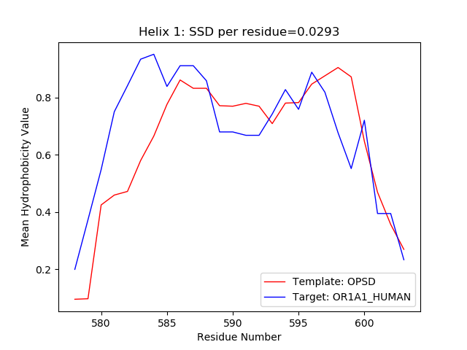

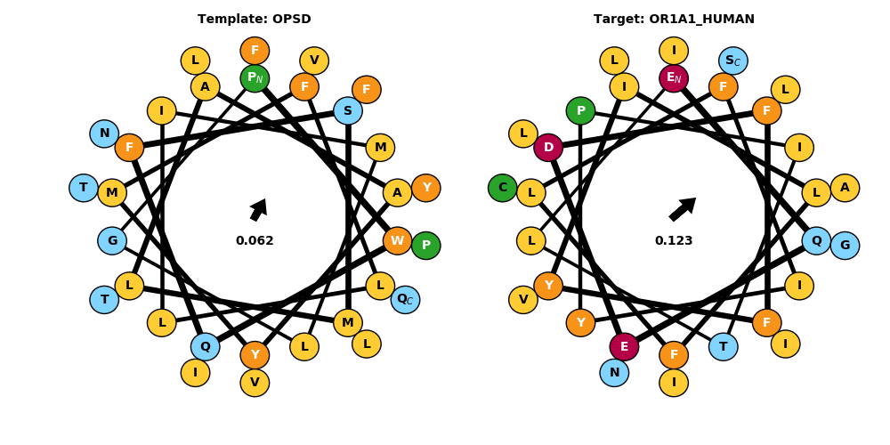

## TM2

Template: PLNYILLNLAVADLFMVFGGFTTTLYTSLH  
Target: PMYFLLANLSLVDIFFSSVTIPKMLANHL-

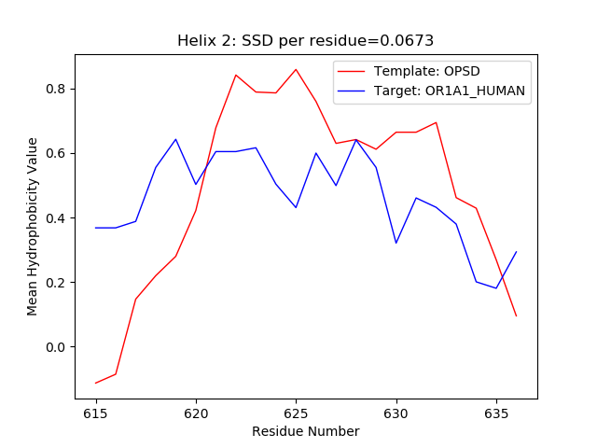

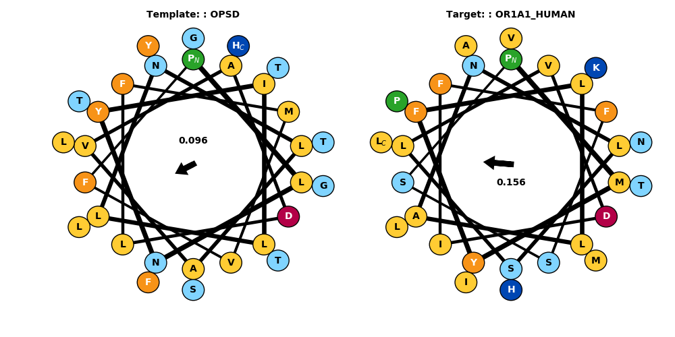

## TM3

Template: GPTGCNLEGFFATLGGEIALWSLVVLAIERYVVVC  
Target: -FGGCLTQMYFMIALGNTDSYILAAMAYDRAVAIS

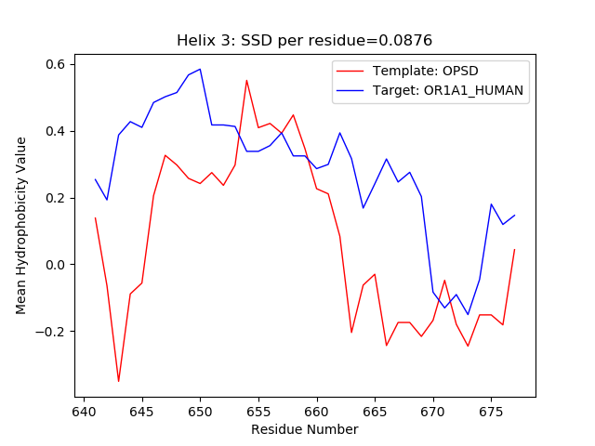

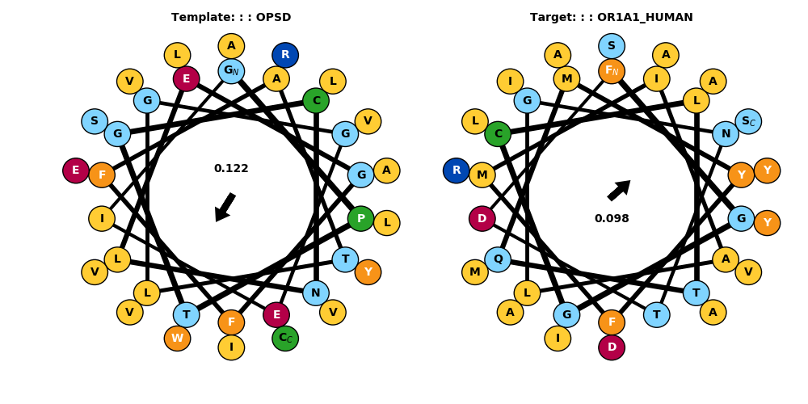

## TM4

Template: ENHAIMGVAFTWVMALACAAPPL--  
Target: PRSCIWLIAGSWVIGNANALPHTLL

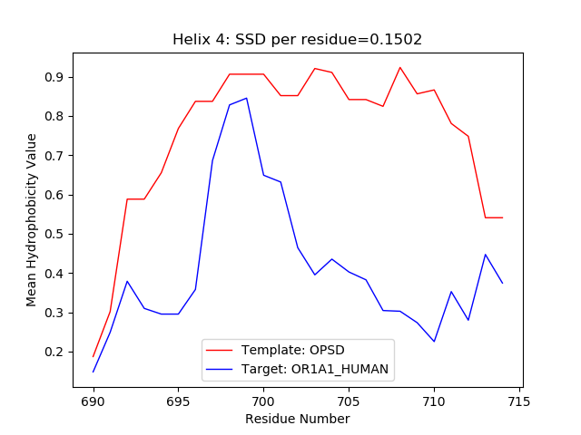

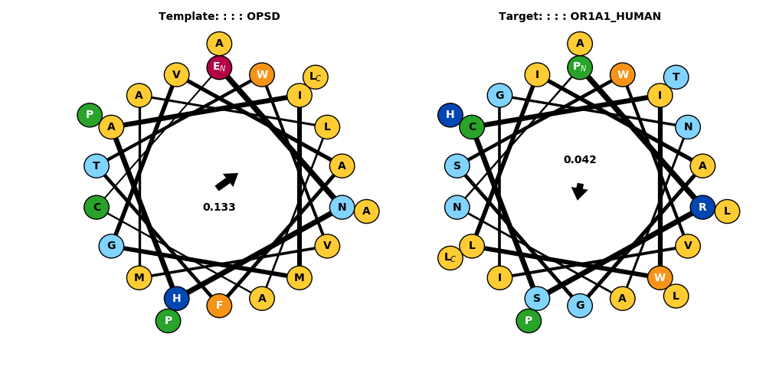

## TM5

Template: -NESFVIYMFVVHFIIPLIVIFFCYGQLVFTV--  
Target: HFHVKMMYLGVGIFSVPLLCIIVSYIRVFSTVFQ

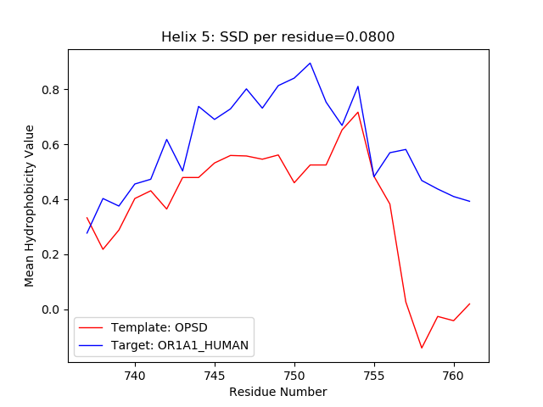

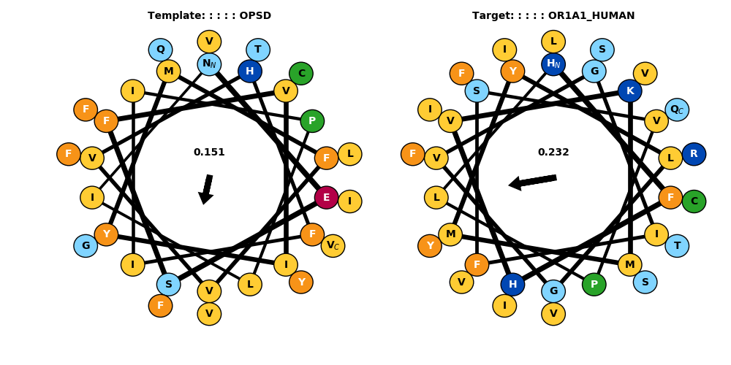

## TM6

Template: ATTQKAEKEVTRMVIIMVIAFLICWLPYAGVAFYIF-  
Target: ----KGVLKAFSTCGSHLTVVSLYYGTVMGTYFRPLT

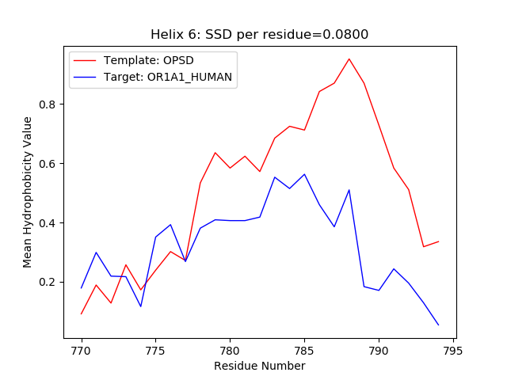

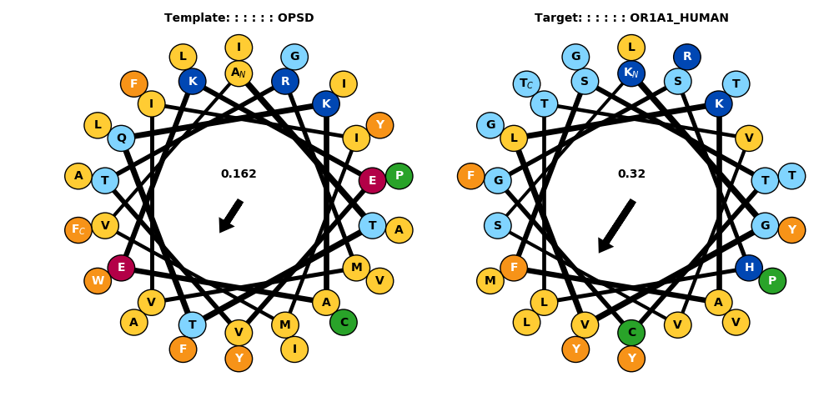

## TM7

Template: ---IFMTIPAFFAKTSAVYNPVIYIMM  
Target: YSLKDAVITVMYTAVTPMLNPFIYSLR

