TrustGap
Detecting Authentication Passing Business Email Compromise via Contact Baseline and Lookalike Domain Analysis
An explainable email security prototype for detecting lookalike-domain fraud
Final Year Project Proposal
Session 2023 – 2027
A project submitted in partial fulfilment of the requirements for the degree
of Bachelor of Science in Computer Science

Department of Computer Science
Namal University, Mianwali
October 21, 2026
Industry Supervisor: Mr. Awais Saeed, Full Stack Developer, Amrood Labs (Email Authentication & AI Systems)

Project Registration
Project ID (for office use) |  |  | 14
Type of project |  |  | Industrial
Nature of project |  |  | Development and Research
Area of specialisation |  |  | Cybersecurity
Project Group Members
Sr.# | Reg. # | Student Name |  | Email ID | Phone # | Signature
(i) | NUM-BSCS-2023-14 | Amara Bibi |  | bscs23f14@namal.edu.pk | 03281076886 | Amara
(ii) | NUM-BSCS-2023-33 | Sumaira Majeed |  | bscs23f33@namal.edu.pk | 03274265603 | Sumaira
Declaration: FYP group members have cleared all prerequisites courses (mentioned below) for FYP-I as per their degree requirements.

Plagiarism Free Certificate
This is to certify that, I am Amara Bibi, S/D/o Saif-ullah, group member of FYP under registration no NUM-BSCS-2023-14 at the Computer Science Department, Namal University. I declare that my FYP proposal has been checked by my supervisor and that the similarity index is ______%, which is less than the 20% limit acceptable to HEC. The Turnitin report is attached herewith as Appendix A.
Date: October 21, 2026
Name of Group Member 1: Amara Bibi Signature: ____________________
Name of Group Member 2: Sumaira Majeed Signature: ____________________
Name of Supervisor: Mr. Ramzan Shahid Khan
Name of Co-supervisor: Dr. Mudassar Raza & Dr. Muzammil Ahmad
Signature: ____________________________

Project Abstract
Many businesses and universities depend on email. Fraudsters take advantage of this by pretending to be a known supplier, a manager or a partner, and asking for a payment, a change of bank account or private information. SPF, DKIM and DMARC are the standard checks that mail providers use to stop fake emails, but they only confirm that an email was sent from a server that is allowed to send for that domain. A fraudster can buy a domain that looks almost the same as a real supplier's domain, set it up correctly, and pass all three checks. The email looks safe to the system, yet it is still fake. We call this the Trust Gap.
TrustGap is a prototype that tries to close this gap. It reads saved emails, builds a short history for each contact, and checks whether a new email really matches that contact. It looks at how close the sender's domain is to a known domain, how new that domain is, whether the sender is new, whether the email asks for money or a bank change, and, when enough past emails exist, whether the writing sounds like the contact. A simple machine learning model turns these signals into a Low, Medium or High risk level, and the system explains its reason in plain words.
We will test TrustGap on public email data (the Enron emails and public phishing collections) and on synthetic attack emails that we create ourselves. We will compare it with simple baselines, including the free Sublime Security rules, and report how many false alarms it raises when it catches 90% of the attacks. The main goal is a working detection engine that is proven on data. Connecting it to a live Gmail mailbox for a small pilot is a stretch goal.

1. Introduction

1.1 Background
Email is the main way businesses talk to clients, suppliers and staff. Fraudsters know this, so email is also one of the most common ways to attack a business. To fight fake emails, three standards were created: SPF [Sender Policy Framework], DKIM [Domain Keys Identified Email] and DMARC [Domain-based message authentication reporting and conformance]. They check that an email was sent from a server that is allowed to send for the domain it claims to come from. These standards help, but many organisations have not adopted them fully [4].
An email that passes all three checks is technically genuine. But a business still has a bigger question: is this really the supplier or client we normally deal with? Losses from business email compromise (BEC) are very large, and earlier work puts them above 12 billion US dollars [5].

1.2 The Trust Gap
Attackers have found a way around these checks. Instead of faking a real domain, they buy a new domain that looks almost the same, for example by changing one letter or adding a word. They then set up SPF, DKIM and DMARC correctly on this new domain, so every check says PASS. The email is not forged in the technical sense. It simply comes from the wrong company.
The attack often starts with a harmless first email that has no link, no attachment and no request. Its only job is to build trust. A later email contains the real fraud, such as a changed invoice or new bank details. Some of these domains are registered only a few days before the first email. Because every technical check passes, ordinary filters give no warning.

1.3 Business Use Cases
  - Fake supplier bank change. A company pays its supplier every month. One day an email arrives from a domain that is one letter different from the supplier's. It says, “Our bank account has changed, please pay the next invoice here.” All login checks pass, but the domain is new and the request is not what this supplier normally sends.
  - Fake manager request. An accounts officer gets an email that looks like it is from the owner: “I am in a meeting. Pay this invoice today and do not call me.” The timing, the urgency and the writing do not match the owner's usual emails.
  - Trust-building first email. An email from a lookalike domain politely asks about a past project. It has no link and asks for nothing. Its only purpose is to prepare the ground for a fraud email later.

1.4 Problem Statement and Research Question
Small and medium organisations have little protection against BEC emails that pass all the login checks. Strong tools exist, but many are built for security teams, and it is hard for others to see how they decide or to compare them fairly.
Research question: can a simple, explainable system that learns what is normal for each contact tell a lookalike-domain fraud email from a genuine one, even when SPF, DKIM and DMARC all pass?
TrustGap is not a replacement for Gmail or Outlook, and it does not host email. In this project it is a detection engine that reads saved emails and shows a risk level with the reason in plain words. A live connection to Gmail is a possible extension, described in Section 3.2.

2. Related Work

2.1 Email Authentication and Its Limits
Most research on SPF, DKIM and DMARC looks for weaknesses in the protocols. Shen et al. tested 30 popular email services and 23 email clients and found attacks that get past the checks and past the warnings shown to users [6]. Hu et al. asked email administrators why these protocols are adopted so slowly. The answers were weaknesses in the protocols, little reason to deploy them, and difficult setup [4].
These studies are about forged emails. Our project looks at a different case: the email passes the checks honestly, because the attacker really owns the lookalike domain.

2.2 Existing Tools
Several tools already work on this problem. We list them by name below. We do not claim that checks such as first-time sender, lookalike domain or domain age are new, because some of these tools already use them.
Type | Tools
Commercial | Abnormal Security, IRONSCALES, Barracuda Impersonation Protection
Free and open source | Sublime Security [7], dnstwist [8]
Built into email | Gmail (Google Workspace), Microsoft Defender for Office 365
Local (Pakistan) | PhishStop.ai
Research | BEC-Guard [5]
Table 1. Existing tools and research on this problem.
Because Sublime Security is free and can be run on our own computer, we use its lookalike and sender-history rules as one of the baselines for our evaluation. dnstwist is used only to create lookalike domains for our test data.

2.3 Research Gap
We did not find an open, labelled test set made for emails that pass all authentication checks. We also did not find a study that measures what each signal adds on its own: the domain check, contact history, behavior and writing style. TrustGap aims to put these signals together in one explainable system, to measure each layer honestly, and to release the test set so that others can repeat and compare our work. If a layer adds very little, we will report that too.

3. Project Rationale
Lookalike-domain BEC emails are built to look normal and to pass every technical test. They are hard to catch, and one successful fraud can cause a large loss, especially for a small organisation without a security team. We want to show, with measured results, how well a simple and explainable system can do this job, and to share our code and test data so that other students and researchers can build on it.

3.1 Aims and Objectives
Objective 1. Build an offline detection engine that reads saved emails, keeps a short history for each contact, and checks the sender for lookalike domains, domain age and unusual behavior.
Objective 2. Turn these signals into a Low, Medium or High risk level using a simple machine learning model, and show a plain-language reason for every result in a small dashboard.
Objective 3. Build a labelled test set of emails that pass SPF, DKIM and DMARC, using public data and synthetic attacks, and release it openly.
Objective 4. Evaluate the system against simple baselines, including Sublime's free rules, using the false-positive rate at 90% recall as the main measure, and show what each layer adds.

3.2 Scope of the Project
  - Core deliverable (must finish). An offline engine that reads saved English business emails (.eml or mbox files), builds a history for each contact, checks lookalike domains, domain age and behavior, gives a Low, Medium or High risk with reasons, and is tested on a labelled dataset. A simple dashboard shows the results.
  - Stretch goal (only if the core is stable by the end of January). A read-only live Gmail connection for a small pilot with volunteer mailboxes. Namal University uses Google, so Gmail comes first. This needs approval from Namal IT and the university, and each volunteer approves access on Google's own sign-in screen.
  - Out of scope. Automatically deleting or blocking emails (TrustGap only warns); protecting outgoing email; scanning attachments for viruses; deep scanning of links; a service for many companies; a mobile app; Outlook; and languages other than English, including Urdu and Roman Urdu (a stated limitation).
TrustGap does not replace SPF, DKIM or DMARC. It works on top of them. It also cannot catch a genuine supplier account that has been hacked, because the domain is then real. We state this as a limitation.

3.3 Novelty of the Project
Several tools already check sender history and lookalike domains, so we do not claim those ideas as new. What TrustGap adds is the following.
  - Focus on emails that pass authentication. We start from the case where every login check passes and ask whether the sender is really the contact we know.
  - All signals in one explainable system. Domain similarity, domain age, contact history, behavior, request words and, when enough past emails exist, writing style are combined, so one weak signal alone does not decide the result.
  - Plain-language reasons. Each flag comes with a short sentence such as “the domain is one letter different from your supplier's and was registered 6 days ago.”
  - Open and measured. We release a labelled test set and compare against baselines. Our main measure is the false-positive rate, which is how many good emails are wrongly flagged when the system catches 90% of the attacks. We aim to keep this rate clearly lower than the baselines, because every false alarm wastes an administrator's time.
  - Trust-building emails. A special rule looks for a harmless first email from a lookalike domain, which may allow a warning before the fraud email arrives.

3.4 Dataset
We plan the evaluation using data that is already public or that we create ourselves. The project does not depend on any private company data.
Source | What it contains | How we use it
Enron email corpus [9] | About 500,000 real business emails from about 150 people | Normal emails; builds each contact's history
Public phishing collections (for example the Nazario phishing corpus) | Real phishing emails | Attack text for training and testing
Synthetic attack emails (made by us) | Lookalike-domain emails of three kinds: trust-building, payment change and login request, with simulated passing SPF, DKIM and DMARC headers and domain dates | Main test for authentication-passing attacks
Hard normal emails (made by us) | New genuine senders, suppliers that really change domain, free-mail senders, newsletters | Check that the system does not raise false alarms
Small Pakistan scenario set (made by us) | Hand-written examples such as fee, scholarship, supplier invoice, courier and bank notices | Local test, clearly labelled as synthetic
Table 2. Data sources.
No public dataset contains authentication-passing lookalike attacks, so we build that part ourselves. The Enron emails are old and have no modern authentication headers, so we add simulated headers and domain dates and say so clearly in the report. We split training and test data by contact or by time, never by random email, so that the system does not see the test contact in advance. Results on real data and on synthetic data are reported separately. If a volunteer gives a mailbox export with written consent, we will remove personal details before using it, but the project does not depend on it. If Amrood Labs is later able to share anonymised examples, we will treat them as a bonus only.

3.5 Proposed Methodology and Architecture
TrustGap works in six steps, shown in Figure 1. The same engine runs on saved emails now and could run on live mail later.
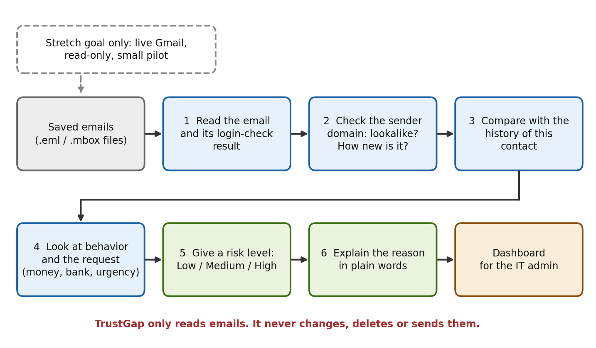
Figure 1. TrustGap system flow.

3.5.1 Reading the Email and the Login-Check Result
TrustGap reads each saved email and takes out the sender, reply-to address, display name, date, subject, body text, link domains and attachment types. It also reads the SPF, DKIM and DMARC result that the receiving mail provider has already written in the email header. We do not repeat the check. A PASS is treated as one clue, not as proof that the email is safe.

3.5.2 Contact History
For each contact, TrustGap keeps a short profile built from past emails: the domains and display names the contact has used, how often and at what hours the contact writes, who the contact writes to, and how the contact usually asks for things. This profile shows what is normal for that contact. A lookalike sender has no history of its own, so TrustGap compares the email with the known contact it looks like.

3.5.3 Domain Checks
The sender's domain is compared with the domains in the contact history and with the organisation's own domains. We use edit distance and a list of look-alike characters (for example the letter l and the digit 1) to find domains that are very close but not identical. We then look up how old the domain is and whether it has mail records. The answers are saved so the same domain is not looked up again and again. We will test early whether domain-age data is available for .pk domains.

3.5.4 Behavior and Writing Style
TrustGap checks whether the email is unusual for this contact: a first-time sender, a different reply-to address, a reply to a conversation that never existed, an unusual time, or a new recipient. It also looks for risky requests such as payment, bank change, gift cards, passwords and urgent words, and for the trust-building pattern from Section 1.2. Writing style is compared only when the contact has enough past emails, because short emails give a weak signal, and we will report how often this is possible. An unusual email is not always bad, so each of these is only one signal.

3.5.5 Risk Level
All signals are turned into numbers and given to a model. We start with logistic regression and then try one gradient-boosted tree model (XGBoost or LightGBM), because tree models work well on table-like data and can be explained [10]. We always report the simple model next to the boosted one. The output is Low, Medium or High, and the thresholds are set from the test results, not guessed.

3.5.6 Explanation and Dashboard
For each flagged email, TrustGap lists the signals that raised the risk using SHAP values [11] and turns them into short sentences. A simple dashboard shows flagged emails with the highest risk first, the reason for each, the contact's profile, and buttons to mark an alert as correct or wrong. TrustGap never changes, deletes or sends email.

3.5.7 Evaluation
We compare TrustGap with three baselines: a rule that only matches domains, Sublime's lookalike and sender-history rules, and a text-only classifier that ignores contact history. We run tests with the domain check only, then add behavior, then writing style, to see what each layer adds. Stress tests include domains two or three edits away from the real one, an older attacker domain and an attack email written by a language model. We also measure the time taken per email, ask a few volunteers to rate how clear the explanations are, and run a red-team session where we try to fool our own system. The main measure is the false-positive rate at 90% recall, reported with confidence intervals.

4. Individual Tasks
Amara Bibi builds the email reading, contact history, domain checks and behavior signals. Sumaira Majeed builds the writing-style check, the risk model, the explanations and the dashboard. We build the test data and the evaluation together. The plan runs from October 2026 to March 2027.
Month | Amara Bibi | Sumaira Majeed | Together
October 2026 | Study existing tools and run Sublime locally; build the email reader and login-check reader | Read about BEC-Guard, writing style and SHAP; set up the repository and Enron data | Agree core and stretch scope with the supervisor; check dataset terms
November 2026 | Contact history store; lookalike scoring; domain age and DNS look-ups | First version of the synthetic attack generator; plan the writing-style features | First labelled test set; decide whether the style layer is worth building
December 2026 | Behavior and request signals; trust-building rule | Writing-style profile; first models and calibration | Evaluation setup; first results against baselines
January 2027 | Fix errors found in testing; add hard normal emails | Explanations; dashboard | Error analysis; go or no-go on the live Gmail pilot at the end of the month
February 2027 | Domain-only and behavior-only tests; stress tests | Full system tests; precision-recall curves; false-positive study | Layer-by-layer tests; red-team session; live pilot only if approved; freeze features mid-month
March 2027 | Write the sections on email reading, domain and behavior checks | Write the sections on the model, evaluation and results; prepare the demo | Final report; open release of code and data that may be shared; defense practice
Table 3. Monthly plan.

5. Tools and Technologies
Table 4 lists the tools we plan to use and why. We will check the licence of each library before using it.
Area | Tool | Why we use it
Engine | Python 3.11, FastAPI | One language for the whole pipeline
Email reading | Python email and mailbox libraries | Read .eml and mbox files with no extra install
Login-check result | Authentication-Results header | Use the result the mail provider already wrote
Domain checks | RapidFuzz, tldextract, dnspython, RDAP/WHOIS | Edit distance, splitting names like .com.pk, DNS records, domain age
Test domains | dnstwist [8] | Create lookalike domains for test data
Text features | scikit-learn (character n-grams), spaCy or NLTK | Writing-style distance and request words
Risk model | scikit-learn (logistic regression), XGBoost or LightGBM [10] | Simple baseline plus one boosted model
Explanation | SHAP [11] | Show which signals raised the risk
Storage | SQLite | Contacts, signals and alerts; no setup needed
Dashboard | FastAPI pages or Streamlit | Simple results page (final choice with the supervisor)
Baseline | Sublime Security rules in Docker [7] | Free tool to compare against
Data | Enron corpus, public phishing data, synthetic emails | Training, testing and evaluation
Development | Git/GitHub, pytest, Docker, VS Code | Version control, testing and repeatable setup
Stretch only | Gmail API with read-only OAuth 2.0 [12], [13] | Live pilot with volunteer mailboxes
Table 4. Tools and technologies.

6. Gantt Chart
Figure 2 shows the plan from October 2026 to March 2027. The red diamonds are decision points where we check progress and decide whether to continue, drop or add something. The live Gmail pilot is shown hatched because it only happens if the core is stable and approvals are given.
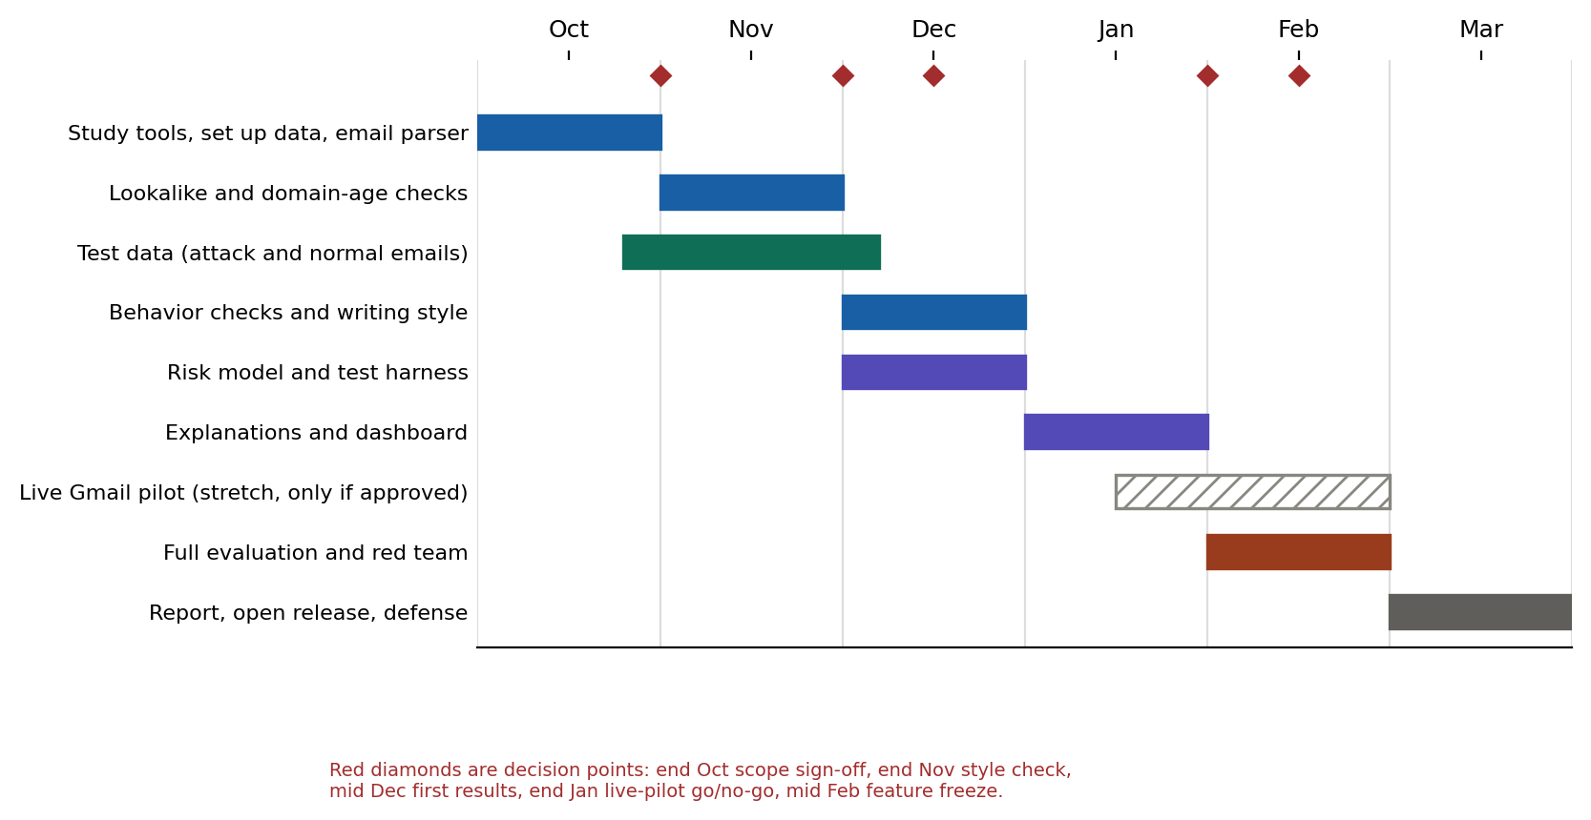
Figure 2. Project timeline.

7. References
[1] S. Kitterman, “Sender Policy Framework (SPF) for Authorizing Use of Domains in Email, Version 1,” RFC 7208, IETF, Apr. 2014.
[2] D. Crocker, T. Hansen, and M. Kucherawy, Eds., “DomainKeys Identified Mail (DKIM) Signatures,” RFC 6376, IETF, Sep. 2011.
[3] M. Kucherawy and E. Zwicky, Eds., “Domain-based Message Authentication, Reporting, and Conformance (DMARC),” RFC 7489, IETF, Mar. 2015.
[4] H. Hu, P. Peng, and G. Wang, “Towards the Adoption of Anti-spoofing Protocols,” arXiv:1711.06654, 2017.
[5] A. Cidon, L. Gavish, I. Bleier, N. Korshun, M. Schweighauser, and A. Tsitkin, “High Precision Detection of Business Email Compromise,” in Proc. 28th USENIX Security Symposium, 2019, pp. 1291–1307.
[6] K. Shen et al., “Weak Links in Authentication Chains: A Large-Scale Analysis of Email Sender Spoofing Attacks,” in Proc. 30th USENIX Security Symposium, 2021 (arXiv:2011.08420).
[7] Sublime Security, “Sublime detection rules,” GitHub. [Online]. Available: https://github.com/sublime-security/sublime-rules
[8] dnstwist, “Domain name permutation engine,” GitHub. [Online]. Available: https://github.com/elceef/dnstwist
[9] W. W. Cohen, “Enron Email Dataset,” Carnegie Mellon University, 2015. [Online]. Available: https://www.cs.cmu.edu/~enron/
[10] T. Chen and C. Guestrin, “XGBoost: A Scalable Tree Boosting System,” in Proc. 22nd ACM SIGKDD Int. Conf. Knowledge Discovery and Data Mining, 2016, pp. 785–794.
[11] S. M. Lundberg and S.-I. Lee, “A Unified Approach to Interpreting Model Predictions,” in Advances in Neural Information Processing Systems (NeurIPS), 2017.
[12] Google, “Gmail API overview,” Google for Developers. [Online]. Available: https://developers.google.com/gmail/api
[13] D. Hardt, Ed., “The OAuth 2.0 Authorization Framework,” RFC 6749, IETF, Oct. 2012.

Appendix A
Include here the first page of the Turnitin similarity report.

