**Apache**

Need to download apache from below link, unzip and copy where it is installing.

<https://www.apachehaus.com/cgi-bin/download.plx>

You must first install the Visual C++ Redistributable for Visual Studio 2015-2019 x86.

Download and Install, if you have not done so already, see:

**When you unzip to an other location:**

Change Define SRVROOT "c:/Apache24” in httpd.conf, for example to "E:/Apache24"

To install as a service. Open command prompt as Administrator, install and change httpd.conf file

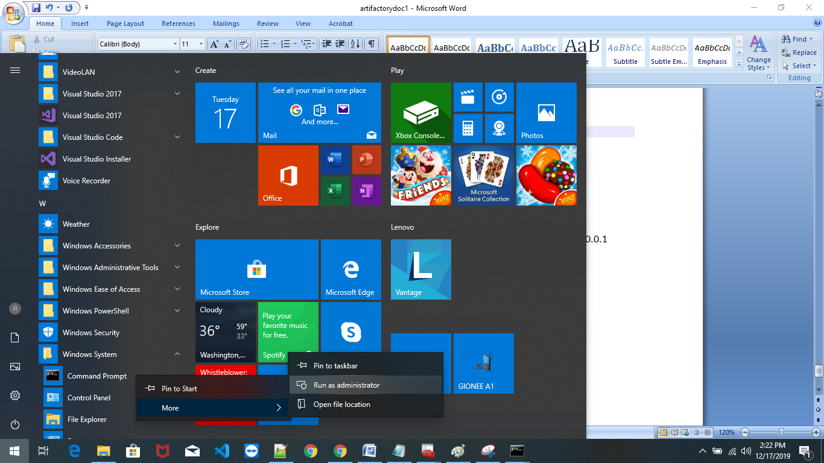

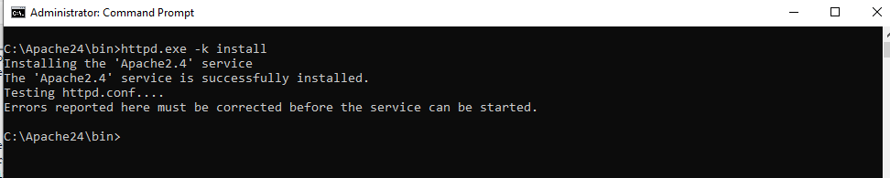

You can start/stop the service with the command:

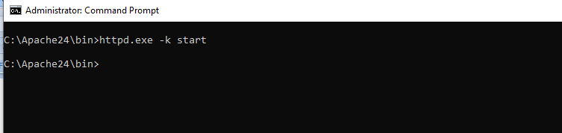

Need to connect artifactory server and click admin 🡪 Http Settings

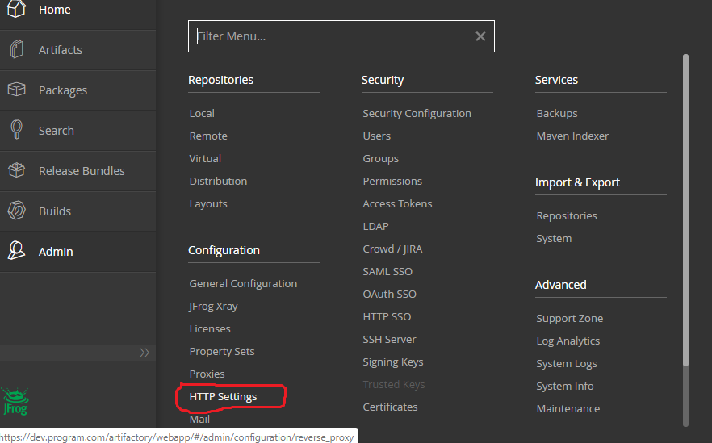

Need to provide required information as below

Save , download the file and put it apache server.

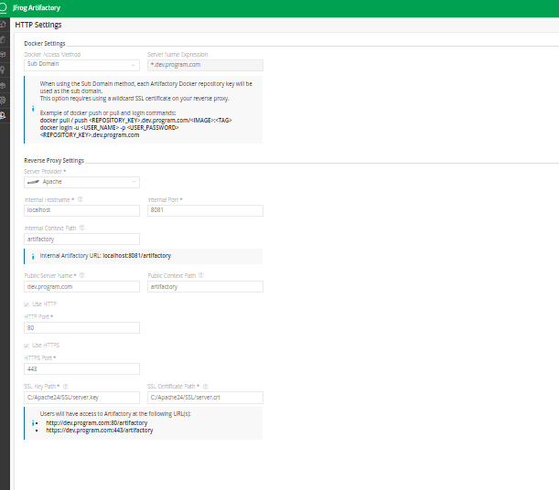

Step 5 – Select “Computer Account” and click “Next”

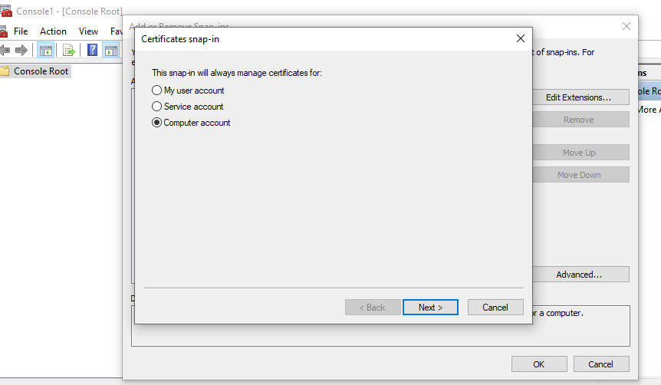

Step 6 – Select “Local Computer” then click “Finish”

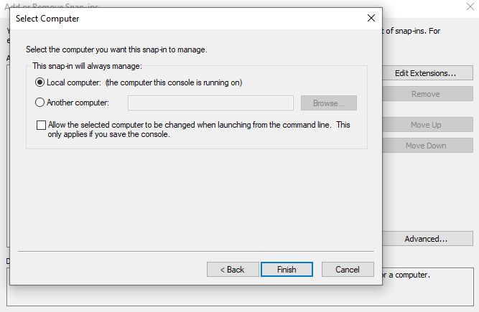

Step 7 – Click “OK” to go back to the MMC window

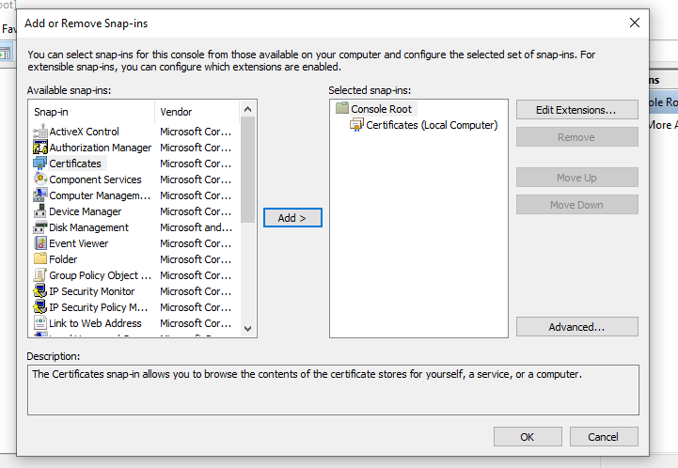

Step 8 – Double-click “Certificates (local computer)” to expand the view

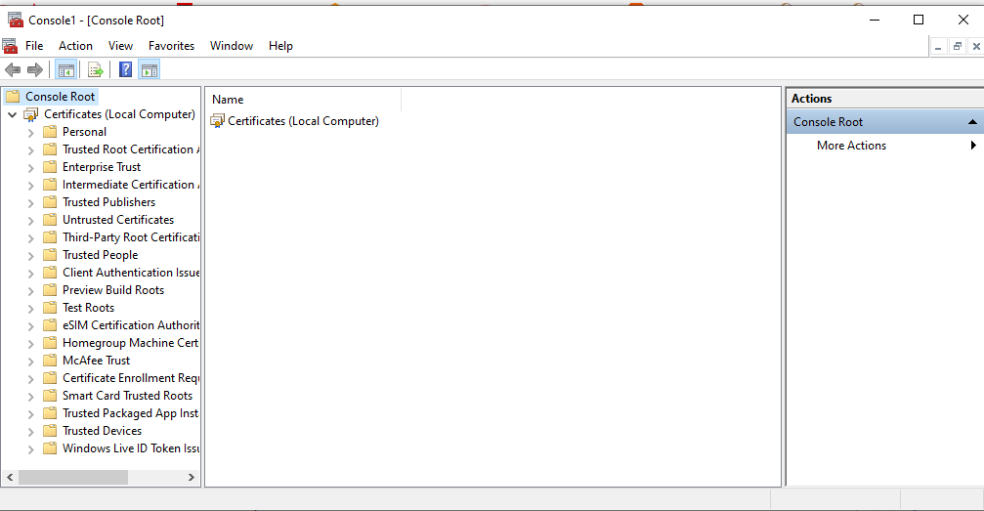

Step 9 – Select “Trusted Root Certification Authorities”, right-click “Certificates” and select “All Tasks” then “Import”

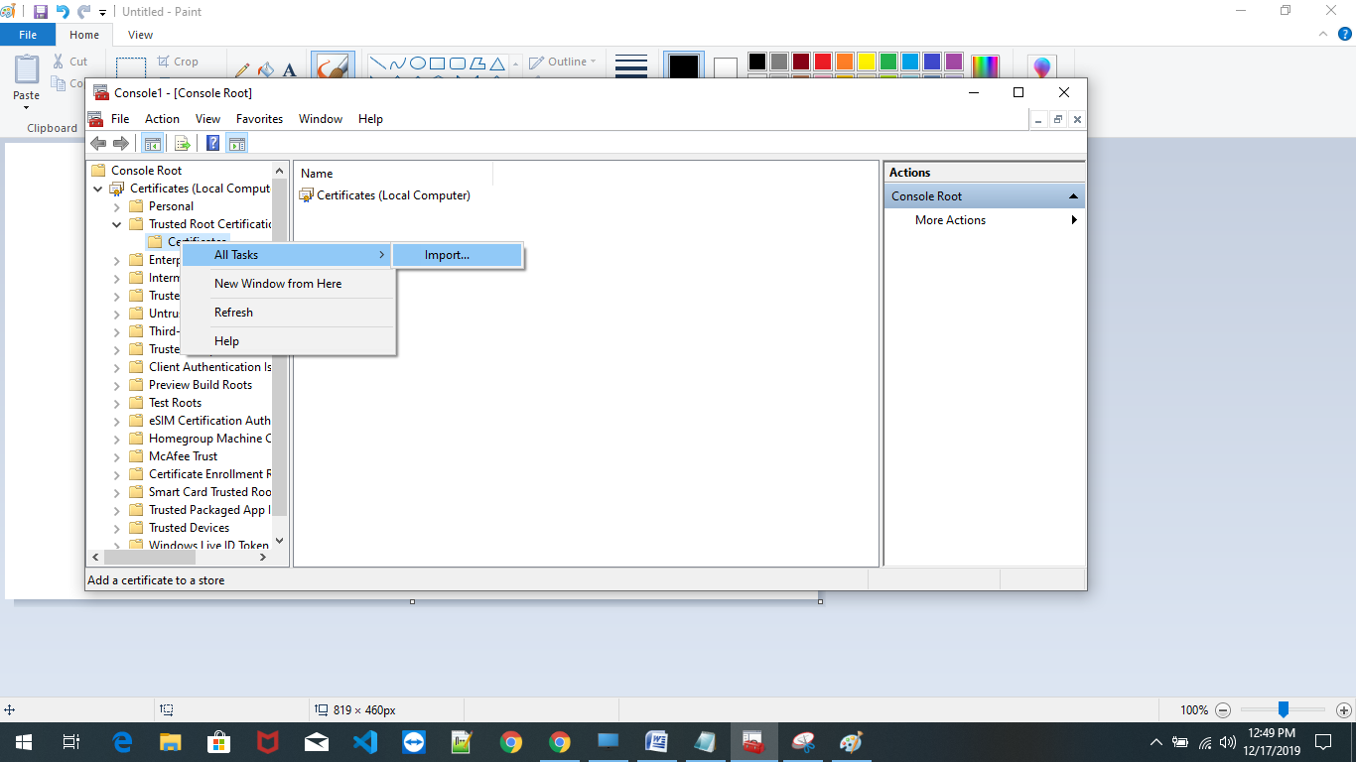

Step 10 – Click “Next” then Browse and locate the “C:\Apache24\SSL\server.pfx” file we created in step 2 and put the password .

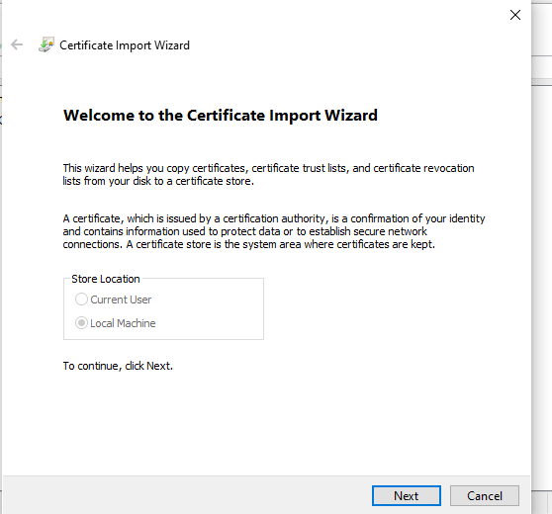

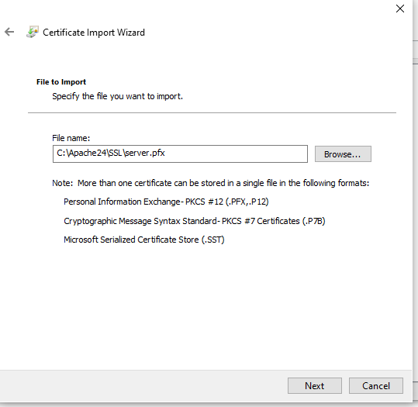

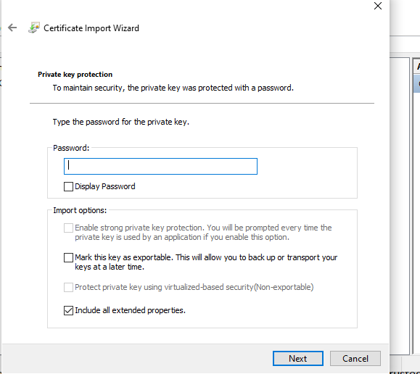

Step 11 – Select “Place all certificates in the following store” and select the “Trusted Root Certification Authorities store”. Click “Next” then click “Finish” completing the wizard.

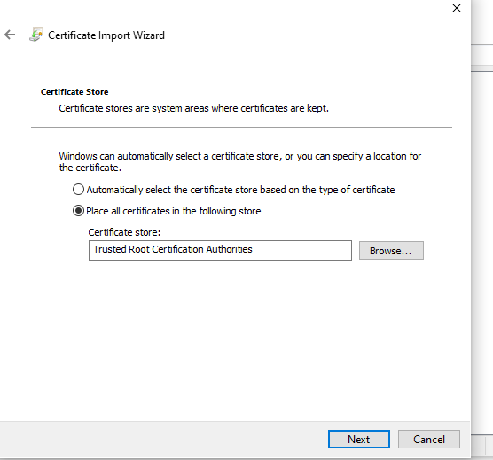

Browse the certificates to see yours in the list.

Now you can start issuing SSL certificates for all your local domains.

**Issuing Certificates for Local Domains**

Creating a Local Domain Site

I’m not going to cover setting up the actual site in Nginx or whatever web server you use.

The first step will be to create a local domain.

You do this in your c:\program files\windows\system32\drivers\etc\hosts file.

Here’s an example hosts file.

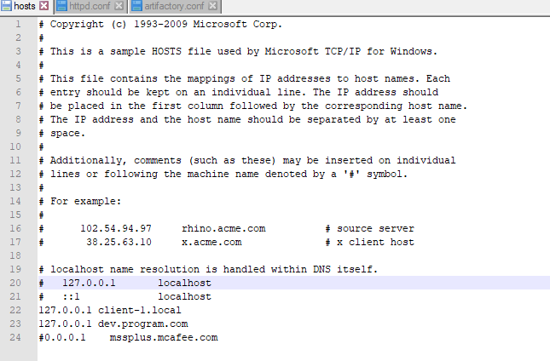

You can see that I’ve added a “dev.program.com” domain to point to my local IP address 127.0.0.1

So “dev.program.com” is the new website address and I want to connect to it using “https:// dev.program.com”

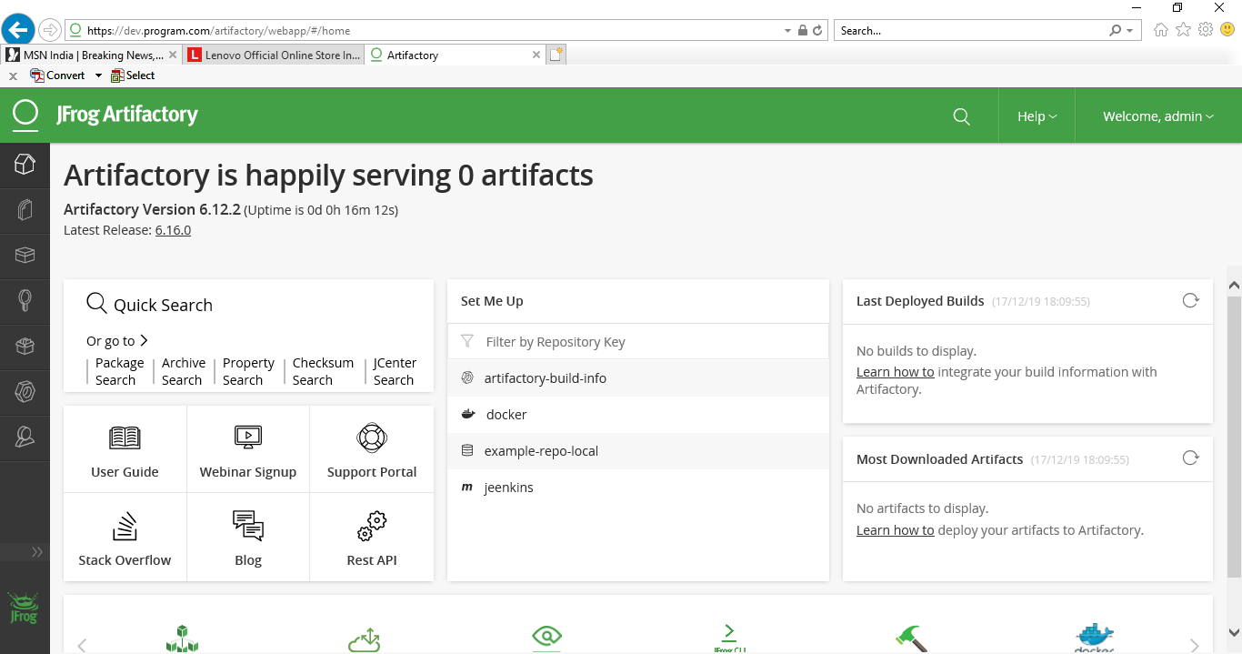

Check the certification

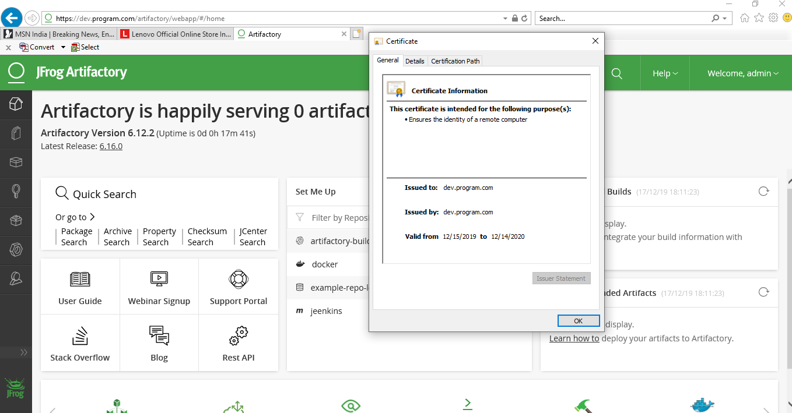

openssl genrsa -out server.key 2048

openssl req -new -x509 -key server.key -out server.crt -days 365

openssl pkcs12 -export -in server.crt -inkey server.key -out server.pfx