﻿World Bank Indicators are collected for last 50 years from different offcial sources an organised as data bank in the world bank portal . There are differrent types of Indicators available on public,private,health,education,climate and energy rtc..

The topic of ineterst is climate change and the analysis is drwan from the below data points

1. GDP (current US$)
2. Access to electricity (% of population)
3. Electric power consumption (kWh per capita)
4. Energy use (kg of oil equivalent per capita)
5. Total CO2 emissions (thousand metric tons of CO2 excluding Land-Use Change and Forestry)

As an initial understanding of the data the above indicators are compared among different neighbourhood countries to India. The indicators are as below

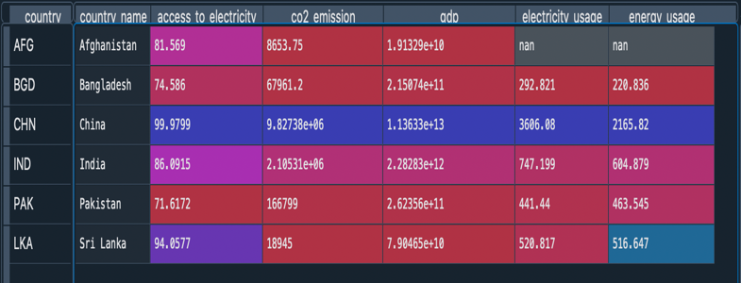

**Fig(1)**

It is clearly understandable from the above that China tops all the indicators compared to other countries. The gap between china and others is very huge and we can understand this as china is heavily populated country, but we cannot deny the fact that india is also heavily populated country but the co2 emissions and electricity usage and energy usage is still very low compared to china. Interestingly Srilanka has more percentage of people have access to electricity compared to India. This summary itself doesn’t tell any relations between these factors . The reason for this gap can be clearly understandable from the correlation analysis

See the Fig(2).

The Correlation factor between co2 emissions and gdp is very high (0.97) . we can unserstand that as chinas GDP is very high compared all neighbour countries so the Co2 emissions are vey high and this is driving the huge gap among countries.

**Fig(2)**

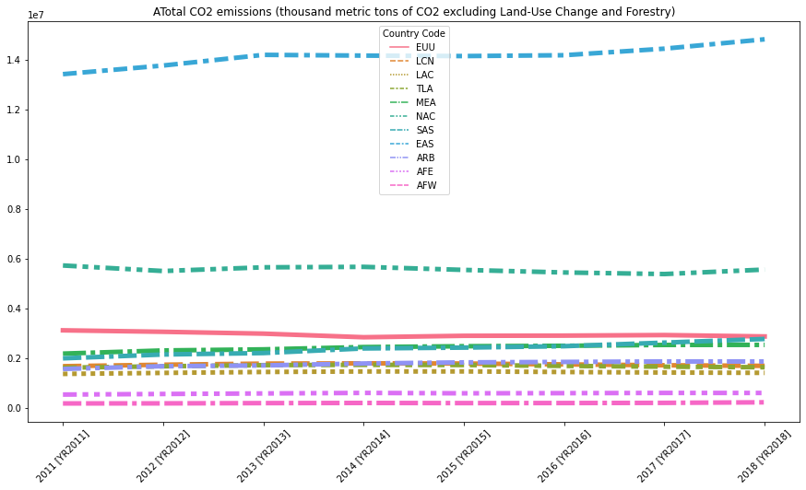

**Co2 Emissions**

From the Timeseries of different regions, the top line is for EAS (East Asia) region, and it is mostly dominated by china and Japan and next to it NAC (North America) mostly dominated by USA and followed by European Union and South Asian regions.

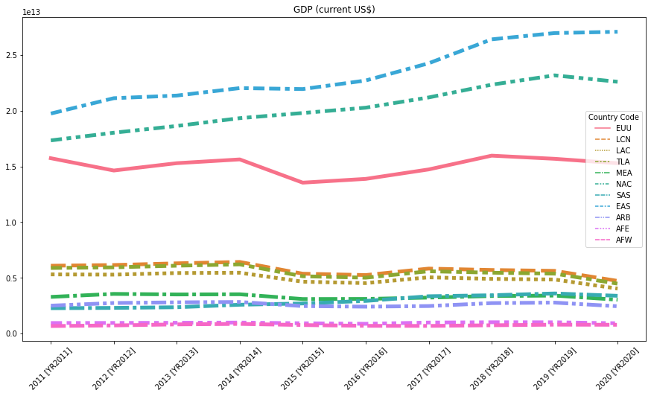

**GDP ($US)**

From the GDP trajectory we can observe the same pattern as before. EAS AND NAC regions leading the GDP contributions and followed by EU region. But the gap between EAS and NAC is slightly less compared to the CO2 emissions gap.

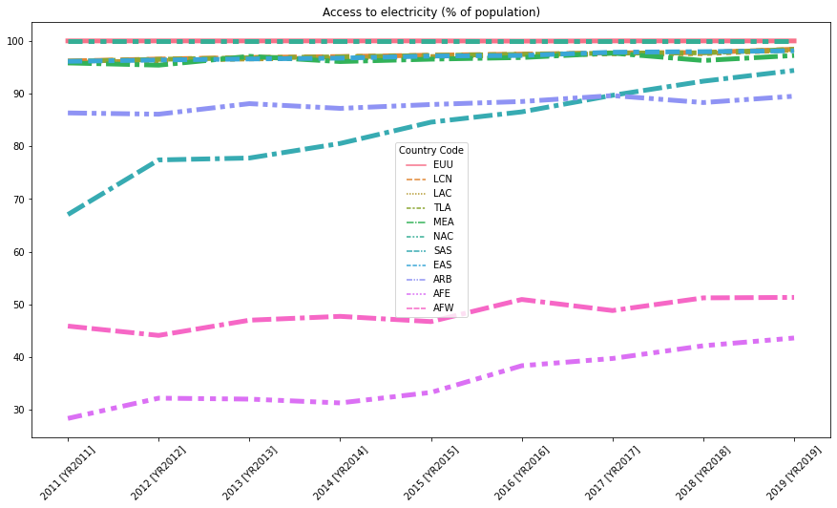

**ACCESS TO ELECTRICITY (% of Population)**

From the above trajectory by the end of year 2019, Africa Eastern and Southern and Africa Western and Central zones population have the least access to electricity ranging below 50% of population. Whereas, by 2019 all other countries population were able to access to electricity ranging above 80% of population.

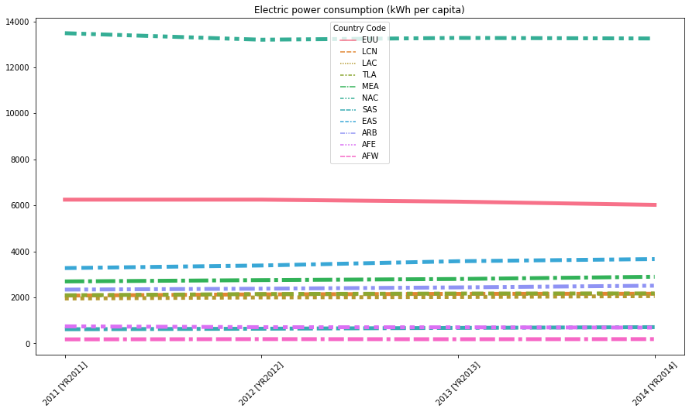

**ELECTRIC POWER CONSUMPTION (kWh per capita)**

From the trajectory NAC regions consumed more power and electricity of 13304 kWh when compared to all other regions. While, EU stands second with 6169 kWh and all other regions followed by EU have consumed under 4000 kWh of power and electricity.

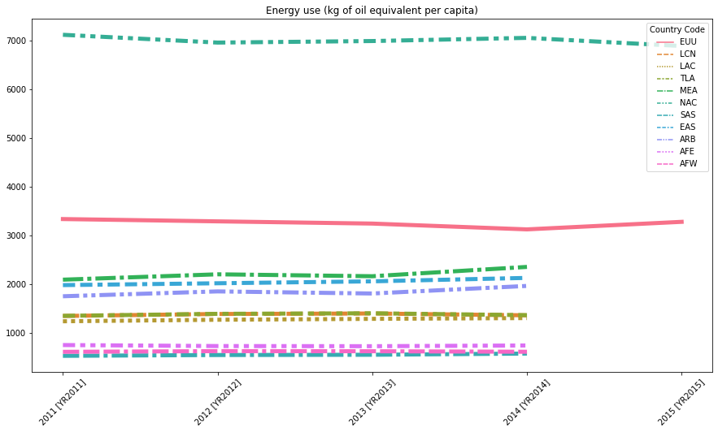

**ENERGY USE (KG of oil equal per capita)**

Similar to power and electricity consumption, NAC regions have used the energy of 7000 KG of oil to generate power and electricity which is higher than any other regions. EU stands second with using 3253.6 KG of oil as energy and all other regions followed by EU have used under 2500 KG of oil as energy to generate power and electricity.