Calil Amaral

MECHANICAL PROPERTIES OF METALLIC COMPONENTS ADDITIVELY MANUFACTURED BY POWDER FED LASER BASED DIRECTED ENERGY DEPOSITION

Documento submetido ao Programa de Pós-Graduação em Engenharia Mecânica da Universidade Federal de Santa Catarina para a Qualificação do mestrado no Programa.

Orientador: Prof. Dr. Milton Pereira
Coorientador: -
Área de concentração: Fabricação.

Florianópolis
2019
SUMÁRIO

1 INTRODUCTION 3
1.1 GOALS 5
1.1.1 General goals 5
1.1.2 Specific goals 5
2 BIBLIOGRAFIC REVIEW 6
2.1 LASER 6
2.2 ADDITIVE MANUFACTURING 7
2.2.1 Directed Energy Deposition 9
2.2.2 Powder fed Directed Energy Deposition Laser (DED-L) 9
2.2.3 Process description 11
2.2.4 Thermal cycles and resulting properties 13
2.2.5 Influence of residual porosity in mechanical properties 15
2.2.6 Reported mechanical properties and sampling strategy 16
3 MATERIAIS E MÉTODOS 17
3.1 METODOLOGIA DE ENSAIOS E DESENVOLVIMENTO 17
3.2 RECURSOS TÉCNICOS 18
2.1.1. Sistema laser 18
3. CRONOGRAMA DE TRABALHO 18
4 BIBLIOGRAFIA 19

INTRODUCTION
Product development processes start from understanding and translating the needs of customers into technical attributes that represent constraints and requirements of the application [1]. These attributes must communicate as well as possible the perception of what the client understand as value. Attributes such as cost, reliability, geometrical tolerances and structural integrity are frequently valuable among buyers of machinery and product development teams makes use of this information to create a system of interdependent components, robustly designed to withstand the boundary conditions of the application avoding critical system failure modes [2][3].
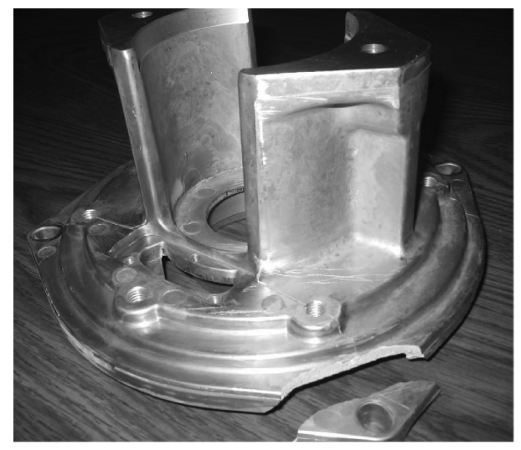 | 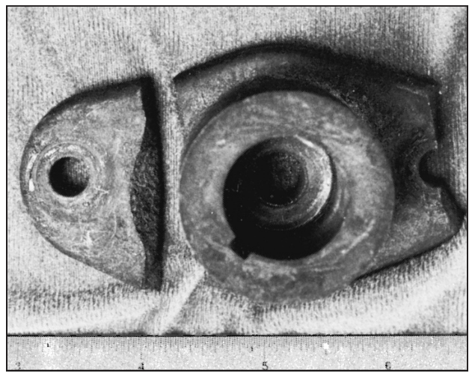 | 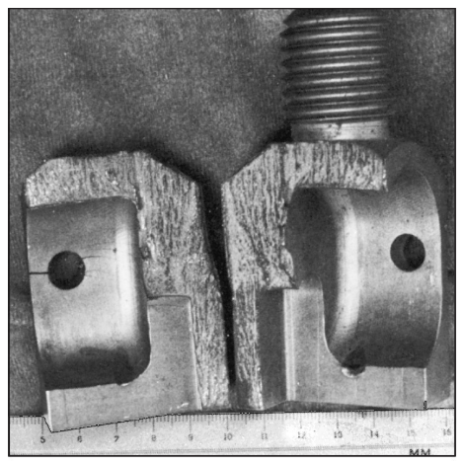
(a) | (b) | (c)
Figure 1 - Examples of mechanical failure of different components. (a) Broken aluminum die-casting endbell due to the porosity and impurities in the part [4]; (b) Impact failure of a lawn-mower blade driver hub; (c) Example of brittle fracture initiated by stress concentration in a chain test fixture that failed in one cycle [1].
One of the main type of failures that engineers try to prevent during the mechanical design of a component is the permanent distortion or complete separation of the part in two or more pieces as illustrated in Figure 1. In the above examples, the maximum stresses in the component surpassed the component’s strength at critical locations [1].
The choice of material, manufacturing process and treatment of a component plays an important role during the mechanical design since the strength is a mechanical property that depends on that selection. For stablished processes such as forging and casting, reference mechanical properties are readily available in the literature for different materials and processing conditions [1][5][6][7]. When statistical information is needed for specific processing conditions, a variety of tests can be performed to extract the required mechanical properties of materials before evaluating the performance of a part as illustrates Figure 2.

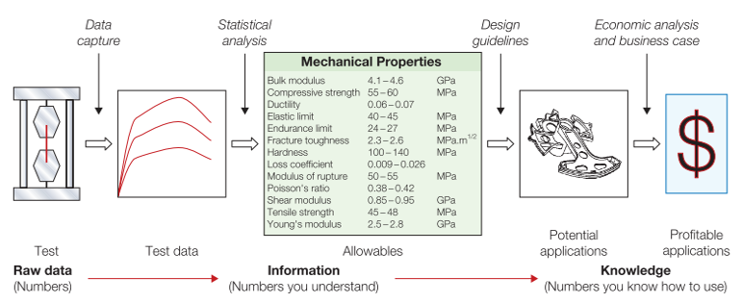
Figure 2 - Types of material information. Structured data for design “allowables” and the characteristics of a material that relate to its ability to be formed, joined, and finished; records of experience with its use; and design guidelines for its use [5].
Among the available manufacturing processes, additive manufacturing (AM) has recently begun to emerge as an important commercial manufacturing method with few technologies applicable to metallic materials. Powder fed Directed Energy Deposition Laser (PL-DED) is one of these technologies and compared to others, it offers advantages such as suitability to repair failed components [8], produce larger parts with higher build rate when compared to Powder Bed Fusion (PBF) technology [9] and manufacture components with variations in alloy composition along the build volume [10][11][12].
Although PL-DED is suitable to manufacture parts with high level of geometrical and structural complexity and low tool dependence, the process is still only competitive for production of custom components with high aggregate value and low batch sizes. Despite that, machines, material and servicing costs tend to decrease overtime according to a report from 2014 [13]. According to the same report, education in AM is one of the future challenges that need to be addressed to make the technology readily available for mass production and customization [13][14].
One of the biggest challenges to use PL-DED for final manufacturing is related to the AM paradigm shift in component design. Current design paradigm starts with CAD solid modeling and further CAE simulations based on isotropic and homogeneous property considerations. On the other hand, in order to unleash full process capabilities, such paradigm needs to evolve to an inverse design methodology that assists the designer in navigating complex process-structure-property relationships while accounting for design with variability in shape properties and process [10][13][15].

GOALS

General goals
Considering the context described previously, the general goal of the present study is to investigate the relationship between geometric characteristics, processing parameters and the resulting selected mechanical properties of components manufactured by PL-DED. It is of the author’s interest, that the study can serve as input data for product development engineers interested on prototyping or manufacturing components using the technology.

Specific goals
In order to reach the proposed goal, the present study has as specific goals:
- Select critical geometric features (e.g. aspect ratio, wall thickness, curvature radius and part height) and processing parameters (e.g. processing speed, laser power and overlap distance) from the literature;
- Define processing parameter levels that result in a stable process for manufacturing the selected geometric features;
- Successfully manufacture geometries with selected features and machine local samples for uniaxial tensile tests:
  - Aligned to build direction Z;
  - Aligned with perpendicular direction X;
- Conduct hardness, microhardness and tensile tests to characterize:
  - HB hardness;
  - HV microhardness along the build direction Z;
  - Elastic modulus (E);
  - Yield strength (Sy);
  - Tensile strength (Su);
  - Elongation at fracture (%);
  - Anisotropy in strength;
- Report the dependency of the measured values on the build direction and wall thickness;
- Conduct a case study to evaluate the applicability of the measured characteristics to design and build a structural component with PL-DED technology.

BIBLIOGRAFIC REVIEW

LASER
The term “laser” was originally an acronym for Light Amplification by Stimulated Emission of Radiation, characterizing a special process of light amplification, but is often used to represent a special source of light. Laser, as a special type of electromagnetic radiation, can be described by its wavelength (λ) and intensity (I), differing from general light in its high degrees of directionality, monochromaticity and coherence [16].
The history of laser began with an appropriate description of electromagnetic radiation formulated by Maxwell in 1873. The following discoveries included the processes of spontaneous emission and absorption and the process of stimulated emission postulated by Einstein in 1917. In 1960, Theodore Mainman reported about the pulsed laser activity of a ruby laser for the first time [17].
Table 1 - Some important commercial lasers. Adapted from [16].
Laser | Wavelength | Average power range
Carbon dioxide (CO₂) | 10,6 µm | Milliwatts to tens of kilowatts
Nd:YAG | 1,06 µm | Milliwatts to hundreds of watts
 | 532 nm | Milliwatts to watts
Nd:glass | 1,05 µm | Watts
Diodes | Visible and IR | Milliwatts to kilowatts
Argon-ion | 514,5 nm | Milliwatts to tens of watts
 | 448,0 nm | Milliwatts to watts
Fiber | IR | Watts to kilowatts
Excimer | Ultraviolet | Watts to hundreds of watts
Since 1960, different types of laser have been developed as listed in Table 1, greatly varying in terms of dimensions, output power and emission wavelength (λ) [17], the last characteristic being of special importance to understand the interaction between laser and matter.
According to Poprawe [18] the fundamental principles involved in laser material processes are related to the absorption of light by the workpiece and its partial conversion to heat. The absorption depends on the wavelength and polarization of the laser light and also on the material physical properties as well as the characteristics and geometry of the workpiece surface [18]. Figure 3 illustrates absorption coefficients of different metals as a function of the wavelength of the incident radiation and shows that certain laser sources are better absorbed by specific materials.
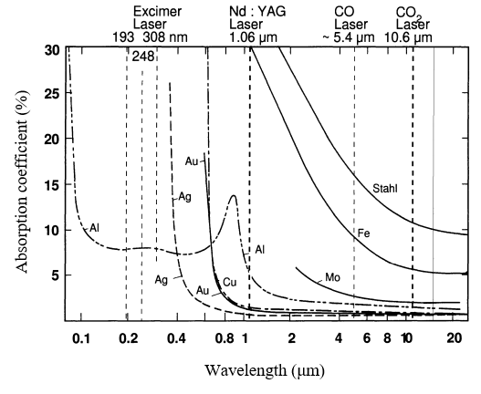 | 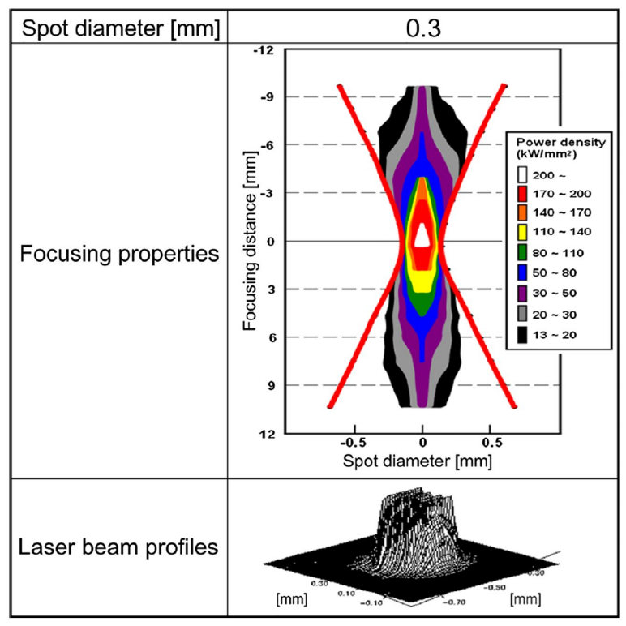
(a) | (b)
Figure 3 – (a) Absorption coefficient of a variety of metals as function of the wavelength of the incident radiation [19]; (b) Example of focusing feature of disk laser beam and power density distribution at focal point [20].
The laser energy is not homogeneously distributed along a cross section of a laser beam and its distribution depends on the wavelength, beam quality and the focusing optics. From the irradiated surface, a heat front moves into the inner material by conduction due to the developed temperature gradients. The heat flux lead to rise in temperature, depending on the absorbed intensity, the duration of the interaction, the beam radius at the surface, the velocity of the workpiece relative to the laser beam and the thermo-physical parameters of the material like heat conductivity and heat capacity [18].
High energy intensities available at a small controllable area on the intersection between the laser beam and the workpiece surface, make the laser a well-suited tool for additive manufacturing processes. With the right combination of laser source and material, it is possible to melt and deposit metal on specific regions of a workpiece creating metallurgical bonds, layer by layer, until whole functional components are built.

ADDITIVE MANUFACTURING
Additive manufacturing (AM) can be defined as a process of joining materials to make parts from 3D model data, usually layer upon layer, as opposed to subtractive manufacturing and formative manufacturing methodologies [21].
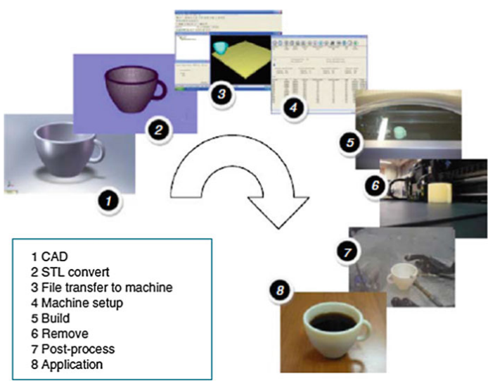
Figure 4 - Generic process of CAD to part, showing eight stages [22].
The idea was first documented in 1892 when Blanther applied the technique for building molds for topographic maps in three dimensions, but now it has developed into a highly digital manufacturing process, usually following the steps illustrated in Figure 4 to convert a digital 3D geometry into a physical part. The starting point is a 3D CAD model that is virtually sliced into thin layers with layer thickness of 20 µm – 1 mm, depending on the AM process. Based on this data the physical part is then built by repetitive deposition of single layers and locally melting the material by a heat source [23]. The part is then removed and usually post-processed before being suitable for the application.
AM methods can essentially be classified by the nature and the aggregate state of the feedstock as well as by the binding mechanism between the joined layers of the material [23]. A complete list of categories is available in Table 2, highlighting the suitability of each category to produce dense metal parts.
Table 2 - Categories of additive manufacturing and suitability for producing dense metal parts. Adapted from [21], [24], [25].
Category | Example | Processed materials | Density of metal parts
Binder Jetting | 3D printing; | Metals, Polymers, Composites, Ceramics | Low
Directed Energy Deposition | WAAM¹, Laser Cladding; | Metals | High
Material Extrusion | FDM² | Thermoplastics, Waxes | -
Material Jetting | Polyjet | UV curable resins | -
Powder Bed Fusion | SLS³, SLM⁴ | Metals, Thermoplastics, Ceramic | High
Sheet Lamination | Sheet forming | Metals, Polymers, Paper | Low
Vat Polymerization | Stereolithography | UV curable resins, Wax, Ceramic | -
¹ Wire Arc Additive Manufacturing;
² Fused Deposition Modeling;
³ Selective Laser Sintering;
⁴ Selective Laser Melting;

AM has attracted much attention over the past ten years due to its inherent advantages, such as high design freedom and short lead times [23] and although AM techniques were at first limited to rapid prototyping of porous structures, recent advancements in technology made possible to reliably manufacture even dense metal parts with certain AM processes, including steel, aluminum and titanium. In the present work, one of the processes suitable for processing metal (Directed Energy Deposition) will be discussed in further detail.

Directed Energy Deposition
Directed Energy Deposition, or DED, is defined as an additive manufacturing process in which focused thermal energy is used to fuse materials by melting as they are being deposited [26]. DED systems comprise multiple categories of machines using laser beam (LB), electron beam (EB), or arc plasma energy sources as categorized in Figure 5. Feedstock material typically comprises either powder or wire. Deposition typically occurs either under inert gas (arc systems or laser) or in vacuum (EB systems) [26]. The process was a natural evolution of welding techniques and the first of its kind was LENS ®, documented in 1998 by the Sandia Labs in Albuquerque, New Mexico [10].
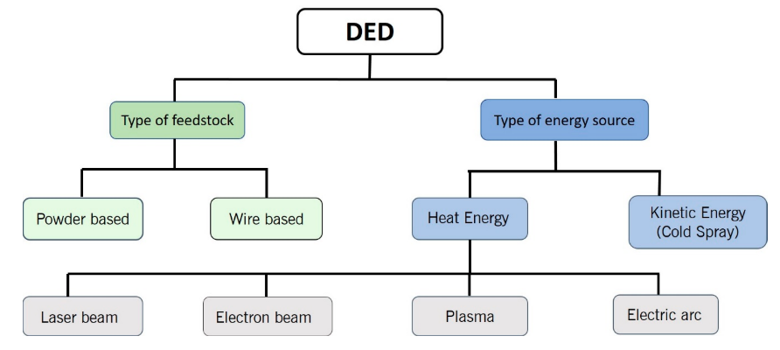
Figure 5 - Classification of Directed Energy Deposition (DED) systems [27].

Powder fed Directed Energy Deposition Laser (PL-DED)
Among the DED systems illustrated in Figure 5, in the present work we focus our attention to the laser-based process (DED-L), using powder as feedstock material. The process is well suited for manufacturing finer details when compared to arc technologies yet without using expensive vacuum chambers such as the ones needed for electron beam systems [23]. These two factors combined, make the laser systems very attractive among other DED processes.
In contrast to powder bed technologies, DED-L technology provides a high build rate and allows for larger build volumes although presenting lower layer thickness resolution. Depending on the main parameters, build rates up to 300 cm³/h can be achieved using a layer thickness of 40 μm – 1 mm. Feed rates between 4 g/min and 30 g/min are realized for the deposition of metal powder [23].
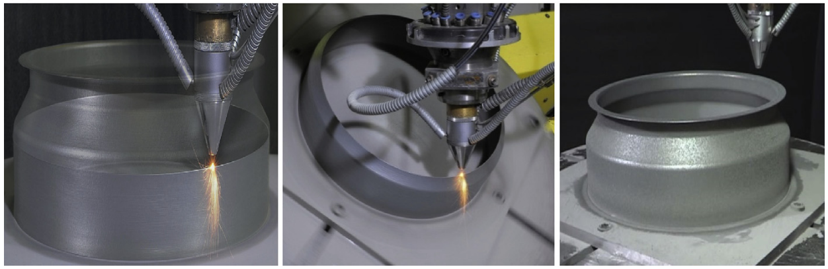
(a) | (b) | (c)
Figure 6 – IN718 helicopter engine combustion chamber fabricated by a five-axis laser DED process. (a) Deposition showing the 2.5-dimensional tool path; (b) Multiaxis deposition; (c) Finished part [28].
Moreover, as the material is melted while being deposited, it is possible to use 4 or 5-axis systems, as show Figure 6, to build structures with high overhang angles, reducing or eliminating the undesired metal support structures and reducing component postprocessing time [29]. One particular benefit of this characteristic is the potential to deposit material onto curved surfaces and existing metal structures. For this reason, one of the DED technologies, referred to as laser Cladding, is often used to repair damaged parts, particularly for the aerospace industry [30].
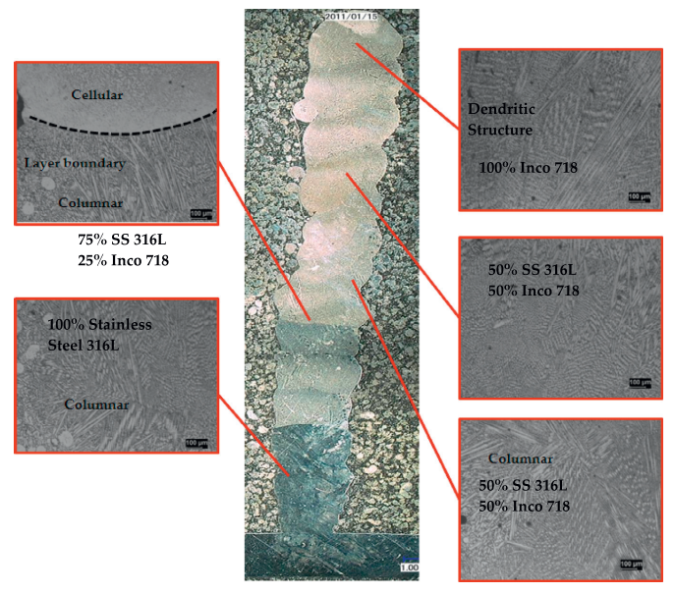
Figure 7 - Transverse cross section showing the transition between 100% 316L to 100% Inconel 718 from bottom to top [31].
Regarding the choice of feedstock material, one of the main advantages of using powder, is the capability of mixing different powders during the deposition, thus enabling the creation of gradient metal alloys in-situ, also known as functionally graded materials (FGM) as illustrates Figure 7. The concept extends the design space to components that can be made of a continuum structure that uses cost-intensive alloys in highly-loaded regions, and cheaper compositions in non-critical areas [32].
In order to make use of the full potentials of powder fed laser based DED process, a list of challenges and unanswered questions need to be addressed. This list includes uncertainties about predicting the geometry, metallurgical integrity and mechanical properties of the formed components. These outputs highly depend on interactions between laser beam, powder stream and scanning speed, which will be briefly discussed in the next sessions.

Process description
A powder fed laser based DED system comprises five fundamental subcomponents: laser source, inert gas, powder feedstock feed mechanism, positioner and a computer control system. The process consists in the formation of a melt pool in the substrate through absorption and conversion of irradiated laser energy into heat. Simultaneously powder is fed into this pool and melts, subsequently solidifying to form a layer of deposited material as illustrated by Figure 8. A strong fusion bond between added material and substrate is achieved immediately [33].
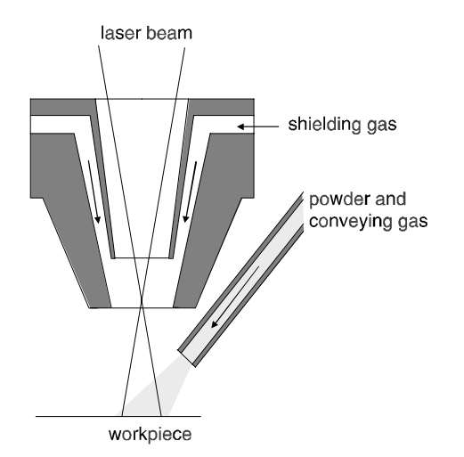 | 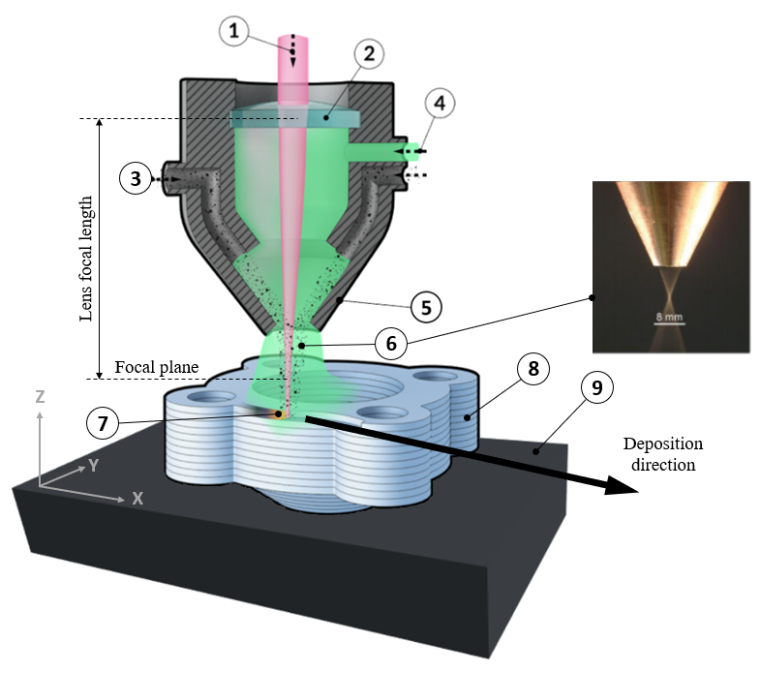
(a) | (b)
Figure 8 – (a) Lateral powder supply [33]; (b) Continuous coaxial powder nozzle during the deposition. (1) Process laser beam; (2) Focalizing lens; (3) Mix of metal powder with carrier gas; (4) Shielding inert gas; (5) Deposition nozzle; (6) Schematic (left) and realistic (right) views of a powder cone; (7) Melt pool; (8) Deposited structure; (9) Substrate. Adapted from [34] and [18].
A variety of nozzle configurations are reported in the literature, from lateral to coaxial, from discrete to continuous, two of which are schematically illustrated in Figure 8 (a) and (b). The powder is delivered to the melt pool by feeders, that can be based on various working principles, one of which consists of a container from which powder flows by gravity into a slot in a rotating disk. The powder is transported to a suction unit from which it is transported by a gas stream to a powder nozzle. The volumetric powder feed rate is controlled by the dimensions of the slot and the speed of the disk [33].
The nozzle head is programmed to move along a path, previously defined by the user, and as it moves, continuously deposit material on the surface of the substrate, usually maintaining a constant distance between the nozzle tip and the surface. After forming the first layer, the nozzle moves in the positive Z direction, represented in Figure 8, and starts to add material on top of the previously deposited layer. This process repeats until the entire part has been built. A schematic view of key input and output factors that affect the stability of the process are represented in Figure 8, some of which will be described in more detail later.
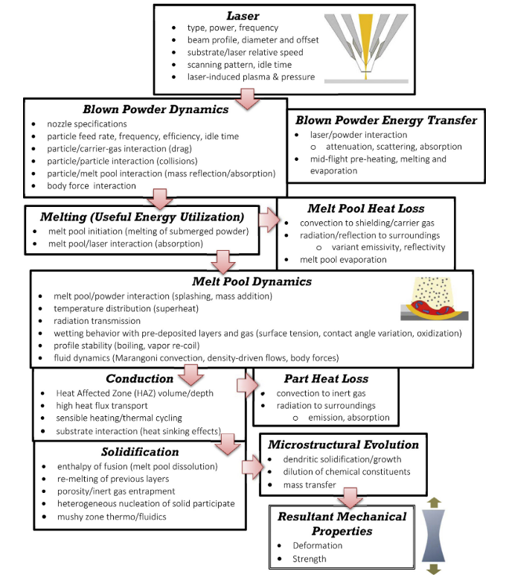
Figure 9 – Physical events occurring during DLD for given instant in time [35].
Along the process, several critical input variables schematically listed in Figure 9, interact with one another in a complex physical processes that involves light absorption, heat conduction and convection, mass diffusion and result in the geometry, microstructure, mechanical properties and other relevant characteristics [33]. The present study will focus on discussing geometric features, process parameters and their relationship with the resulting microstructure and mechanical properties.

Thermal cycles and resulting properties
During AM, a defined volume element, or voxel, of the material is usually subjected to a complex thermal cycle. This thermal cycle involves a rapid heating above melting temperature due to the absorption of the laser energy and its transformation into heat, a rapid solidification of the molten material after the heat source has moved on, and numerous re-heating and re-cooling processes when the following layers are welded and the voxel is still exposed to heat [8]. The effect is better pictured in Figure 10 (a) derived from a numerical investigation conducted by Manvatkar et. Al [36].
AM microstructure is therefore a result of the described thermal cycle. Independently of the material, a fine-grained structure has usually been observed for AM in comparison to other processes (e.g. casting) [23]. The effect can be explained by the high cooling rates of up to 12000 K/s as shown in Figure 10 (b) when compared with 1 – 100 K/s for casting [11], which itself is a result of the very local heat input and the small volumes of molten material [23].
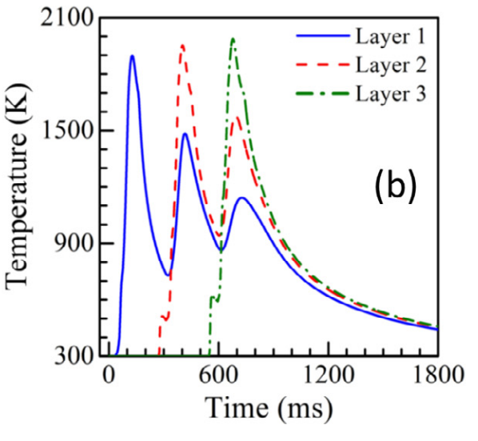 | 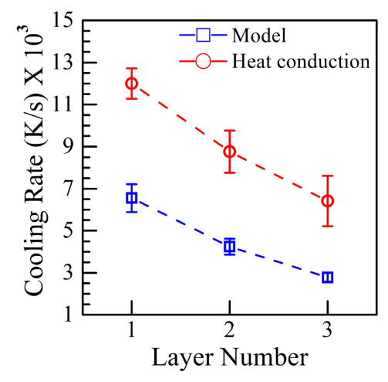 | 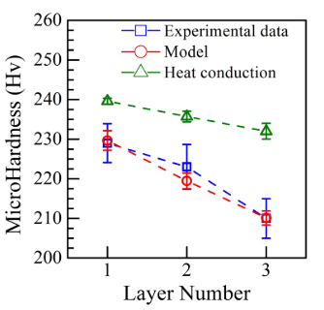
(a) | (b) | (c)

Figure 10 – (a) Simulated thermal cycles at three monitoring locations in the first three layers in a DED-L of 316 stainless steel at a laser power of 210 W and 12.7 mm/s speed; (b) Variation of cooling rate at three monitoring locations in the three layers. The results of the heat conduction calculations are from the literature; (c) Computed and the experimentally determined hardness values in three layers compared with heat conduction model; [36]
The temperature gradients are obviously influenced by several process parameters, e.g. the energy density, laser power, scanning speed, layer thickness and pre-heating temperature, if applied [23]. Moreover, the temperature gradients are also affected by the surrounding material, and as heat conduction in build direction is typically higher than in other spatial directions as a result of the solidified material from lower, previously built layers, anisotropy in both microstructure and properties has been reported in several studies [23].
For constant laser power and scanning velocity, the layer width and peak temperature increase while the cooling rate decreases toward the top layers as shown in Figure 10 (b) extracted from simulated results [36]. As a result, the solidified deposit usually exhibits finer grain structure close from the substrate with coarser grains towards the top. Correspondingly, the yield strength and hardness also reduce from the bottom toward the top layers [37]. Figure 10 (c) illustrates simulated values that match with experimental data.

Influence of residual porosity in mechanical properties
With advancements in AM technology over the past years, dense metallic parts with mechanical properties comparable to conventional manufacturing methods are achievable for several material and process combinations. As porosity facilitates crack propagation and deteriorates mechanical properties, the manufacture of parts with a high density, typically greater than 99.5%, is the first goal in AM process optimization [23].
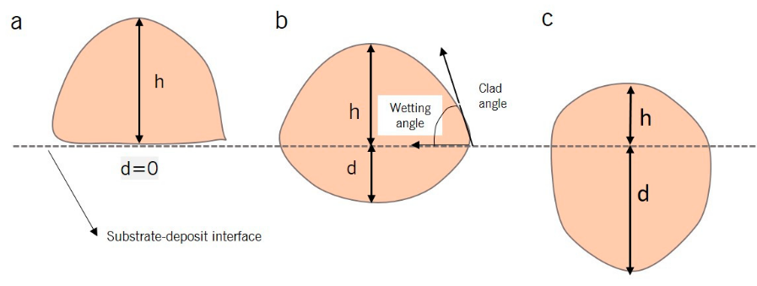
Figure 11 – (a) Zero or low penetration, meaning a lack of fusion with the substrate; (b) Optimal level of dilution (generally between 10% and 30%); (c) High d leads to keyholing [27].
Besides other influences, part density depends on the applied volume energy
(1)
Where is the laser power, stands for the scan speed, is the hatch distance and the layer thickness of the deposited layer. According to Herzog et. Al [23], too low energy input will result in unmolten material and thus reduced density by the formation of irregular-shaped voids. On the other hand, too high energy input will lead to higher melt pool dynamics and keyholing phenomenon resulting in spherical shaped pores formed due to entrapped gas, formed during evaporation of material, and reducing part density [23]. Figure 11 illustrates the schematics of weld pool cross sections of the above-mentioned circumstances and Figure 12 shows diagrams of the resulting pores geometry as well as a graph of the desired processing condition that generates minimum porosity.
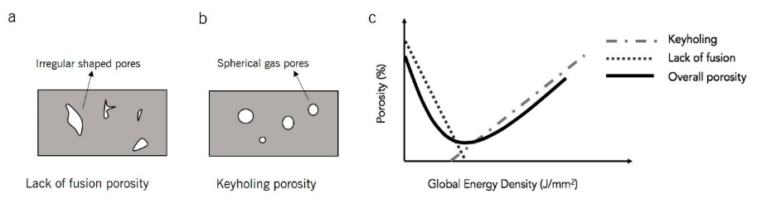
Figure 12 - Schematic showing: (a) Lack of fusion porosity (interlayer porosity), (b) keyholing porosity (intralayer porosity), and (c) the intersection of interlayer and intralayer porosity with respect volume energy [27].

Reported mechanical properties and sampling strategy
The resulting mechanical properties of components manufactured by DED-L have been documented in the literature for a variety of materials and processing conditions with emphasis in those used in high end applications. The tensile strength (Su), yield strength (Sy), elongation (ε) and elastic modulus (E) of tool steels, high speed steels and high performance alloys such as Titanium and IN618 are more commonly found in the literature.
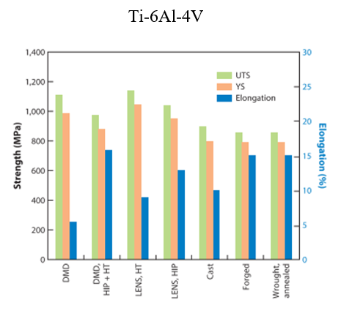 | 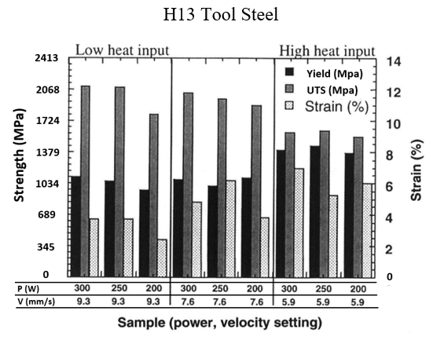
(a) | (b)
Figure 13 – (a) Summary of Ti-6Al-4V AM tensile properties. Abbreviations: DMD, direct metal deposition; HT, heat treated; HIP, hot isostatic pressing; LENS, laser-engineered net shaping; UTS, ultimate tensile strength; YS, yield stress. Adapted from [38]. (b) Comparison of room temperature tensile properties for H13 tool steel shell build samples fabricated at various power and velocity values [39].

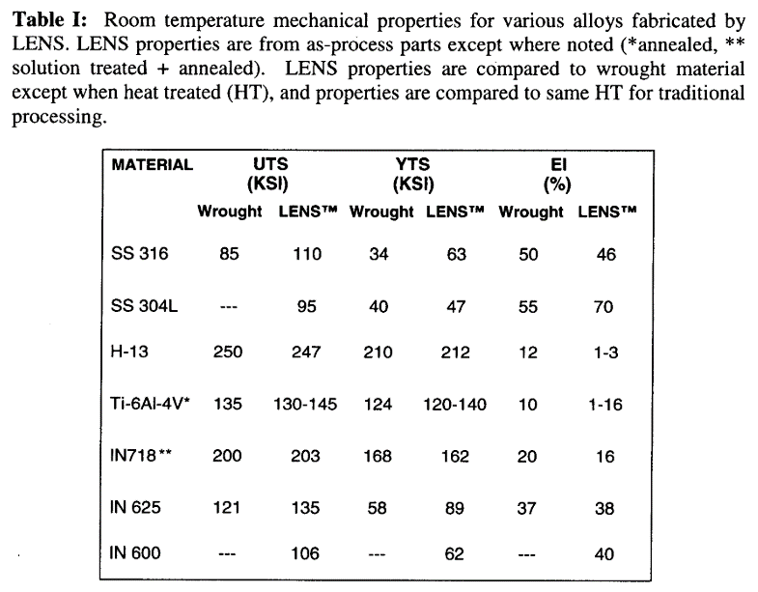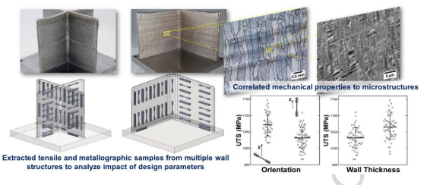

MATERIAIS E MÉTODOS

METODOLOGIA DE ENSAIOS E DESENVOLVIMENTO
O projeto inclui etapas para o desenvolvimento do sistema de alimentação dinâmica, integração do sistema ao microcontrolador e fonte de soldagem para o processo laser cladding. Os critérios de avaliação dos resultados alcançados ao longo do projeto serão baseados em dois aspectos principais. Um deles é a capacidade de integração entre a fonte de soldagem, microcontrolador e o próprio alimentador, o que implica em um levantamento de motores e drivers de potência compatíveis com as exigências do projeto.
Outro aspecto diz respeito à capacidade do sistema de executar sua função principal, ou seja, comprovar a integração mecânica, eletroeletrônica e computacional para a alimentação dinâmica e técnica de arame quente para o processo laser cladding. Para tal, o sistema será avaliado em relação a frequência de avanço e recuo do arame, assim como precisão e aumento de produtividade em relação ao processo convencional.

RECURSOS TÉCNICOS

Sistema laser
Os ensaios e construção do protótipo serão realizados no laboratório LMP. O laboratório possui um sistema de fonte LASER de fibra da IPS YLS-10000 com feixe de cerca de 300 mm no ponto focal e 880 de diâmetro. O cabeçote LASER utilizado consiste em duas partes: sistema ótico integrado ao sistema, sistema do gás de proteção como ilustrado na Figura 16.

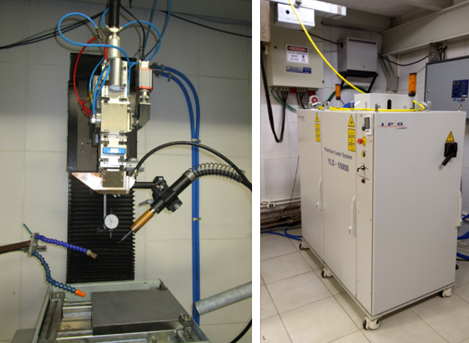
Figura 16– Esquerda Montagem cabeçote de soldagem para o processo laser cladding; Direita: fonte laser de fibra IPS YLS-10000 (Autoria própria).

CRONOGRAMA DE TRABALHO
O cronograma a seguir (Quadro 1) ilustra a distribuição das principais etapas pertencentes ao projeto de dissertação de mestrado.
Quadro 1- Cronograma de atividades do projeto de dissertação. [35]
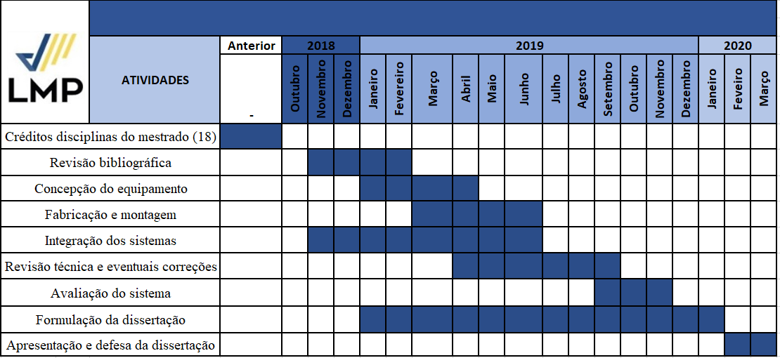

BIBLIOGRAFIA
[1] R. G. Budynas and J. K. Nisbett, Shigley’s Mechanical Engineering Design, vol. 112, no. 483. 2011.
[2] F. Jensen, A. S. Morris, M. A. Levin, T. T. Kalal, N. Pascoe, and C. Carlson, Effective FMEAs. .
[3] J. F. Shackelford, Failure analysis. 2004.
[4] W. Tong, Mechanical design of electric motors. 2014.
[5] M. Ashby, Materials selection in mechanical design: Fourth edition, vol. 9780080952. 2011.
[6] A. Handbook, “ASM Metals HandBook Volume 1 - Properties and Selections - Irons Steels and High and Performance,” Technology, vol. 2, p. 3470, 1990.
[7] W. F. Gale and T. C. Totemeir, Smithells Metals Reference Book, vol. 48, no. 7. 2016.
[8] A. Saboori, A. Aversa, G. Marchese, S. Biamino, M. Lombardi, and P. Fino, “Application of Directed Energy Deposition-Based Additive Manufacturing in Repair,” Appl. Sci., vol. 9, no. 16, p. 3316, 2019.
[9] Y. Zhang et al., “Additive Manufacturing of Metallic Materials: A Review,” J. Mater. Eng. Perform., vol. 27, no. 1, pp. 1–13, 2018.
[10] N. Volpato et al., Manufatura Aditiva - Tecnologias e aplicações da impressão 3D. Blucher, 2017.
[11] T. DebRoy et al., “Additive manufacturing of metallic components – Process, structure and properties,” Prog. Mater. Sci., vol. 92, pp. 112–224, 2017.
[12] D. K. Kim, W. Woo, E. Y. Kim, and S. H. Choi, “Microstructure and mechanical characteristics of multi-layered materials composed of 316L stainless steel and ferritic steel produced by direct energy deposition,” J. Alloys Compd., vol. 774, pp. 896–907, 2019.
[13] D. L. Bourell, D. W. Rosen, and M. C. Leu, “The roadmap for additive manufacturing and its impact,” 3D Print. Addit. Manuf., vol. 1, no. 1, pp. 6–9, 2014.
[14] D. L. Bourell, M. C. . Leu, and D. W. Rosen, “Roadmap for Additive Manufacturing: Identifying the Future of Freeform Processing,” 2009.
[15] J. Schmelzle, E. V. Kline, C. J. Dickman, E. W. Reutzel, G. Jones, and T. W. Simpson, “(Re)Designing for Part Consolidation: Understanding the Challenges of Metal Additive Manufacturing,” J. Mech. Des. Trans. ASME, vol. 137, no. 11, pp. 1–12, 2015.
[16] C. B. Hitz, J. Ewing, and J. Hecht, Introduction to Laser Technology. 2012.
[17] R. Poprawe, K. Boucke, and D. Hoffman, Tailored Light 1. 2018.
[18] R. Poprawe, Tailored Light 2 Laser Application Technology. 2016.
[19] G. Herziger and H. Weber, Laser in Technik und Forschung. 1998.
[20] Y. Kawahito et al., “Elucidation of the effect of welding speed on melt flows in high-brightness and high-power laser welding of stainless steel on basis of three-dimensional X-ray transmission in situ observation,” Weld. Int., vol. 31, no. 3, pp. 206–213, 2016.
[21] ISO and ASTM, “ISO/ASTM 52900:2015(E) - Standard Terminology for Additive Manufacturing – General Principles – Terminology,” vol. i, pp. 1–9, 2019.
[22] I. Gibson, D. Rosen, and B. Stucker, Additive manufacturing technologies: 3D printing, rapid prototyping, and direct digital manufacturing, second edition. 2015.
[23] D. Herzog, V. Seyda, E. Wycisk, and C. Emmelmann, “Additive manufacturing of metals,” Acta Mater., vol. 117, pp. 371–392, 2016.
[24] C.-J. Bae, A. B. Diggs, and A. Ramachandran, Quantification and certification of additive manufacturing materials and processes. Elsevier Inc., 2018.
[25] T. Caffrey and T. Wohlers, “Additive manufacturing state of the industry,” Manuf. Eng., 2015.
[26] ASTM and ISO, “F3187 − 16: Standard Guide for Directed Energy Deposition of Metals 1,” pp. 1–22, 2019.
[27] A. Dass and A. Moridi, “State of the Art in Directed Energy Deposition: From Additive Manufacturing to Materials Design,” Coatings, 2019.
[28] R. Liu, Z. Wang, T. Sparks, F. Liou, and J. Newkirk, Aerospace applications of laser additive manufacturing. Elsevier Ltd, 2016.
[29] J. Xu, X. Gu, D. Ding, Z. Pan, and K. Chen, “A review of slicing methods for directed energy deposition based additive manufacturing,” Rapid Prototyp. J., vol. 24, no. 6, pp. 1012–1025, 2018.
[30] M. Molitch-Hou, Overview of additive manufacturing process, vol. 83, no. 1. Mississauga: Elsevier Inc., 2018.
[31] K. Shah, A. Khan, S. Ali, M. Khan, and A. J. Pinkerton, “Parametric study of development of Inconel-steel functionally graded materials by laser direct metal deposition,” Mater. Des., vol. 54, pp. 531–538, 2014.
[32] Z. Quan et al., “Additive manufacturing of multi-directional preforms for composites: Opportunities and challenges,” Mater. Today, 2015.
[33] M. Schneider, “Laser clading with powder effect of some machining parameters on clad properties,” 1998.
[34] Manufacturing Guide, “Laser Cladding 3D, LC3D | Find suppliers, processes &amp; material.” [Online]. Available: https://www.manufacturingguide.com/en/laser-engineered-net-shaping-lens-0. [Accessed: 04-Jul-2019].
[35] S. M. Thompson, L. Bian, N. Shamsaei, and A. Yadollahi, “An overview of Direct Laser Deposition for additive manufacturing; Part I: Transport phenomena, modeling and diagnostics,” Addit. Manuf., vol. 8, pp. 36–62, 2015.
[36] V. Manvatkar, A. De, and T. Debroy, “Heat transfer and material flow during laser assisted multi-layer additive manufacturing,” J. Appl. Phys., vol. 116, no. 12, 2014.
[37] V. D. Manvatkar, A. A. Gokhale, G. Jagan Reddy, A. Venkataramana, and A. De, “Estimation of melt pool dimensions, thermal cycle, and hardness distribution in the laser-engineered net shaping process of austenitic stainless steel,” Metall. Mater. Trans. A Phys. Metall. Mater. Sci., vol. 42, no. 13, pp. 4080–4087, 2011.
[38] J. J. Lewandowski and M. Seifi, “Metal Additive Manufacturing: A Review of Mechanical Properties,” vol. 46, no. 1, pp. 151–186, 2016.
[39] M. L. Griffith et al., “Understanding the Microstructure and Properties of,” vol. 625, pp. 9–20, 2000.

