An Automated Visual Analytics System for Exploratory Analysis of Dubai Real Estate
Syeda Fatima Rafique¹
College of Business and Economics, United Arab Emirates University, Al Ain, UAE
700037831@uaeu.ac.ae
Abstract:

This report offers a thorough analytical overview of Dubai's real estate portfolio, leveraging the "DLD Buildings - Open" dataset. The analysis examines important aspects such property distribution among districts, building kinds and sizes, amenity availability, parking capacity, construction trends, and the significance of community projects through a series of visualizations made in an RShiny application. The results show that the market is dominated by villas, which are concentrated in master communities that are expanding quickly and place a high value on contemporary facilities. Investors, developers, and urban planners can use this report as a decision-support tool to comprehend market dynamics and spot important trends and opportunities in the Dubai real estate market.

Keywords: Real estate analytics, urban planning, visual analytics, RShiny application, open data, Dubai real estate, property market analysis, decision support system, portfolio analysis, interactive visualization.

- Introduction
The Emirate of Dubai has established a distinctive global presence by innovative urban planning, architectural achievements, and a thriving economy that has expanded beyond its petroleum foundations. A key component of this evolution is its real estate sector, which acts as a catalyst for growth by attracting investment, talent, and tourism.
The "DLD Buildings - Open" dataset, available on the Dubai Pulse platform, provides a resource for analysis, maintained by the Dubai Land Department (DLD)the authoritative agency overseeing the emirate's real estate. https://www.dubaipulse.gov.ae/data/dld-registration/dld_buildings-open
This report delivers a detailed analysis of Dubai's real estate landscape, utilizing this critical dataset to convert raw data into valuable insights through visualizations created within an RShiny application. By examining geographical hotspots, different property types, and the prevalence of key amenities, the report aspires to offer a well-rounded, evidence-based snapshot of the current state of the real estate market. The results are designed to inform a varied audience, including investors scouting market prospects, developers crafting new ventures, urban planners responsible for sustainable development, and policymakers formulating regulations, all by presenting a robust, data-driven narrative of the market's developmental journey.

2. Methodology
2.1 Dataset
The dataset used in this study is the DLD Buildings - Open dataset from the Dubai Pulse. It is an official register of building and property records within the Emirate of Dubai. The dataset contains a comprehensive set of attributes for each property:
- Geographical Data: Zone ID, District Name, Community Name.
- Property Characteristics: Type (e.g., Villa, Building), Size Category, Built-up Area, Actual Area.
- Configuration: Number of Bedrooms, Building Age.
- Amenities and Features: Availability of Elevator, Parking (number of spaces), Swimming Pool, etc.
- Temporal Data: Year of construction/completion.
The data was accessed and visualized in its entirety within the RShiny application, with interactive filters allowing users to focus on specific subsets of interest.
2.2 User Interface Environment
The R programming language, which was selected for its robust statistical computing capabilities and wide range of data visualization packages, was used to construct the software. The RShiny framework, which allows the development of interactive web applications directly from R, forms the foundation of the application. By bridging the gap between intricate data analysis and intuitive user interaction, this framework enables people to dynamically explore data without having to write code.
Key R packages integrated into the system include:
- Ggplot2 & Plotly: Used to create sophisticated and interactive visualizations. Plotly allows users to hover, zoom, and click on plot elements for detailed exploration.
- Dplyr: Employed for efficient data manipulation, including filtering, grouping, and summarizing the large dataset in real-time.
- Readr: Ensures fast and reliable reading of data.
- Shinythemes: Provides a clean and professional aesthetic for the application interface.
The application is entirely code-driven, ensuring transparency, reproducibility, and full control over the analytical process.

2.3 Process of Implementation
The web application was developed and implemented using an organized pipeline:
- Data Input: The system is designed to work directly with the DLD dataset. The data is loaded into the R environment, making it ready for processing and visualization.
- Data Preprocessing & Profiling: The data is cleaned and converted as necessary using dplyr. To give users a preliminary picture of the features of the dataset, summary statistics are automatically computed.
- Visualization Modules: A number of visualization modules are applied to the pre-processed data. These modules provide a wide range of plots, each intended to highlight a distinct facet of the real estate portfolio, such as bar charts, pie charts, scatter plots, histograms, and violin plots.
- Interactive Dashboard & Report Generation: The visualizations are rendered in an interactive Shiny dashboard. The key outcome is the automated generation of a report that compiles all visualizations and their interpretations, providing a standalone analytical document.

3. Analysis and Results
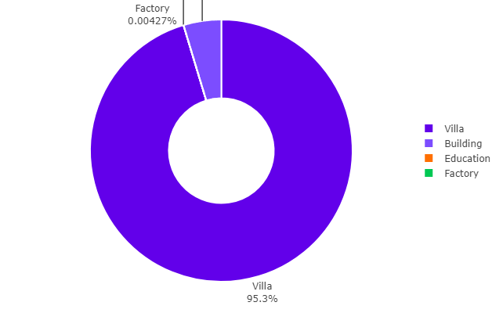

Fig. 1. Property Type Distribution

The chart demonstrates the overwhelming dominance of Villa properties in Dubai's registered building stock, constituting 95.3% of all records. Other property types, such as Buildings, Factories, and educational institutions, make up a very small fraction of the market. This indicates a market heavily oriented towards low-rise, residential family units, which is a defining characteristic of Dubai's urban sprawl.

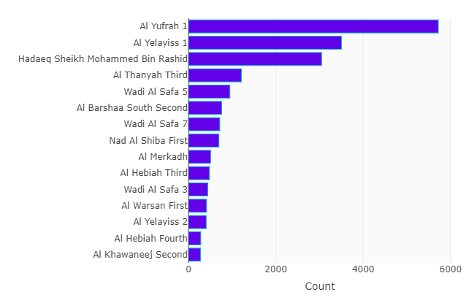
Fig. 2. Geographical Distribution by District

This visualization shows the distribution of properties across Dubai's districts. Areas like Al Yufrah 1, Al Yelayiss 1, and Hadaeq Sheikh Mohammed Bin Rashid show the highest property counts. This highlights that development activity is not confined to the city's core but is widespread across various zones, reflecting Dubai's expansive growth.
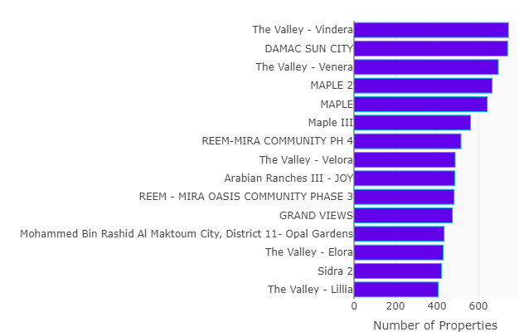

Fig. 3. Community-Level Analysis

This chart zooms into specific master-planned communities. The Valley (Vindera, Venera, Velora), DAMAC SUN CITY, and the MAPLE communities are among the most prominent. This underscores the significant trend towards large-scale, integrated community living as a primary model for new development

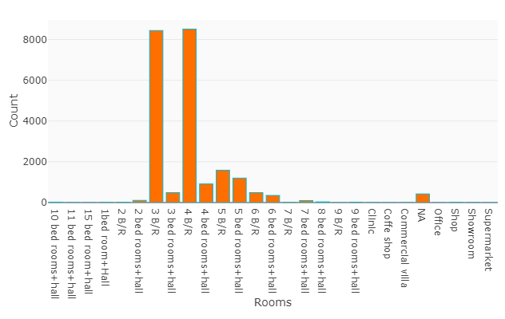
Fig. 4. Room Configuration

The analysis of room configurations shows a high prevalence of properties with 3, 4, 5, and 6 bedrooms (plus a hall), aligning perfectly with the villa-dominated market and catering to medium and large families.

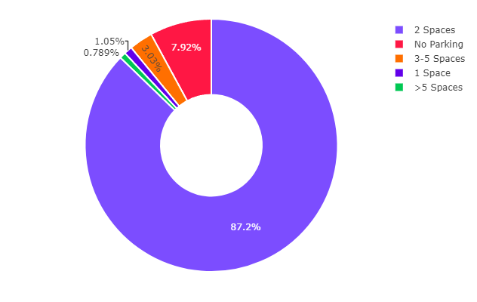
Fig. 5. Parking Capacity Analysis

The pie chart reveals that the vast majority of properties (87.2%) offer 2 parking spaces, establishing this as the market standard for villas. A smaller but significant segment (7.92%) offers 3-5 spaces, catering to larger households or those with multiple vehicles.

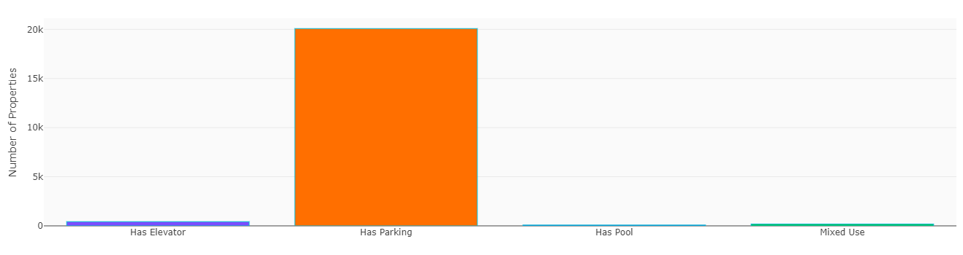
Fig. 6. Amenity Prevalence

The plot above confirms that Parking is a near-ubiquitous feature. Elevators and Swimming Pools are also common amenities, reflecting the modern, high-standard nature of the housing stock. This aligns with the image of Dubai as a provider of luxury residential amenities.

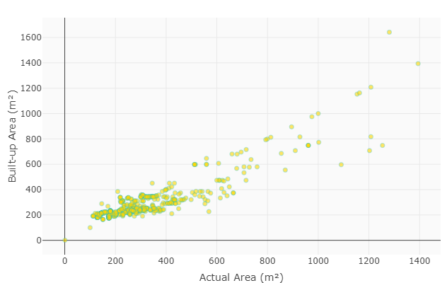
Fig. 7. Built-up Area vs. Actual Area

The scatter plot shows a strong positive correlation between the built-up area and the actual plot area. The clustering of points along a diagonal line confirms that the built-up area is a consistent and predictable proportion of the total land area for most villas.
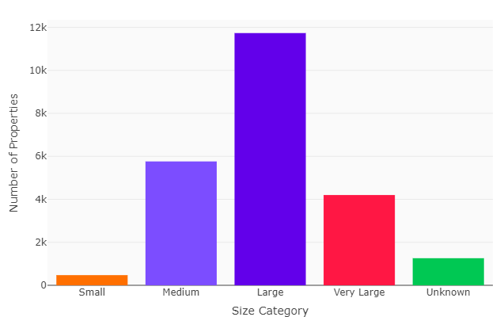
Fig. 8. Property Size Category

The chart shows the market is primarily composed of Medium and Large sized properties, with fewer in the "Small" and "Very Large" categories. This further reinforces the findings related to villa prevalence and room configurations.

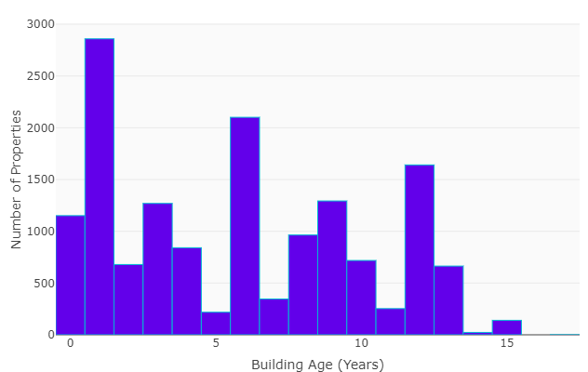
Fig. 9. Building Age Distribution

The histogram is one of the most revealing, showing that a very large proportion of Dubai's building stock is less than 10 years old, with a peak for very new buildings (0-5 years). This underscores the rapid and recent expansion of Dubai's urban fabric.

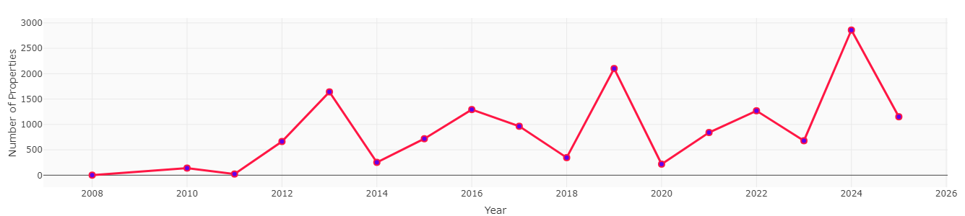
Fig. 10. Construction Trends Over Time

The plot shows the number of property registrations/completions by year. It reveals a dramatic surge in activity starting around 2014-2015, peaking just before 2020. The data indicates a strong recovery and continued high levels of activity post-2020, illustrating the market's resilience and growth trajectory.

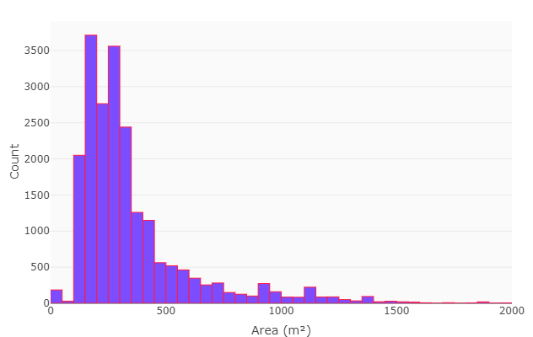
Fig. 11. Area Distribution

The histogram shows the distribution of property areas is right-skewed, with a high concentration of properties in the low to mid-range area (m²) and a long tail of increasingly larger, likely luxury, properties.

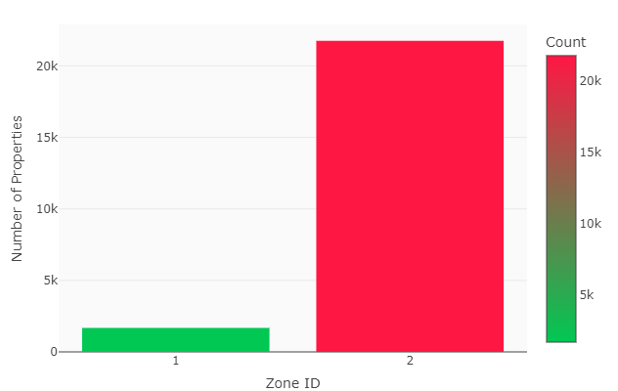
Fig. 12. Zone ID Distribution

The plot shows the distribution of properties across Zone IDs is highly skewed, with one zone (ID 1) containing a vastly larger number of properties than others, suggesting it is a major development hub.

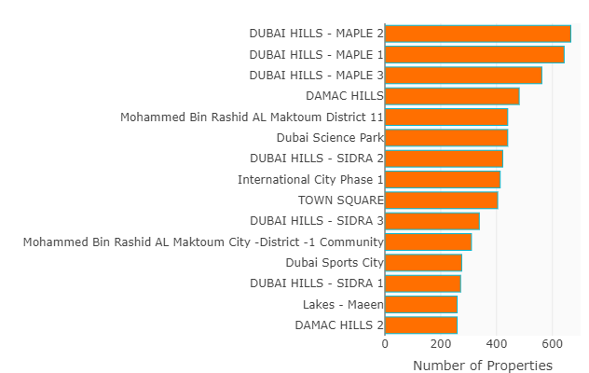
Fig. 13. Community Focus

The chart provides an extended view of prominent communities, reinforcing the significance of DUBAI HILLS (MAPLE 1, 2, 3), DAMAC HILLS, and Mohammed Bin Rashid Al Maktoum City in the current market supply.

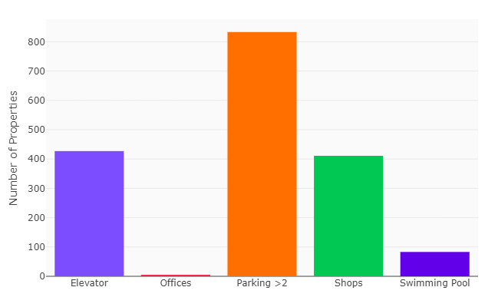
Fig. 14. Ammenity Focus

The plot provides a consolidated view of the prevalence of key amenities like Elevators, Offices, ample Parking, Shops, and Swimming Pools across the property portfolio.

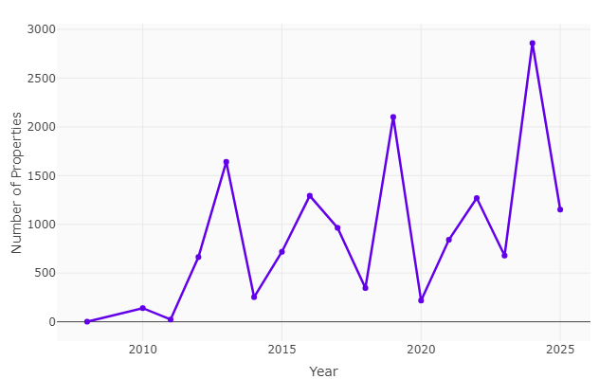
Fig. 15. Construction Timeline

The plot offers an alternative view of the construction timeline, clearly showing the low level of activity prior to 2010 and the steep growth curve that followed.

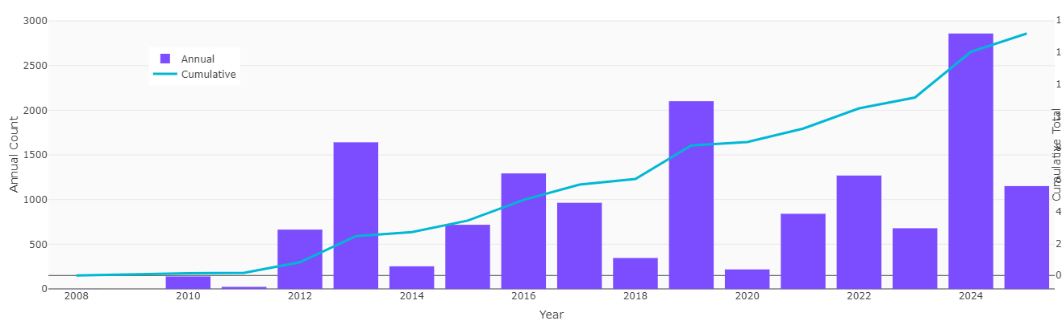
Fig. 16. Yearly Registration Trend

The plot is a combination of a boxplot and scatter points, showing the number of levels (floors) in buildings. Most buildings are clustered together at the bottom of the scale. This shows most villa-type properties are more prominent in Dubai.

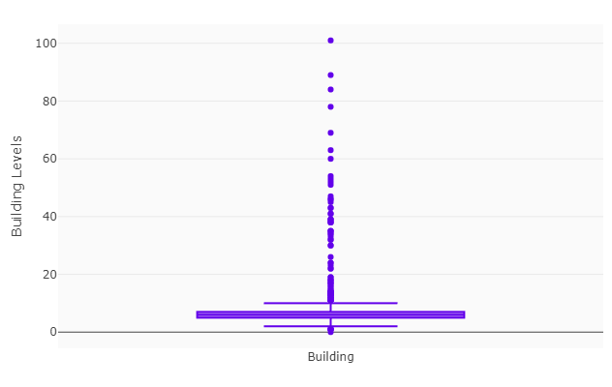

Fig. 17. Building Levels

The plot is a combination of a boxplot and scatter points, showing the number of levels (floors) in buildings. Most buildings are clustered together at the bottom of the scale. This shows most villa-type properties are more prominent in Dubai.

4. Decision Support System (DSS)

This RShiny-based visual analytics application serves as an advanced Decision Support System (DSS) tailored for various participants in the Dubai real estate sector. By automating the processes of data ingestion, processing, and visualization, it converts a complex public dataset into actionable intelligence for its users.
For real estate investors and developers, the DSS provides essential market insights, underscoring the prevalence of villas and highlighting rapidly developing neighborhoods such as "The Valley" and "Dubai Hills." The application also analyzes amenities, determining competitive standards, such as the necessity for two parking spaces and pools, thereby guiding investment and development efforts.
Urban planners and governmental bodies benefit from macro-level insights that are crucial for effective strategic planning. Geographical distribution maps illustrate areas in need of improved infrastructure, transportation, and public services. Additionally, the construction trend analyses are pivotal for tracking market cycles, anticipating future supply, and facilitating the sustainable distribution of resources.

End-users, including buyers and tenants, gain a transparent understanding of the market landscape. The application clarifies what is available, primarily focusing on modern, medium-to-large villas situated within master-planned communities that boast high-quality amenities.
The DSS's interactive features foster a cyclical approach to inquiry and testing, allowing users to filter data by district, community, or size, and to address specific queries. A standout feature of the system is its automated report generation capability, which enables professionals to efficiently compile their findings into polished PDF reports, thus enhancing communication and collaboration among teams. Overall, this project exemplifies how a well-structured DSS can connect open data to strategic decision-making, ultimately fostering a more informed and transparent real estate market in Dubai.

5. Conclusion
This project developed an automated visual analytics system for exploring Dubai's real estate portfolio by leveraging the open DLD dataset and the RShiny framework. The system integrates automated data processing, interactive visualization, and one-click report generation, which allows non-technical users to engage in complex market analysis. Key findings highlight that villa properties dominate the market, making up 95.3% of the portfolio, with significant development mainly in master-planned communities on the city's outskirts. The analysis also reveals a youthful building stock, attributed to a significant construction surge in the last decade, and a high standard of living, indicated by the prevalence of multiple parking spaces and amenities like swimming pools and elevators. The innovative use of R and its visualization packages have allowed for the creation of a robust analytical platform. This project represents a pivotal advancement in democratizing data access in real estate, facilitating informed investment decisions, strategic planning, and comprehensive market analysis. The system provides a clear, data-driven overview of Dubai's urban landscape, enhancing the understanding of this vibrant real estate market.

6. Acknowledgment
I extend my heartfelt gratitude to everyone involved in the successful completion of this capstone project. I especially thank my instructor, Dr. Gurdal Ertek, and the academic advisors for their invaluable guidance and support in developing the automated visual analytics system. Their expertise in data analytics and fraud detection greatly enriched the work. I also appreciate the Department of Statistics and Business Analytics for providing essential resources and a supportive learning environment, critical for our project’s foundation during the STAT482 Capstone in Analytics for Business course.
We are profoundly grateful to the Government of Dubai and the Dubai Land Department (DLD) for their commitment to transparency and open data by making the "DLD Buildings - Open" dataset publicly available on the Dubai Pulse portal. This initiative is instrumental for research and informed decision-making within the emirate.
Additionally, I acknowledge the support of my family and friends, whose patience and encouragement were invaluable during the intense research and analysis phases. This project not only marks the end of our academic journey in the analytics program but also highlights the collaborative efforts of all contributors. This project highlights the potential of leveraging open data to generate meaningful insights and I am genuinely thankful for the chance to contribute to a deeper understanding of the Dubai real estate market.

