Business Analytics Case Study
Bank Marketing Campaign Analysis
Analyst Lab Africa Internship Program — Week 5

1. Introduction
Direct marketing campaigns, phone calls made to offer a product such as a term deposit are a major cost center for banks, and their effectiveness varies widely across customer segments. Understanding which customers are most likely to respond positively allows a bank to focus its resources where they generate the most value, rather than contacting customers indiscriminately. This report analyzes a dataset of 11,162 bank marketing contacts to identify what distinguishes customers who subscribed to a term deposit from those who did not, and to recommend how future campaigns should be targeted.

2. Business Problem Statement
The bank in this dataset runs phone-based marketing campaigns to sell term deposits, but only 47.4% of contacted customers ultimately subscribe. Every unsuccessful call represents wasted staff time and campaign cost, while every successful one generates new deposit revenue. The business needs to understand why some customers subscribe while others do not, and which customer groups are most likely to respond positively to future campaigns. Answering this allows the bank to prioritize its calling lists and campaign strategy toward the segments most likely to convert.

3. Dataset Description
The dataset contains 11,162 records and 17 columns, based on the direct marketing campaigns of a Portuguese banking institution (Kaggle Bank Marketing dataset). Each row represents one customer contact, with fields covering:
- Demographics: age, job, marital status, education
- Financial profile: default status, account balance, housing loan, personal loan
- Campaign contact details: contact type, day and month of last contact, call duration, number of contacts in this campaign
- Previous campaign history: days since last contact, number of previous contacts, outcome of previous campaign
- Target variable: deposit (yes/no — did the customer subscribe to a term deposit)
No duplicate records or genuinely missing values were found. Two data points needed careful interpretation rather than cleaning: the balance column includes legitimate negative values (customers who were overdrawn), and pdays uses -1 as a placeholder meaning the customer was never contacted in a prior campaign, not an actual day count. Both were kept as its with this context noted.

4. Data Analysis Process

4.1 Dataset Overview
The dataset shows an average customer age of 41.2 years, average account balance of $1,528.54, and average call duration of 372 seconds. The target variable is fairly balanced: 52.6% did not subscribe and 47.4% did, giving a healthy comparison group for analysis.

4.2 Target Variable Distribution
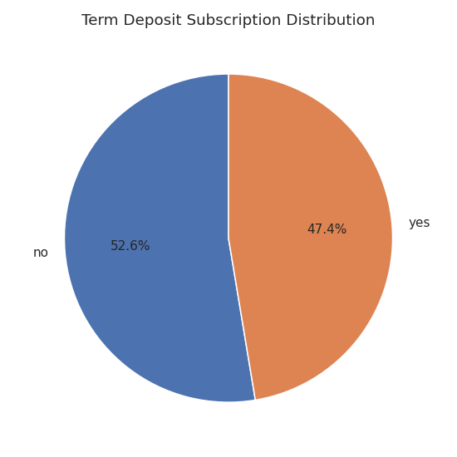
Figure 1: Subscription outcome — 47.4% of contacted customers subscribed to a term deposit.

4.3 Subscription by Job Type
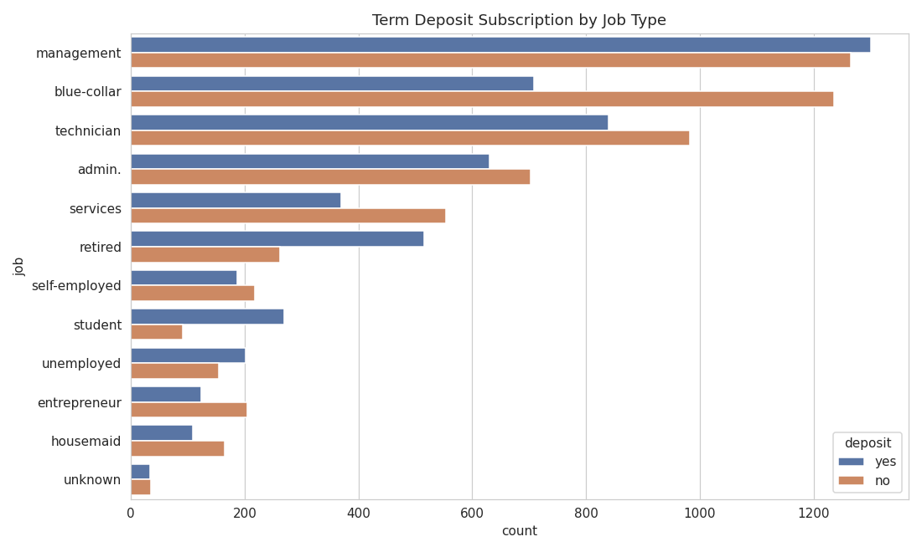
Figure 2: Students and retirees subscribe at much higher rates than blue-collar or technician customers.

4.4 Age Distribution by Subscription
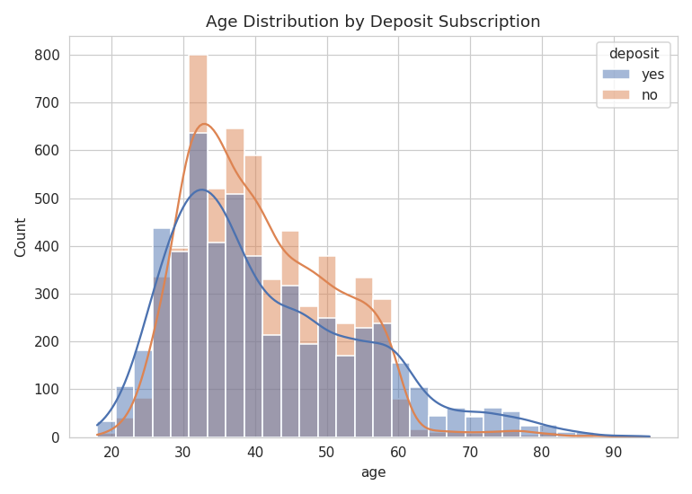
Figure 3: Subscribers skew toward younger (under 30) and older (60+) age groups.

4.5 Account Balance by Subscription
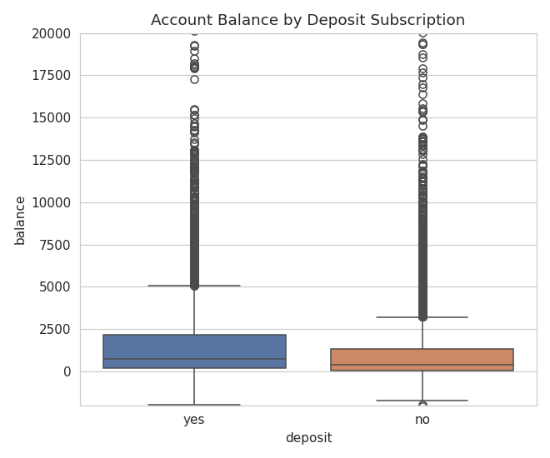
Figure 4: Subscribers tend to carry somewhat higher account balances, though the difference is moderate.

4.6 Correlation Heatmap
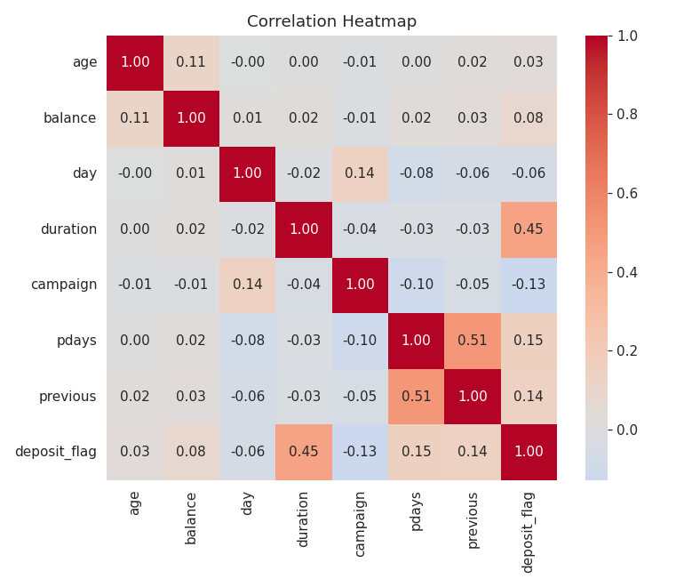
Figure 5: Call duration shows the strongest correlation with subscription (0.45) among numeric variables.

5. Key Findings
Driver | Finding
Job type | Student: 74.7% subscribe, Retired: 66.3% vs Blue-collar: 36.4%, Entrepreneur: 37.5%
Previous campaign outcome | Prior success: 91.3% subscribe again vs Unknown/no history: 40.7%
Contact method | Cellular: 54.3% vs Unknown contact method: 22.6%
Account balance | Subscribers average $1,804.3 vs $1,280.2 for non-subscribers
Call duration | Subscribers average 537.3 seconds vs 223.1 seconds for non-subscribers
Age | Subscription is highest among under-30 and over-60 customers; lowest in the 30-50 working-age range

6. Business Insights
Taken together, these findings point to a clear profile of the customer most likely to subscribe, and to what happens during a successful call:
- Call engagement is the single strongest signal of success. Customers who eventually subscribed were on the phone more than twice as long on average as those who did not (537 vs 223 seconds). This suggests that once an agent can hold a customer's attention long enough to explain the product, conversion odds rise sharply making call quality and agent training a high-leverage investment.
- Life stage matters more than raw job prestige. Students and retirees customers with more flexible finances or long investment horizons subscribe at the highest rates, while working-age professionals in demanding jobs (blue-collar, technician) subscribe the least, likely due to time pressure or existing financial commitments.
- Past success predicts future success dramatically. Customers who subscribed to a previous campaign convert again at 91.3%, more than double the rate of customers with no prior campaign history. This is the strongest single lever the bank has for improving campaign ROI.
- Cellular contact outperforms unknown/other methods. Customers reached via cellphone subscribe at more than double the rate of those with an unknown or unlogged contact method, suggesting a real opportunity in contact data quality.
- Financial comfort provides a modest edge. Subscribers carry higher balances on average, indicating that customers with more disposable savings are somewhat more receptive to a term deposit offer, though this is a weaker predictor than call engagement or job type.

7. Recommendations
- Prioritise past campaign responders. Build a fast-follow campaign that re-contacts customers who subscribed previously, given their 91.3% re-subscription rate, this is the highest-return segment in the entire dataset.
- Target students and retirees specifically. Design messaging and offers tailored to these life stages (e.g., a starter savings product for students, a stable-income deposit product for retirees) rather than a one-size-fits-all pitch.
- Invest in agent training to extend meaningful call time. Since call duration correlates strongly with conversion, train agents to build rapport and thoroughly explain benefits rather than rushing through a script, and consider call-quality coaching for underperforming agents.
- Improve contact data quality. Prioritize acquiring verified cellular numbers over unknown contact methods, since unknown-method contacts convert at less than half the rate of cellular contacts.
- De-prioritize low-yield segments during high-volume periods. When campaign capacity is limited, deprioritize blue-collar and entrepreneur segments in favor of higher-converting groups, without excluding them entirely from future campaigns.

8. Conclusion
This analysis shows that term deposit subscription is far from random. It is shaped by identifiable factors including job type, age, prior campaign history, and especially the quality of the customer's phone engagement. By concentrating outreach on past responders, tailoring messaging by life stage, and investing in call quality, the bank can meaningfully improve on its current 47.4% subscription rate and generate a stronger return from its marketing spend.

