ASSIGNEMENT

Name: Aravind Menon

QUESTION 1

1. IBM.COM

(base) Aravind-MacBook-Air:~ aravind$ nslookup

> set type=mx

> IBM.com

Server: 59.179.243.70

Address: 59.179.243.70#53

Non-authoritative answer:

IBM.com mail exchanger = 5 mx0a-001b2d01.pphosted.com.

IBM.com mail exchanger = 5 mx0b-001b2d01.pphosted.com.

1. WIPRO.COM

(base) Aravind-MacBook-Air:~ aravind$ nslookup

> set type=mx

> wipro.com

Server: 59.179.243.70

Address: 59.179.243.70#53

Non-authoritative answer:

wipro.com mail exchanger = 0 wipro-com.mail.protection.outlook.com.

QUESTION 2

1. IBM.com

LOCATION : Denver, Colorado, USA.

1. WIPRO.com

LOCATION : Redmond, us.

QUESTION 3

**Scan and find out port numbers open 203.163.246.23**

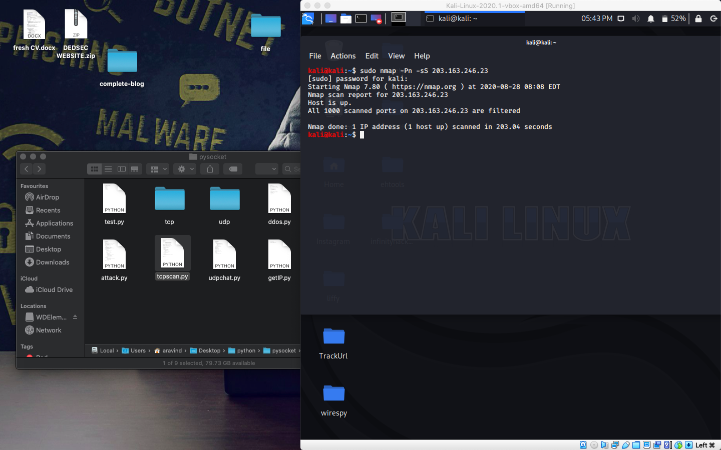

QUESTION 4

Install Nessus in a VM and scan your laptop/desktop for CVE.

* Critical
* High
* Medium
* Low
* Info

