**Q1. Delete array element at begining and From any position**

void printarr(int arr[],int sizearr){

for(int i=0; i<sizearr; i++){

printf("%d ",arr[i]);

}

printf("\n");

}

void deleteatstart(int arr[],int *sizee){

for(int i=0; i<*sizee; i++){

arr[i]=arr[i+1];

}

*sizee = *sizee-1;

printf("After delete at start \n");

printarr(arr,*sizee);

}

void deleteatposition(int arr[],int *sizee,int cap){

printf("Enter the position \n");

int pos;

scanf("%d",&pos);

pos--;

if(pos > cap || pos > *sizee-1){

printf("Invalid position \n");

}else{

for(int i=pos; i<*sizee-1; i++){

arr[i]=arr[i+1];

}

*sizee = *sizee-1;

printf("After delete at specific position \n");

printarr(arr,*sizee);

}

}

int main(){

int arr[50];

int capacity = 50;

printf("How many number u want to enter \n");

int arrsize; cin>>arrsize;

for(int i=0; i<arrsize; i++){

printf("Enter the number \n");

scanf("%d",&arr[i]);

}

deleteatposition(arr,&arrsize,capacity);

}

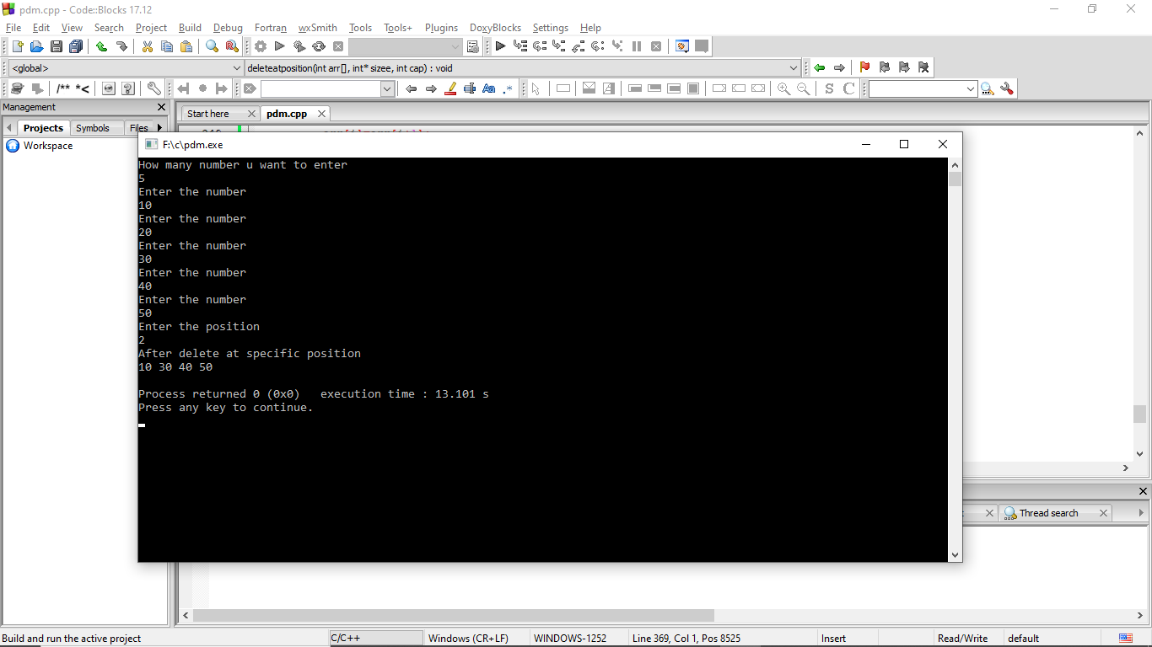 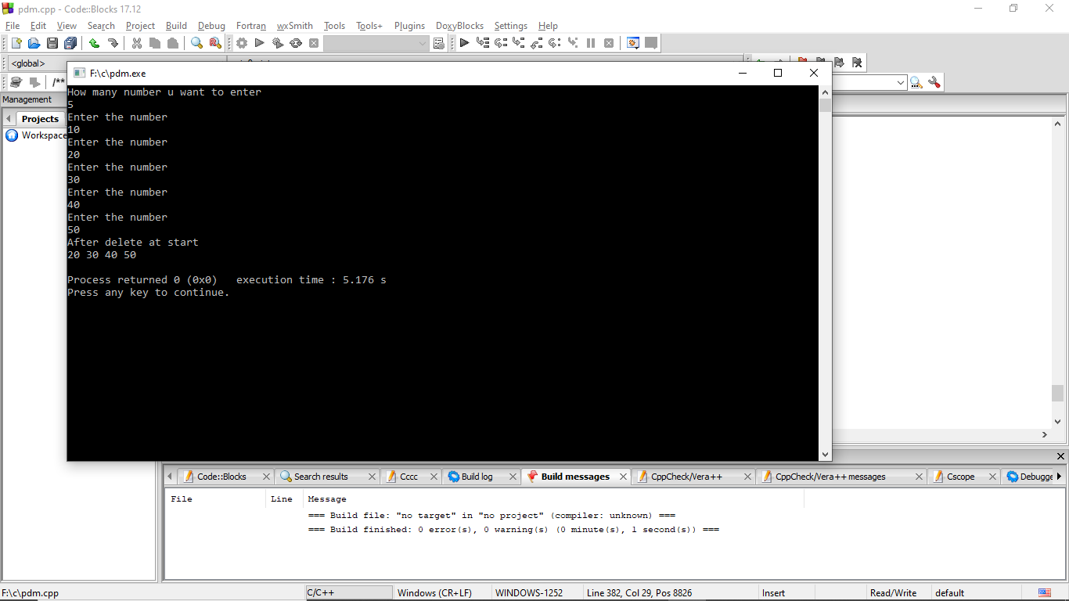

**Q2. Wap to print array after k rotation towards left.**

void printarr(int arr[],int sizearr){

for(int i=0; i<sizearr; i++){

printf("%d ",arr[i]);

}

printf("\n");

}

void leftRotate(int arr[], int d, int n)

{

for (int i = 0; i < d; i++){

int temp=arr[0],k;

for(k=0; k<n-1; k++){

arr[k] = arr[k+1];

}

arr[k] = temp;

}

}

int main()

{

int arr[] = { 1, 2, 3, 4, 5, 6, 7 };

printf("How many time you rotate: \n");

int rotate;

scanf("%d",&rotate);

printf("before rotate \n");

printarr(arr, 7);

leftRotate(arr, rotate, 7);

printf("After rotate \n");

printarr(arr, 7);

return 0;

}

