**SECTION 1**

* **SQL script that creates and populates your tables saved as an sql script file (this is a simple text file with a .sql extention). Upload to GitHub. 8 points**

* **Copy the script in your report. 2 points**

**Answer:**

**CREATE TABLE `brand` (**

**`Brand_id` VARCHAR(50) NULL DEFAULT NULL,**

**`Brand_name` VARCHAR(50) NULL DEFAULT NULL,**

**`quantity` FLOAT NULL DEFAULT NULL,**

**`price` FLOAT NULL DEFAULT NULL**

**)**

**COLLATE='latin1_swedish_ci'**

**;**

**SELECT `DEFAULT_COLLATION_NAME` FROM `information_schema`.`SCHEMATA` WHERE `SCHEMA_NAME`='glosary';**

**SHOW TABLE STATUS FROM `glosary`;**

**SHOW FUNCTION STATUS WHERE `Db`='glosary';**

**SHOW PROCEDURE STATUS WHERE `Db`='glosary';**

**SHOW TRIGGERS FROM `glosary`;**

**SELECT *, EVENT_SCHEMA AS `Db`, EVENT_NAME AS `Name` FROM information_schema.`EVENTS` WHERE `EVENT_SCHEMA`='glosary';**

**SELECT * FROM `information_schema`.`COLUMNS` WHERE TABLE_SCHEMA='glosary' AND TABLE_NAME='brand' ORDER BY ORDINAL_POSITION;**

**SHOW INDEXES FROM `brand` FROM `glosary`;**

**SELECT * FROM information_schema.REFERENTIAL_CONSTRAINTS WHERE CONSTRAINT_SCHEMA='glosary' AND TABLE_NAME='brand' AND REFERENCED_TABLE_NAME IS NOT NULL;**

**SELECT * FROM information_schema.KEY_COLUMN_USAGE WHERE TABLE_SCHEMA='glosary' AND TABLE_NAME='brand' AND REFERENCED_TABLE_NAME IS NOT NULL;**

**/* Entering session "Unnamed-1" */**

**SHOW CREATE TABLE `glosary`.`brand`;**

**SELECT CONSTRAINT_NAME, CHECK_CLAUSE FROM `information_schema`.`CHECK_CONSTRAINTS` WHERE CONSTRAINT_SCHEMA='glosary' AND TABLE_NAME='brand';**

**LOAD DATA LOW_PRIORITY LOCAL INFILE 'C:\\Users\\rupan\\OneDrive\\Desktop\\brand.csv' REPLACE INTO TABLE `glosary`.`brand` CHARACTER SET latin1 FIELDS TERMINATED BY ',' OPTIONALLY ENCLOSED BY ',' ESCAPED BY ',' LINES TERMINATED BY '\r\n' IGNORE 1 LINES (`Brand_id`, `Brand_name`, `quantity`, `price`);**

**CREATE TABLE `category` (**

**`Category_id` VARCHAR(50) NULL DEFAULT NULL,**

**`Category_name` VARCHAR(50) NULL DEFAULT NULL,**

**`quantity` FLOAT NULL DEFAULT NULL**

**)**

**COLLATE='latin1_swedish_ci'**

**;**

**SELECT `DEFAULT_COLLATION_NAME` FROM `information_schema`.`SCHEMATA` WHERE `SCHEMA_NAME`='glosary';**

**SHOW TABLE STATUS FROM `glosary`;**

**SHOW FUNCTION STATUS WHERE `Db`='glosary';**

**SHOW PROCEDURE STATUS WHERE `Db`='glosary';**

**SHOW TRIGGERS FROM `glosary`;**

**SELECT *, EVENT_SCHEMA AS `Db`, EVENT_NAME AS `Name` FROM information_schema.`EVENTS` WHERE `EVENT_SCHEMA`='glosary';**

**SELECT * FROM `information_schema`.`COLUMNS` WHERE TABLE_SCHEMA='glosary' AND TABLE_NAME='category' ORDER BY ORDINAL_POSITION;**

**SHOW INDEXES FROM `category` FROM `glosary`;**

**SELECT * FROM information_schema.REFERENTIAL_CONSTRAINTS WHERE CONSTRAINT_SCHEMA='glosary' AND TABLE_NAME='category' AND REFERENCED_TABLE_NAME IS NOT NULL;**

**SELECT * FROM information_schema.KEY_COLUMN_USAGE WHERE TABLE_SCHEMA='glosary' AND TABLE_NAME='category' AND REFERENCED_TABLE_NAME IS NOT NULL;**

**/* Entering session "Unnamed-1" */**

**SHOW CREATE TABLE `glosary`.`category`;**

**SELECT CONSTRAINT_NAME, CHECK_CLAUSE FROM `information_schema`.`CHECK_CONSTRAINTS` WHERE CONSTRAINT_SCHEMA='glosary' AND TABLE_NAME='category';**

**LOAD DATA LOW_PRIORITY LOCAL INFILE 'C:\\Users\\rupan\\OneDrive\\Desktop\\category.csv' REPLACE INTO TABLE `glosary`.`category` CHARACTER SET latin1 FIELDS TERMINATED BY ',' OPTIONALLY ENCLOSED BY ',' ESCAPED BY ',' LINES TERMINATED BY '\r\n' IGNORE 1 LINES (`Category_id`, `Category_name`, `quantity`);**

**CREATE TABLE `Customer_details` (**

**`customer_id` VARCHAR(50) NULL DEFAULT NULL,**

**`customer_name` VARCHAR(50) NULL DEFAULT NULL,**

**`customer_address` VARCHAR(50) NULL DEFAULT NULL,**

**`phone_number` VARCHAR(50) NULL DEFAULT NULL**

**)**

**COLLATE='latin1_swedish_ci'**

**;**

**SELECT `DEFAULT_COLLATION_NAME` FROM `information_schema`.`SCHEMATA` WHERE `SCHEMA_NAME`='glosary';**

**SHOW TABLE STATUS FROM `glosary`;**

**SHOW FUNCTION STATUS WHERE `Db`='glosary';**

**SHOW PROCEDURE STATUS WHERE `Db`='glosary';**

**SHOW TRIGGERS FROM `glosary`;**

**SELECT *, EVENT_SCHEMA AS `Db`, EVENT_NAME AS `Name` FROM information_schema.`EVENTS` WHERE `EVENT_SCHEMA`='glosary';**

**LOAD DATA LOW_PRIORITY LOCAL INFILE 'C:\\Users\\rupan\\OneDrive\\Desktop\\Customer_details.csv' REPLACE INTO TABLE `glosary`.`customer_details` CHARACTER SET latin1 FIELDS TERMINATED BY ',' OPTIONALLY ENCLOSED BY ',' ESCAPED BY ',' LINES TERMINATED BY '\r\n' IGNORE 1 LINES (`customer_id`, `customer_name`, `customer_address`, `phone_number`);**

**CREATE TABLE `Glosary_items` (**

**`item_id` VARCHAR(50) NULL DEFAULT NULL,**

**`stock` VARCHAR(50) NULL DEFAULT NULL,**

**`quantity` INT(20) NULL DEFAULT NULL,**

**`price` INT(20) NULL DEFAULT NULL**

**)**

**COLLATE='latin1_swedish_ci'**

**;**

**SELECT `DEFAULT_COLLATION_NAME` FROM `information_schema`.`SCHEMATA` WHERE `SCHEMA_NAME`='glosary';**

**SHOW TABLE STATUS FROM `glosary`;**

**SHOW FUNCTION STATUS WHERE `Db`='glosary';**

**SHOW PROCEDURE STATUS WHERE `Db`='glosary';**

**SHOW TRIGGERS FROM `glosary`;**

**SELECT *, EVENT_SCHEMA AS `Db`, EVENT_NAME AS `Name` FROM information_schema.`EVENTS` WHERE `EVENT_SCHEMA`='glosary';**

**LOAD DATA LOW_PRIORITY LOCAL INFILE 'C:\\Users\\rupan\\OneDrive\\Desktop\\Glosary_items.csv' REPLACE INTO TABLE `glosary`.`glosary_items` CHARACTER SET latin1 FIELDS TERMINATED BY ',' OPTIONALLY ENCLOSED BY ',' ESCAPED BY ',' LINES TERMINATED BY '\r\n' IGNORE 1 LINES (`item_id`, `stock`, `quantity`, `price`);**

**CREATE TABLE `store` (**

**`Store_id` VARCHAR(50) NULL DEFAULT NULL,**

**`Store_name` VARCHAR(50) NULL DEFAULT NULL,**

**`Total_order` INT NULL**

**)**

**COLLATE='latin1_swedish_ci'**

**;**

**SELECT `DEFAULT_COLLATION_NAME` FROM `information_schema`.`SCHEMATA` WHERE `SCHEMA_NAME`='glosary';**

**SHOW TABLE STATUS FROM `glosary`;**

**SHOW FUNCTION STATUS WHERE `Db`='glosary';**

**SHOW PROCEDURE STATUS WHERE `Db`='glosary';**

**SHOW TRIGGERS FROM `glosary`;**

**SELECT *, EVENT_SCHEMA AS `Db`, EVENT_NAME AS `Name` FROM information_schema.`EVENTS` WHERE `EVENT_SCHEMA`='glosary';**

**SELECT * FROM `information_schema`.`COLUMNS` WHERE TABLE_SCHEMA='glosary' AND TABLE_NAME='store' ORDER BY ORDINAL_POSITION;**

**SHOW INDEXES FROM `store` FROM `glosary`;**

**SELECT * FROM information_schema.REFERENTIAL_CONSTRAINTS WHERE CONSTRAINT_SCHEMA='glosary' AND TABLE_NAME='store' AND REFERENCED_TABLE_NAME IS NOT NULL;**

**SELECT * FROM information_schema.KEY_COLUMN_USAGE WHERE TABLE_SCHEMA='glosary' AND TABLE_NAME='store' AND REFERENCED_TABLE_NAME IS NOT NULL;**

**/* Entering session "Unnamed-1" */**

**SHOW CREATE TABLE `glosary`.`store`;**

**SELECT CONSTRAINT_NAME, CHECK_CLAUSE FROM `information_schema`.`CHECK_CONSTRAINTS` WHERE CONSTRAINT_SCHEMA='glosary' AND TABLE_NAME='store';**

**LOAD DATA LOW_PRIORITY LOCAL INFILE 'C:\\Users\\rupan\\OneDrive\\Desktop\\store.csv' REPLACE INTO TABLE `glosary`.`store` CHARACTER SET latin1 FIELDS TERMINATED BY ',' OPTIONALLY ENCLOSED BY ',' ESCAPED BY ',' LINES TERMINATED BY '\r\n' IGNORE 1 LINES (`Store_id`, `Store_name`, `Total_order`);**

* **Screenshots of your populated tables with at least three records from your data files: 10 points**The ‘before’ picture shows an empty table. If it helps, you can merge all images into one screen capture.

**Answer:**

**Table:1**

**SELECT * FROM brand;**

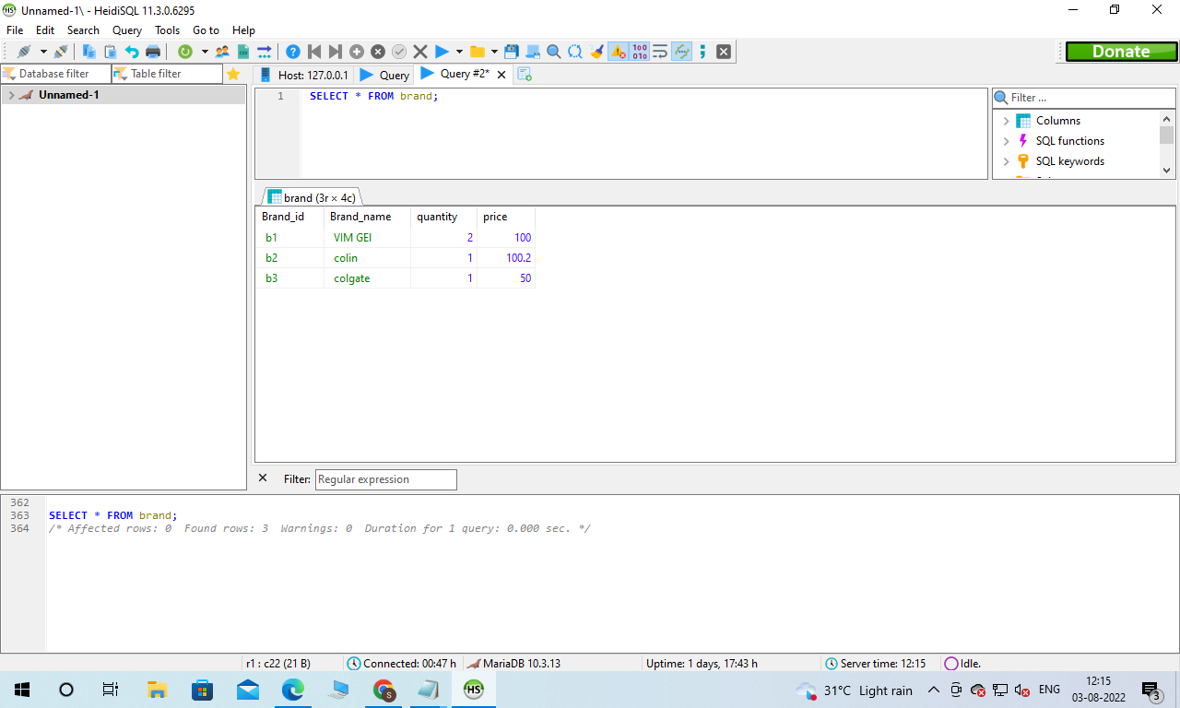

**SELECT * FROM category**

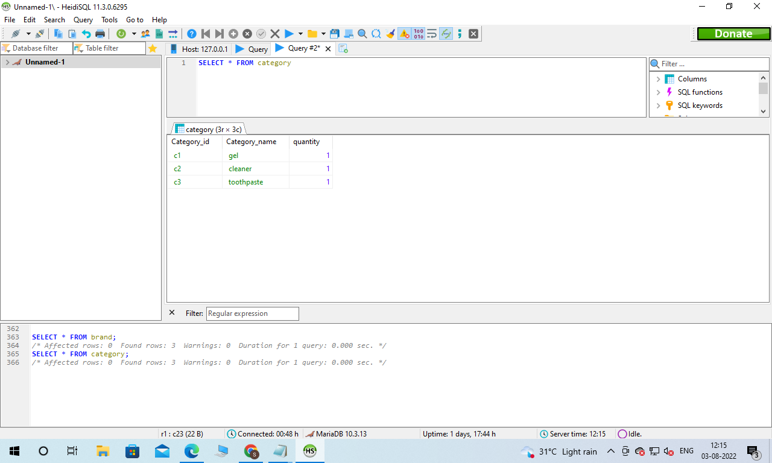

**SELECT * FROM customer_details**

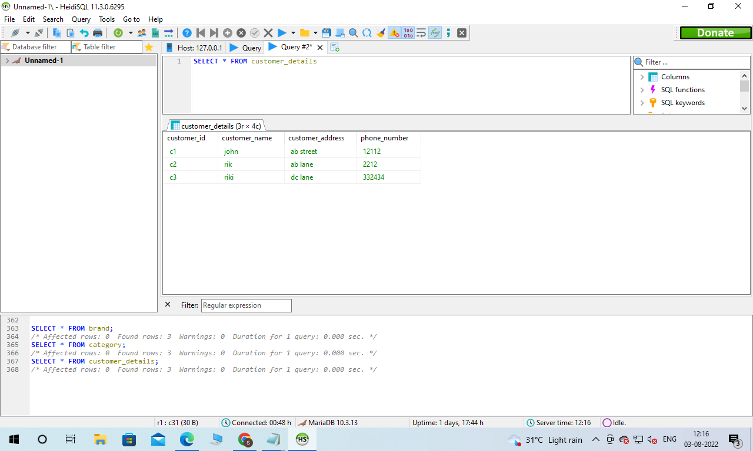

**SELECT * FROM glosary_items**

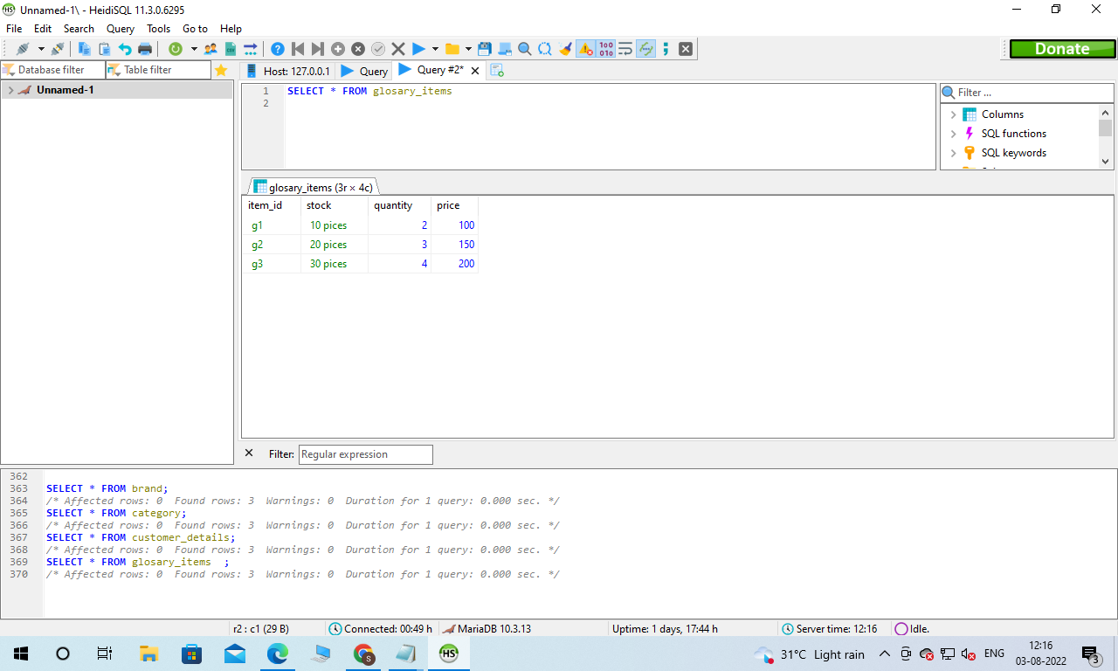

**SELECT * FROM store**

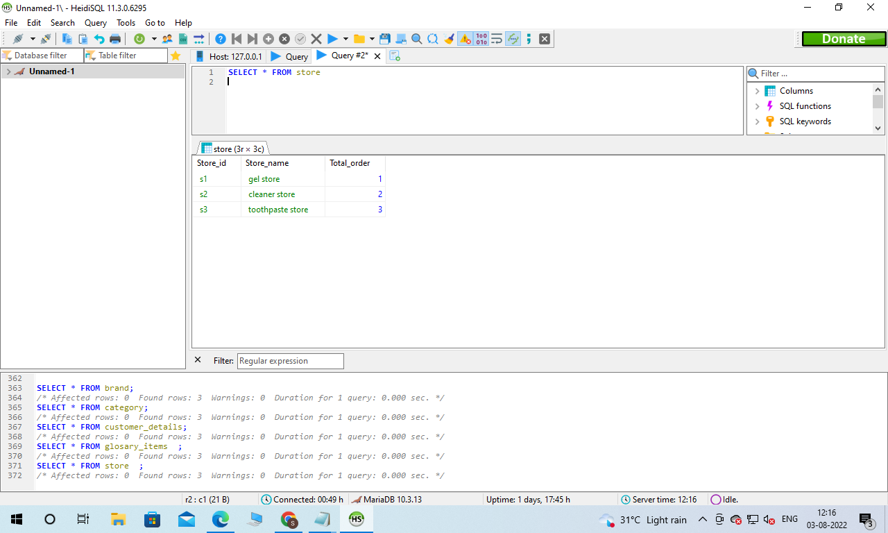

**SECTION 2**

**1 point for one insert statement**

**Answer:**

**INSERT INTO brand(brand_id,Brand_name,quantity,price)**

**VALUES('b4','detol',2,100)**

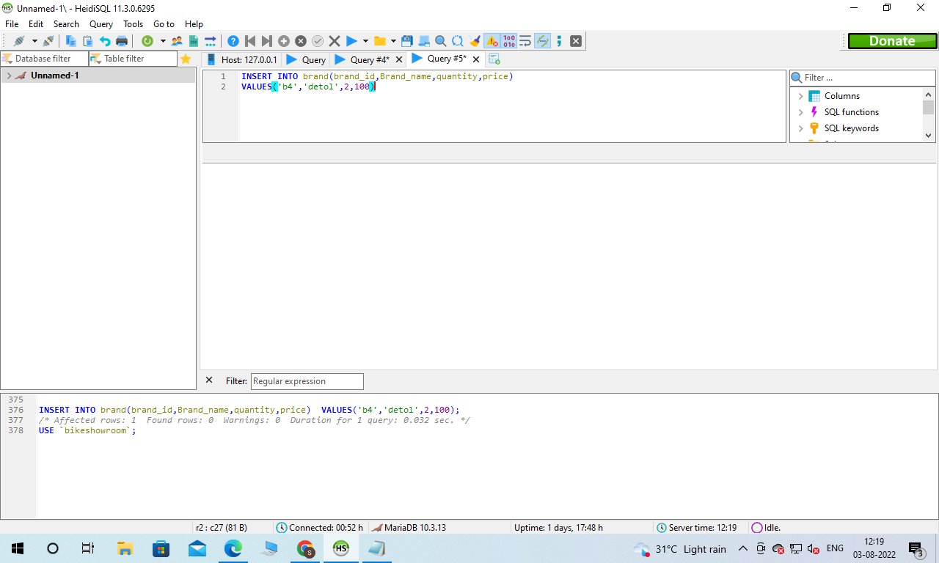

* 1 point for one update statement

**Answer:**

**UPDATE brand**

**SET Brand_name='savlon',quantity=5,price=250**

**WHERE brand_id='b4';**

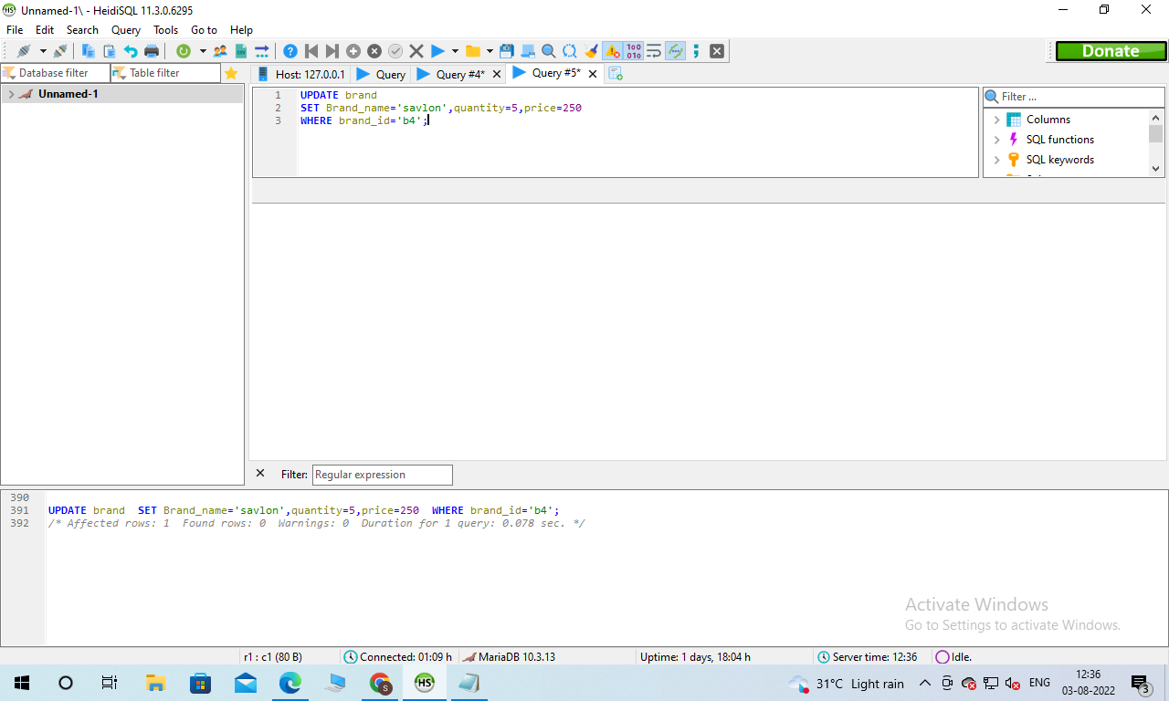

* 1 point for using the delete statement (1 pt)

**Answer:**

**DELETE FROM brand WHERE brand_id='b4';**

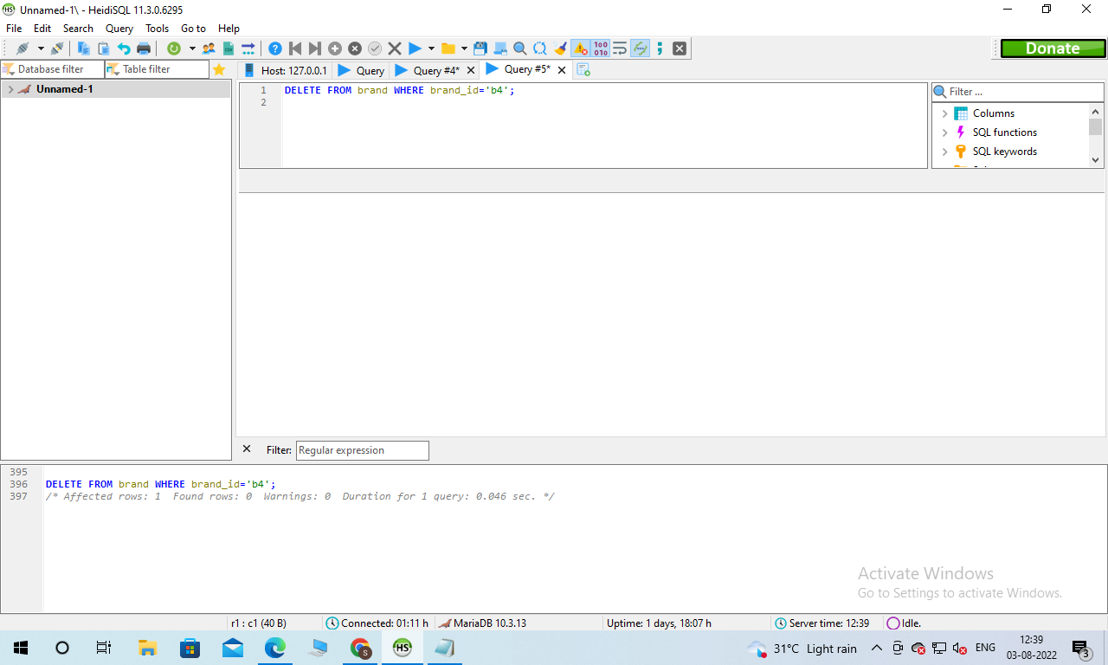

* 1 point for select with ORDER BY statement (1 pt)

**Answer:**

SELECT Brand_name, price

FROM brand

ORDER BY Brand_name, price ASC

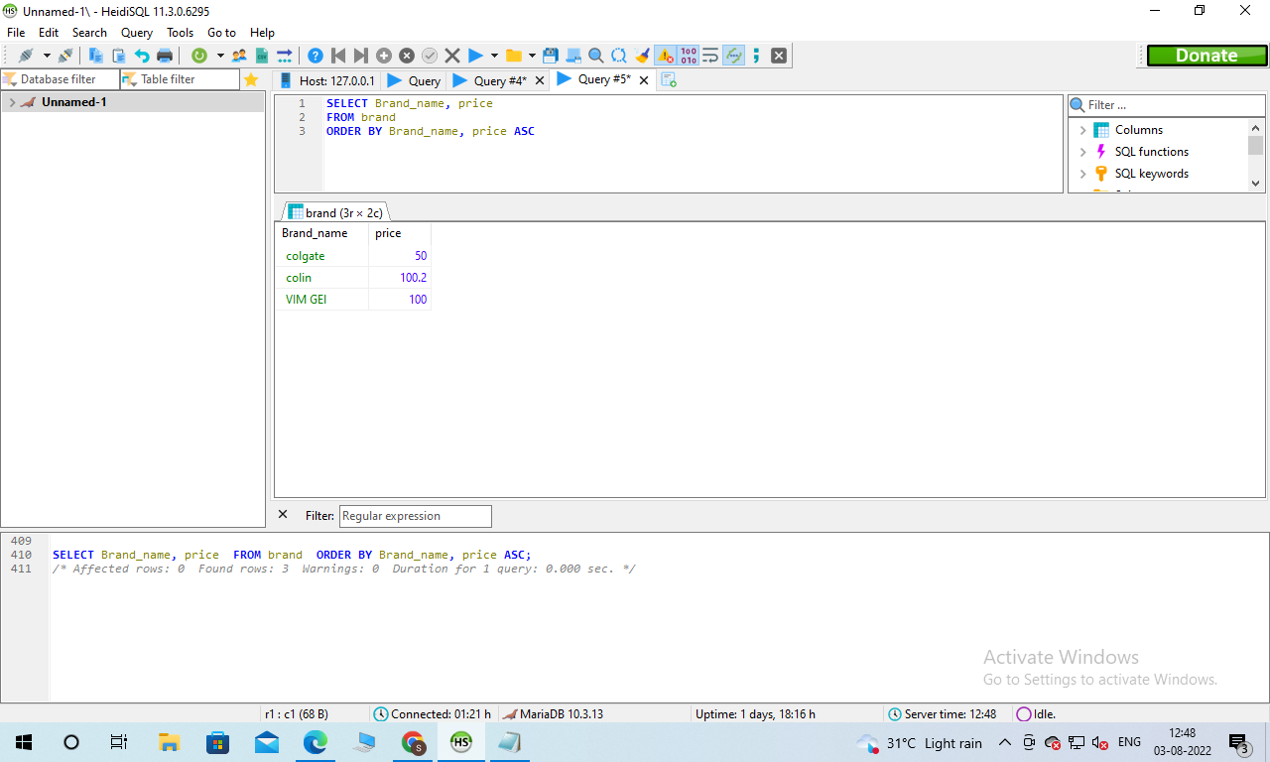

* 1 point for select with a filtering condition using ‘WHERE’

**Answer:**

**SELECT brand_name**

**FROM brand**

**WHERE brand_name='colgate';**

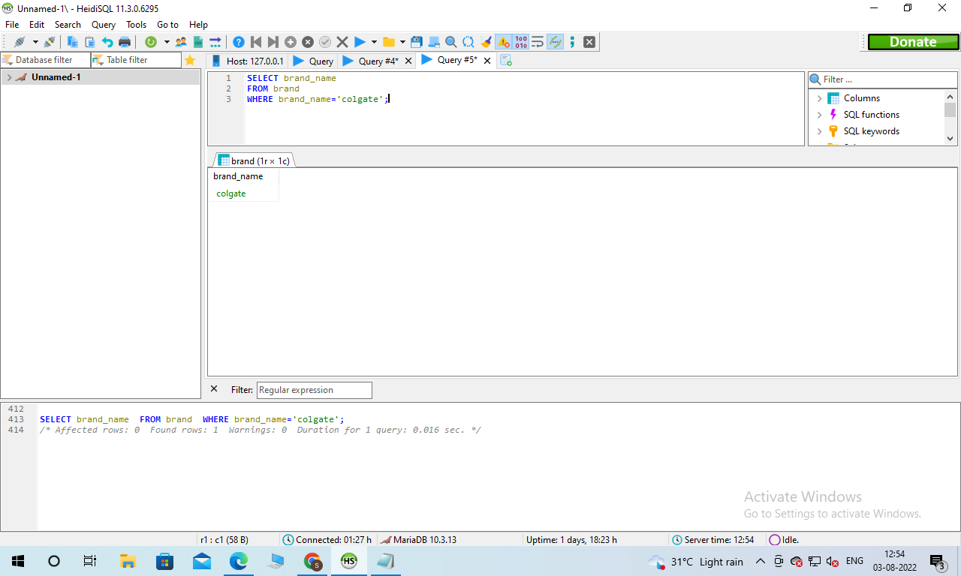

* 2 points for using the join statement

**Answer:**

**SELECT brand.Brand_id, Category_name, brand.Brand_name**

**FROM brand**

**INNER JOIN category ON brand.Brand_id=Category.Category_id;**

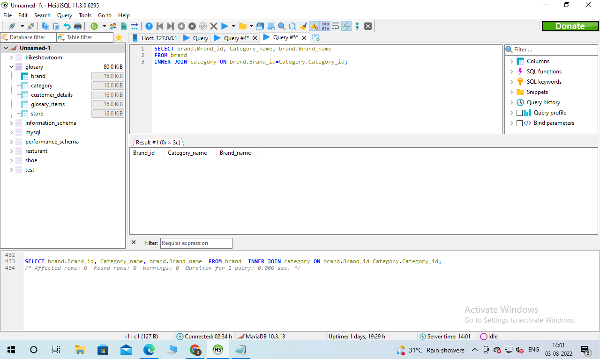

* 6 points each for three queries that use DIFFERENT summary statements (max, min, avg, count) (2 pts eachl)  
  You cannot use the same summary statement 3 times.

**Answer: SELECT MAX(Total_order)**

**FROM store**

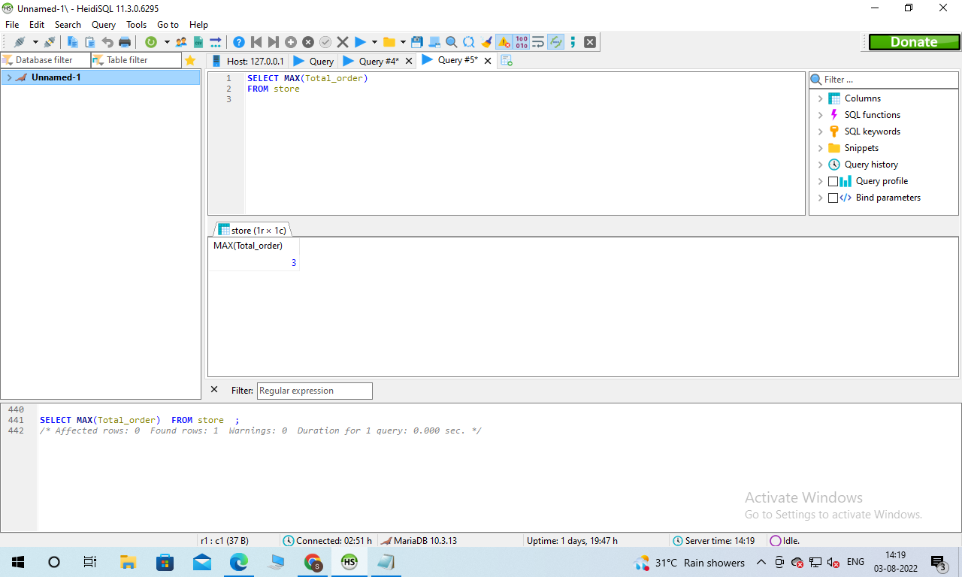

**SELECT MIN(price)**

**FROM glosary_items**

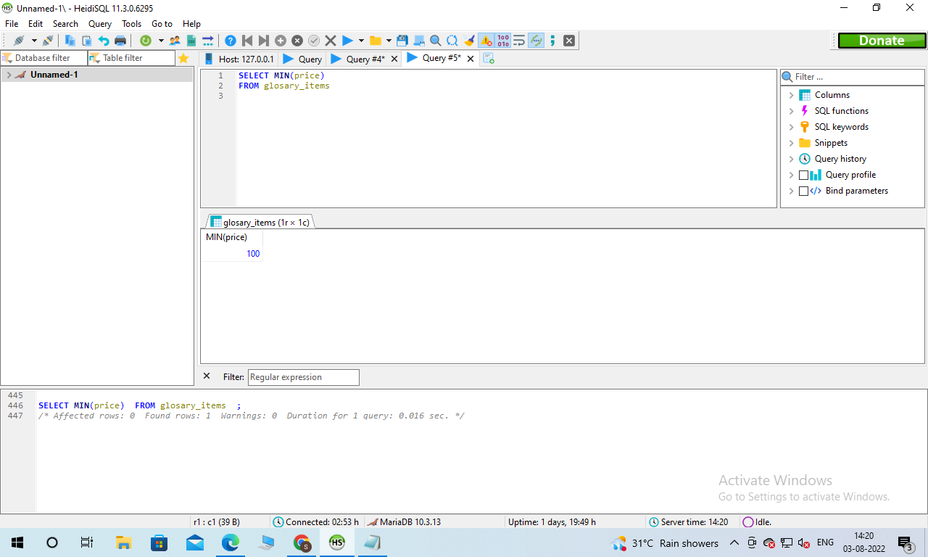

**SELECT AVG(price)**

**FROM brand**

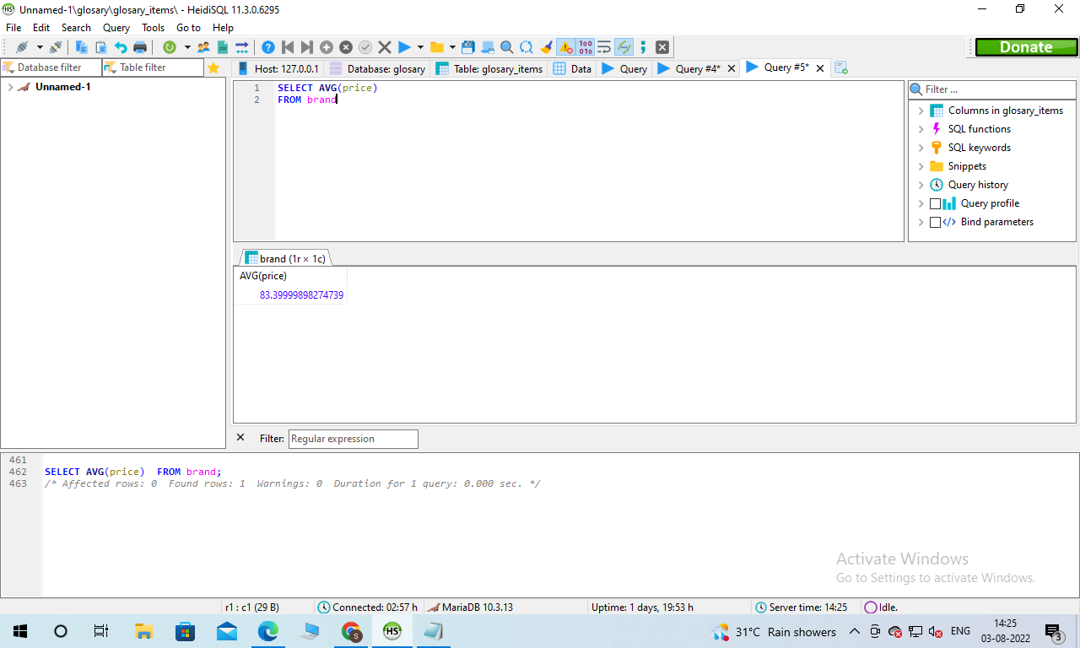

**SELECT COUNT(quantity)**

**FROM category**

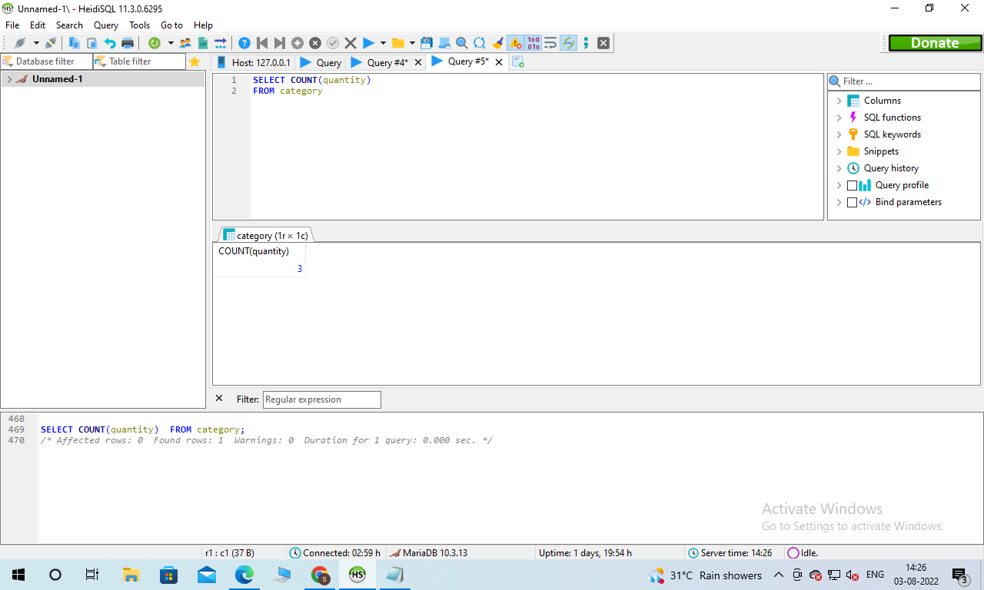

* 2 points for a multi-table query that uses an alias for the output (the ‘as’ keyword)

**Answer:**

SELECT stock AS glosary_stock

FROM glosary_items;

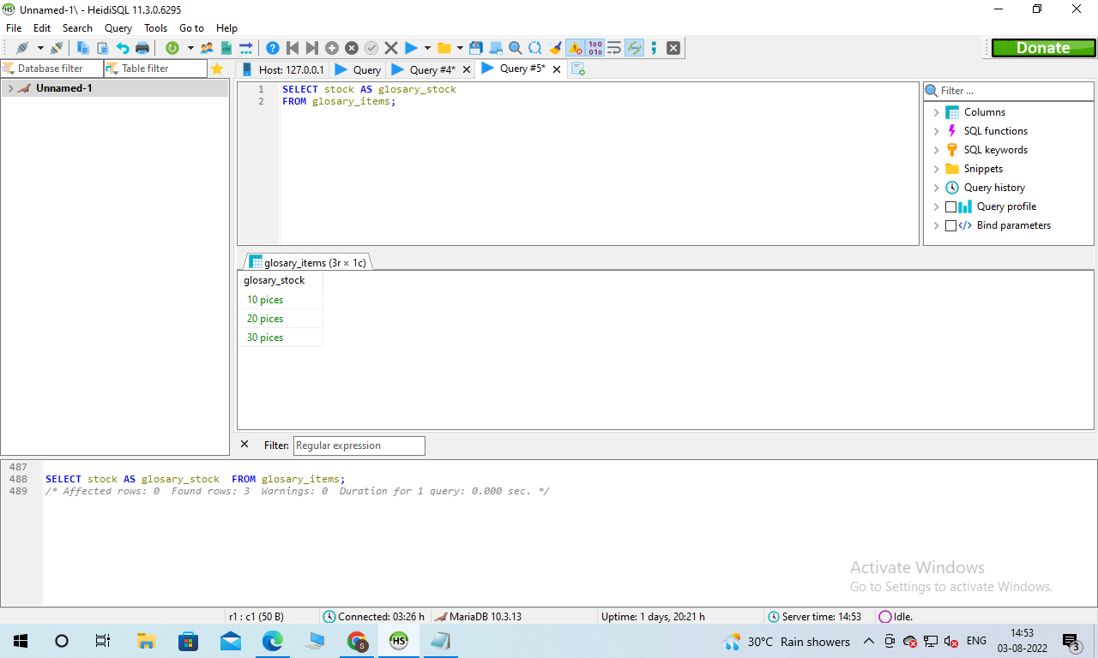

**SECTION 3 – 20 points**

Imagine you are ready to hire someone technical at your company to help administrate the database. Write a paragraph or two (less than a page) explaining what technical resources you need to develop to help your business grow with your database system in terms of

1) handling customer interactions.

2) technical components such as language, language implementations, or anything else relevant

3) sales operations

4) administrative maintenance and operations

For example, how would a customer interact with the database? What software would you use and how would you implement it? Would you need a dedicated IT administrator? If not, how would you submit work requests? What would a salesperson do to add an order to the system?

There is no single correct answer to this challenge. I just want to see that you have a thought process and understand these concepts. Address each of the 4 talking points above in your **report** for a total of 20 points.

**Answer**

There are different kinds of technical resources we need to develop to help our business grow with our database system in terms of handling customers, technical components such as language, language implementation, or anything else relevant, sales operations and administrative maintenance and operations. A customer is a very important factor in any kind of business. S/he interacts with the database with the help of taking security seriously, gathering information ethically, backing up the data from the database. Oracle database management software is the most popular and used at large by the users of the database management. The various windows, unix and linux are supported in this software. The oracle database management helps the system being secured to possess low space, assist a great database and reduce the time of CPU operation for the processing of data. A dedicated IT administrator would be needed for the reliable customer interaction in the process. A dedicated IT administrator helps to run the oracle database software in a secured way. The SQL server and basic queries will be dealt successfully with the help of the dedicated IT administrator. The submission of the work request with the permission of workflow application adding supporting files and deliverable titles. The confirmation of all order information, using standardized order form, elimination of paper processes and utilizing cloud systems would be added to the system by a salesperson for the improvement of the business.