Assignment1:

* Initialize a directory as git repository.

I have make a directory name of king

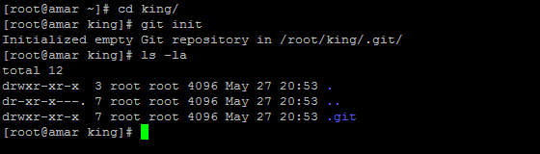

* Create a blank files like a.txt, b.txt.







* Set git config variables.

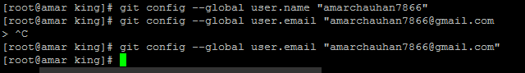

* Commit both files.

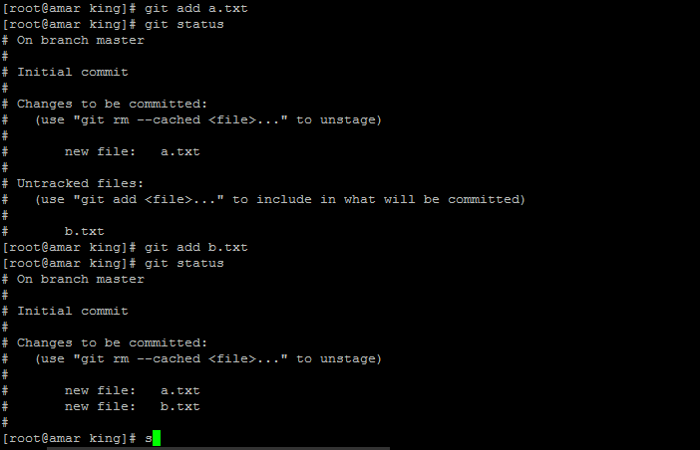

* Commit both files.

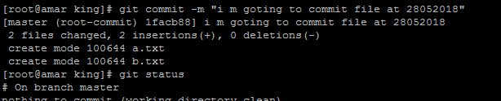

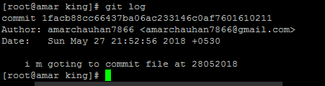

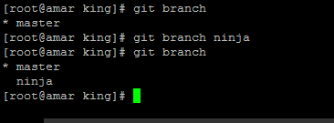

* Switch into branch **ninja**

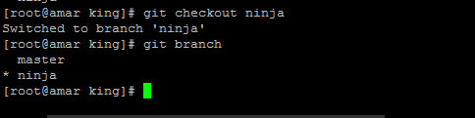

* Check for the difference made in the file.



* Check difference between last two commits.

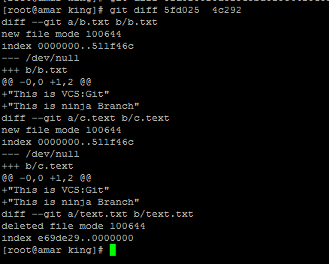

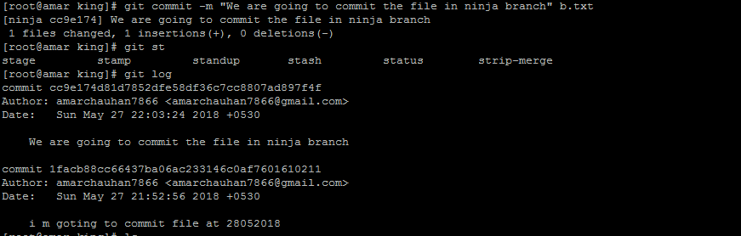

* Rename your file b.txt to c.txt

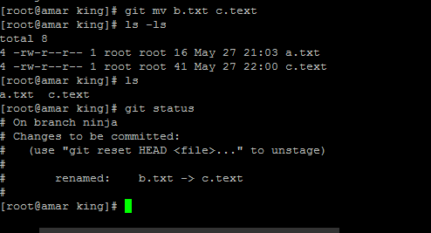

* Commit your changes.

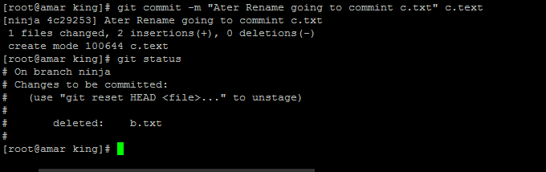

* Remove file c.txt.

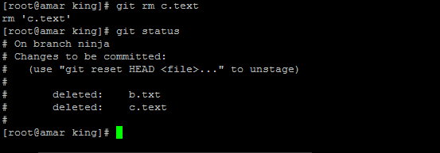

* Commit your changes.

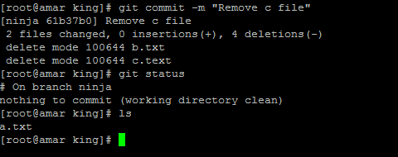

* Create a file text.txt and add it.

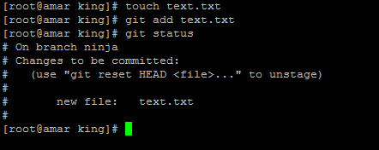

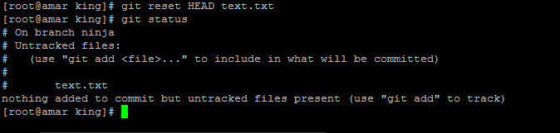

**Assignment2:**

* Create a account on github.com.

I have created account on github.com

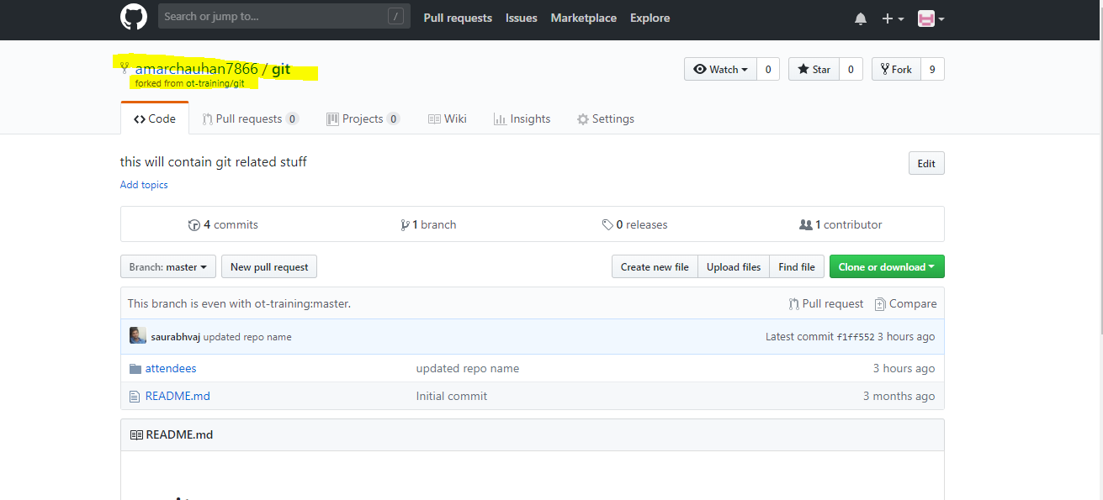

I have generated the ssh key using the ssh -keygen and added it to the github under the sshkeys

