**Assignment1:**

* Create a script to generate a meagre conflict.

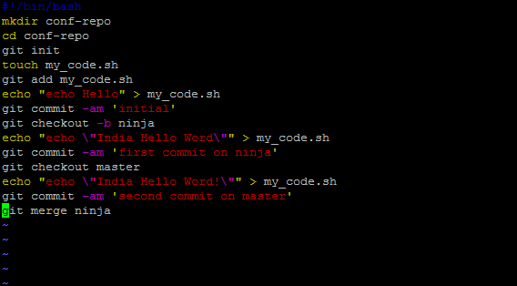

Output :-

* Create multiple branches and push changes for each branch into remote repo.

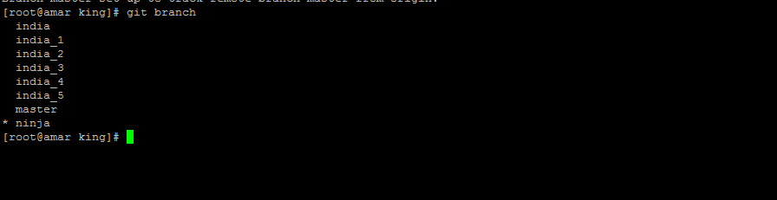

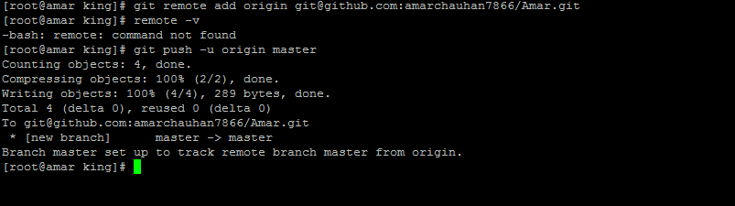

* Create a script to clone remote repo and check out all existing remote branch.

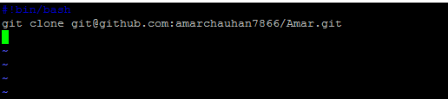

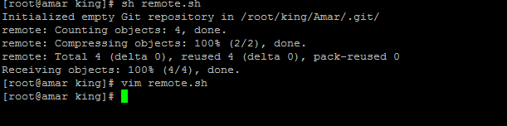

* Use both https and ssh protocal to clone your remote repo.

For the ssh key clone I have generate the ssh key and clone the remote repo

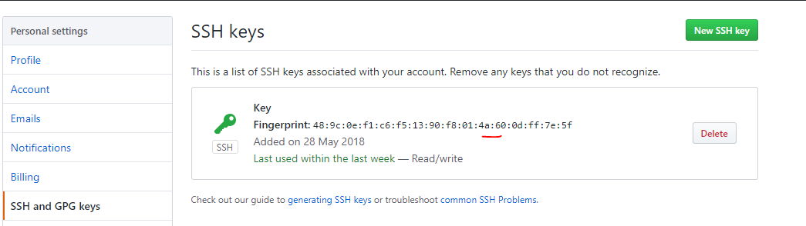

Clone through the https I have the add the https in remote

git remote add origin master [https://github.com/amarchauhan7866/git.git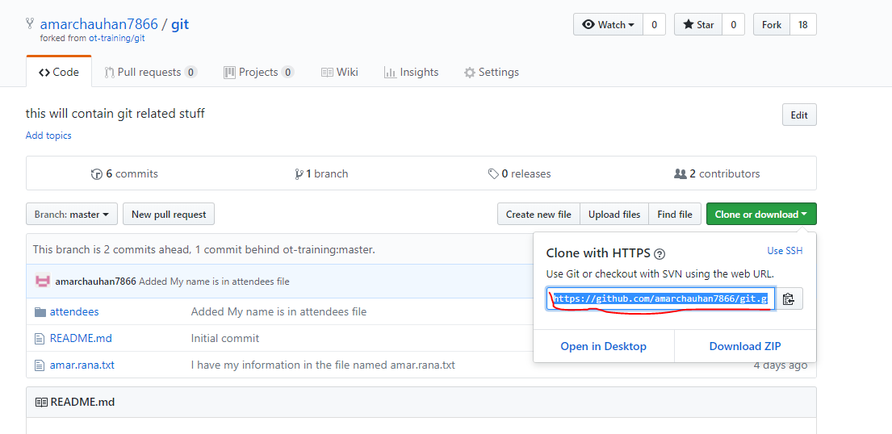](https://github.com/amarchauhan7866/git.git)

and now clone the remote report

git clone <https://github.com/amarchauhan7866/git.git>

* Change your working copy into a clonable remote repo

Firstly Create a another vm for the same and make the password less authentication through ssh key

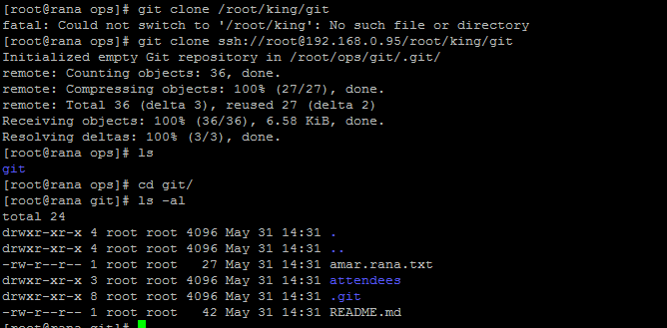

* Ignore backup, swp and pyc file from being commited.

Create a file with .gitignore

touch .gitignore

git config --global core.excludesfile ~/.gitignor

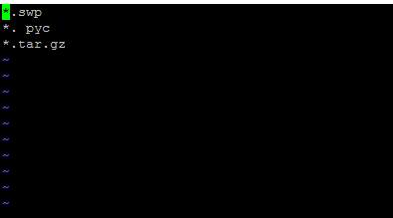

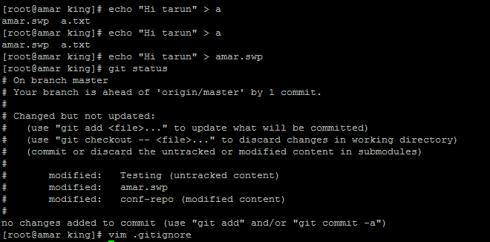

Add remote name **parent** for [ot-training/jenkins](https://github.com/ot-training/jenkins.git) to your own repo

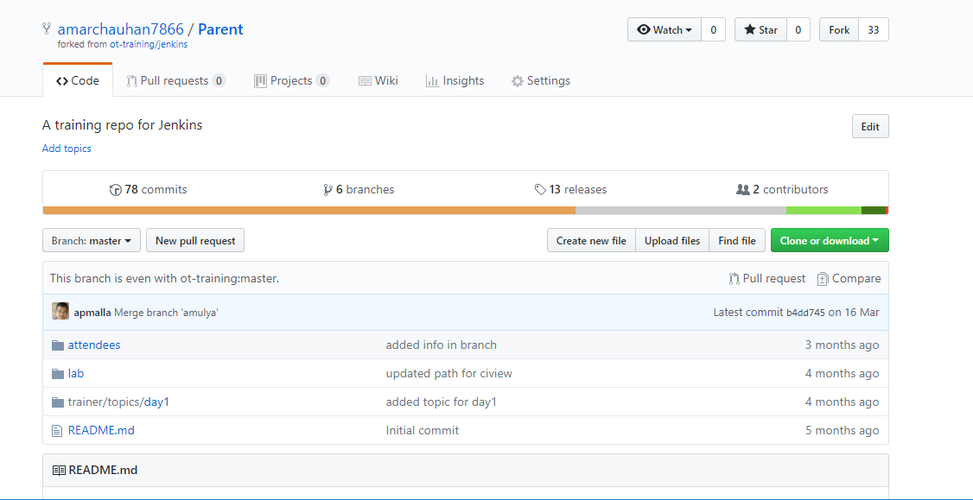

* Check and verify two remotes.
* Git fetch changes from **parent** repo.

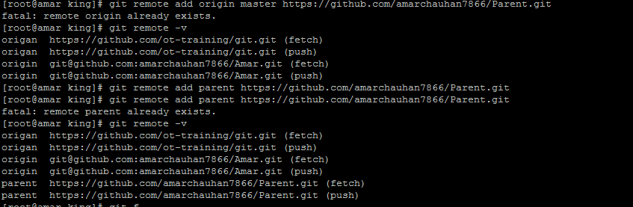

git fetch <https://github.com/amarchauhan7866/Parent.git>

git fetch command is not reflect any changes on the local repo