Created the Account on GitHub, GitLab and Git bitbucket

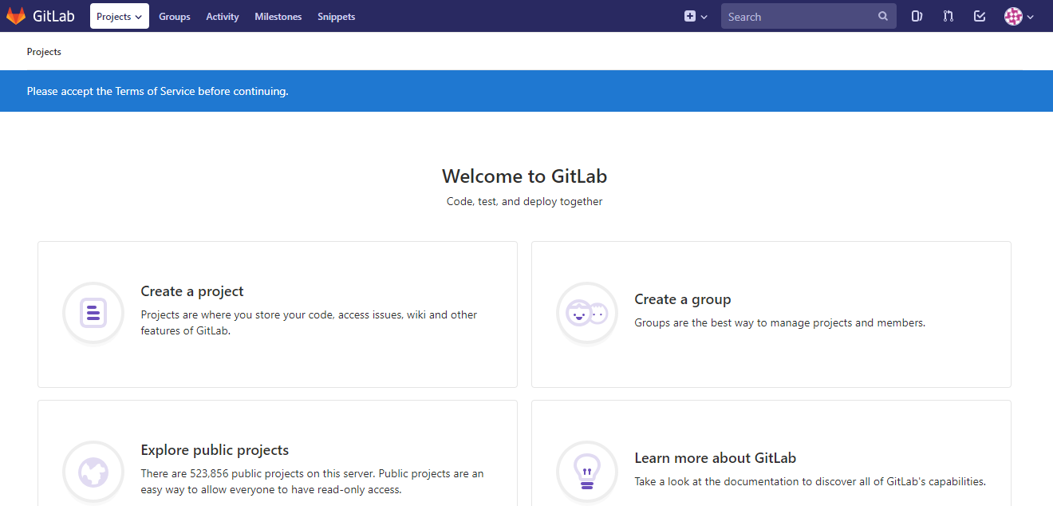

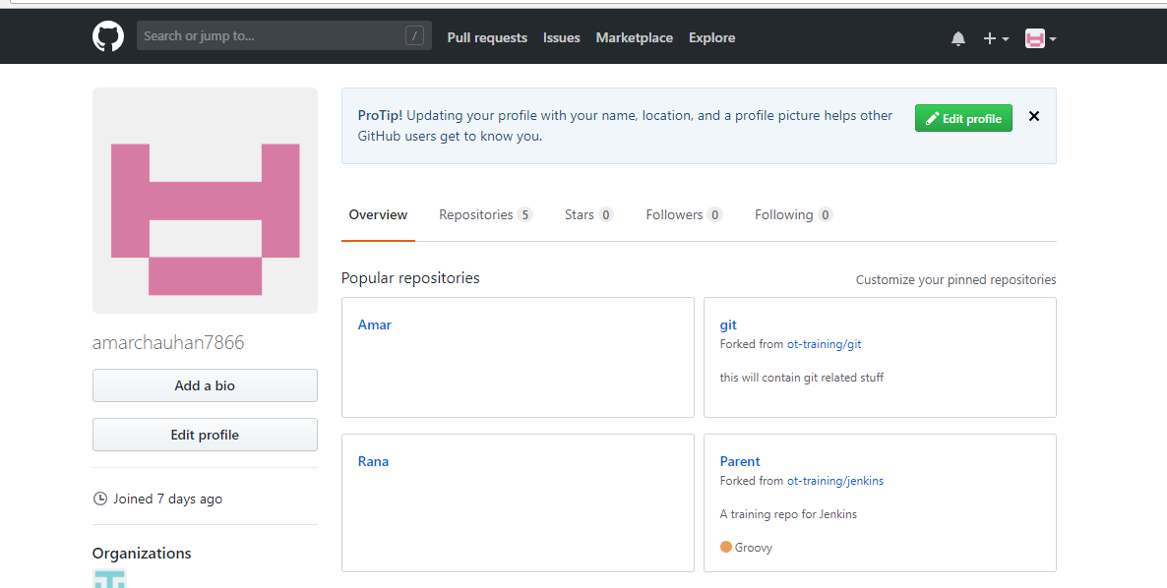

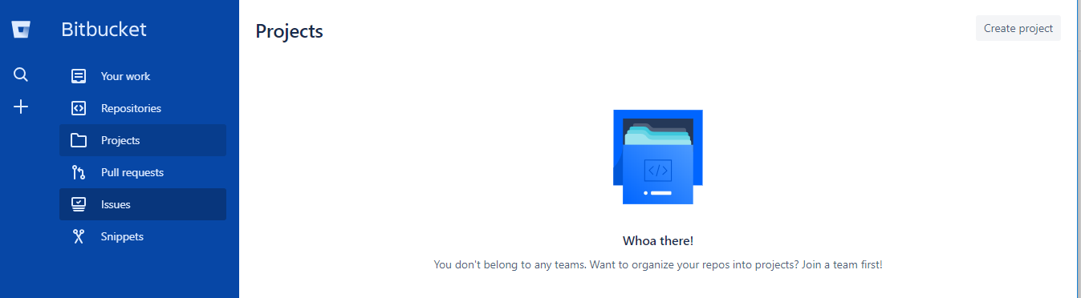

Try to findout key features and major differences between all.

**Bitbucket: -**

Bitbucket is written in Python and uses the Django web framework.

We get free private repositories on Bitbucket

It offers free accounts with an unlimited number of private repositories.

Snippets that allow developers to share code segments or files

**GitHub: -**

it is free for public repositories and for private one it is paid.

GitHub is written using Ruby and Erlang

* It has something called Gists(a way to share code snippets

Email notifications

**Gitlab: -**

It do almost everything that GitHub does, so it is like Github, but here we have free private repositories that github doesn’t

GitLab Community Edition is free and open sourced.

Email notifications

**Assignment2: -**

* **Check for organization and repository level permission for team and users over repositories and branches**.

Created the Group and project in Gitlab and git hub and checked the permission in userswise or group

**Assignment3:**

**Create a test repo in your github account, write some demo commits.**

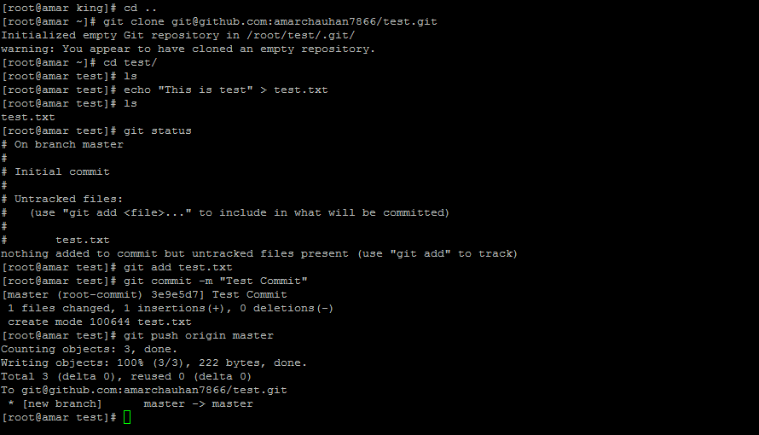

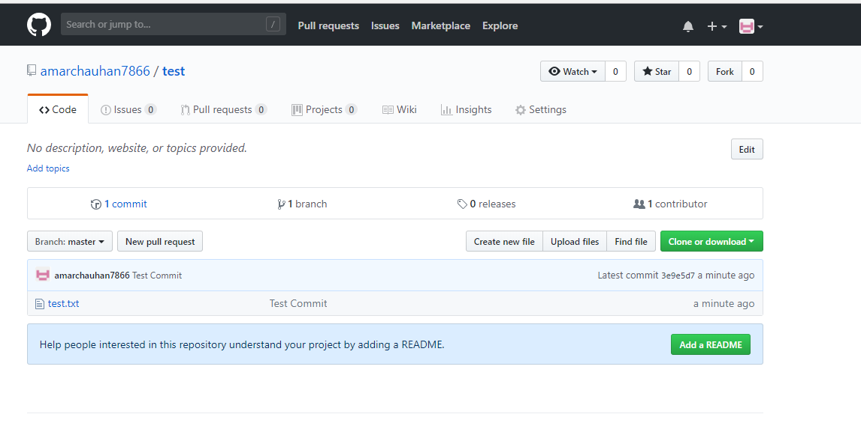

* Add this test repo as submodule inside your git repo.

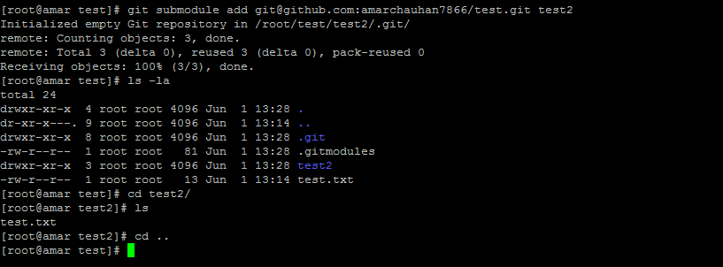

* Clone git repo with submodule.

Pause the submodule on remote repo

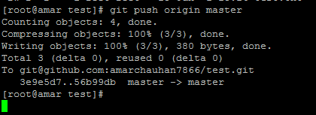

* Clone git repo with submodule.

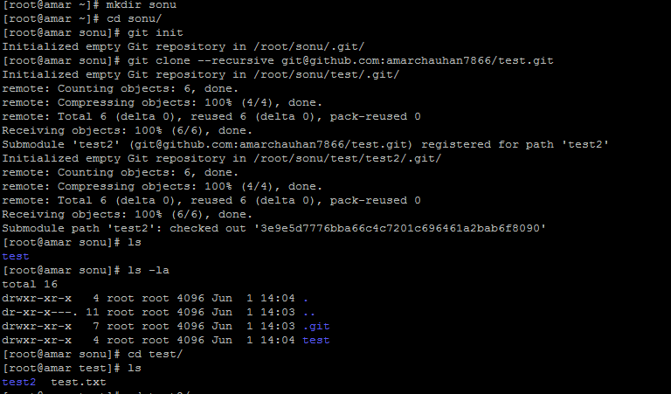

**Assignment4:-**

* **Configure & setup gitolite server to host private git server.**

**Installation Gitolite Server installation details are below.**

**Add user git and set the password**

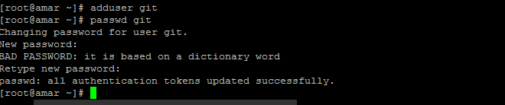

**Create SSH public key and copy it to the git user**

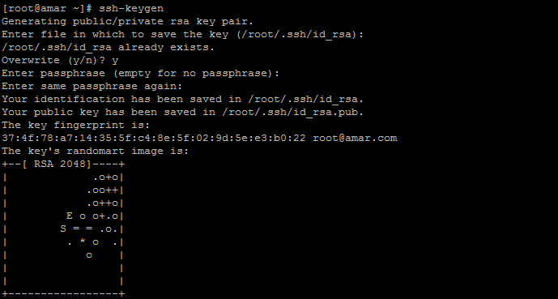

[root@amar ~]# cp .ssh/id_rsa.pub as.pub

[root@amar ~]# cp as.pub /home/git/.

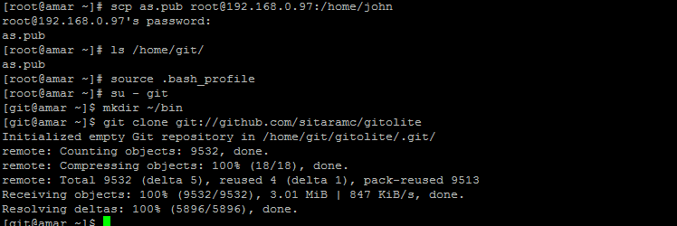

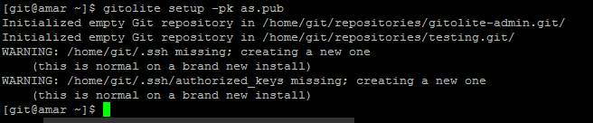

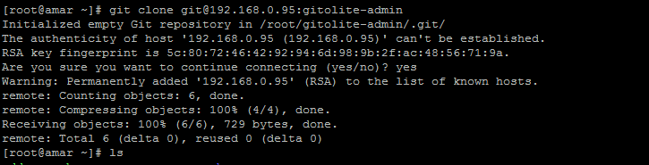

**Gitolite has been installed successfully**

**Now create the repo in gitolite**

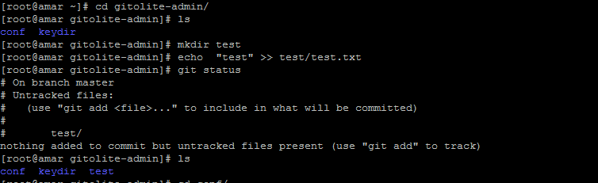

**Add the and commit the file**

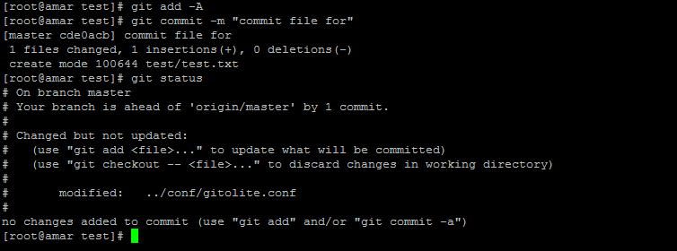

**Push the commit file**

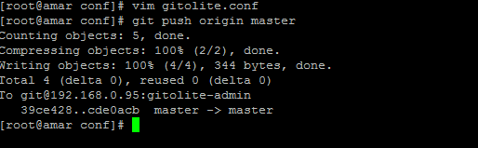

**We can set the user permission from the /gitolite-admin/conf/** **gitolite.conf**

