Zabbix installation through script:-

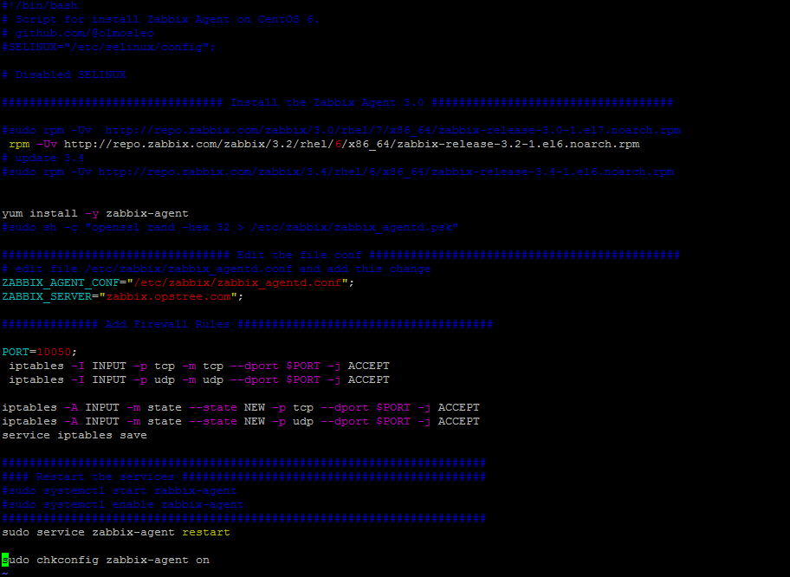

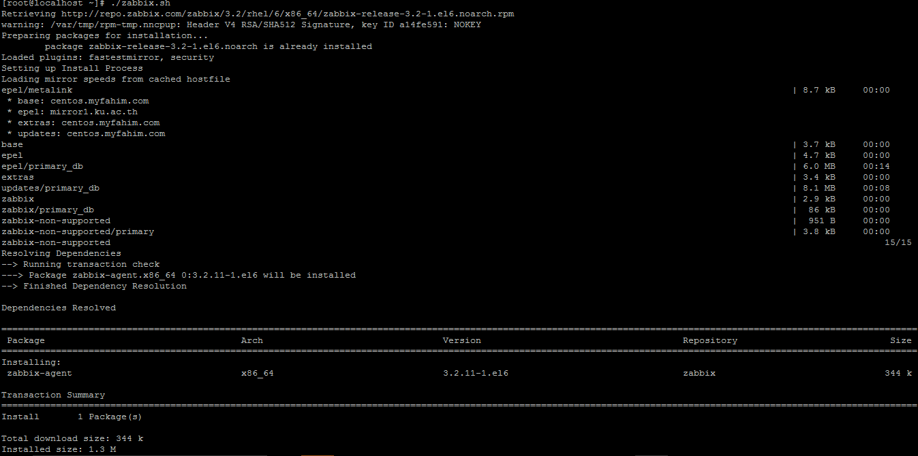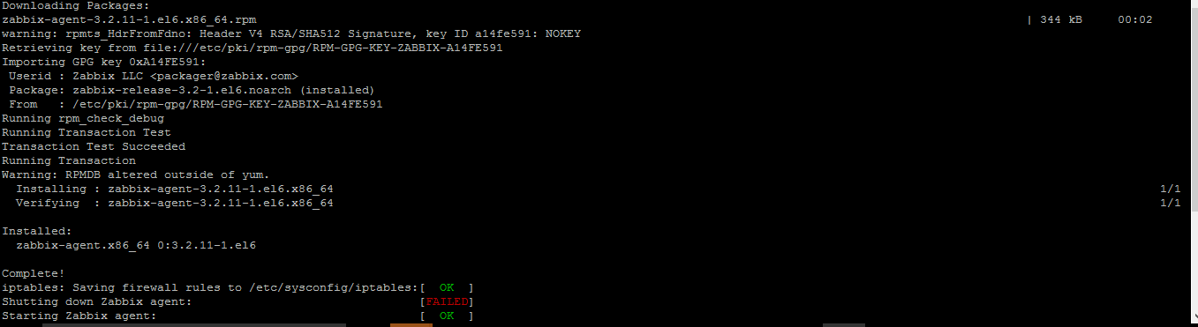

Through the script we can disable the selinux as well as we have to configured the iptables .

#!/bin/bash

# Script for install Zabbix Agent on CentOS 6.

# github.com/@olmosleo

#SELINUX="/etc/selinux/config";

# Disabled SELINUX

################################ Install the Zabbix Agent 3.0 ###################################

#sudo rpm -Uv http://repo.zabbix.com/zabbix/3.0/rhel/7/x86_64/zabbix-release-3.0-1.el7.noarch.rpm

rpm -Uv http://repo.zabbix.com/zabbix/3.2/rhel/6/x86_64/zabbix-release-3.2-1.el6.noarch.rpm

# update 3.4

#sudo rpm -Uv http://repo.zabbix.com/zabbix/3.4/rhel/6/x86_64/zabbix-release-3.4-1.el6.noarch.rpm

yum install -y zabbix-agent

#sudo sh -c "openssl rand -hex 32 > /etc/zabbix/zabbix_agentd.psk"

################################# Edit the file conf #############################################

# edit file /etc/zabbix/zabbix_agentd.conf and add this change

ZABBIX_AGENT_CONF="/etc/zabbix/zabbix_agentd.conf";

**ZABBIX_SERVER="zabbix.opstree.com";**

############## Add Firewall Rules #####################################

PORT=10050;

iptables -I INPUT -p tcp -m tcp --dport $PORT -j ACCEPT

iptables -I INPUT -p udp -m udp --dport $PORT -j ACCEPT

iptables -A INPUT -m state --state NEW -p tcp --dport $PORT -j ACCEPT

iptables -A INPUT -m state --state NEW -p udp --dport $PORT -j ACCEPT

service iptables save

######################################################################

#### Restart the services ############################################

#sudo systemctl start zabbix-agent

#sudo systemctl enable zabbix-agent

######################################################################

service zabbix-agent restart

chkconfig zabbix-agent on

#########################################################################

Script Assignment: -1

#!/bin/bash

echo "Enter any charcter you want to print"

read input

echo "Enter no of times you want to print$input "

read x

r=0;

while [[ $r -lt $x ]]

do

echo "$input"

r=$((r+1))

done

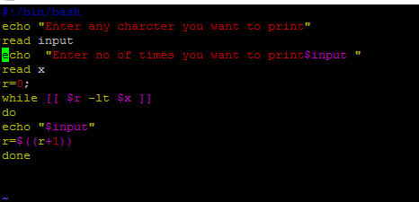

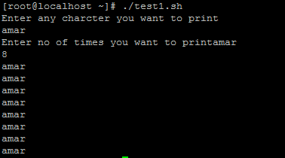

Script Assignment: - 2

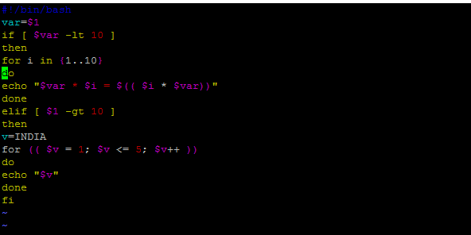

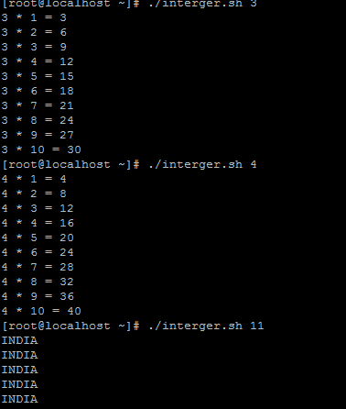

#!/bin/bash

var=$1

if [ $var -lt 10 ]

then

for i in {1..10}

do

echo "$var * $i = $(( $i * $var))"

done

elif [ $1 -gt 10 ]

then

v=INDIA

for (( $v = 1; $v <= 5; $v++ ))

do

echo "$v"

done

fi