 | Pimpri Chinchwad Education Trust’s  Pimpri Chinchwad College of Engineering  (PCCoE)  (An Autonomous Institute)  Affiliated to Savitribai Phule Pune University(SPPU) ISO 21001:2018 Certified by TUV | 
Course: Software Testing and Quality Assurance Laboratory | Code: BIT26PE11
Name: Amar Vaijinath Chavan | PRN: 124B2F001
Assignment 3: Implement white box unit test cases using unit test Framework.

1. OBJECTIVE
- To design and implement automated Unit Test cases for the "Hotel Management System."
- To decouple business logic from the presentation layer (HTML/CSS) using the Helper Pattern.
- To verify the integrity of Admin and User-side functionalities using the PHPUnit framework.
2. TEST ENVIRONMENT & CONFIGURATION
2.1 Software Stack
- Operating System: Windows 11 (XAMPP Environment)
- Language: PHP 8.0.30
- Testing Framework: PHPUnit 9.6.34
- Dependency Manager: Composer

2.2 Configuration File (phpunit.xml)
The phpunit.xml file serves as the test runner's configuration, defining the bootstrap process and
the test suites.
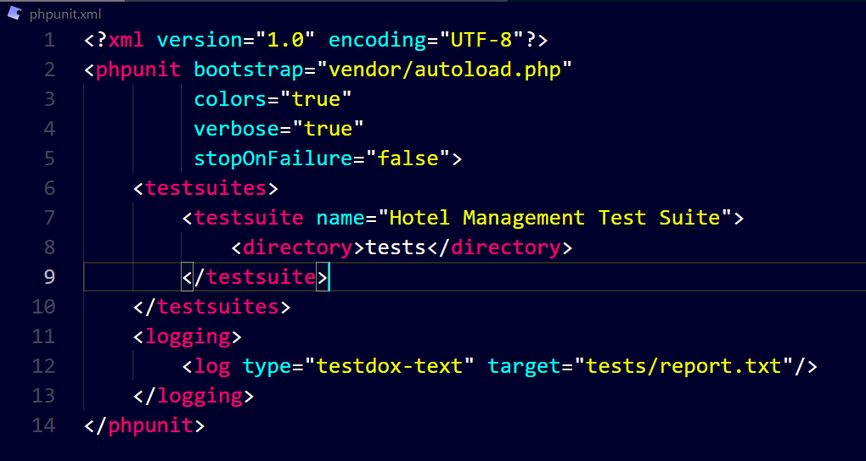
- Bootstrap: Loads the Composer autoloader to link Helper classes.
- Colors: Provides visual feedback (Green for Success, Red for Failure).
- Logging: Automatically generates a report.txt file for audit trails.

3. Project Structure
Project Root: C:\xampp\htdocs\hbwebsite
- inc/helpers/ — Isolated Business Logic (The "System Under Test").
- tests/ — PHPUnit Test Classes.
- vendor/ — Composer dependencies.
- phpunit.xml — Centralized Test Configuration.

4. Implementation Details (Business Logic)
The business logic of the Hotel Management System has been decoupled from the monolithic files and encapsulated into modular Helper classes. This architecture allows for isolated testing of functions without database or UI dependencies.
4.1 Authentication & User Security
This module contains the logic for validating credentials and matching passwords for both public users and administrative staff.
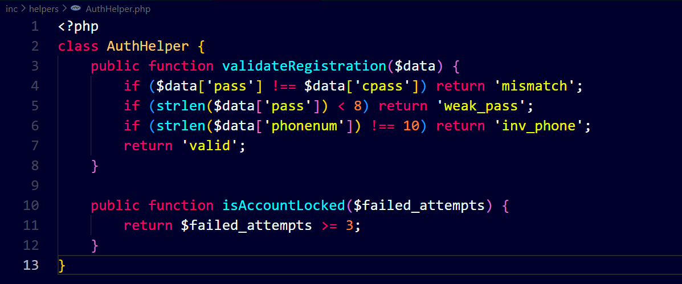
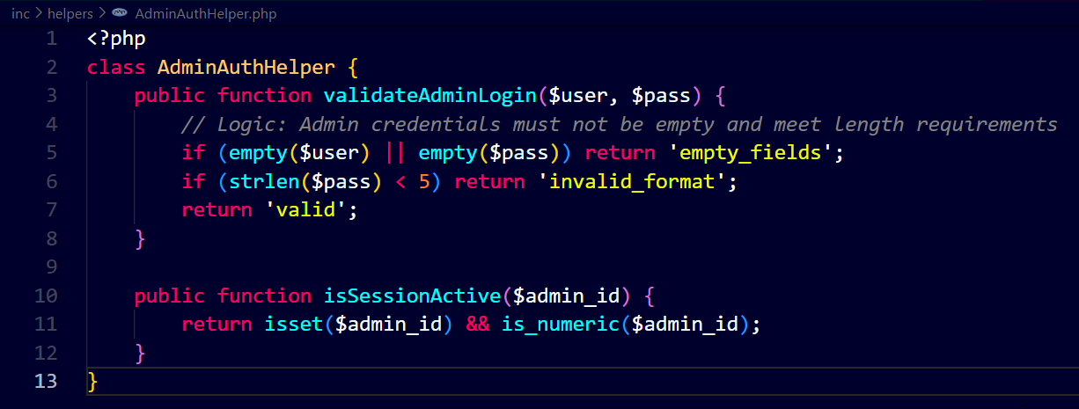
Description: Implementation of administrative session security and user registration validation
logic.

4.2 Booking, Financial & Room Logic
These helpers manage core transactional logic, stay duration calculations, and room inventory management rules.
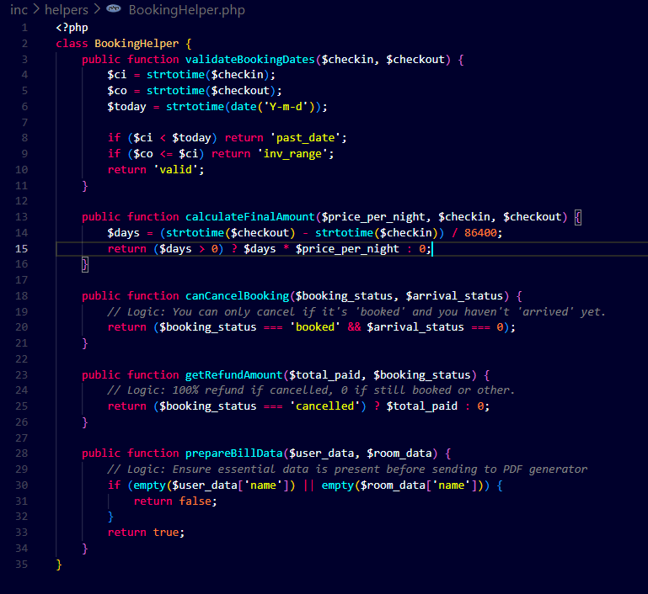
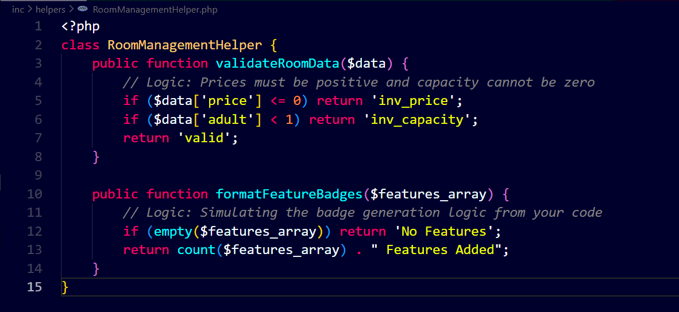
Description: Implementation of calculateFinalAmount, canCancelBooking, and room capacity
4.3 Administrative Analytics & Dashboards
Logic for aggregating raw data into dashboard statistics, including revenue sums, booking counts, and system analytics.
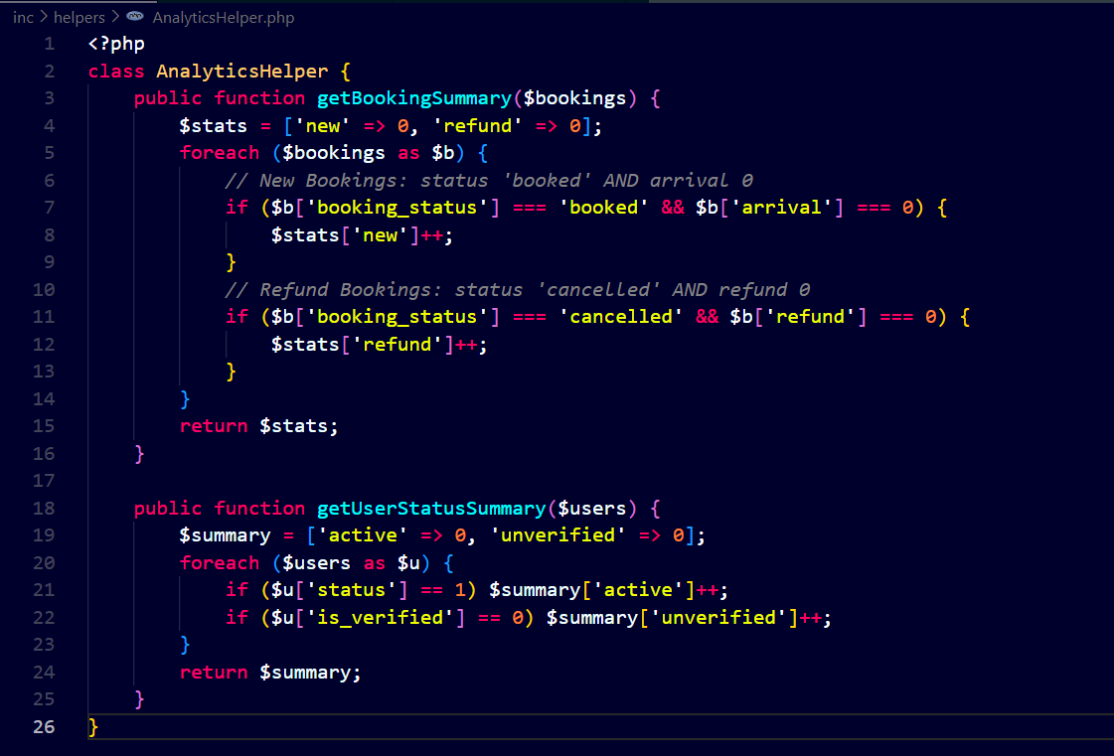
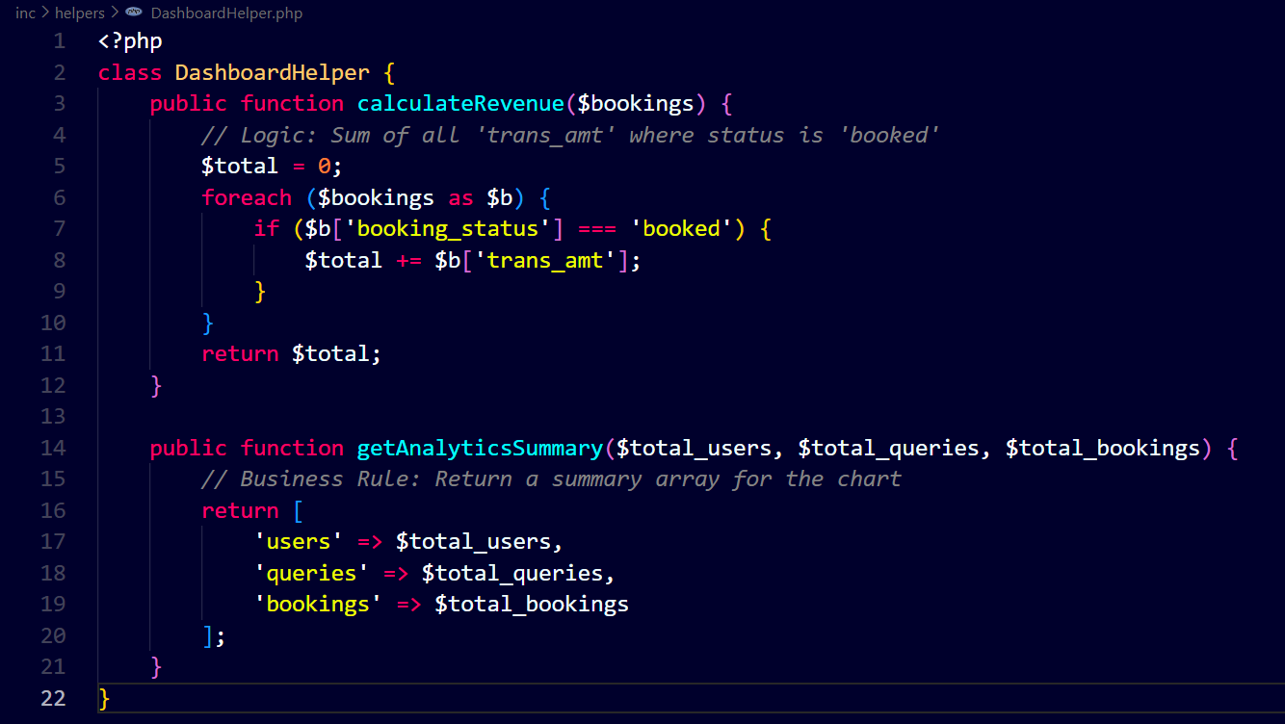
Description: Business intelligence logic for the Admin Dashboard to track revenue and booking
trends.
4.4 User Profile & Data Management
Handles the integrity of user-specific data, including pincode verification, phone number formatting, and general profile updates.
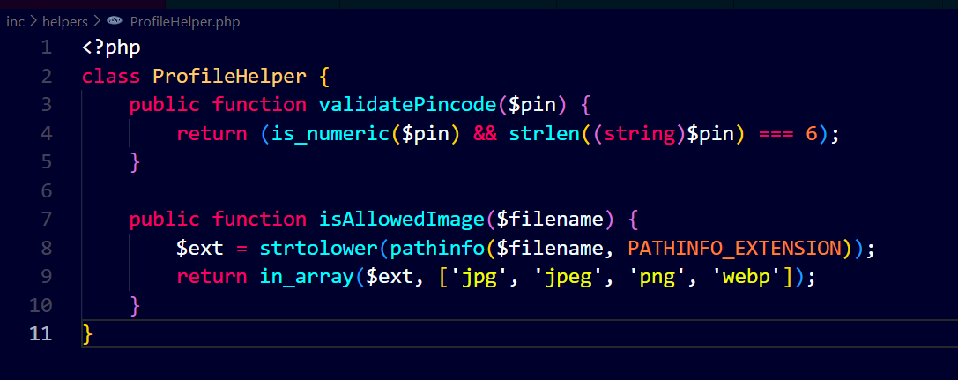
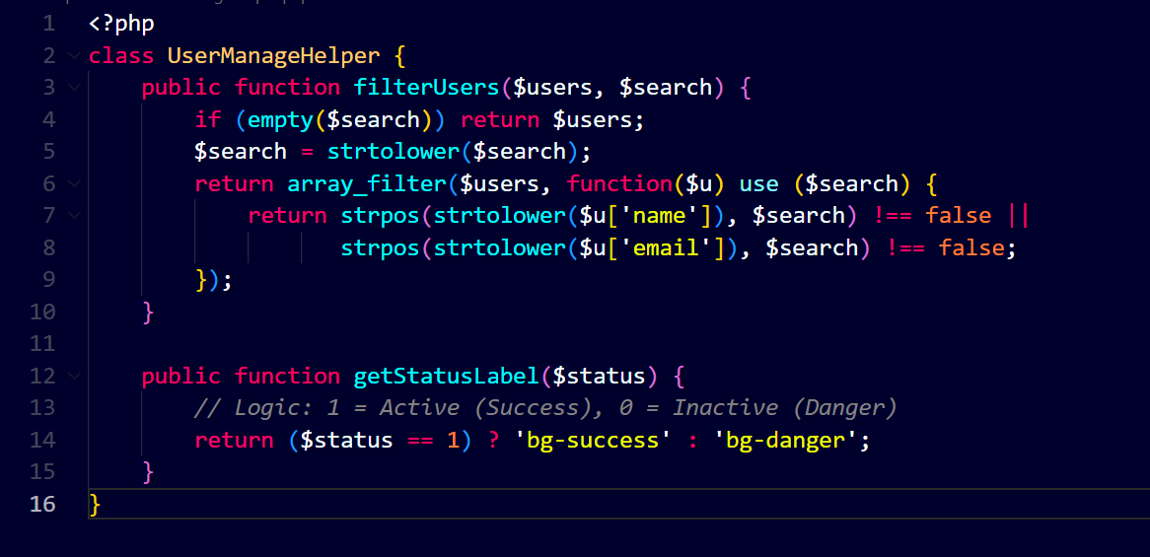
Description: Data validation logic for user profiles and administrative user management controls.

4.5 Search & Media Processing
Logic for multi-criteria search functionality across the site and validation of administrative media uploads for carousels and room galleries.
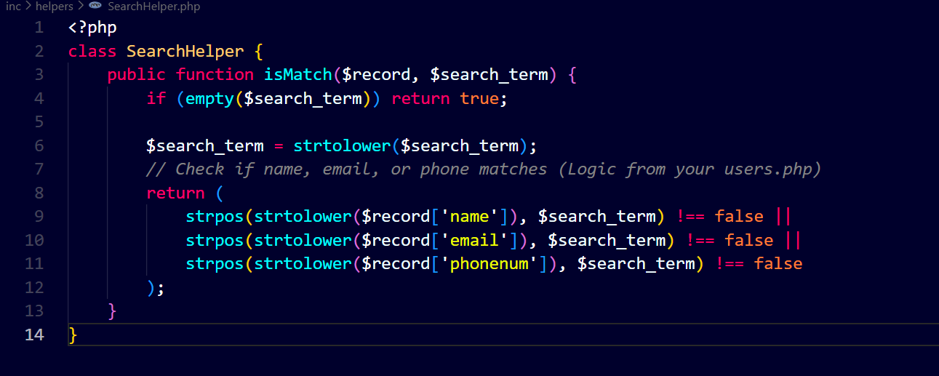
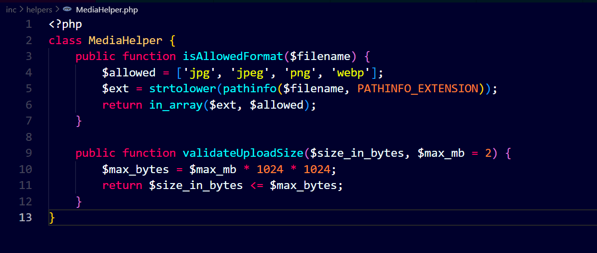
Description: Filtering logic for search queries and secure file extension/size validation for image
uploads.

5. Unit Test Suite Development
test cases were developed using the PHPUnit framework. These tests target the Helper classes to verify that all functional requirements are met.
5.1 User-Side Test Cases
Comprehensive testing of the user journey, including valid/invalid registration data, stay date boundaries, and refund logic.
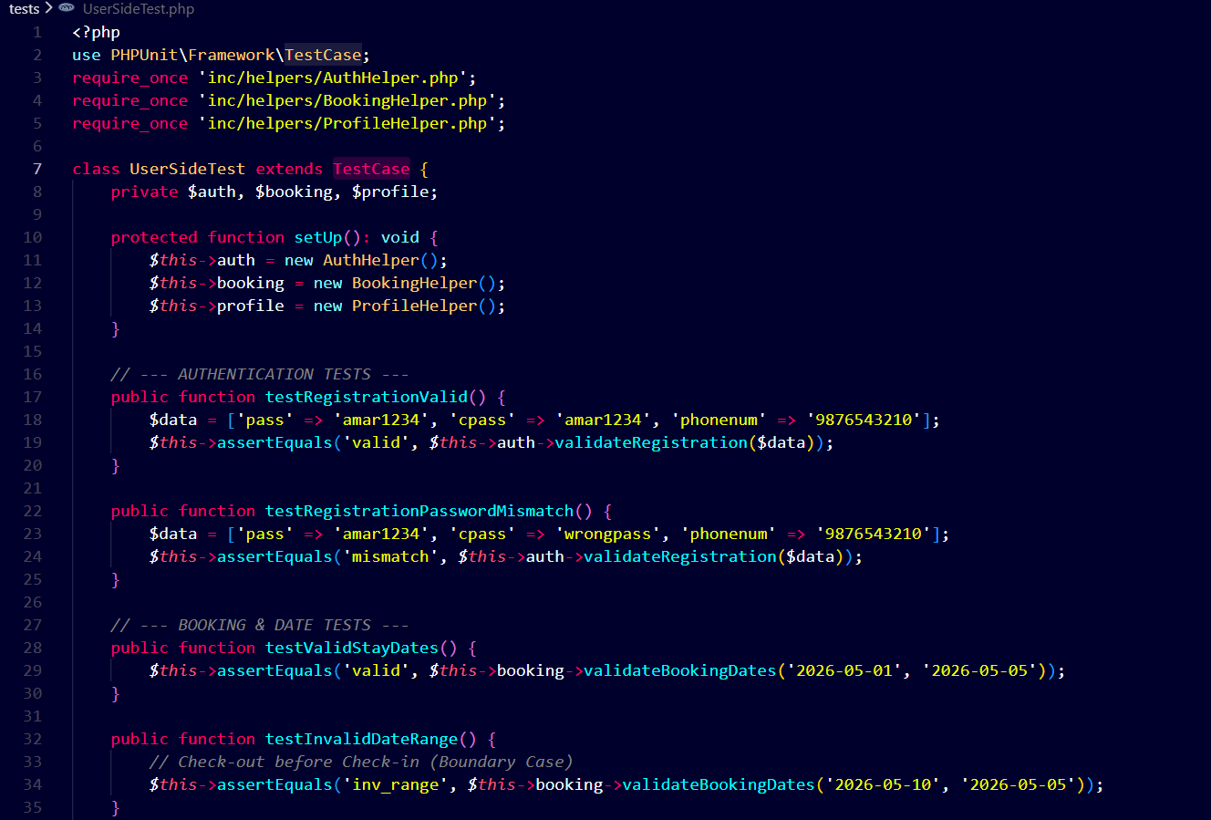
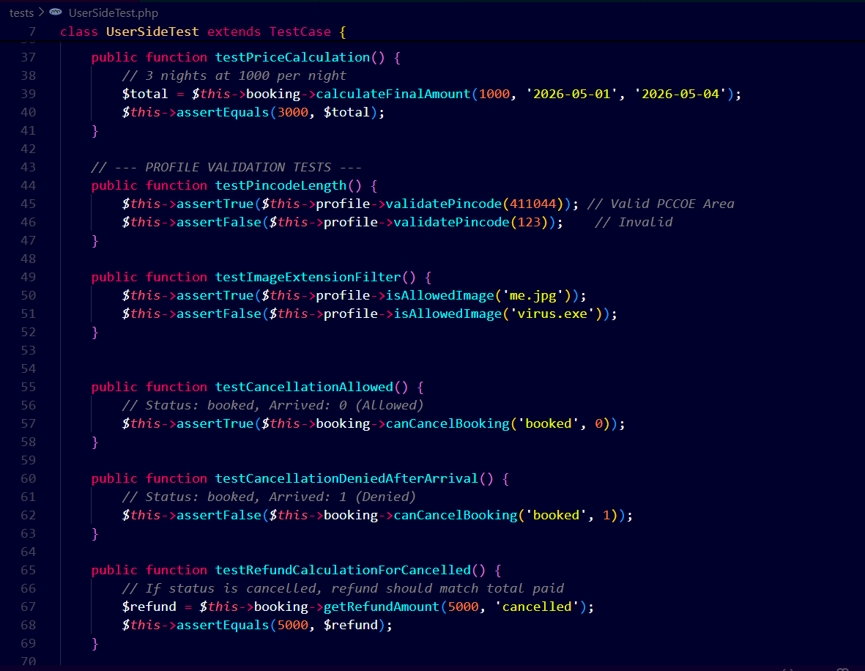
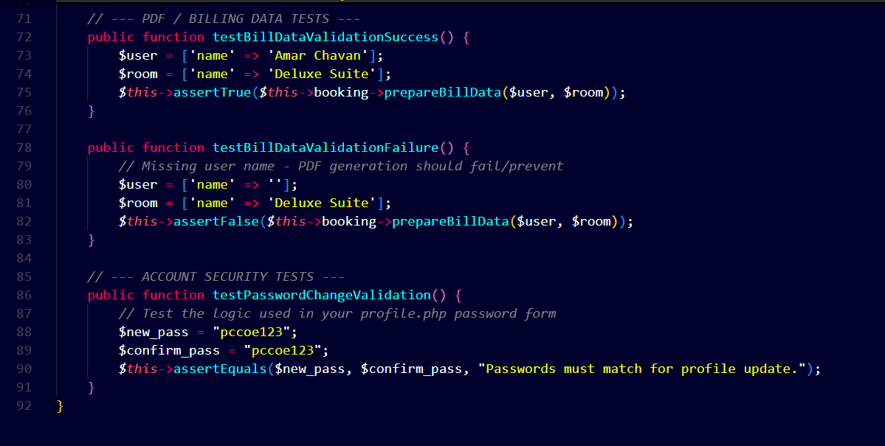
Description: PHPUnit test methods utilizing assertions to verify User-side functional requirements.

5.2 Admin-Side Test Cases
Validation of administrative controls, including login security, the accuracy of the revenue dashboard, and search filter precision.
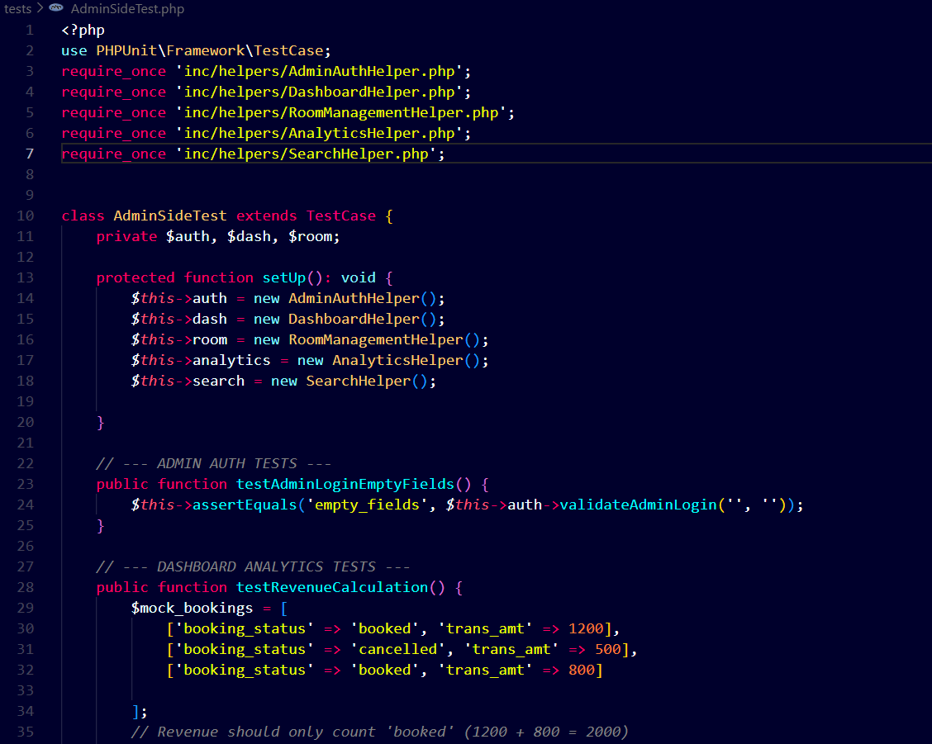
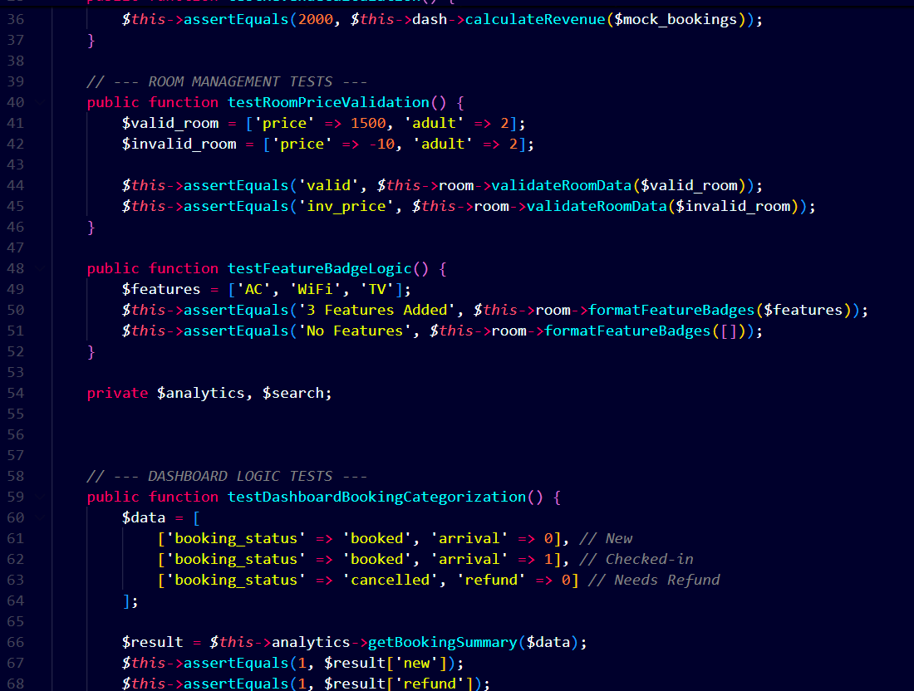
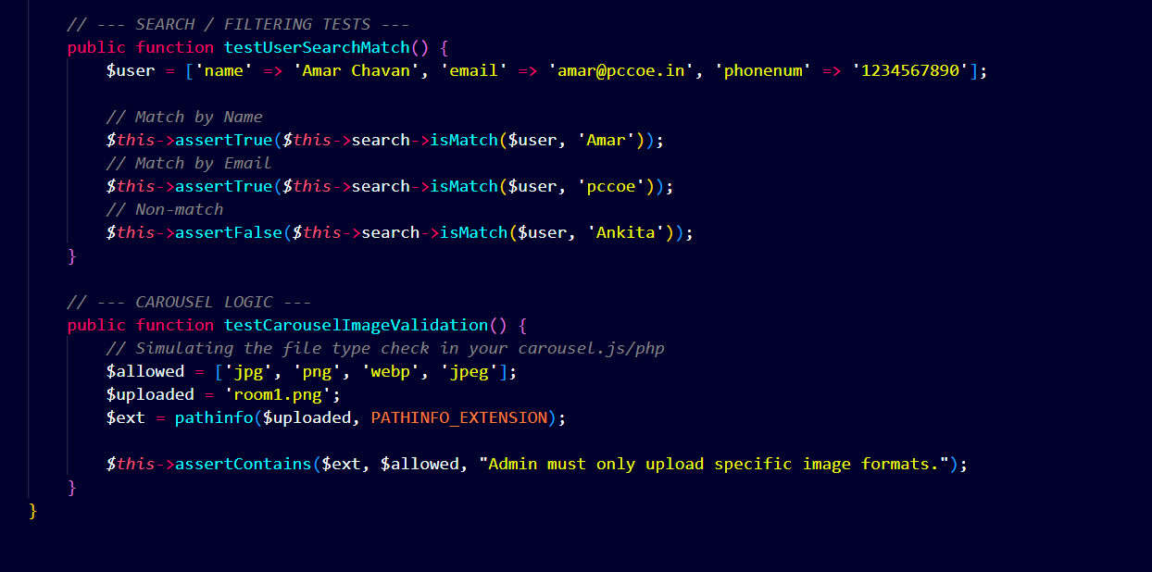
Description: PHPUnit test methods verifying Admin-side analytical and security logic.

6. Test Execution & Reporting
The test suite was executed via the command line interface to provide a comprehensive verification of the system state.
6.1 Execution Command
The following command was used to trigger the automated test runner: vendor\bin\phpunit --testdox
6.2 Final Test Execution Output
The final execution report confirms that the system is robust, with all units passing the defined criteria.
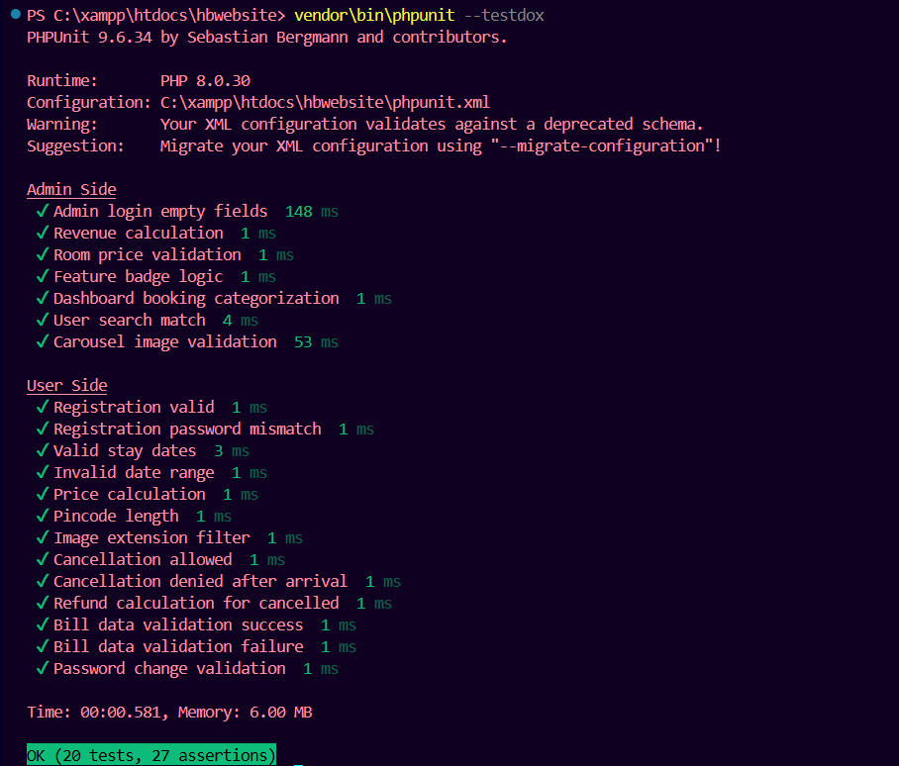
Description: CLI output displaying 20 successful tests, 27 assertions, and the "OK" status bar.

7. Conclusion
The implementation of unit testing successfully validates the core logic of the Hotel Management System. By utilizing a modular Helper-Test architecture, the project ensures high reliability for critical financial and security operations. With a 100% pass rate across 20 test cases, the application is verified as stable and ready for the next phase of the software testing lifecycle.

